**Instructional Unit Authors**

North Routt and Hayden School Districts

Lori Raper

Ali Moyer

**Based on a curriculum**

**overview Sample authored by**

Aurora Public Schools

Chris Strater

Colorado Springs School District 11

Aaron Ford

Community Leadership

Shannon Loveridge

Woodland Park School District Re-2

Sue Wright

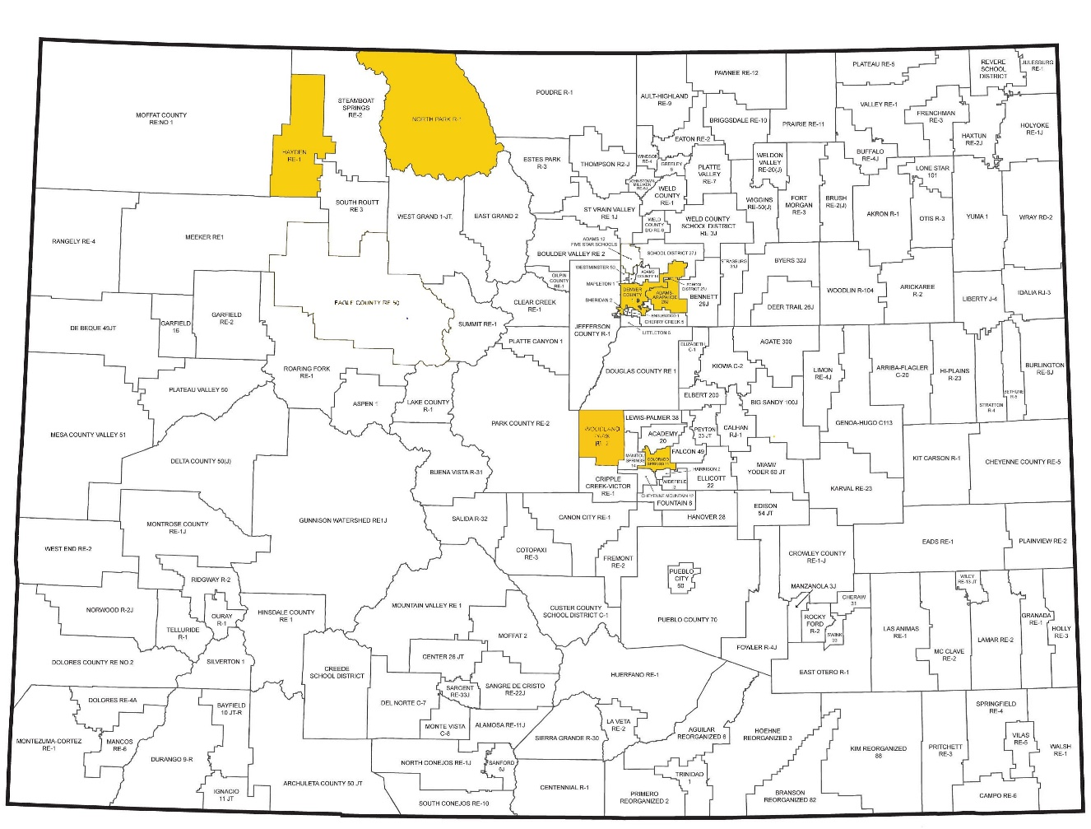

*This unit was authored by a team of Colorado educators. The template provided one example of unit design that enabled teacher-authors to organize possible learning experiences, resources, differentiation, and assessments. The unit is intended to support teachers, schools, and districts as they make their own local decisions around the best instructional plans and practices for all students.*

**Colorado’s District Sample Curriculum Project**

Date Posted: APRIL, 2018

Physical Education

1st Grade

Colorado Teacher-Authored Instructional Unit Sample

**Feel the beat**

|  |  |  |  |  |  |  |  |
| --- | --- | --- | --- | --- | --- | --- | --- |
| **Content Area** | Physical Education | | | **Grade Level** | 2nd Grade | | |
| **Course Name/Course Code** |  | | | | | | |
| **Standard** | **Grade Level Expectations (GLE)** | | | | | | **GLE Code** |
| Movement Competence and Understanding | 1. Demonstrate basic locomotor and non-locomotor skills, and rhythmic and cross-lateral movements | | | | | | PE09-GR.1-S.1-GLE.1 |
| 1. Demonstrate fundamental manipulative skills | | | | | | PE09-GR.1-S.1-GLE.2 |
| 1. Establish a beginning movement vocabulary | | | | | | PE09-GR.1-S.1-GLE.3 |
| Physical and Personal Wellness | 1. Identify the body’s normal reactions to moderate and vigorous physical activity | | | | | | PE09-GR.1-S.2-GLE.1 |
| Emotional and Social Wellness | 1. Demonstrate positive and helpful behavior and words toward other students | | | | | | PE09-GR.1-S.3-GLE.1 |
| 1. Follow the rules of an activity | | | | | | PE09-GR.1-S.3-GLE.2 |
| Prevention and Risk Management | 1. Develop movement control for safe participation in games and sports | | | | | | PE09-GR.1-S.4-GLE.1 |
| **Colorado 21st Century Skills**    **Critical Thinking and Reasoning:** *Thinking Deeply, Thinking Differently*  **Information Literacy:** *Untangling the Web*  **Collaboration:** *Working Together, Learning Together*  **Self-Direction:** *Own Your Learning*  **Invention:** *Creating Solutions* | |  | | | | | |
| **Unit Titles** | | | **Length of Unit/Contact Hours** | | | **Unit Number/Sequence** | |
| Feel the Beat | | | 6 – 10 weeks | | | 3 | |

|  |  |  |  |  |  |
| --- | --- | --- | --- | --- | --- |
| Feel the Beat | Feel the Beat | | | **Length of Unit** | 6 – 10 weeks |
| **Focusing Lens(es)** | Rhythms | **Standards and Grade Level Expectations Addressed in this Unit** | PE09-GR.1-S.1-GLE.1  PE09-GR.1-S.3-GLE.1 | | |
| **Inquiry Questions (Engaging- Debatable):** | * What does it mean to have rhythm? (PE09-GR.1-S.1-GLE.1-EO.d,e; IQ. 2,4;) * Why is it important to have personal space? (PE09-GR.1-S.1-GLE.3-EO.d; IQ. 4; RA. 1,3; N.1) * Why are dances (like the “chicken dance, “bunny hop,” and “electric slide”) so popular at group gatherings such as wedding receptions? (PE09-GR.1-S.1-GLE.1-EO.d,e; IQ.2; RA.1; N.2,3) | | | | |
| **Unit Strands** | Movement Competence and Understanding; Social and Emotional Wellness | | | | |
| **Concepts** | Tempos, Pattern Understanding, Cooperation, Collaboration, Fluid Movement, Directional Movement, Sequencing, Guidelines, Performance, Rhythm, Traveling, Variation | | | | |

|  |  |  |
| --- | --- | --- |
| **Generalizations**  **My students will Understand that…** | **Guiding Questions**  **Factual Conceptual** | |
| Understanding patterns and tempos will lead to fluid movement and rhythm in dance and music. (PE09-GR.1-S.1-GLE.1-EO.d,e; IQ.2,4; RA.1; N.1,2) | How does your rhythm change with a change in tempo? | What other areas do we use patterns in? |
| Rhythms and patterns recur across subject areas and in the real world. (PE09-GR.1-S.1-GLE.1-EO.d,e,f; IQ.2,4; RA.1; N.2) | How are patterns used in math? | What are ways that patterns can be used in another area of school? |
| Performance of rhythms, patterns and other movements should express variation and improvisation. (PE09-GR.1-S.1-GLE.1-EO.d,e; IQ.2,4; RA.1; N.1,2) | How do you perform the two different rhythms in tinkling? | What are variations in rhythms in dance? |

|  |  |  |  |
| --- | --- | --- | --- |
| **Critical Content:**  **My students will Know…** | **Key Skills:**  **My students will be able to (Do)…** | | |
| * A simple sequence of movements within given parameters and guidelines, rhythmical movements using small musical aides, a singing dance in a group, a simple dance step in keeping with a specific tempo, travel to a variety of rhythms changing time, force and flow (PE09-GR.1-S.3-GLE.2-EO.a; PE09-GR.1-S.1-GLE.1-EO.d,I,h) * Patterns and rhythm in other content areas. (PE09-GR.1-S.1-GLE.1-EO.d,e) * The difference between rhythms, patterns and sequencing. (PE09-GR.1-S.1-GLE.1-EO.d,e) | | * Perform a simple sequence of movements within given parameters and guidelines, rhythmical movements using small musical aides, a singing dance in a group, a simple dance step in keeping with a specific tempo, travel to a variety of rhythms changing time, force and flow (PE09-GR.1-S.3-GLE.2-EO.a; PE09-GR.1-S.1-GLE.1-EO.d,I,h) * Integrate patterns and rhythm in other content areas. (PE09-GR.1-S.1-GLE.1-EO.d,e) * Demonstrate the difference between rhythms, patterns and sequencing. (PE09-GR.1-S.1-GLE.1-EO.d,e) |

|  |  |  |
| --- | --- | --- |
| **Critical Language:** includes the Academic and Technical vocabulary, semantics, and discourse which are particular to and necessary for accessing a given discipline.  EXAMPLE: A student in Language Arts can demonstrate the ability to apply and comprehend critical language through the following statement: *“Mark Twain exposes the hypocrisy of slavery through the use of satire.”* | | |
| **A student in ______________ can demonstrate the ability to apply and comprehend critical language through the following statement(s):** | | *Sarah performed a dance that required various forms of rhythmical understanding.* |
| **Academic Vocabulary:** | Perform, guidelines, variety, time, parameters | |
| **Technical Vocabulary:** | Tempo, movement, rhythm, travel, force, flow | |

|  |  |  |
| --- | --- | --- |
| **Unit Description:** | This unit allows students to demonstrate various body awareness and the development of locomotor skills. Learning experiences focus on locomotor skills, a variety of tempos, rhythm, patterns and sequencing, dance and body movement. The performance assessment provides students with the opportunity to create and perform a self-expressive dance to a classic nursery rhyme. | |
| **Considerations:** | Most first grade students will have a general understanding of personal space, general space, locomotor skills, responsible use of equipment, and expectations for partner cooperation. However first graders will vary in developmental readiness, therefore this unit is designed to allow students to develop and/or experience manipulation of objects.  In addition you may need to consider:   * time spent with students (i.e. length of class, number of days a week) * technology * space * class size * physical challenges * cultural diversity | |
| **Unit Generalizations** | | |
| **Key Generalization:** | | Identification and practice of physical skills provides a foundation for participation in sports and activities throughout life. (PE09-GR.2-S. 2-GLE. 1-EO. a,b; IQ. 1,2,; RA. 1,2,34; N.2) |
| **Supporting Generalizations:** | | Awareness of body and space help demonstrate balance in movement. |
| Experimentation with various locomotor patterns, varied levels of effort and force, increase balance, coordination and movement capacities. |

|  |  |
| --- | --- |
| **Performance Assessment:** *The capstone/summative assessment for this unit.* | |
| **Claims:**  (Key generalization(s) to be mastered and demonstrated through the capstone assessment.) | Performance of rhythms, patterns and other movements should express variation and improvisation. |
| **Stimulus Material:**  (Engaging scenario that includes role, audience, goal/outcome and explicitly connects the key generalization) | As a class, you have been asked to perform a self-expressive dance to a classic nursery rhyme. Your performance should include at least 5 different poses that will demonstrate your ability to express through movement. |
| **Product/Evidence:**  (Expected product from students) | Students will perform a rhythmic series or patterns of self-expression. The performance will include at least 5 different poses that demonstrate the students’ ability to express a story through movement. |
| **Differentiation:**  (Multiple modes for student expression) | Students may   * choose different nursery rhyme * create pictures to incorporate to routine * split up into groups, performing different parts * read nursery rhyme aloud * use equipment/instruments |

|  |  |
| --- | --- |
| **Texts for independent reading or for class read aloud to support the content** | |
| **Informational/Non-Fiction** | **Fiction** |
| *Rhythmic Activities and Dance* - 2E / Edition 2 by John Bennett | *I Got the Rhythm* by Connie Schofield-Morrison  Dancing Feet by Marc Brown and Lindsey Craig |

|  |  |  |  |  |
| --- | --- | --- | --- | --- |
| **Ongoing Discipline-Specific Learning Experiences** | | | | |
| 1. | Description: | Think/work like a dance instructor to create a sequence. | Teacher Resources: | <https://www.metronomeonline.com/>  Define Tempo |
| Student Resources: | <https://www.youtube.com/watch?v=45aFXHpKVGA> (Tempo music video)  <https://www.youtube.com/watch?v=j24_xH5uvdA> (Movement cues video) |
| Skills: | Creating patterns and sequences. | Assessment: | Students will perform a line dance displaying their understanding of patterns as well as adding self-expression. |
|  | | | | |
| 2. | Description: | Think/work like a dancer to connect movement with various topics such as: nature, and mathematics. | Teacher Resources: | [http://www.stem4teachers.org/wp content/uploads/2012/05/STEM_Dance_LessonPlanFinal.pdf](http://www.stem4teachers.org/wp%20content/uploads/2012/05/STEM_Dance_LessonPlanFinal.pdf) (Examples of STEM activities)  <http://artsedge.kennedy-center.org/educators/lessons/grade-k-2/Butterfly_Dance>  <https://www.youtube.com/watch?v=Jll0yqdQclw> -nature sounds  <https://www.youtube.com/watch?v=5fNLEPrNi2A> -thunderstorm |
| Student Resources: | <https://www.youtube.com/watch?v=9iQjHL-fEkM> (Yoga kaleidoscope)  <https://www.youtube.com/watch?v=qn1FAeJxHh8> (Math comparison)  <https://teachlearngrow.wikispaces.com/file/view/Sample+Rubric+for+Grade+1+Dance.pdf> (rubric for final grade)  <https://www.youtube.com/watch?v=zS7zNf8K4ZA> -grass swaying  <https://www.youtube.com/watch?v=Ljg4MQk_lxk> -movement under the sea |
| Skills: | Examine patterns and sequences in nature and math. | Assessment: | Students will perform their own routine to create a partner or group dance routine to demonstrate their understanding in patterns and sequencing. |
|  | | | | |

|  |
| --- |
| **Prior Knowledge and Experiences** |
| The learning experiences build on students’ working knowledge of rhythm, tempo, and patterns while using dance movements. Student experiences and developmental readiness will vary due to cultural opportunities and prior community enrichment activities with nature and types of dance. |

|  |  |  |
| --- | --- | --- |
| **Learning Experience # 1** | | |
| The teacher may choose to play a variety of tempos so that the students can respond creatively using different body parts. | | |
| **Generalization Connection(s):** | Understanding patterns and tempos will lead to fluid movement and rhythm in dance and music. | |
| **Teacher Resources:** | <https://www.metronomeonline.com/>  Define Tempo | |
| **Student Resources:** | <https://www.youtube.com/watch?v=45aFXHpKVGA> (Tempo music video)  <https://www.youtube.com/watch?v=j24_xH5uvdA> (Movement cues video) | |
| **Assessment:** | The students will be able to perform a specific pattern or tempo dance to demonstrate fluidity and rhythm (i.e. Ti-ti and Ta, Do-Mi-So). | |
| **Differentiation:**  (Multiple means for students to access content and multiple modes for student to express understanding.) | **Access** (Resources and/or Process) | **Expression** (Products and/or Performance) |
| The teacher may   * use different tempos for culture * use soft and loud cues * mirror other students for understanding | The students may   * share other cultures * share own culture * design authentic dance |
| **Extensions for depth and complexity:** | **Access** (Resources and/or Process) | **Expression** (Products and/or Performance) |
| The teacher may bring in organizations to perform for school. | The students may draw/write a story to give feedback about the performance. |
| **Critical Content:** | * simple sequence of movements within given parameters and guidelines, rhythmical movements using small musical aides, a singing dance in a group, a simple dance step keeping with a specific tempo, a variety of rhythms changing time, force and flow * difference between rhythms, patterns and sequencing | |
| **Key Skills:** | * perform simple sequence of movements within given parameters and guidelines, rhythmical movements using small musical aides, a singing dance in a group, a simple dance step keeping with a specific tempo, travel to a variety of rhythms changing time, force and flow * difference between rhythms, patterns and sequencing | |
| **Critical Language:** | Tempos, Pattern Understanding, Sequencing, Rhythm, Variation | |

|  |  |  |
| --- | --- | --- |
| **Learning Experience # 2** | | |
| The teacher may present a video of people performing a line dance so that students can observe how patterns and tempos lead to expressive dance. | | |
| **Generalization Connection(s):** | Rules, responsibility, respect, positive encouragement and cooperation promote safety. (PE09-GR.2-S. 3-GLE. 1-EO. a,b,c; IQ. 1,2,3,4; RA. 1,2; N. 1) | |
| **Teacher Resources:** | Understanding patterns and tempos will lead to fluid movement and rhythm in dance and music.  Performance of rhythms, patterns, and other movements should express variation and improvisation. | |
| **Student Resources:** | <https://www.youtube.com/watch?v=Imhi98dHa5w&list=RDEMppqbSn7svFJsdsXaDM2NVA> (Dance-along video) | |
| **Assessment:** | <https://www.youtube.com/watch?v=uMuJxd2Gpxo> (Dance-along video)  <https://www.youtube.com/watch?v=HiigHQX_bks> (Line dance instructional video) | |
| **Differentiation:**  (Multiple means for students to access content and multiple modes for student to express understanding.) | **Access** (Resources and/or Process) | **Expression** (Products and/or Performance) |
| The teacher may   * model a line dance * present a well-known line dance * create picture cues | The student may   * follow a video, peer or teacher * perform a well-known line dance * create picture cues |
| **Extensions for depth and complexity:** | **Access** (Resources and/or Process) | **Expression** (Products and/or Performance) |
| The teacher may   * select more technical dances * speed up tempo | The student may   * perform more technical dances * perform at faster tempo |
| **Critical Content:** | * Simple sequence of movements within given parameters and guidelines, rhythmical movements using small musical aides, a singing dance in a group, a simple dance step in keeping with a specific tempo, travel to a variety of rhythms changing time, force and flow | |
| **Key Skills:** | * Perform a simple sequence of movements within given parameters and guidelines, rhythmical movements using small musical aides, a singing dance in a group, a simple dance step in keeping with a specific tempo, travel to a variety of rhythms changing time, force and flow | |
| **Critical Language:** | Tempos; Pattern Understanding; Fluid Movement; Directional Movement; Sequencing; Performance; Rhythm; Traveling; Variation | |

|  |  |  |
| --- | --- | --- |
| **Learning Experience # 3** | | |
| The teacher may model patterns to dance by numbers so students can recognize the math relationship of patterns and sequences. | | |
| **Generalization Connection(s):** | Rhythms and patterns recur across subject areas and in the real world. | |
| **Teacher Resources:** | <http://www.stem4teachers.org/wp-content/uploads/2012/05/STEM_Dance_LessonPlanFinal.pdf> (Examples of STEM activities) | |
| **Student Resources:** | <https://www.youtube.com/watch?v=9iQjHL-fEkM> (Yoga kaleidoscope)  <https://www.youtube.com/watch?v=qn1FAeJxHh8> (Math comparison)  <https://teachlearngrow.wikispaces.com/file/view/Sample+Rubric+for+Grade+1+Dance.pdf> (rubric for final grade) | |
| **Assessment:** | Students will watch each other’s performance and critique each other from a rubric and possibly do a “jump in” to add their own routine to create a partner or group dance routine. | |
| **Differentiation:**  (Multiple means for students to access content and multiple modes for student to express understanding.) | **Access** (Resources and/or Process) | **Expression** (Products and/or Performance) |
| The teacher may   * challenge groups to change their sequencing * count how many times they would have to do dance to last one minute | The student may   * choose other song to perform routine to * freestyle but repeat patterns and relate to math concepts |
| **Extensions for depth and complexity:** | **Access** (Resources and/or Process) | **Expression** (Products and/or Performance) |
| The teacher may graph data on line graph for beats. | The student may create own math representation of counting or fractions. |
| **Critical Content:** | * Rhythms and patterns recur across subject areas and in the real world. * Other languages for number counting | |
| **Key Skills:** | * Rhythms and patterns recur across subject areas and in the real world. * Can use other language (i. e. sign, Spanish, French, etc.) | |
| **Critical Language:** | Tempos; Pattern Understanding; Cooperation; Collaboration; Fluid Movement; Directional Movement; Sequencing; Guidelines; Performance; Rhythm; Traveling; Variation | |

|  |  |  |
| --- | --- | --- |
| **Learning Experience # 4** | | |
| The teacher may pose the question: “What kinds of things in nature can dance and move?” So that students can make connections between movements in nature and body movements. | | |
| **Generalization Connection(s):** | Rhythms and patterns recur across subject areas and in the real world.  Performance of rhythms, patterns and other movements should express variation and improvisation. | |
| **Teacher Resources:** | <http://artsedge.kennedy-center.org/educators/lessons/grade-k-2/Butterfly_Dance>  <https://www.youtube.com/watch?v=Jll0yqdQclw> -nature sounds  <https://www.youtube.com/watch?v=5fNLEPrNi2A> -thunderstorm | |
| **Student Resources:** | <https://www.youtube.com/watch?v=zS7zNf8K4ZA> -grass swaying  <https://www.youtube.com/watch?v=Ljg4MQk_lxk> -movement under the sea | |
| **Assessment:** | Students will work in a small group to create a self-expressive dance to an environmental concept (i.e. thunderstorm, tornado, blizzard, waves in the ocean, trees swaying). | |
| **Differentiation:**  (Multiple means for students to access content and multiple modes for student to express understanding.) | **Access** (Resources and/or Process) | **Expression** (Products and/or Performance) |
| The teacher may   * show example videos * model movements * use cue cards | The student may   * follow examples in videos * follow movements modeled by teacher or peer * follow cue cards |
| **Extensions for depth and complexity:** | **Access** (Resources and/or Process) | **Expression** (Products and/or Performance) |
| The teacher may   * present complex concept (i.e. move like you and your group are in the middle of a storm with severe winds etc.) * ask groups to guess each other's concept (charades) * add props (instruments, scarves, etc.) | The student may   * express a complex concept * guess each other’s concepts * perform with props |
| **Critical Content:** | Patterns and rhythm in other content areas. | |
| **Key Skills:** | Integrate patterns and rhythm in other content areas. | |
| **Critical Language:** | Cooperation; Collaboration; Fluid Movement; Directional Movement; Performance; Rhythm; Traveling; Variation | |