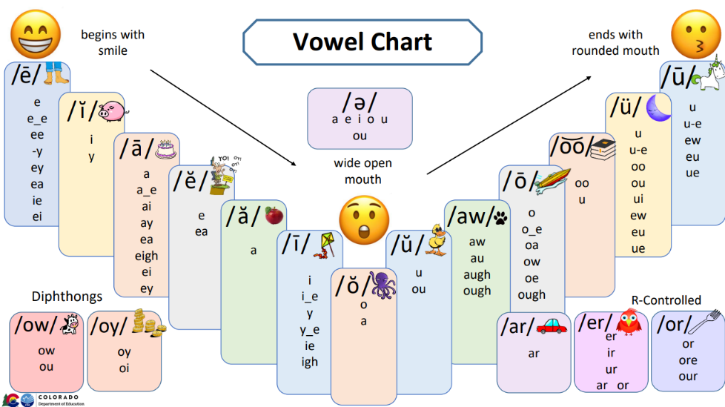Basic Sound Wall Cards

These basic sound wall cards include orthographic patterns found in early phonics instruction. For more advanced concepts, find the advanced sound wall cards found on CDE’s Educator Resources webpage. Also included on this page is information on how to set-up a sound wall.

These cards are provided in an editable format for flexibility to include concepts that have been introduced in your scope and sequence.

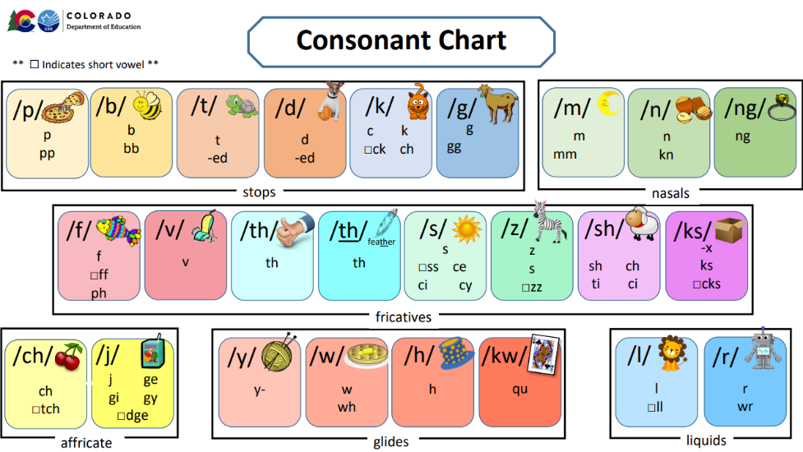

Sound walls are a high-leverage tool when the concepts as well as how to use the tool has been taught explicitly to students.

More information can be found here:

<http://www.cde.state.co.us/coloradoliteracy/readacteducatorresources>

*\*Note: The /hw/ sound typically spelled ‘wh’ in English words is not commonly utilized in American English; therefore, the ‘wh’ spelling has been incorporated into the sound card for the voiced /w/ phoneme in this resource.*

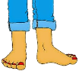 /ē/

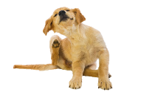 / ĭ /

e

e_e

ee

-y

i

/ ā/ 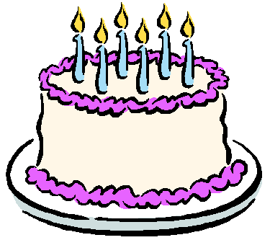

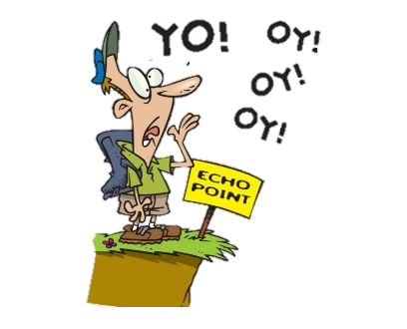 /ĕ/

a

a_e

ai

ay

e

ea

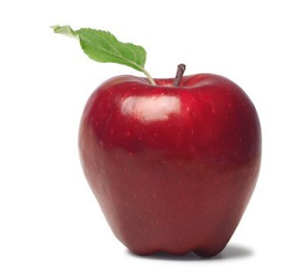 / ă/

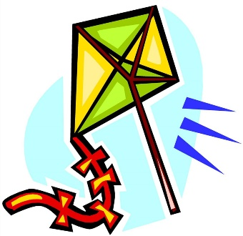 / ī /

a

i

i_e

ie

y

igh

 / ŏ/

 /ə/

o

a

e

i

o

u

 / aw/

 /ō/

aw

au

a(l)

o

o_e

oa

ow

duck


/ŭ/

u

 /o͝o /

 /ü/

oo

u

oo

ew

_ue

ou

u

u_e

 / ū/

 /ow/

u

u_e

_ue

ew

ow

ou

 / oy/

 /ar/

oi

oy

ar

 / er/

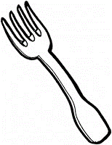 /or/

er

ir

ur

or

 / p/

 /b/

p

b

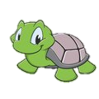 / t/

 /d/

t

-ed

d

-ed

 / k/

 /g/

c

k

□ck

g

monkey

 /m/

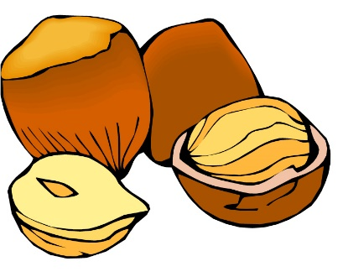 /n/

m

n

kn_

gn

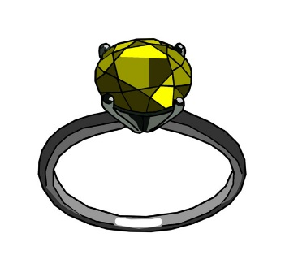 / ng/

fish
 /f/

ng

f

□ff

vacuum
 / v/

 /th/

v

th

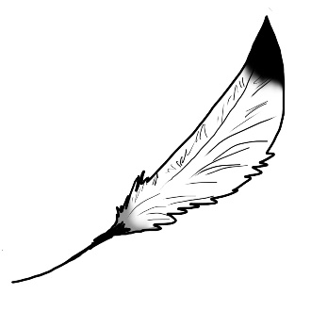 / th/

feather

 /s/

th

s

□ss

ce

ci

cy

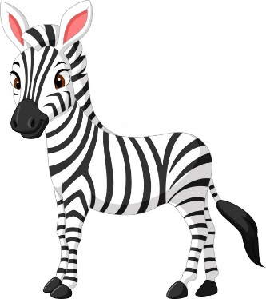 / z/

 /sh/

z

_s

□zz

sh

 / ks/

 /ch/

x

-ks

□cks

ch

□tch

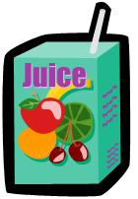 / j/

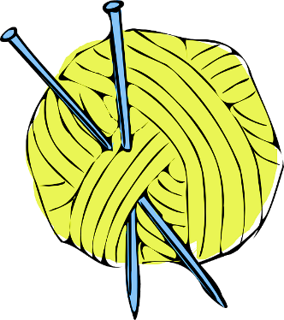 /y/

j

ge

gi

gy

□dge

y-

 / w/

 /h/

w

wh

h

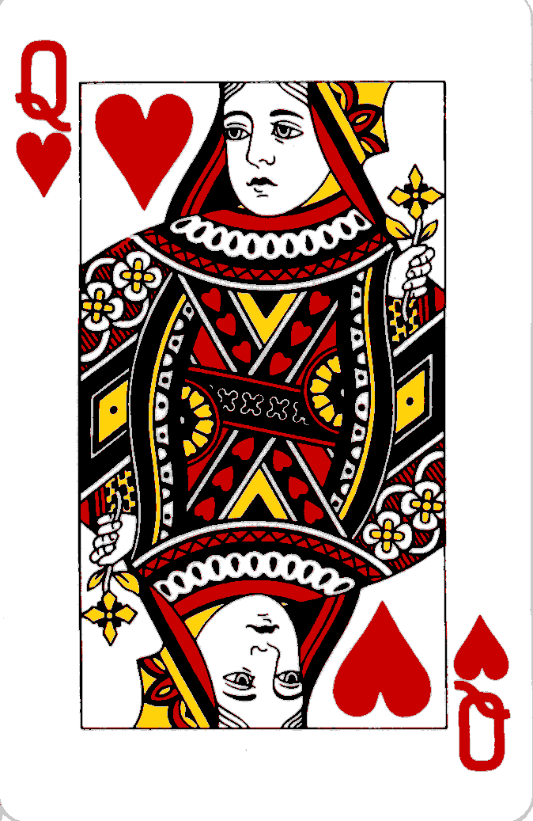 / kw/

 /l/

qu

l

□ll

 / r/

r

wr



