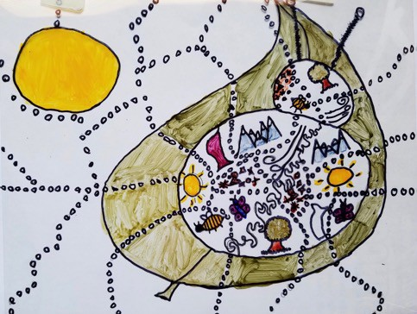

Reflecting Culture through Art - Personal Maps
Normandy Elementary School
Visual Arts Instructional Practices| All Students All Standards

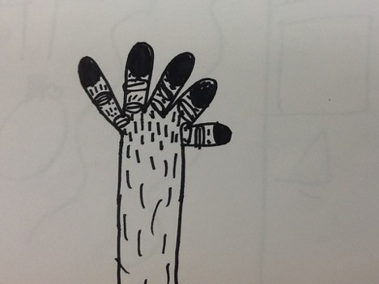
Table of Contents

Classroom Management |  | 3
Element 1: Classroom Context |  | 4
Element 2: Lesson Planning with Rationales for Your Decisions | 5-10

Element 3: Description of the Lesson Implementation 11
Element 4: Reflection 12

How to Be a Poet By Wendell Berry

(to remind myself) i
Make a place to sit down. Sit down. Be quiet.
You must depend upon affection, reading, knowledge, skill—more of each
than you have—inspiration, work, growing older, patience, for patience joins time
to eternity. Any readers who like your poems, doubt their judgment.

ii

Breathe with unconditional breath
the unconditioned air. Shun electric wire.
Communicate slowly. Live a three-dimensioned life; stay away from screens.
Stay away from anything
that obscures the place it is in. There are no unsacred places; there are only sacred places and desecrated places.

iii

Accept what comes from silence.
Make the best you can of it.
Classroom Management

Wendell Berry instructs in his poem ‘How to Be a Poet’ to : ‘Make a place to sit down. Sit down. Be quiet.’
This is about listening; listening to the quiet. Classroom management is about listening to the quiet space between student action and student learning.

Students do need to talk with one another about their art/art making and the art room does look different. The quiet is about routines, relationship, safe environment, consistent kindness and intentional adult action. All of which when in place instructional practices can and do thrive; conversely without routines, relationship, safe environment, consistent kindness and intentional adult action the very best resources, units and planning fall flat.

Classroom management is a deep layer within the strata of the studio classroom. It can and does look different with every teacher. And every teacher at some point in their day or week struggles with management of behaviors of the human beings they are charged with educating in visual arts practices. So, think about it. How are the routines going in your classroom? Do you have some? Are there consistent predicable things you do with your students? Do you have systems in place that ensure the safety of all students all the time? As the adult in the room, how do you follow up on those systems when a student/s are or become unsafe or off task?

In my studio classroom we have agreements. Agreements look like rules; the difference is we all generated the pieces that we felt made artists and art making meaningful as well as doable within our studio classroom. So the change is that the students created the agreements through group activity instead of the ‘rules’ coming from the teacher (me). The students decided what they felt was important about ‘what arts do…’ and ‘what art is…’; then individually made choices about what was important. In the ‘individual step’ each student from 2nd -6th grade completed some form of the following sentence: I agree to and

Of the little words that come so that I can in our creative learning environment.
out of the silence, like prayers

prayed back to the one who prays,
make a poem that does not disturb
the silence from which it came.

Source: Poetry (Poetry)
Then we moved from the individual back to the collective by sharing with two thought partners (other students). For 1st grade we generated what artists do… and what is art… then each student shared with two thought partners (other students) what they felt they could do to be an artist and ‘do’ art. The agreements are posted in our classroom on chart paper as a reminder; the sentences are in the student journals. The purpose in doing this is to create a collaborative and collective responsibility for the function of the daily environment in the studio classroom.

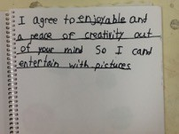
Classroom management must be cultivated and attended to. Management is woven into instructional practices. There is not one without the other; to ensure student success in the visual arts we consistently must ‘make a place’ for the ‘quiet’ in the space between management and instructional practice.

Element 1: Classroom Context

Normandy Elementary School Profile

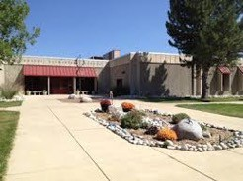
John Irwin School of Academic Excellence Award since 2002.

Science/Social Studies, technology, ecology, the Arts, and Advanced Mathematics options support Core Knowledge programming that sustains rigorous learning for all.

Committed volunteers support state-of- the-art classroom, technology, artistic, and environmental resources.

Students at Normandy Elementary, a Core Knowledge school, attain their highest
potential through a rigorous, content-rich educational program. Normandy has earned the prestigious John Irwin School of Excellence Academic Award continuously since 2002 for our outstanding results on state assessments. Normandy delivers a systemic, sequential curriculum that adheres to national, state, and district expectations, as well as the Core Knowledge sequence in grades K-6, including an Advanced Math option for grades 1-6. Our active parent and school community value state-of-the-art technology in all classrooms. Normandy embodies excellence in academic achievement and character development.

Lesson| Content area | Grade level | Class size

Students in 1st -6th grade at Normandy Elementary School go to Art, Music and Physical Education (AMP) on a weeklong rotation. The AMP Team serves approximately 450 students in a school population of approximately 552. There are two full day kindergartens and one half-time kindergarten. Our class size is an average of 28 students per grade level. We have an SIED lab from which students are integrated into AMP; some students come with support, some are independent.

Jefferson County Visual Arts Curriculum, Core Knowledge and Colorado Visual Arts Academic Standards are addressed within each 1st-6th grade unit of learning.
This document will focus primarily on 4th grade Reflecting Identity Through Art- Personal Maps Colorado Teacher-Authored Instructional Unit; specifically Learning Experiences 4 - 8.

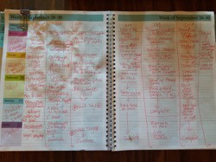
Element 2: Lesson Planning with Rationales for Decisions

Here's my plan book. I always fill it out on the weekend so I have some time to think about what the week ahead will look like; where this rotation is in the lesson or unit; what guiding reflection sentence stems we will address.
Art educators know this; sometimes you need more or less time than you've allotted.
Planning is like budgeting. We are budgeting the time according to the need of each particular art class. Often I think of the plan book as a map. A suggested way to get there but this can and will change with each class.
The goal is the learning. I write the learning at the top of each class period so I can keep track of where we are going and when I need to, not if I need to but when I need to, I refer back to it.

In my heart, I am wondering around the studio classroom with my students. We get interested in something and we go in that direction but it is my responsibility to bring them back to the learning by helping them to see or discussing where the cool thing we just figured out about color fits into our learning about mapping or portraits.

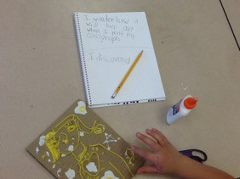
One way I have found are guiding reflection sentence stems. These are sometimes direct fill in the blank questions and at times open ended questions students begin with one sentence stem and end the class with another sentence stem. We close the class with the students either offering the learning reflection to the whole group or a turn or talk model at tables.

The reflection process helps the students 'do what artists do…' that is to say they are thinking about what they have done the day or rotation before and they are looking ahead to considering the possibilities of their work in the current class.

To address 4th grade Reflecting Identity Through Art- Personal Maps Colorado Teacher-Authored Instructional Unit with my students I decided to start with the portrait. The endeavor was to move the student past making an image of their face
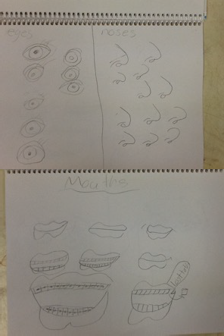
for their personal map. We looked at portraits and talked about portraits. We discussed how artists use portraits to tell a story. Then we practiced and sometimes were introduced to strategies for drawing facial features.

This is done through a direct instruction gradual release modality. I use Sketchbook Pro on my IPad and the AirServer program to project the drawing onto a screen in my classroom so all students can see. We practice and students are encouraged and given time to develop their own drawing strategies.

Part of the reason I do gradual release in my classroom is to model to the students in how and why choices are made. It is always clear to them that if they find through their practice a new strategy then WONDERFUL! And we all share our new discoveries and celebrations.

Here are some examples from 4th grade collograph portraits:
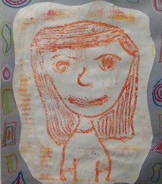
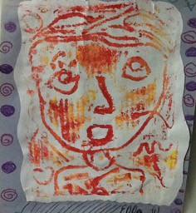

After we experienced a very frenetic and fun day of collograph printing we stepped back and discussed who this portrait might be.

Thinking about portraits as storytelling we moved on to telling our own story. We started by drawing a map of a bird's eye view of a place we go almost every day. The students created alongside the map a collection of colors that represent parts of who they are for example; likes, dislikes, culture. The next step in our planning was to assign shapes and lines ‘symbol’ to each of ‘our parts that represent us’ (likes, dislikes, ambitions, traditions, culture).

Here are student examples of ‘envisioning’ places, symbols and colors that are personal.
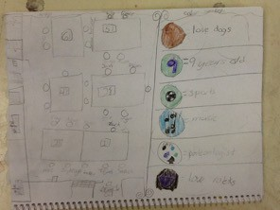
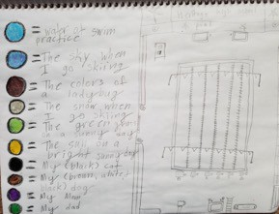

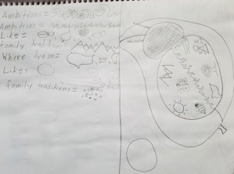
Putting these pieces of ‘envisioning’ side by side; someplace we go almost every day, color and symbols that are personal was intentionally planned to build context for mapping and self-portraiture through color, symbol and personal vision.

Skill building is an often explored world.
Scaffolding lessons into bigger concepts like personal maps sometimes feels like we are collecting a wide variety of experiences that might seem unrelated. I talk to the students about how we are moving from one piece to the next and to think about this as research. We are doing what artists do -- we are gathering our ideas and skills.

Meaning when I introduce a skill like color mixing I give the students ways to mix and think about the colors they have chosen for their personal maps that are experiential and exercises to build awareness of color theory; we considered what would happen if we mixed complements and primaries and discovered some lovely no color colors.
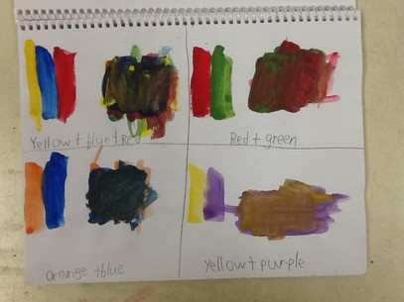

The students created a plan in their journal using their symbols and colors and adding in a larger symbol to serve as the shape of the map. The students were encouraged to think about something that they identified with because they liked it, wanted to be it someday or something that was
The purpose here to enlist symbols and colors was to take a deliberate step away from the image of the face as the only way to express
who we are to the world.
a tradition or part of their culture. The personal symbols and colors were then arranged in the map in regions; similar to the regions in our own lives, the maps tell the stories of the regions of the identities of the students.

Students transferred their plans to drawing paper then overhead projector film. At this time we are painting the film using acrylic paint.

Here are examples of in process student work.
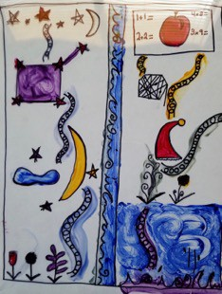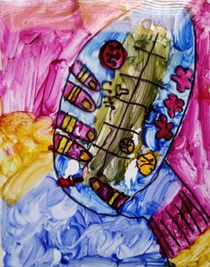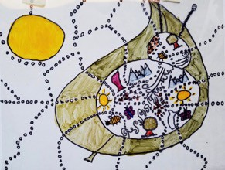

Element 3: Description of the Lesson Implementation
The 4th grade Reflecting Identity through Art- Personal Maps Colorado Teacher- Authored Instructional Unit has been and continues to be a varied and layered process of teaching and art making for both my students and me. The lessons began with looking at portraiture and portraits then moved to symbol and color, next to skill building with color the planning personal maps and now we are painting our maps.

A light went on one day when I was thinking through how and what I was going to demonstrate for our planning. Seems obvious but modeling is a key component in my students success and independence in my studio classroom.

How I model and what I model to my students is then modeled in the work.
The implementation of the unit and lessons described is, at the core about modeling. It matters when are students gathered around to be shown the 'next step' or the 'how to apply' demonstration that I am intentional in my words and actions. I believe that what is important about what I do is how I am demonstrating through my actions that art making is not so much about talent but more about practice.

Demonstrating practice in planning, in thinking through choices of images or color and all of the implicit pieces of art making should happen through in modeling.

I look for evidence in student work after a demonstration that helps me see if the demonstration met the goal for the designated portion of learning. Not that the students are doing what I did; rather I know a demonstration has been successful when I see and hear an interpretation of what I showed. I rarely hang up the demonstration piece; instead leave it out on a table so students can 'check'. I do this because students who have executive functioning or processing challenges need the opportunity to listen, watch then 'check back'; leaving the demonstration piece out gives everyone the opportunity to 'check back'.

While teaching 4th grade Reflecting Identity Through Art- Personal Maps Colorado Teacher-Authored Instructional Unit my intentional practice has been to model my vision, my story and to clearly show how to think through ideas while making sure that students understand there are many different strategies.

Element 4: Reflection

We have been in school for a little over two months. I have seen all 450 of my students for two rotations. This means we spent approximately 8 hours together.
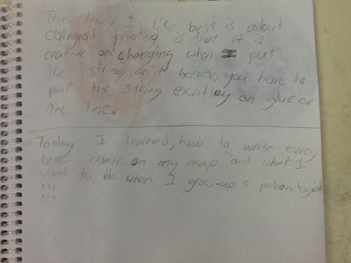
A very short amount of time relative to the volume of work the students have already produced. To clarify: produced means sketch journal, processes,

reflecting, discussion and all the pieces we do each lesson. In the studio classroom I maintain ‘an every moment counts’ approach. It has been very interesting to talk with and build connections with the students through their personal maps. I see this happening amongst the students as well when we are sharing our ideas and working. Scaffolding and front loading skills, planning and applications has been the most meaningful learning for me in teaching 4th grade Reflecting Identity Through Art- Personal Maps Colorado Teacher-Authored Instructional Unit. The data that drives my practice is what I use to design and build the lesson for the next day. For example, we explored and exercised our color mixing skills because the evidence of blending a variety of colors that were personal and specific to each students vision was that the students needed a means to create their own color vocabulary through for their personal map. So we stepped to the side and fine-tuned our skills, then stepped forward to use them.

More reflection about instructional practice can be found on my blog: Art Spirit.

