
Requesting Funds from CDE Using FormSite – Workflow Procedure
Overview
The new Request for Funds process is done in two parts and will include a workflow approval process
- Part 1: The first part is done by the ‘person completing the form’. Will we refer to them as Person A. Person A will click on the link to the RFF they are going to complete, create a profile (or log in if you have already created one) and fill out the fields on the form. They will then submit that form to the Authorized Representative (Person B) by including their email address on the form, which will trigger a workflow approval process.
- Part 2: The Authorized Representative will receive the e-mail with the link to review, approve (by entering their 4 digit Authorized Rep code), and then submit the form. Person B will not have a log in, but the link will remain active until it is submitted to CDE for payment. The link can be opened and closed multiple times, but once it has been submitted, the link will break as to avoid duplicate payments. A confirmation of the RFF submission will go to both Person A, and Person B or whichever e-mail is entered into the confirmation e-mail field.

Locating Request for Funds Forms
- These are the links Person A will use to fill out the Request for Funds (RFF) form
- Click on the link to access RFF for the grant you wish to receive reimbursement
- The ESSA and IDEA RFFs are due on the 1st of the month (unless the 1st falls on a holiday or weekend, then they are due the next business day)
- EASI and COMP RFFs are due on the 15th of the month (unless the 1^{5th} falls on a holiday or weekend, then they are due the next business day)

Grant Type | Link
Consolidated Federal Programs (ESSA) | Title I Part A - 84.010, CDE Grant Code 4010  Title I Part D LEA - 84.010A, CDE Grant Code 7010  Title I Part D SEA - 84.031A, CDE Grant Code 4013  Title II Part A Teacher Quality - 84.367, CDE Grant Code 4367  Title III Part A - 84.365, CDE Grant Code 4365  Title III Part A, SAI - 84.365, CDE Grant Code 7365  Title IV Part A, Student Support & Academic Enrichment - 84.424A, CDE Grant Code 4424  Title V Part B, Rural & Low Income - 84.358, CDE Grant Code 6358  Connecting Colorado Students Grant - 84.425D, CDE Grant Code 5525  ESSER Funding- 84.425D, CDE Grant Code 4425  Governor’s Emergency Education Relief Fund- 84.425C, CDE Grant Code 6425  GEERS Quality Teacher- 84.425C, CDE Grant Code 7425
Empowering Action for School Improvement (EASI) | Accountability Pathways  AEC Pilot  Community Engagement  Connect For Success  Diagnostic Review  District Design and Led  Expansion  MTSS  School Transformation  School Turnaround Leaders  School Turnaround Network
Individuals with Disabilities Act (IDEA) | IDEA Part B - 84.027A , CDE Grant Code 4027  IDEA Preschool - 84.173A , CDE Grant Code -4173
Competitive Grants | 21st Century After School Learning Center- 84.287, CDE Grant Code 5287 Cohort VII  21st Century After School Learning Center- 84.287, CDE Grant Code 6287 Cohort VIII  Adult Education - 84.002A, CDE Grant Code 5002  CDC Improving Student Health  Colorado Charter School Program - 84.282A, CDE Grant Code 5282  Colorado Charter School Program 2020 – 84.282, CDE Grant Code 5282  Colorado Multi-Tiered Behavioral Framework - 84.184F, CDE Grant Code 8174  Colorado Project Aware - 93.243, CDE Grant Code 7243  IEL Civics - 84.002A, CDE Grant Code 6002  McKinney Vento Homeless Assistance Grant - 84.196A, CDE Grant Code 5196  MTB Framework - 84.18F, CDE Grant Code 8174  MTSS - 84.323A, CDE Grant Code 5323  Preschool Development - 93.434, CDE Grant Code 7434  Remote Learning Grant - CCSP - 84.282A, CDE Grant Code 8282  School Climate - 84.184F, CDE Grant Code 8174  Tiered Intervention Grant (TIG) Cohort 5  Tiered Intervention Grant (TIG) Cohort 6  Tiered Intervention Grant (TIG) Cohort 7  Title I Reallocated Funds Assistance Grant - 84.010A, CDE Grant Code 5010  Title IC Migrant Education - 84.011, CDE Grant Code 4011  Title III BOCES Professional Learning Focus - 84.365, CDE Grant Code 5362  Title V State SRAE - 93.235, CDE Grant Code 7235  USDA Equipment – 10.579, CDE Grant Code 5579  USDA Equipment FY20-22 – 10.579, CDE Grant Code 5579

- The link for each grant will lead you to this page. If you already have an account, enter your Username and Password into the ‘Returning User’ box and click ‘Submit’
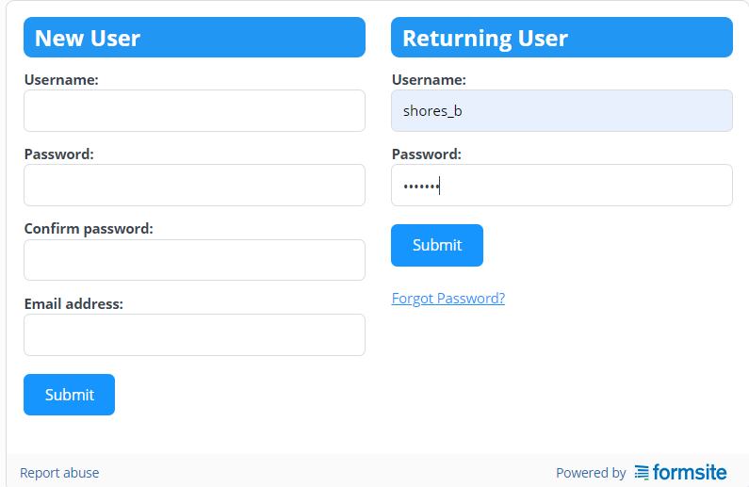

- If you have not yet created an account, follow the below instructions

Creating a New User Account
- Creating an account associated with the RFF forms allows you to log in and save your work, and then return to it later. This will allow Person A to create the RFF, save it, and return to their work if need be
- The log in can be either generic, or personal since only Person A will be utilizing this log in
  - If multiple people will be creating RFFs to submit to Person B, a generic log in may be best, but it is up to the district/organization
- Please note that an account must be created for each RFF (4 times) but it can be the same Username and Password for each one if you prefer. If you prefer to have 4 separate log ins for the 4 different forms, that is also a possibility
- Click on the link for the form you wish to create an account
- Enter in the information you wish to use under ‘New User’ and click ‘Submit’
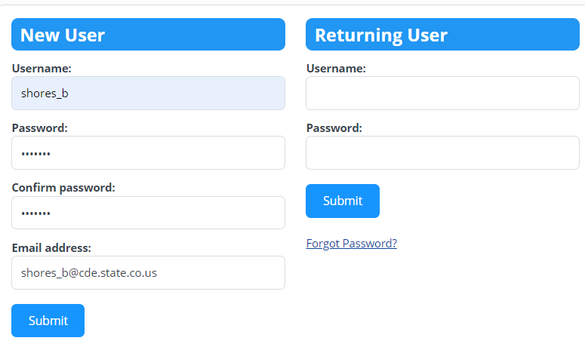
- This will take you to the RFF and let you know a new account has been created
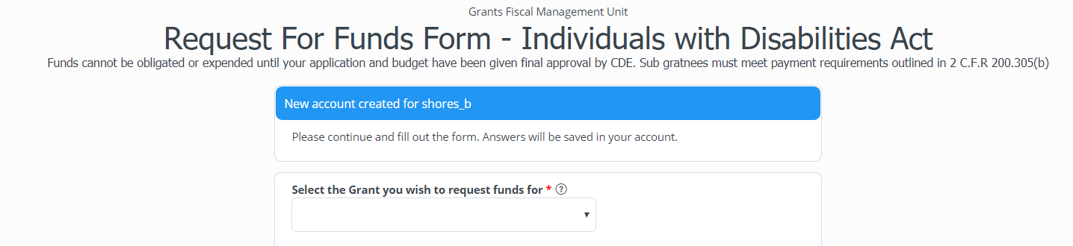
- You can then fill out the RFF. The bottom will ask if you want to save the report, or submit it.

- If you ‘Submit’ the RFF, you will see the ‘Thank You’ screen and an e-mail with the link to this form will be sent to Person B for their review, approval, and submittal
- If you click ‘Save Progress’ you will get a note that your information was saved. You can then exit out of the screen
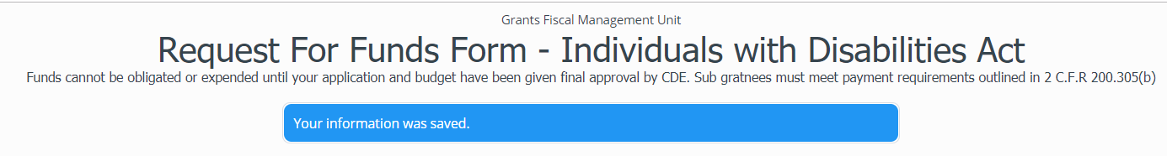

Editing a previously saved RFF

- Click on the link for the RFF you wish edit, and log in
- This will take you to a page that allows you to edit the RFF you are working on, or start a new one. In the example below you will see that I have one RFF that I have previously saved
  - To edit the RFF, click ‘Edit’
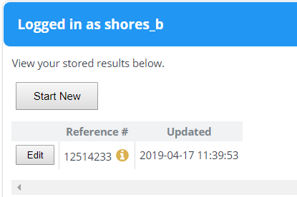
- This will take you to the form to continue filling it out. Once you are done, click ‘submit’
  - If you would like to save the RFF again without submitting it, click ‘Save Progress’. When you are ready to edit the form again and submit, log back in and complete the above process

- You can completely change all the information in the RFF once you hit ‘Edit’. Incomplete or RFF waiting to be e-mailed to Person B will show up on this dashboard as incomplete until you submit it. There is no way to delete an incomplete RFF on your dashboard, so the best thing to do is to edit the form. If you do not want to edit it, please call Grants Fiscal and we can delete the incomplete RFF on our end and they will delete it from your dashboard
- Once you complete the RFF and submit it to Person B, it will sit in your dashboard as complete. You will not be able to edit or resubmit complete transactions
  - Quarterly, CDE will remove all complete transactions that are 3 months old. Once that is done, they will no longer be in the dashboard so make sure the confirmation e-mails are saved

Part 1/Person A: Filling out the Request for Funds Forms
Note: For this example of how to complete the RFF, we will use the ‘ESSA Consolidated Federal Programs’ form. Please be aware that each of the forms are different to accommodate the information needed for each individual grant.
- Click on the link that corresponds with the RFF you need to complete for your district/organization
  - Log into your account
- Note the name at the top of the form to ensure you are completing the one you need
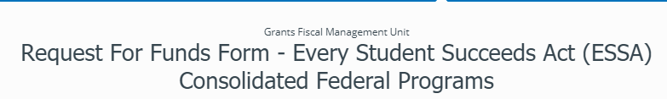
- Click on the dropdown arrow and select the grant you wish to request reimbursement for.
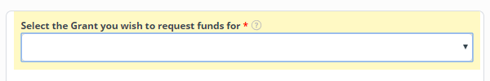
- Click on the dropdown arrow and select the district you wish to request reimbursement for. The district you are selecting must correspond to the grant you selected in the previous dropdown.
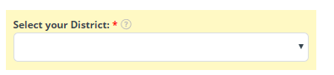

- Click the button next to the fiscal year in which the expenditures occurred. The fiscal year must correspond to the grant and the district selected above. If your award is alive across several fiscal year, please be sure to select the year in which is expense actually occurred.
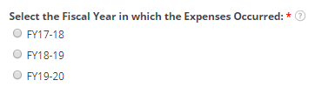
- Type in your district expenditures to date that align with the grant and fiscal year selected above.
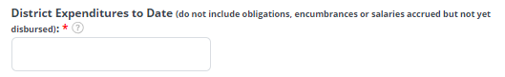
- Type in the amount of funds you have previously requested for the grant, district, and fiscal year selected above. Note that you can now enter cents into the RFF form.
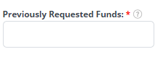
- Click on the ‘Calculate’ button. This will subtract the amount entered in ‘Previously Requested Funds’ from the ‘District Expenditures to Date’. Note that you can now enter cents into the RFF form.
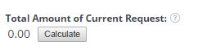
  - Example (after you click ‘Calculate’): 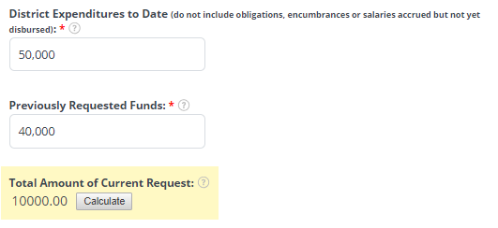
- If you are filling out an RFF for a State run agency, a box to enter your ITI number will appear once you select your agency. The ITI is 20 characters and the entire number must be entered. The easiest way to enter in the ITI would be to copy/paste it from CORE so you do not miss any numbers.
  - If you are not a State run agency, this box will not appear, and this step does not apply

- Type in the name and phone number of the person who completed the report. 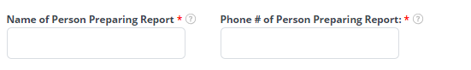
- Enter in the e-mail address of Person A. This is an optional field, but is recommended, especially if the confirmation will not go to Person A’s e-mail. If Person B makes any changes on the form, this will allow Person A to see what ended up being submitted to CDE.

- Type in the name and title of the person who is the Authorized Representative and allowed to submit RFF forms to CDE for reimbursement. Note that comma’s are not allowed.
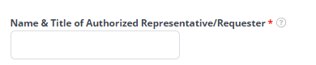
- Type in Person B’s e-mail address. This is where the link to finish and submit the RFF will be sent. If you are at a district where you are both Person A and Person B, you will have to e-mail this link to yourself.
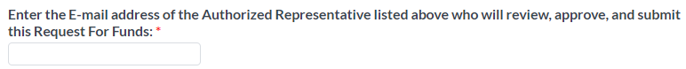
- Now Person A’s work is complete. Click either ‘Save Progress’ which will allow you to return to your work, or ‘Submit’ which will send a link to the filled out form to Person B

Part 2/Person B: Reviewing, Approving, and Submitting the RFF Form
- Person B will receive am e-mail form Formsite with a link to the form that Person A has completed
- Click on the link to open the RFF. The work that Person A has done will populate in the form.
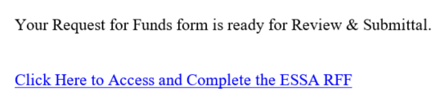
- This link can be opened and reviewed as many times as you like, but once you submit the RFF to CDE it will be broken. You will get this message
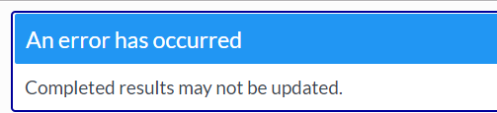

- The below statement ensures that the information on the Request for Funds form is true and accurate
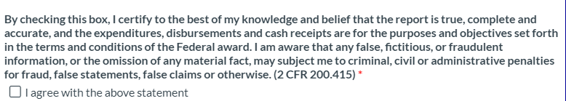
- Check the box below to ensure you are authorized to submit RFFs to CDE on behalf of your district/organization
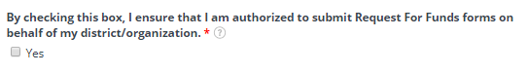
- Enter the 4 digit code that has been assigned to each Authorized Representative by CDE. IF you do not have your 4 digit code, please reach out to us
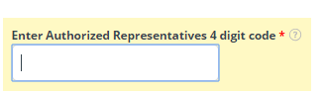
- Enter the E-mail address you wish to have the verification of form submission sent to. This can either be Person A, Person B or any other e-mail that will allow the district/organization to keep record of the RFFs they have submitted.
- The confirmation e-mail received will be from Formsite and the subject line will include the form type, and the reference number of your submission. The body of the e-mail will have a table that includes all the information you entered on the form, except Person B’s 4 digit code
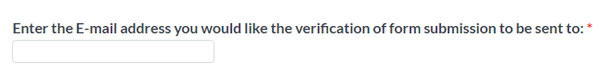

- Once all the fields have been complete, click ‘Submit’. Note that all fields with a red asterisk next to them must be completed before the form can be submitted


- Once you have clicked ‘Submit’, you will get a confirmation from FormSite that your RFF has been completed


- You will also receive an e-mail confirmation to the e-mail entered into the form

Notes
- You can only complete one RFF per district/school/organization at a time. Person A will have to log back in using the link if you wish to create multiple RFFs at a time
- Each RFF form will look different to accommodate each different grant. The form is designed to lead you through step by step. You will notice that in some cases, once you select an option from one dropdown, another may appear based on your selection. For example, if you have a grant that is awarded to a specific school, once you select the district, the schools associated with that district will appear, and you can then select the appropriate school. Continue to select an option from each field until the form is complete.
- If you are filling out a RFF that requires an attachment (Adult Education, SRAE), the Authorized Representative must re-attach the document to the RFF before it is submitted for payment
- The new RFF is only asking for your expenditures to date, and previously requested expenditures; we no longer have ‘Allocation’ on the form. If you need this information, please go to the allocation reports or distribution sheets on our website. That information can be found here:
  - Distribution Reports: https://www.cde.state.co.us/cdefisgrant/grant_distribution_reports
  - Allocations: https://www.cde.state.co.us/cdefisgrant/allocations

Have Questions or Need Assistance?
If you have any questions, or need any help filling out your RFF, please contact shore_b@cde.state.co.us
If you have questions regarding your specific grant, the Grants Fiscal Analyst assigned to each grant can be found here: https://www.cde.state.co.us/cdefisgrant/GFMSU_responsibilities

