



Paola Paga

Schools of Choice May 2020

1

Charter School Waiver Requests



Presentation Overview

* Introduction
* Types of waiver requests
* Process, timing, form
* Recent activity and guidance
* Resources
* Example
* Public Notice and Financial Transparency



Introduction

* What is a charter waiver request?
  + Request to operate free from district policy, state statute, and/or state rule.
* What is the purpose of a charter waiver request?
  + Flexibility
  + Planning and accountability
* What are the more commonly requested charter waiver requests?
  + Personnel, curriculum, evaluations, school readiness, calendar
* How long do waivers last?
  + Valid through charter term, request again upon charter renewal or modification



Types of waiver requests

|  |  |
| --- | --- |
| **Term** | **Definition** |
| Automatic | Waivers being granted automatically to all charter schools upon the establishment of a charter contract, renewal or extension, for the term of the contract. |
| Non-Automatic | Waivers formally requested by a charter school not included on the automatic or prohibited list. A rationale and replacement plan must be provided in the request. |
| Prohibited | Provisions of law which charter schools are not allowed to seek waivers |
| Rationale and Replacement Plan (RRP) | Each waiver must contain rationale as to why the waiver is being requested and a replacement plan indicating how the school will continue to meet the intent of the law |
| Delegatory | RRPs in which the authority has been delegated from the authorizing board to the charter school governing board to create policies and practices |
| Substantive | RRPs which provide greater detail on how the charter will meet the intent of the law. |



Types of waiver requests – Automatic & Non automatic

* Automatic
  + Pursuant to 22-30.5-103, C.R.S., automatic waivers are now defined as those being granted automatically to all charter schools upon the establishment of a charter contract, renewal or extension, for the term of the contract.
  + A charter school is not required to submit an RRP for an automatic waiver; however, a charter school must identify which automatic waivers it plans to invoke.
* Non-Automatic

*“Within 10 days after the contract is approved by the chartering local board of education, the chartering local board of education shall deliver to the state board any request for waiver of state statutes and state board rules that are not automatic waivers. The chartering local board of education shall request the release by* ***submitting a complete copy of the signed charter contract.”***

*C.R.S. § 22-30.5-105(3)*



Types of waiver requests - Prohibited

# Charter Schools may not waive out of any of these provisions of law:

* + Public School Finance Act
  + State assessments
  + School Accountability Committees
  + School performance reports
  + Children’s Internet Protection Act
  + Requirement to post online the list of waivers that have been obtained
  + Notification to parents of alleged criminal conduct by school employees
  + Requirements concerning suspension and expulsion of students in preschool through second grade
* In addition, the State Board of Education does not have authority to grant waivers from non-education statutes (statutes outside of title 22); or Federal statutes, including ESSA and IDEA.



Types of waiver requests – Delegatory vs. Substantive

* Delegatory
  + RRPs in which the authority has been delegated from the authorizing board to the charter school governing board to create policies and practices.
    - Example: Journey Academy shall be delegated the authority from the School District to in accordance with the Charter School Agreement.
* Substantive
  + RRPs that provide greater detail on how the charter school will meet the intent of the law. They are meant to clarify that certain minimum standards will still be met. Typically they are used for provisions related to licensure and school readiness.
    - Example: “Charter school will adopt its own policies concerning teacher certification. All teachers will at a minimum have .”



Process for charter waiver requests

* Formal Request
  + Made by charter school as part of charter application, amendment or renewal
* Early review (optional)
  + Conducted by SOC (Paola)
* Approval by charter authorizer
  + Becomes part of charter contract
* Approval by State Board of Education
  + State Board approves or denies (can approve or deny individual waivers)
* Renewal of charter or charter modifications



New Activity from the Past Few Years

# Waivers that were not granted by the State Board

* + School readiness data reporting, PERA
  + The State Board has the discretion to approve or deny any waivers

# What waiver replacement plans have had questions – specifically around how the school meets intent?

* + Licensure (Highly Qualified vs. CO ESSA Plan)
  + School Readiness (valid readiness assessment within 60 days that is used to develop an ILP for a student vs. curriculum taught)
  + Evaluation – Intent of 191 (annual evaluation by a trained administrator using an established rubric and basing a part of an evaluation on student achievement and using the evaluation to inform employment decisions)

# Each year, some legislation may be called out as un-waivable

* + Posting waivers, parental consent

# Some waivers are no longer automatic

* + Calendar, gifts/grants/donations policy, procurement



Let’s look at an example

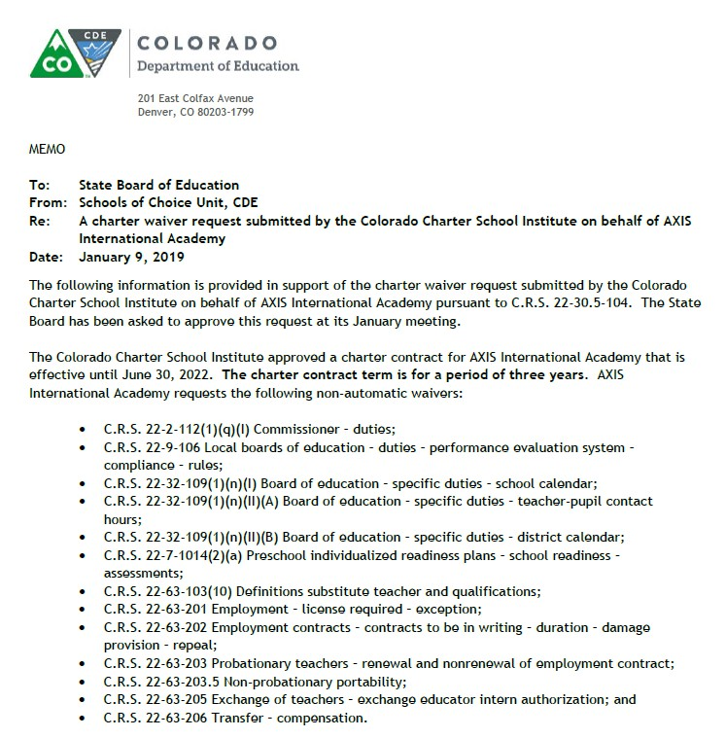

Public Notice – Posting of waivers

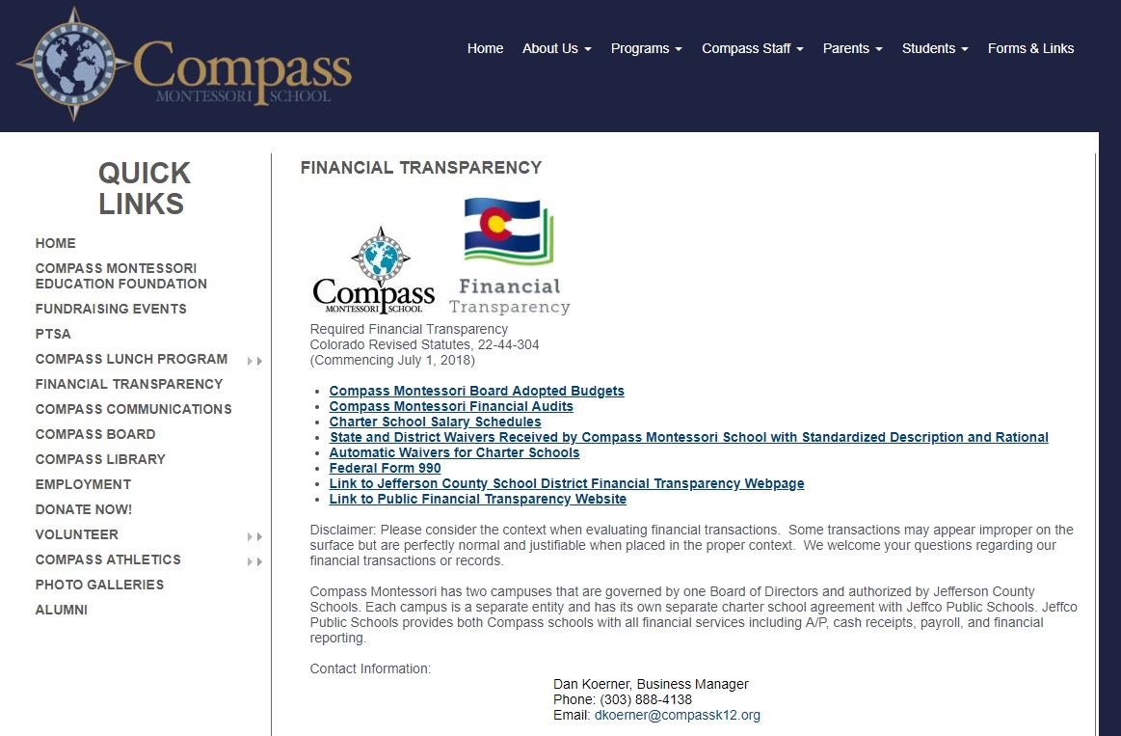

Resources

* CDE’s waiver webpage (<https://www.cde.state.co.us/cdechart/waivers>)
  + List of automatic waivers
  + List of charter schools and what waivers they have
  + Waiver guidance document
  + Sample cover sheet
  + Sample rationale and replacement plans
* Colorado State Board of Education’s BoardDocs (<https://www.boarddocs.com/co/cde/Board.nsf/Public>)
* Colorado League of Charter Schools
* Legal counsel
* Other charter school peers



Questions?

Paola Paga [paga_p@cde.state.co.us](mailto:paga_p@cde.state.co.us) 303-866-6848

13