

**ARP EANS II**

**Instructions for Asset Tagging**

CDE has issued all asset tags based on inventory reported by FACTS Education. Please add items that may be unaccounted for in the Asset Tagging Sheet.

**Step 1- Verify** the school's name, quantity, total amount, company/vendor, invoice/transaction number, and serial number in the “Asset Tags” tab. If the spreadsheet provided does not have a serial number listed, like in the example below, update the spreadsheet with the serial number and add the asset tag. The serial number is a required field.

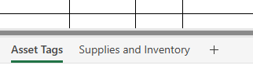

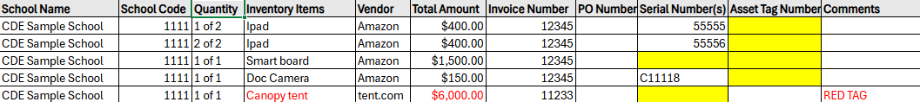

**Step 2- Affix** asset tags to the items

For the highly walkable, attractive, non-capital items, such as Chromebooks, laptops, tablets, printers, webcams, microphones, etc. please affix the following black tag. All items listed on the “Asset Tags” Tab need to be tagged. If you have additional items that were not recorded properly, please add them and reach out to [eansapplications@cde.state.co.us](mailto:eansapplications@cde.state.co.us) for more tags.

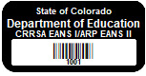

For single item(s) listed over $5,000, such as awnings, body temperature measuring systems, floor scrubber, air purifier, any items that’s cost per unit is $5,000 or greater, please affix the following red tag.

Red Asset tag with Barcode 

**Step 3-** In the column titled “Asset Tag Number”, please enter the corresponding asset tag number to the serial number.

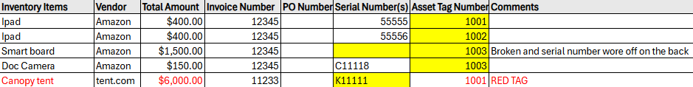

**Step 4 -** In the column labeled “Serial Number(s)”, please verify that the serial numbers are correct. If there are any missing serial numbers, please enter them onto the spreadsheet. If you cannot locate the serial number, please complete the comments section, and explain why. Please note that for most electronic devices (Chromebooks, laptops, smartboards, tablets etc.) even if a serial number has worn off the exterior of the device, they will have the serial number within the system settings of the device.

**Step 5** – **Review “Supplies and Inventory” tab –** This tab is meant for reference only and is not a requirement to complete for monitoring purposes. The information in this tab will be recorded in GAINS.

Icon showing the second tab of the asset tagging sheet that holds supplies and inventory information. 

The Tab is located at the bottom left of the ”Asset Tagging” sheet.

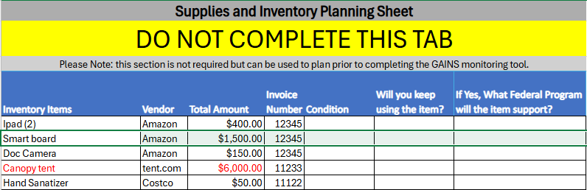

Items listed in the “Supplies and Inventory” tab are items that you will be asked to report on in the GAINS Instrument. The blank cells represent the questions you will be asked about each item(s). If you have additional supplies or inventory purchased through EANS, please also note this in GAINS. There may be some items listed in both the “Asset Tags” and “Supplies and Inventory” Tabs.

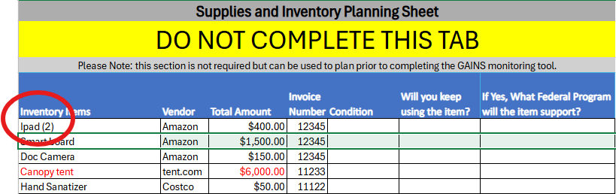

You may notice in the “Supplies and Inventory” multiple items may be listed as one line item. If this is the case AND you have a different “condition” to report on some of those items, you may mark the condition as “in use” and add additional information in question 2. For example, if you have 2 iPads as one line item, and 1 is broken, please note something like “We notated that the 2 iPads from Amazon are working and we are keeping them; however, 1 is broken and needs disposed of. The serial number for the broken iPads is A1234.”.

**NOTE:**

If you received asset tags, but do not receive an email from CDE in the next 5 days, please reach out to eansapplications@cde.state.co.us to update your contact information.