Post Administration Clean up in PearsonAccess

Late November-Early December

After the administration window has closed, districts will have two opportunities to clean up student information in PearsonAccess. Districts should perform the following activities within PearsonAccess.

Initial Clean-up: November 22 - December 3. Beginning the day after the test administration window closes, districts should perform the following tasks in PearsonAccess.

- Mark Complete all PearsonAccess student test assignments that are not in “Completed” status. DACs and SACs should perform the steps outlined in Section 9.4.1 of the PearsonAccess User Guide.

- Stop all PearsonAccess test sessions that are still in “Started” status. DACs and SACs should follow the steps outlined in Section 9.4.2 of the PearsonAccess User Guide.

- Update used accommodation fields in PearsonAccess. DACs and SACs can perform this task through the PearsonAccess User Interface. Steps for this process are outlined in Section 9.2.2.2 in the PearsonAccess User Guide.

- Update all the demographic fields in PearsonAccess. This update should include the non-required fields that will be used for reporting. DACs and Student Enrollment user roles can perform this task. Fields can be updated via an SDU upload or through the PearsonAccess User Interface (Section 9.2.2.1 in the PearsonAccess User Guide).

- Update Invalidation Codes. DACs, SACs, and Student Enrollment users can update invalidation codes via the PearsonAccess User Interface. (See directions below: Update Invalidation Codes through the PearsonAccess User Interface)

Final PearsonAccess Clean-up: December 9 - December 12.

- Update remaining temporary SASIDs and confirm invalidation codes; update as necessary.
  - DACs and Student Enrollment users can download a test attempt extract and update temporary SASIDs and invalidation codes. (See directions below: Downloading a Test Attempt Extract, Importing the Test Attempt Extract File into Excel to make updates, and Uploading a Test Attempt Extract File to PearsonAccess)
  - DACs and Student Enrollment users can update student demographic information used in reporting through the PearsonAccess User Interface (Section 9.2.2.1 in the PearsonAccess User Guide).

Student Biographical Data Review

January 2015

The purpose of the CMAS and CoAlt: Science and Social Studies Student Biographical Data (SBD) review is to allow districts the opportunity to verify the accuracy of the demographic data submitted for each student in PearsonAccess. This is completed for students that have their district coded as the Reporting District. The review process takes place in CDE’s Data Pipeline System after the assessment window closes and before final results are made available.

The SBD review is not a mandatory process. Districts may choose to participate or to not participate in the SBD process. State and Federal accountability reporting (including school and district performance framework ratings, Title III AMAOs, and priority and focus school designations) rely on accurate demographic and test score data. Therefore, the impact of the SBD review of demographic data on accountability reporting is profound. Districts should be aware that performance framework requests for reconsideration or AMAO appeals will only be considered for districts that participate and approve their data in the SBD process.

Detailed information about SBD can be found at the following locations:
- Processes and procedures are available in the SBD Manual posted on the Assessment Unit Trainings website (http://www.cde.state.co.us/assessment/trainings).
  - Note: The SBD manual is updated every January.
- File Layouts can be found on the Data Pipeline Website (http://www.cde.state.co.us/datapipeline/cmascoaltsciencesocialstudiessbd).
  - Note: Layouts are updated in the fall.

Test Invalidation Codes and Descriptions

Selecting any invalidation code other than 00 (DEFAULT: Student Record to be Scored) means that the student will not receive a score for the assessment. Table 1 provides a brief overview of the invalidation codes. More detailed guidance on each code can be found after the table.

Table 1: Invalidation Codes
Code | Field Name
00 | DEFAULT: Student Record to be Scored
01 | Took Other Assessment
02 | Interrupted and Not Completed
03 | Withdrew Before Completion
04 | Test Refusal
05 | Non-approved Accommodation
06 | Misadministration
07 | District Education Services
08 | Part Time Public and Part Time Home School Student
97 | State Use – Attempt Not Met
98 | State Use 1
99 | State Use 2

DEFAULT: Student Record to be Scored
- This is the default value for student records uploaded to PearsonAccess.
- Student should have tested but may not have completed all sections and none of the below apply. Contractor will apply attemptedness rules.

Took Other Assessment
- When a student has been administered both the CMAS and CoAlt assessments, this invalidation code is used to indicate the record that should not be counted.
  - If a student should have only been administered the CoAlt, then the CMAS record is invalidated with this code. The CoAlt record will remain as the student’s assessment of record.
  - If a student should have only been administered the CMAS, then the CoAlt record is invalidated with this code. The CMAS record will remain as the student’s assessment of record.

Interrupted and Not Completed
- Student was present at the start of a test section but forced to leave prior to the completion due to unforeseen circumstances. The student could not complete testing in a make-up session or within the allotted testing window. The student may have met the psychometric attemptedness criteria but was not able to complete the full test. An example is if a student becomes ill during Section 3 after answering 10 questions but cannot complete the section during a make-up session.
- This code should only be used for true test attempts that were unable to be completed. This code should not be used for absent students; State Use – Attempt Not Met will automatically be applied in the Post-SBD file that is returned to Pearson by CDE after the Final PearsonAccess Clean-up window.

Withdrew Before Completion
- This code should only be used for students who withdrew from the district/transferred and one of the following conditions is also met:
  - The district was not able to transfer the student record to the new district.
  - The student withdrew from Colorado Public schools (e.g., moved to another state).

Test Refusal
- The student refused to take the test.

Non-approved Accommodation
- Any accommodation used during testing that is not in a student’s IEP, 504 Plan or EL plan.

Misadministration
- A misadministration occurs any time a procedure has been violated or when the validity of a student’s test score cannot be assured.
- Some examples are:
  - Students share answers during testing
  - Students receive information about test items from anyone prior to testing
  - A Test Administrator or school staff member:
    - Fails to follow test environment and/or posted materials guidelines
    - Fails to provide directions for the test including the opportunity for students to access sample items
    - Does not observe time limits and requirements (e.g., not giving students the entire section time to test, or giving students more than the maximum testing time without an extended time accommodation)
    - Reads or clarifies any test items for students (reading is only allowed from an oral script for students with the oral script accommodation)
    - Gives any cue about possible answers, verbal or non-verbal to students
    - Provides students with information about test items prior to the test
    - Asks student or students to change answers
    - Enters answers for students (except for scribe accommodation)
    - Leaves test materials unattended anywhere outside of the central secure storage area in the school
    - Loses test materials, or is at any time unable to account for the location of test materials at all times
    - Fails to provide students with accommodations needed to access the test

Part Time Public and Part Time Home School Student
- Districts may use this code for any student with half-time district and half-time home school status.
- NOTE: Students assigned the Part Time Public and Part Time Home School Student invalidation code will not receive a score. If a district wants a score generated for a part-time homeschool student but does not want the score to be included in district or school reports, the following coding should occur:
  - Invalidation Code = 00 (DEFAULT: Student Record to be Scored)
  - Reporting District Code = District Code where test was administered
  - Reporting School Code = HHHH

District Education Services
- Student is homebound due to illness or injury (not discipline) and receiving instruction through district educational services.

State Use – Attempt Not Met
- Field reserved for state use.
- Student did not answer enough items for a valid score to be generated.
- Will be automatically applied to any student record with an invalidation code of 00 (DEFAULT: Student Record to be Scored) that does not meet attemptedness in the Post-SBD file that is returned to Pearson by CDE after the Final PearsonAccess Clean-up window.

State Use 1
- Field reserved for state use.
- Districts may not use this code without permission from CDE’s Assessment Unit.

State Use 2
- Field reserved for state use.
- Districts may not use this code without permission from CDE’s Assessment Unit.

Update Invalidation Codes through the PearsonAccess User Interface

To invalidate only one of the student’s two test assignments:

- Log in to PearsonAccess.

- Select the Test Management tab.

- Select the Manage Test Sessions task.

- Search for the student by selecting the Students radio button on the Manage Test Sessions screen.

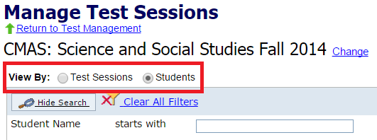

- Select the appropriate Session Name for the student.

- Select the student's name on the Test Session Details screen.

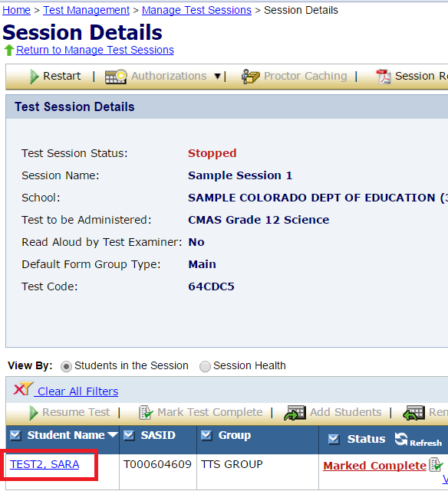

- Select Edit in the upper right corner of the Student Test Details screen.

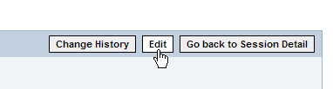

- Select the Invalidation Code from the drop-down menu.

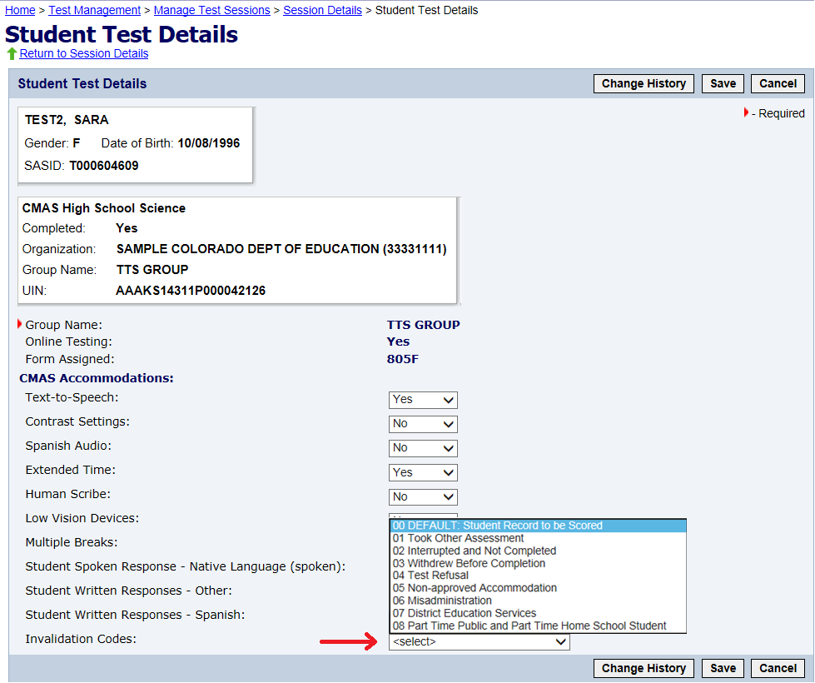

- Select Save in the upper right corner of the Student Test Details screen.

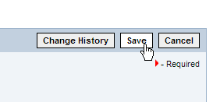

To invalidate both of the student’s test assignments:

- Log in to PearsonAccess.

- Select the Test Management tab.

- Select the Register Students task.

- Search for the student by selecting the Registered Students radio button on the Register Students screen.

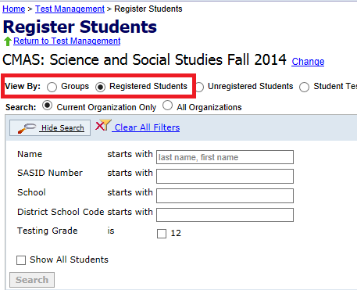

- Select the student’s name on the Register Students results screen.

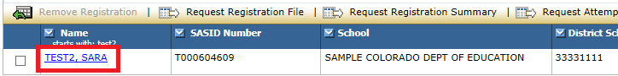

- From the Student Registration Record screen, select the Assigned Tests tab.

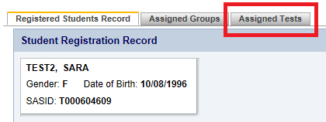

- Select the name of the first test that needs to be invalidated on the Assigned Tests screen.

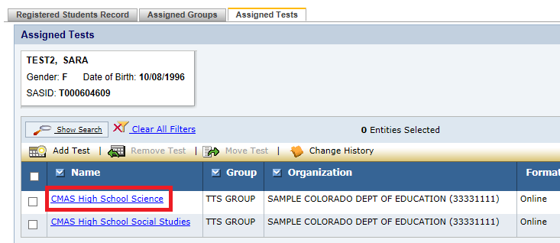

- Select Edit in the upper right corner of the Student Test Details screen.

- Select the Invalidation Code from the drop-down menu.

- Select Save in the upper right corner of the Student Test Details screen.

- From the confirmation screen, select Return to Assigned Tests.

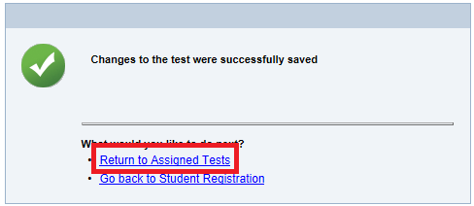

- Repeat steps 5 through 8 for the second test that needs to be invalidated.

Downloading a Test Attempt Extract

To download a test attempt extract.

- Log in to PearsonAccess.

- Select the Test Management tab.

- Select the Register Students task.

- On the Register Students page, select the Registered Students radio button and then the Request Attempt File button.

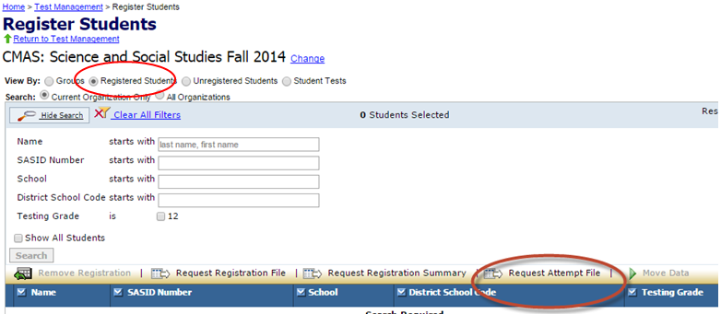

- Select “Yes - Continue with Request” on the next screen.

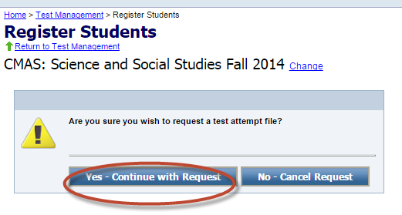

- PearsonAccess will send an email when the file is ready for downloading.

- To download the file, select the Test Results tab in PearsonAccess.

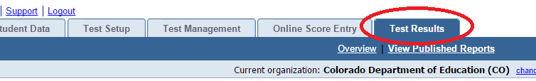

- Select the View Published Reports task.

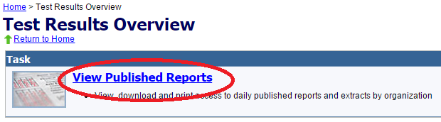

- Select the name of your organization.

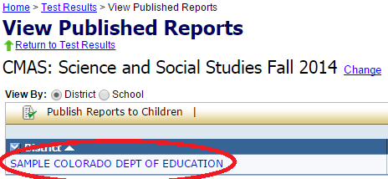

- Select the Test Attempt Extract.

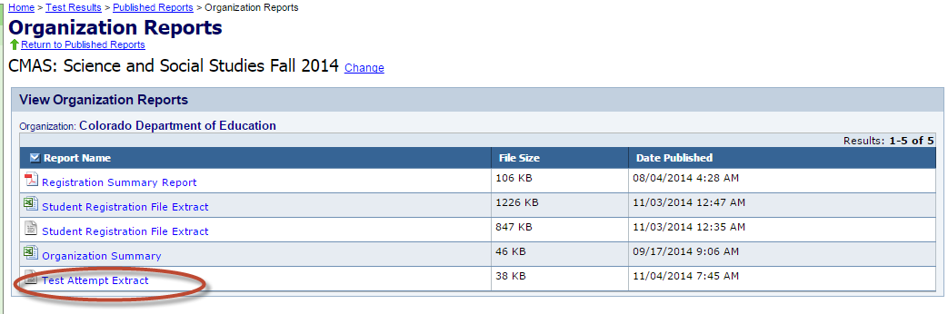

Importing the Test Attempt Extract File into Excel to make updates

- Open Excel.

- On the Data tab and select From Text.

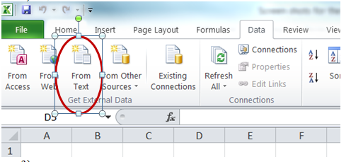

- On the Text Import Wizard – Step 1 of 3, select Delimited and then the Next button.

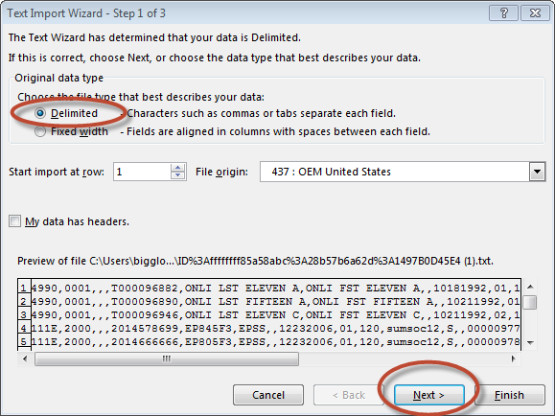

- On the Text Import Wizard – Step 2 of 3, select Comma and then the Next button.

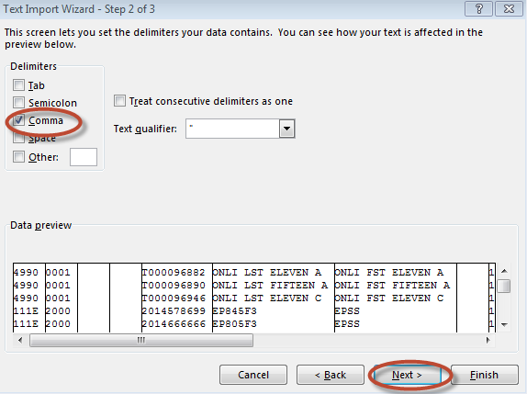

- On Text Import Wizard – Step 3 of 3,
  - Highlight all the fields in the file. (Select the first column, hold down shift, and drag the cursor to the right to highlight all fields at once.)
  - Once all fields are highlighted, select Text in the Column data format box.
  - Select the Finish button.

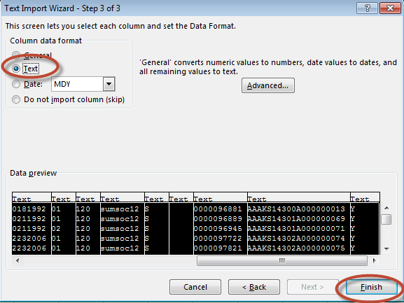

- Update all temporary SASIDs to valid SASIDS and, as needed, update invalidation codes.

- Save the file in .csv format.

Uploading a Test Attempt Extract File to PearsonAccess

- Log into PearsonAccess.

- Select the Student Data tab.

- Select Test Attempt Update.

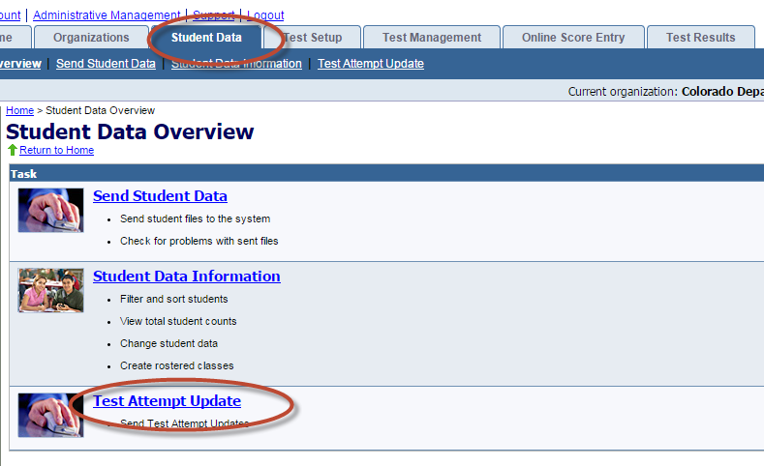

- In the Test Attempt Update window,
  - Select browse to locate the file to be uploaded.
  - Select send to upload the file to PearsonAccess.

