Matriculation

PWR Sub-Indicator Overview

Overview
This resource describes the current matriculation sub-indicator and assumes knowledge about state accountability and performance frameworks. See the links for additional information.

Background
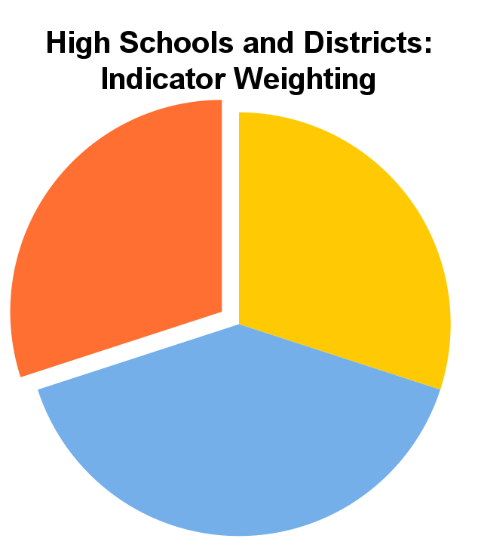
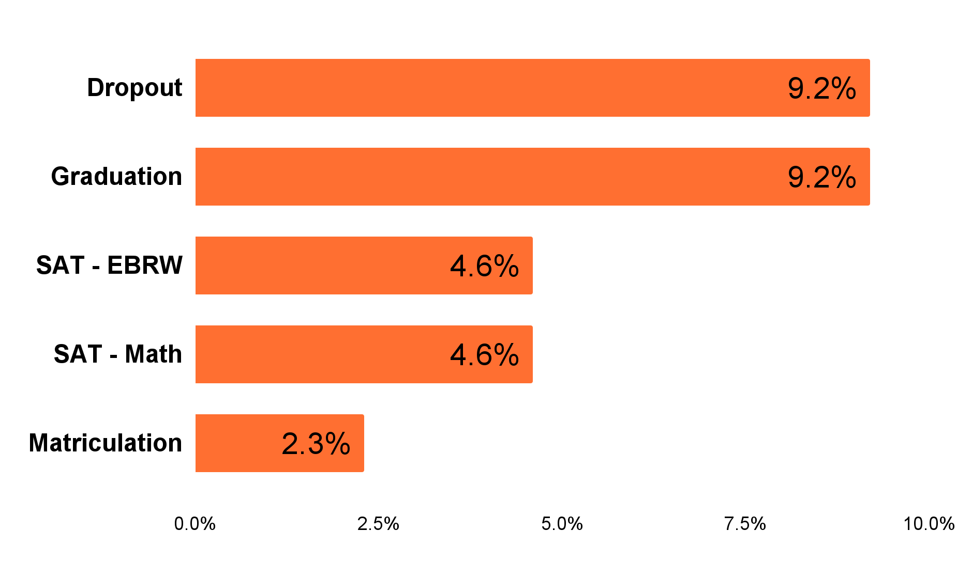
The “Increasing Postsecondary and Workforce Readiness Act”, HB15-1170, was drafted to encourage the matriculation of high school graduates into various post-secondary opportunities, including higher education and career and technical education (CTE) programs. Signed into law in May of 2015, this bill requires the inclusion of an additional matriculation sub-indicator within the Postsecondary and Workforce Readiness (PWR) indicator of district and high school performance frameworks. Along with high school graduation rates, dropout rates, and SAT Evidence Based Reading and Writing (EBRW) and math scores, matriculation rates are one of five metrics that comprise the PWR indicator, which accounts for 30% of performance framework scores for districts and high schools overall. See the Postsecondary and Workforce Readiness Indicator Fact Sheet for more information about the PWR Indicator.

PWR
30%
Achievement
30%
Growth
40%
Current PWR Weighting
The above graph shows the weighted percent of points each PWR sub-indicator represents for high school and district framework ratings (with all sub-indicators/subgroups included). These percentages may vary based on the number of sub-indicators/ subgroups that are reported for individual schools/districts.
How Much Do Each of the PWR Sub-Indicators Contribute to Overall Ratings?

First implemented in the fall of 2016, the matriculation sub-indicator was designed to reflect the percentage of high school graduates who enroll in CTE programs and 2-year or 4-year institutions of higher education. Beginning with 2022 performance frameworks, military enlistment was added as an additional matriculation sub-indicator enrollment pathway (S.B. 18-012). Other qualifying industry credentials have also been incorporated into matriculation rates based on data submitted by districts on an optional basis.

Calculation and Scoring of the Matriculation Sub-Indicator
Overall, the PWR indicator accounts for 30% of performance framework scores for districts and high schools. The matriculation sub-indicator accounts for 4 of 52 total points within the PWR category, or about 2.3% of a district or high school’s overall framework score. This weighting was based on feedback from the Accountability Work Group, Technical Advisory Panel (TAP), and other stakeholders.
Per legislation, each matriculation pathway (i.e., CTE, 2-year & 4-year higher education programs, and military enlistment) is weighted equally in the calculation of the overall matriculation sub-indicator. It is important to note that, because of the timing of data releases, this sub-indicator reflects data lagged by one year. For example, performance frameworks released in the fall of 2023 reflect matriculation data from students who graduated during the spring of 2022 and subsequently enrolled in a qualifying matriculation pathway during the summer or fall of 2022. The matriculation rate for a high school or district would thus be calculated using the formula below:
Colorado Institutions Reporting Enrollment Data to NSC
Adams State University
Aims Community College
American Sentinel University
Arapahoe Community College
Bel-Rea Institute of Animal Tech.
Colorado Christian University
Colorado College
Colorado Mesa University
Colorado Mountain College
Colorado N.W. Community College
Colorado School of Mines
Colorado State University
Colorado State University – Pueblo
Colorado Technical University
Colorado Tech. University – Denver
Community College of Aurora
Community College of Denver
Denver Seminary
Emily Griffith Technical College
Fort Lewis College
Front Range Community College
ILIFF School of Theology
Jones International University
Lamar Community College
Metropolitan State College
Morgan Community College
Naropa University
Northeastern Junior College
Otero College
Pikes Peak State College
Pueblo Community College
Red Rocks Community College
Regis University
Rocky Mountain College of Art & Design
The Art Institute of Colorado
The Bryman School – Aurora
Trinidad State College
University of Colorado, Boulder
University of Colorado, Denver
University of Denver
University of Northern Colorado
Western Colorado University

* Note: The numerator (graduates with qualifying credential or enrollment status) includes the number of 2021-22 high school graduates who received a CTE credential, higher education diploma (e.g., associate’s, bachelor's), or enlisted in the military during high school plus the number of 2021-22 high school graduates who enrolled in a CTE program enrolled in a 2-year or 4-year institution of higher education, or enlisted in the military during the summer or fall term immediately following graduation. A student is counted only once in the numerator even if they qualify for multiple pathways.
In performance framework scoring, aggregated matriculation (i.e., for all students) is worth between 1 and 4 points depending on the target rates outlined in the table below. Although CDE reports matriculation rates disaggregated by pathway (i.e., 2-year, 4-year, CTE, military), this disaggregation is presented for informational purposes only and does not contribute additional points to framework scores. Optionally submitted industry credentials are reflected within CTE and overall rates only. Unlike other PWR sub-indicators, matriculation rates are not disaggregated by student subgroup (i.e., students eligible for free or reduced price lunch, Multilingual Learners, minority students, students with disabilities).
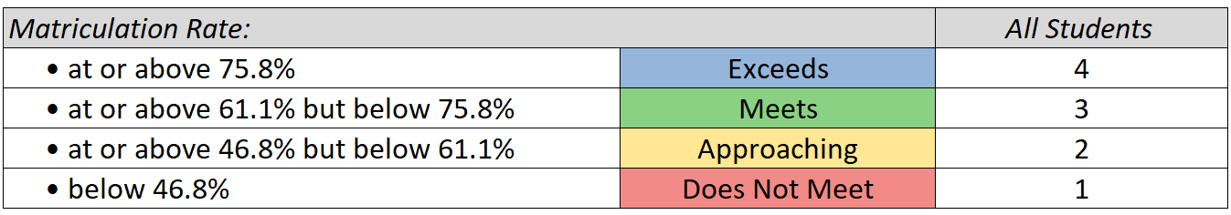

Matriculation Pathway Data Sources & Process
2-Year, 4-Year, and CTE
The Colorado Department of Higher Education (CDHE) provides CDE with and supports the validation of 2-year & 4-year institution and CTE student enrollment information. CHDE utilizes the Student Unit Records Data System (SURDS) to obtain enrollment information for all students enrolled in public higher education institutions within the state of Colorado. By statute, CDHE also holds a contract on behalf of CDE with the National Student Clearinghouse (NSC), which provides enrollment information for students in higher education institutions across the United States. Per NSC, 99% of public and private U.S. institutions are covered by their services. Statute does not specify a minimum number of credits that must be met for a student to be counted as enrolled in a CTE or higher education program. See the sidebar for a list of participating institutions within the state of Colorado (as of August 2023). A list of participating enrollment reporting institutions is available here.
Data from NSC and SURDS are linked and validated by CDHE staff in order to provide additional data quality assurance. The resulting file also identifies students who completed a CTE certificate or higher-education degree while still enrolled in high school in Colorado. The final file provided by CDHE to CDE is then used for matriculation sub-indicator calculations. Please note that CDE does not own and cannot alter this underlying matriculation data. The request to reconsider process is designed to address rare instances where a district or school rating may be impacted by missing data.
Military Enlistment
Since 2022, military enlistment information has been included in the matriculation sub-indicator of the performance frameworks. Military enlistment data is reported to CDE by districts for individual students during the End-of-Year data collection.
Optional: Qualifying Industry Credentials
Since 2018, local education agencies (LEAs) have had the option to submit lists of students who obtain an industry credential recognized by the Colorado Workforce Development Council for inclusion in CTE and overall matriculation rates. This submission process is optional and occurs during the spring of each year. Notifications regarding timelines are sent to district accountability contacts and via regular CDE communication channels (e.g., The Scoop & CDE Update). For more information, see CDE Accountability Resources.

Frequently Asked Questions
- Why doesn’t CDE use a “Best Of” criterion when calculating matriculation sub-indicator points, as is done with graduation rates?
The legislation regarding matriculation rates was designed in part to incentivize matriculation within a time frame that could reasonably be attributed to a district or school. For this reason, it stipulates that enrollment be considered only in the year immediately following graduation from high school.
- Do LEAs get credit for CTE and/or college enrollment while a student is still in high school?
Colorado statute is explicit that credit be assigned for students who have graduated and then enrolled in a matriculation pathway option during the following year. Thus, credit is not assigned solely based upon participation in the matriculation pathways described above. However, credit will be given if a student completes a verified and accepted industry credential, certificate, or degree while in high school.
- What about other matriculation options? For example, a student may transition to a high-paying job based on skills obtained in high school. Would this student be counted in the “numerator” of the matriculation calculation?
Statute does not identify additional pathways to qualify students for inclusion in the matriculation rate numerator. In addition, labor data for the determination of adequate employment is unavailable. Thus, credit would not be granted as part of the standard process. However, supplemental data may be considered by CDE as part of the request to reconsider process.
- Why else might a student who matriculated to a qualifying institution not appear as such in the data?
While NSC reports a capture rate of 97% of graduating students, there may be infrequent cases where a student is not captured within NSC or CDHE data. This could occur, for example, if a student attends an out-of-state or out-of-country institution that does not report to NSC. Students may also opt out of having their personal information reported to NSC. In these instances, the district may submit supporting documentation about student matriculation outcomes to change a framework rating through the request to reconsider process, but the reported matriculation rates themselves cannot be changed.
- What additional documentation regarding matriculation could be evaluated by CDE in the request to reconsider process?
Supporting documentation can include certificates that have been and/or are recognized by the Colorado Workforce Development Council (qualifying certificates are available in the CDIP submission guidelines), evidence of enrollment in higher education institutions (e.g., official/unofficial transcripts, updated data from NSC), and evidence of military enlistment (e.g., letters from military recruiters or the Department of Defense). Additional information is provided within the request to reconsider documentation.
- What resources and supports are available from CDE to assist LEAs in establishing processes that facilitate higher education matriculation, concurrent enrollment programs, or other options related to matriculation?
The Office of Postsecondary and Workforce Readiness at CDE provides various resources to help LEAs in developing college and career pathways for all students.
- What data will be provided to districts for use related to the matriculation sub-indicator?
CDE provides to districts a student-level file including indicators of enrollment in various matriculation pathways and the states in which students are enrolled.
- Are U.S. military academies included within data provided by CDHE and NSC?
The military academies do not participate in the National Student Clearinghouse, and in particular the Air Force Academy does not submit enrollment information to CDHE, thus making this data unavailable for inclusion in matriculation rates. However, these students may be considered as part of the request to reconsider process, should it impact school or district ratings. Military enlistment data is obtained directly from LEAs in their annual end-of-year data submissions.
If you have questions about the contents of this fact sheet or need further assistance: contact accountability@cde.state.co.us.

