CDE Logo

Office of Facility Schools

Out of District Manual

**August 2018**

Colorado Department of Education

Office of Facility Schools

1560 Broadway, Suite 1100 Denver, CO 80202 • 303-866-6694 • Office of Facility Schools webpage

## Out of District Manual

## Table of Contents

Introduction page 3

1. Facility Overview/Quality Standards page 6
2. Assessment page 8
3. Confidentiality page 10
4. Curriculum Requirements page 12
5. Determination of Student Eligibility for Special Education Services page 14
6. Educational Staff page 16
7. Extended School Year Services page 18
8. Financial Responsibility for Services page 20
9. Foster Placement and Responsibility page 23
10. Graduation and Diplomas page 25
11. Individual Education Plan and Process page 28
12. Personalized Learning Plans/Individualized Learning Plans page 30
13. Post School Outcomes page 31
14. Residency page 33
15. Transcripts/Credits page 36
16. Transfer of Information page 37
17. Transitioning Students to a Less Restrictive Environment page 38
18. 504 Plans page 40
19. Parents and Educational Surrogate parents page 41
20. General Education Students page 43
21. Residency and Responsibility page 44
22. Glossary of Acronyms page 47
23. Template Samples page 49

## Out of District Manual

## Introduction

This manual is intended to be a practical guide to the process and procedures for out-of-district placements in facility schools. It combines the collective expertise of numerous individuals who have worked in this area for many years – both from the perspective of an administrative unit and from that of a facility.

The goal is to help provide consistency and clarity for facilities and school districts in order to provide the best possible services for students in out-of-district placements. Cooperation between facilities, school districts, parents, advocates and other agencies involved with the child is encouraged. Sharing information and using a common language can facilitate that process. This manual is intended to inform and support that work.

As much as possible, the information provided is based on legal requirements found in the state and federal regulations. Citations are given for legal references and links to relevant web sites are contained in each section. However, there are often issues for which there are no direct legal references. For this reason, the manual also contains information which has been developed over time as reasonable solutions or common practices for situations not addressed in statute or rule. This information is provided as a means to facilitate consistency and to support those individuals who may be new in their work with students placed out of district.

The terms Eligible Facility and Approved Facility School are both used in Colorado Statute. The term Eligible Facility means a day treatment center, residential child care facility or a hospital licensed by either the Department of Human Services or the Department of Public Health and Environment. The term Approved Facility School refers to an educational program that is operated by a licensed agency and that has been approved to receive reimbursement for education services for students placed in the program. In the spring of 2008, legislation was passed that addressed facility schools in a number of ways. Commonly referred to as H.B. 08-1204 (22-2-401 C.R.S.), it established a board with rule making authority to set graduation requirements and the approval process for facility schools. It also charged the Facility Schools Board with adopting curriculum and establishing an accountability process. It established a unit within CDE with specific responsibilities related to the board and to facility schools and it specified the purchase of a data system to maintain the educational records of students in placement. This legislation specifically uses the term Approved Facility School.

Often, there is confusion about the different types of agencies and programs in which students may be placed other than by a school district. Facility Schools are distinguished from private schools, district or BOCES programs, State Operated Programs, charter schools and detention centers through the administrative structure and funding streams applicable to each.

Private schools are generally not licensed by a state agency and placements are generally a matter of parent choice. Private schools are not eligible to be approved or to receive public education funding.

Facility Schools may be private agencies, but they are not private schools. The facility must be licensed by the appropriate state agency prior to receiving approval for the school program and funding is only available for placements made by a public agency rather than by parent choice. In the case of hospitals, the student must be a patient of the hospital. The school approval process allows the facility to be reimbursed for education costs.

School districts or administrative units may develop programs for their own students and those of neighboring districts which may be similar to those of a Facility School. If the education staff of the program is employed by the district or BOCES, the mechanism for receipt of public education funds is already in place and there is no need for approval.

State Operated Programs are public agencies defined in statute. They are, the Colorado School for the Deaf and the Blind, the Division of Youth Services, the Department of Adult Corrections and the Colorado Mental Health Institute at Pueblo.

Detention Centers are also specified in statute. Students are most generally placed in a detention center when they have been arrested and are awaiting trial. The school district where the detention center is located is responsible for providing education services to detained students and districts in the surrounding catchment area contribute to the costs on a prorated basis. While some students may move between State Operated Programs, Detention Centers and Facility Schools, the authority, responsibilities and funding streams for each type of agency are distinct.

The primary focus of this manual is on placements in Facility Schools. References to the other types of agencies will be made as needed for clarification.

We hope you will find this manual useful and welcome your comments and suggestions. The manual has been revised several times over the years and will continue to be updated as needed. If you have questions about facility schools, the approval process or other matters related to students in placement, The Office of Facility Schools at CDE is available for assistance.

The following people have contributed their expertise and time in the development of previous manuals:

* Maria Black – Colorado Springs District 11
* Jane Bouman – Englewood, Littleton, and Sheridan Public Schools
* Florie Fisch – Mountain Star Program
* Brigitte Gustafson – Ft. Lupton and Keenesburg School Districts
* Martha Holloway – JADE Trainer
* Christine (Critty) McClendon – Denver Public Schools
* Haley Moran – Academy District #20 and Children’s Ark
* Kelly O’Shea – Tennyson Center
* Bonnie Randle – Cherry Creek Schools
* Ann Schick – Adams #12 School District
* Robin Singer – Mt. St. Vincent Home
* Linda Williams – Blackwell – El Pueblo Boys and Girls Ranch
* Jason Gruhl – The Joshua School

2017 Review Committee:

* Tammy Allen – Southern Peaks
* Tara Butler – Skyline Academy
* Lawrence Green – Shiloh Home
* Annie Haskins – Denver Children’s Home
* Sonjia Hunt – Hilltop
* Dede Landry-Office of Facility Schools, CDE
* Kelli Perez – Metro Children’s Center / Hampden Academy
* Ann Schick – DYS, CDE (retired)
* Robin Singer – Office of Facility Schools, CDE
* Lauren Snider – Denver Children’s Home
* Ann Symalla – Office of Facility Schools, CDE
* Shirley Stubbs-Office of Facility Schools, CDE
* Lisa Thoennes – Forest Heights Lodge

## For more information contact:

Colorado Department of Education

Office of Facility Schools

1560 Broadway, Suite 1100

Denver, CO 80202

Fax: (303) 866-6918

Office of Facility Schools

[**Facility Schools web page**](http://www.cde.state.co.us/facilityschools/index.asp)

[Email Judy Stirman](mailto:Stirman_J@cde.state.co.us), Director of Facility Schools

303 866-6684

[Email Wendy Dunaway](mailto:Dunaway_d@cde.state.co.us), Curriculum Specialist

303-866-6995

[Email Brittany Hanley](mailto:Hanley_b@cde.state.co.us), Data &Technology Specialist

303-866-6892

[Email Lauren Rossini](mailto:Rossini_l@cde.state.co.us), Principal Consultant Finance and Operation

303-866-6688

[Email Robin Singer](mailto:Singer_r@cde.state.co.us), Monitoring Team Leader

303 866-5509

[Email Ann Symalla](mailto:Symalla_a@cde.state.co.us), Monitoring Specialist

303-866-6473

## Out of District Manual

## Facility Overview/Quality Standards

## Section 1

The process to become a Facility School requires meeting a wide range of requirements. These schools must be able to provide educational services which will address the unique needs of Colorado’s most vulnerable, at-risk youth. The guidelines for the approval process for facility schools can be found in the School Approval Process for Approved Facilities.

When a student is placed into a residential or day treatment program by a public agency (County Department of Human Services, Division of Youth Services, the courts, behavioral health agencies, or school districts/BOCES) or is admitted to a hospital and is temporarily unable to attend their neighborhood public school due to their mental health, behavioral or medical needs, the student is still entitled to a publicly funded education. Obtaining approval through the Office of Facility Schools provides access to public education funds, allocated by the Colorado Department of Education through Per Pupil Revenue (PPR).

Agencies which are eligible to apply for school approval are limited to residential, day treatment and hospital programs that are licensed by the Colorado Department of Human Services (CDHS) or the Colorado Department of Public Health and Environment (CDPHE). The students placed in such programs must be in need of mental health treatment, or have been removed from their home due to child protection issues, or must be patients of the hospital.

Funding is only available for students who are considered Colorado residents and who are placed by a public agency of Colorado or who are patients of a hospital. A facility that does not accept students who are publically placed (a facility that only takes private placements or those initiated by parents or private agencies) are not eligible for approval. Furthermore, facilities accepting only out-of-state students are also not eligible for approval.

The school approval process through CDE allows a facility to receive public education funding in order to provide educational services to publicly placed students. That process requires the facility to make commitments to implement required laws and regulations and also provides for the flow of education funds. The approval process is not an accreditation process. There are many required application components and/or documents including:

* CDHS or CDPHE license
* School district acknowledgment
* Support of Board of Directors
* Budget Projection
* Schedule and Calendar for the Educational Program
* Education Personnel Information
* Special Education Director Information
* Academic Curriculum
* Verification of Technology Systems
* Educational Policies and Procedures

Facility Schools are monitored by CDE to verify compliance with and implementation of policies and procedures in addition to delivery of educational services. Each facility is also monitored by its licensing agency. [Click here for a current list of CDE Facility Schools.](http://www.cde.state.co.us/FacilitySchools)

### Quality Standards

* The Quality Standards describe the minimal expectations for Facility Schools. They provide a framework for each facility’s School Improvement Plan and for monitoring. Each Facility School is required to maintain a Quality Standards Notebook/Portfolio to document their attainment of these standards.

### Administrative Unit Information

* The school district of attendance (where the facility is geographically located) is responsible for educational orphans (see glossary) attending the facility school program, ECEA Rules 2.01 (1)(b).
* During a facility’s initial application process, the school district of attendance will be asked to write a letter of acknowledgment stating that the school district is aware of the location of the facility. In addition, the school district must acknowledge their accountability as the school district of attendance for the facility. The letter must be signed by both the Director of Special Education/designee and the Superintendent/designee.

### Facility Information

* The facility must submit a letter from the public school district in which the facility is physically located as part of the initial approval process. The letter must be signed by both the Director of Special Education/designee and the Superintendent/designee. The letter should clearly state that the school district is aware of the location of the facility and acknowledge its accountability as the school district of attendance for the facility.

## Out of District Manual

## Assessment

## Section 2

Students in out‐of‐district placement are required to participate in all state assessments. Eligibility for the alternate assessment is determined by the IEP staffing team and must be clearly documented on the student’s IEP. CDE works directly with facilities to help them prepare for the administration of state assessments and is responsible for coordinating trainings and materials for facilities. Scores for students who take the CMAS/CoAlt while in placement in a facility are not included with the district of residence scores for that year. The test scores are included with all of the Facility Schools as a group.

The accommodations that a particular student needs should be documented in the student’s Individual Education Plan (for special education students) or Personal Learning Plan (for general education students). Generally, accommodations should be in place and have been used in the classroom a minimum of three months prior to the state assessment administration. Encouraging students to use accommodations during the assessment that they are not familiar with does not help their performance. Exceptions would be situations in which an injury or illness requiring an accommodation occurs less than three months prior to the assessment, or if a student’s annual IEP meeting is held within three months of the assessment and additional accommodations are added to the IEP. In these situations, accommodations listed on the current IEP should be provided even if they have been in use less than three months.

When students move between a district and a facility school during the state assessment administration window, communication regarding the situation is vital. If a student has started testing then the district or facility that the student left should un-enroll the student in the testing system as soon as possible so that they may be enrolled in the new placement. Once this is done, the student can start testing exactly where they left off.

If a student has started testing, but moves to a facility that has already closed its testing window it is then up to the facility if they want to have the student finish their testing. PSAT9, PSAT10, and SAT have specific dates that the test is given.

Student scores are tracked in the electronic system by SASID number, so the fact that a student took different subject area assessments in different locations has no impact on student tracking.

The timing of educational placement decisions and transitions must never be based on the state assessment administration window. These decisions must always be based on individual student needs. The student will participate in the assessment wherever he/she happens to be at the time of the assessment window.

### Administrative Unit Information

* Detention centers are not Facility Schools and the Office of Facility Schools Unit is not involved with the assessments for students enrolled at detention centers. Please refer to the District Assessment Coordinator (DAC) for information on the process to be used for detention centers.
* Facilities do not use the pre‐coded labels used by districts.
* Every student placed in a Facility School should be entered into the Administrative Unit’s (AU) student data base with a grade assigned. Such information should be shared at the time of placement. However, if the facility school is unclear about which grade the student is enrolled in and which grade level assessment the student should participate in, be prepared to give that information to the facility school.
* If you have questions about whether a student is placed in an facility school or some other type of program, the  [Facility Schools can be found on the Facility Schools web page](http://www.cde.state.co.us/facilityschools/index.asp) or feel free to contact any of the Office of Facility School staff.

### Facility Information

* The Office of Facility Schools will provide training for CMAS and Co‐Alt. College Board will provide training for PSAT9, PSAT10, and SAT.
* Each facility school must assign a School Assessment Coordinator (SAC).
* The SAC must attend required trainings and oversee the administration of all assessments to ensure ethical and appropriate practices.
* It is recommended that the facility set a one week time frame to administer each of the content area assessments and complete all of the assessments for that content area during that week with the students who are in placement at the time including make‐up opportunities as needed. As new students are placed, do not try to administer subject areas that have been completed in prior weeks.
* All Colorado Students who are placed by a public agency should be included in the CMAS or Co‐Alt assessment. If a student in grades 3‐11 is included in the Per Pupil Revenue (PPR) billing, then the student must be included in the assessment process. Out of state students should not be included. Privately placed students may be included at the discretion of the placing party.
* Scores are generally received in August after the administered assessment the previous spring. Two copies of the assessment results are included in the information received. If the student continues to be in placement at the facility, one copy should be placed in the student’s educational file and one copy sent home to the parents. If the student is no longer in placement, both copies should be sent to the student’s district of residence if that is known. Otherwise the paper copies should be shredded. An electronic version of the student results is maintained at CDE.

### Resources

[Student Assessment Unit web page](http://www.cde.state.co.us/assessment/index.asp)

[CMAS Procedures and Accommodations manuals](https://parcc.pearson.com/manuals-training/)

[Co‐Alt information](http://www.cde.state.co.us/assessment/CoAltAssess.asp)

PSAT9, PSAT10, and SAT Procedures and Accommodations manuals, and test materials are sent to each testing site.

[Email Brittany Hanley](mailto:Hanley_b@cde.state.co.us), Data &Technology Specialist, or call at 303-866-6892

## Out of District Manual

## Confidentiality

## Section 3

Each administrative unit and Facility School shall designate one or more employees to serve as official special education records custodian(s) who shall be responsible for the maintenance, care, and keeping of records on children with disabilities and who shall insure the confidentiality of any personally identifiable information, ECEA Rules *6.01*.

Each administrative unit and Facility School shall permit parent(s) and authorized school employees to inspect and review any education records relating to their children/students which are collected, maintained, or used by the agency in accordance with ECEA Rules *6.01(3)*.

Parties allowed by law to access records are: school officials, including teachers who have a legitimate educational interest; officials of other schools in which the student seeks to enroll; authorized representatives of the Comptroller General of the U.S. Secretary of Education, an administrative agency; State Education Agency authorities; testing organizations (if anonymous); accrediting organizations; a student at the age of eighteen or older; parents of a dependent student, even if the student is of majority; those protecting the health and safety of the student; and others in emergency*,* ECEA Rules *6.01;(34)* *CFR § 99.31*.

### Record of Access

Each administrative unit and Facility School must keep a record of those persons or organizations obtaining access to a student’s education records, including the name of the person or organization, the date access was given, and the purpose for which the person or organization was authorized to use the records. The school does not have to keep a record of access by parents or authorized school employees, ECEA Rules 6.01(4).

### Family Educational Rights and Privacy Act (FERPA)

*20 United States Code § 1232g; 34 CFR Part 99*

FERPA is a federal law that protects the privacy of student education records. The law applies to all schools that receive federal or state funds. FERPA allows schools to disclose educational records, without consent, to the following parties or under the following conditions:

* School officials with legitimate educational interest;
* Other schools to which a student is transferring;
* Specified officials for audit or evaluation purposes;
* Appropriate parties in connection with financial aid to a student;
* Organizations conducting certain studies for or on behalf of the school;
* Accrediting organizations;
* To comply with a judicial order or lawfully issued subpoena;
* Appropriate officials in cases of health and safety emergencies; and
* State and local authorities, within a juvenile justice system, pursuant to specific State law.
* See also C.R.S. 24-72-204.

### Health Insurance Portability and Accountability Act (HIPPA)

HIPPA is a federal law requiring health care providers to keep confidential personally identifiable health records.

### Resources

Confidentiality

ECEA Rules *6.01*

Protection of student data – parental or legal guardians consent for surveys

*C.R.S. 22-1-1123*

[Educational Rights of Parents: Procedural Safe Safeguards](http://www.cde.state.co.us/cdesped/iep_forms#safeguards)

[FERPA (Family Educational Rights and Privacy Act)](https://www2.ed.gov/policy/landing.jhtml?src=go)

[HIPPA (Health Insurance Portability and Accountability Act)](http://www.hhs.gov/ocr/hipaa/)

## Out-of-District Manual

## Curriculum Requirements

## Section 4

The Office of Facility Schools is working to ensure all facility schools have access to a curriculum that is aligned to Colorado Academic Standards, encompasses all core content areas, and is appropriate for use in the facility school setting.

The Office of Facility Schools does not recommend or mandate specific resource choices or instructional strategies. However, in an effort to assure that students receive quality instruction, the Office of Facility Schools has implemented a systematic and comprehensive scope and sequence of curriculum instruction and assessment that all Facility Schools are required to implement. The scope and sequence is closely aligned to the requirements of most school districts in the state. This facilitates a smoother transition back to the home school district as well as transfers to other facility schools.

The requirements that the Office of Facility Schools include:

* All instruction is to be based upon, and aligned to, appropriate age and grade level Colorado Academic Standards.
* The Colorado State Standards are posted on the CDE website as well as through the Office of Facility Schools.
* The Office of Facility Schools has developed a recommended scope and sequence (curriculum guides) as guidance for when to teach specific standards. The curriculum guides include scope, sequence, student friendly learning objectives, level of thinking and key academic vocabulary for Reading, Writing, Math and Science. An “I” in the concept box indicates the concept is “Introduced” at that particular time. A “C” means the “Continuation” of learning a specific concept or skill students are practicing. An “M” will indicate when a concept or skills should be “Mastered”
* In addition, there are “Safety Net” Standards. The Safety Net Standards are those concepts and skills identified as most essential for students, at each grade level, to master.
* The facility has appropriate resources to implement the adopted curriculum for various grade levels.
* [Click here for more information as well as sample lesson plans and templates for instructional planning.](http://www.cde.state.co.us/facilityschools/curriculum)
* Students attending Facility Schools are to receive regular skills assessment using reading and math using the diagnostic assessment tool offered by the Office of Facility Schools.
* State assessment results and diagnostic results are to be recorded in the student information system.
* Affective education is the most common need of students in out of district placements. It is expected that the school programs provide affective education for the students they serve.
* Students that are of Transition Age (15 years and older) must have the opportunity to engage in Transition classes or course work. They also need a plan for post-graduation or transition back to their home high school. If the student has an IEP, the Transition Plan included in the IEP is sufficient.
* Students attending Facility Schools must fulfill the graduation requirements of their home school and/or the Facility Schools Board. See more specific information in the Graduation Section of this manual.
* More information about assessment and the maintenance of student records is located in other sections of this manual.

### Administrative Unit Information

* It is helpful for the district to share a copy of their content standards if a facility requests it.
* Make sure the facility is aware of the graduation requirements of the district.

### Facility School Information

* Make sure that you have a copy of the Colorado Academic Standards available for your program.
* Also request a copy of the standards and graduation requirements used by the district where you are located and/or the home district of most of your students.
* Standards and graduation requirements are developed by districts.

### Resources

[Standards and Instructional Support page on CDE website](http://www.cde.state.co.us/standardsandinstruction)

[Facility Schools Curriculum page on CDE website](http://www.cde.state.co.us/facilityschools/curriculum)

[Email Wendy Dunaway](mailto:Dunaway_d@cde.state.co.us), Curriculum Specialist, or call at 303-866-6995

## Out of District Manual

## Determination of Student Eligibility for Special Education Services

## Section 5

Facility Schools do not have the authority to determine disability and eligibility. The responsible Administrative Unit (AU) must be involved to determine eligibility of a student for special education services, whether for an initial, reevaluation, or eligibility review.(*8.05(1)(c)* Attendance by the AU at the IEP meeting is preferred, but if this is not possible, some other arrangement may be necessary; i.e., conference calls.

AU of residency for a student in a Facility School is determined on the basis of where the parents live. However, ECEA Rules *8.04(1)* and 8.06(1)(c) states that the AU of attendance, based on where the facility is located, is responsible for the initial referral, assessment and staffing process.

In some regions, the special education directors for the administrative units have made informal agreements for the administrative unit where the parent(s) lives to handle the initial identification procedures. It is acceptable to make those kinds of arrangements, but informal agreements do not change legal responsibilities. Everyone involved should be aware of the legal requirements defined in *ECEA Rule 8.044*

The Administrative Unit of Residence (AUR) is responsible for reevaluation. (ECEA Rules *8.04(1)(c)* The responsibility would fall to the Administrative Unit of Attendance (AUA) only when it is an initial staffing and/or when the student is an educational orphan; i.e., parental residence cannot be determined because parents are incarcerated or homeless or parental rights have been terminated. *ECEA Rule 8.06(1)(c); 2.02(1)(b)*

State operated programs function as a local educational agency (LEA) for purposes of special education. This means that state operated programs—Division of Youth Services (DYS), Colorado Mental Health Institute (CMHI) and Colorado School for the Deaf and the Blind (CSBD)--can determine disability and eligibility according to procedures allowed in federal and state regulations, but are required to invite the school district of residence to IEP meetings. They must document that notification. (ECEA Rules *8.04(1)(a); 8.05(1)(c)).*

The (adult) Department of Corrections (DOC) is also a state operated program and an LEA. It has full responsibility for initial assessment and re-evaluation. (ECEA Rules *8.04(1(b)* There is, however, no corresponding requirement that DOC invite the AUR (ECEA Rules *8.05(1)(c))*

In all cases, definitions and criteria described in ECEA Rules must be followed in order to identify a student as having a disability and being eligible for special education services. Issues with identification of students in out-of-district placements often arise in regard to:

Medical or psychological diagnoses may not be part of ECEA criteria for eligibility. This means that a student with any special health care needs or a clinical diagnosis does not automatically qualify for special education services simply based on that diagnosis. Please refer to the most current set of [ECEA Rules](http://www.sos.state.co.us/CCR/GenerateRulePdf.do?ruleVersionId=6624&fileName=1%20CCR%20301-8) or the [CDE website for current definitions and criteria for eligibility](http://www.cde.state.co.us/cdesped/sd-main).

It is not appropriate under ECEA Rules to determine a student eligible for special education simply to facilitate placement options.

Nor is it appropriate to determine a student as either eligible or ineligible as a result of any financial incentive or disincentive.

In all circumstances, an individual decision must be made by an IEP team for that student based on the assessment information, needs of the student, and criteria (including impact on education) as defined in the ECEA Rules.

### Administrative Unit Information

* The student’s AUR is responsible for annuals, reevaluations and eligibility reviews (see Residency Chapter), ECEA 402(2)(a)(iii).
* The student’s AUA is responsible for an initial eligibility and staffing. The AUR must be notified and given an opportunity to participate and may complete the initial eligibility process if it chooses. (ECEA Rules 8.04(1).
* The identified responsible AU must collaborate with the facility school to determine who will provide what information and/or assessments.
* The identified responsible AU must collaborate with the facility to determine who will be responsible for timely notification to all required parties.
* The identified responsible AU must collaborate with the facility to determine who will be responsible for getting parental permission to assess the child and consent for special education placement (if applicable).
* Ultimately, the AUR owns responsibility for the IEP. IEPs for students placed out-of-district are reviewed as part of the responsible AU’s monitoring or mandatory reporting obligations to CDE.

### Facility School Information

* The facility school should establish procedures with the AU (where the facility is located) regarding initial referrals and assessments.
* The facility school is responsible for collaborating with the responsible AU on any IEPs including: initial referrals, re-evaluations, annual reviews, change of placement, etc. (ECEA Rule 8.01(2)(e)).
* The facility school is responsible for making sure that the special education referral, assessment and staffing process is accessible for any student who may be suspected of having a disability.

The facility schools and administrative units are notified by e-mail when there are changes to the ECEA Rules.

## Out of District Manual

## Educational Staff

## Section 6

Educational staff employed by the facility must hold a current CDE license, Temporary Educator Eligibility (TEE), or Authorization/Special Education Temporary Authorization (SETA). The facility is required to employ sufficient numbers of teachers to appropriately serve the number of students placed and to employ sufficient numbers of special education teachers to provide the services required on IEPs. For many facilities, there are not enough students who require related services to justify employment of staff with those credentials. Related services, as identified on the IEP that are not a part of the tuition cost application (i.e., speech/language therapy) must be provided by the school district of residence.

A facility is not required to have all of its teachers endorsed in special education in order to be approved. A special education generalist may teach all special education students except those who are deaf/hard of hearing and/or visually impaired. If the facility has more than one teacher, a mixture of general and special education teachers is allowed. However, if the facility has only one teacher, the teacher must have a special education endorsement or acceptable provisions for special education services must be arranged.

ESSA maintains the requirements that a person employed as a special education teacher in elementary school, middle school or secondary school has:

* Obtained full certification as a special education teacher (including certification obtained through alternative routes), or passed the State special education teacher licensing examination,
* Holds a license to teach in the State as a special education teacher,
* Holds a bachelor’s degree

States must comply with these certification requirements while the current authorization of the Individual with Disabilities Education Act (IDEA) is in effect. (34 CFR **§ 300.156 (c)).**

Refer to your Department of Human Services contact for specific student to staff ratios.

Each facility is required to employ a CDE licensed Director of Special Education. This person is expected to be an educational advocate and instructional leader for the facility. Expectations for this role include, but are not limited to, attending CDE sponsored trainings/meetings, providing staff supervision and participating in monitoring requirements. Depending on the size of the program, a Director of Special Education may be contracted on a part-time basis.

CDE licensed substitute teachers should be available for those times when teachers are absent due to illness or professional development. Substitute teachers are meant to be utilized on a short-term basis only.

### Administrative Unit Information

* Related services, as identified on the IEP, which are not a part of the tuition cost application (i.e., speech/language therapy) must be provided by the school district of residence.

### Facility Information

* If related service staff are included on the tuition cost application, the facility must provide these services.
* The Office of Facility Schools must be notified when there is a change in the Director of Special Education for the facility.

### Resources

[Educator Preparation, Licensing and Enforcement Resources page on the CDE website](http://www.cde.state.co.us/cdeprof/resources)

[Temporary Educator Eligibility (TEE) Renewal page on the CDE website](http://www.cde.state.co.us/cdeprof/checklist-authrenewaltempspecialedspecialservices)

## Out-of-District Manual

## Extended School Year Services

## Section 7

Extended School Year (ESY) services must be provided to a student only if the child’s IEP team determines that the services are necessary for the student to receive a Free Appropriate Public Education (FAPE) IDEA regulations 300.106. The purpose of ESY services is to help students maintain learned skills which would otherwise be lost over a school break and which would take a significant amount of time to relearn.

Eligibility must be determined on an individual basis. The decision is based on the student’s ability to maintain learned skills identified on the IEP during the typical school year. There is no specific amount of time or type of service required. If the student is eligible for services, the amount of service must be determined on an individual basis, by the student’s IEP team. Full time services are not typically required to meet a student’s ESY entitlement.

If a student qualifies for ESY services, the focus will be on the IEP goals where recoupment and retention are of concern. Related services are not typically provided during ESY, but should be discussed during the IEP meeting.

ESY must be considered at every annual review and reevaluation IEP. If a student experiences significant regression and requires an unreasonable long period of time to recoup (recoupment) a previously learned skill documentation of that information must be documented in the IEP or an Amendment.

IEP case managers should track the student’s baseline score on each goal and objective before and following each break, e.g. Fall, Thanksgiving, Winter, Spring, Summer. Any regression and the period of time needed for recoupment should be documented in order to determine if ESY services are needed.

Individual Administrative Units may have their own ESY data collection and tracking worksheets that they require Facility Schools to complete.

IEP case managers should be able to provide rationale for why a student may qualify based upon predictive factors if regression and recoupment data is not available by completing the ESY Predictive Factors Worksheet on the ENRICH system.

Facility Schools should work with Administrative Units in order to determine the date when ESY services should be determined by the IEP team.

ESY is not a traditional summer school program. It is not intended to make up for absences due to truancy, illness, suspension, or expulsion. It is not intended to help a student learn new skills or “catch up.” While these may be valid issues, ESY is not the appropriate mechanism to address them and the district/AU of residence is not responsible for paying excess costs for such programs.

CDE’s guidance on this issue is that if a facility school student is entitled to ESY, and if the general summer school program planned by the facility is sufficient to meet the ESY needs of the student, then the student may be served in the program and the district or AU of residence would not owe any tuition costs to the facility. However, if specific special education services are needed by the student to meet the ESY requirement and those services are not part of the regular summer school program and would result in additional costs, the district or AU of residence may either pay the facility for the additional services, or may provide those services directly. If the district or AU of residence is going to pay the facility to provide the services, a rate must be negotiated that is agreeable to both the facility and the district or AU of residence. CDE does not set ESY rates for facilities.

It is critical that the tuition cost contract between the facility and the district/AU of residence be specific about the time frame of the contract (whether summer services are included) and the specific rate(s). All parties must have a common understanding of the agreements made. Please refer to the “Tuition Cost Contracts” section for more specific guidance about the wording of contracts.

### Administrative Unit Information

* The process for determining out-of-district student’s eligibility for ESY should be as consistent as possible with the process for students enrolled in the public schools.
* The district should inform the facility of its procedures for ESY documentation, and the required timeline, as well as provide forms or other documents which may be helpful.
* Regression/recoupment may be very difficult to document for students who have been in multiple short-term placements or for students who have been out of school for some period of time. It is even more important to consider predictive factors in these circumstances in order to make appropriate determinations.

### Facility Information

* Students most likely to qualify for Extended School Year services are those with significant support needs, but in all cases the ESY determination must be made by the full IEP staffing team on an individual basis.
* The facility should follow as closely as possible the guidelines and documentation requirements of the student’s administrative unit of residence in order to provide appropriate information at the time of the IEP meeting.
* No assumptions should be made about any students’ attendance in the summer school program, ESY eligibility or payment for summer services. Decisions on each of these issues must be made by the IEP team, including input from the district or AU of residence.

### Resources

[Extended School Year Services Guidance Manual](http://www.cde.state.co.us/cdesped/esy_guidelines_rev2017)

[IEP Resources page on the CDE website](http://www.cde.state.co.us/cdesped/iep_resources)

## Out of District Manual

## Financial Responsibility for Services

## Section 8

### Tuition Cost (previously referred to as Excess Costs)

Tuition costs are essentially “special education” funding. Each Facility School is entitled to have a tuition cost rate set. It is a unique rate set for each individual facility school based on the actual costs of providing special education services. Facility Schools shall maintain auditable records of all information used to establish tuition costs, ECEA Rules *7.01(3)(c)*. [Click here for the Colorado Department of Education’s (CDE) approved Facility School tuition costs.](http://www.cde.state.co.us/facilityschools/tuitioncosts)

Tuition cost rates are set once a year by CDE. The facility sets up an individual contract for each special education student with the student’s school district of residence for the payment of tuition costs. Specific procedures must be followed regarding notification, contracts, and the provision for special education services if the district is to pay the facility.

* Identify the parties involved in the contract
* Specify the authority of the parties to enter into the contract
* Specify the purpose of the contract
* Stipulate the effective dates of the contract, not to span more than one fiscal year
* Provide an overall description of the program
* Delineate the specific scope of the services to be provided
* Define the responsibilities of both the Facility School and the school district
* Specify funding information
  + The CDE approved tuition cost rate
  + What the CDE approved tuition cost rate includes
  + Description of individual services per the IEP that are above and beyond the excess cost rate
  + What services defined in the IEP are above and beyond what the tuition cost rate will cost
  + How frequently the facility school will bill the school district
* Specify that any modifications to the contract must be in writing
* Specify provisions for the termination of the contract
* Dated signatures from a person at the Facility School able to legally bind the facility and from the school district’s special education director/designee.

The contract should be reviewed by the respective agency’s attorneys as it is a private contract between the school district and the Facility School.

Prior to initiating a tuition cost contract, the appropriate administrative unit must be notified of the placement and have an opportunity to be involved. According to the ECEA Rules *9.03(2)(a)(ii)*, the social/human services caseworker or the DYS client manager or a mental health agency is responsible for notifying, in writing within fifteen calendar days, the administrative unit of residence (as well as the administrative unit in which the Facility School is located) when a special education student is placed in a day treatment program, residential child care facility or group home. However, since the facility’s funding is dependent on this process, the facility should take responsibility to ensure that the appropriate administrative unit is notified by the caseworker/client manager. One suggestion is to combine the notification of placement and the request for records. (Please note that not all administrative units will accept placement notification from a facility, but may insist on notification from the placing agency.)

If a court or public agency makes a public placement but fails to provide the required written notice, such court or public agency shall be responsible for the tuition costs for the child until such time as the required notification is made, ECEA Rules *9.03(2)(a)(ii)*.

The Department of Education does not set the amount of tuition costs the administrative unit of attendance may charge the district of residence for children in group homes served by the administrative unit of attendance, ECEA Rules *9.03(2)(a)(i)*.

### Per Pupil Revenue (PPR)

PPR is funding defined through school finance regulations. Facility Schools are able to bill CDE each month for the state average PPR based on the monthly student full time equivalency (FTE). Facilities may only bill for those students who have been placed by a Colorado public agency and who have received education through the school program.

Based on numbers from the October Count, PPR funds are allocated at CDE for Facility Schools. Payments to Facility Schools are made monthly from this allocation based on their submission of daily student attendance. However, only 90% of the full amount due is paid out. At the end of the fiscal year, if there are sufficient funds, Facility School will receive the remaining 10% that was withheld during the year.

PPR audit teams will examine financial and attendance records to verify that the facility has appropriately billed CDE. Typically, this occurs every three years. It is imperative that every facility maintain accurate accounting records to document billing. Any discrepancy on funds must be repaid, *PSFA 2254-R-8.01*.

### Administrative Unit Information

#### Public Placements

* If a public agency places a child with a disability into a Facility School, the school district or the administrative unit of residence is required to pay the CDE approved tuition cost rate, as specified on the contract for educational services ECEA Rules *9.03(2)(a)(i), 9.06(1)(e).*
  + If the Facility School does not employ the type of instructional or related service provider specified on the IEP, the Administrative Unit of Residence is contacted and arrangements are made for appropriate services as the AU is responsible for providing these related services as specified on the IEP. This would be in addition to the approved tuition cost rate. (CRS 22-20-109 (2)(a)
  + The district of residence is not responsible for paying tuition costs for Extended School Year services (ESY) for a child unless the child’s IEP specifies the need for extended school year services.
  + The administrative unit should review the tuition cost contract carefully, paying particular attention to any fees above the CDE approved tuition cost rate.

#### School District or Administrative Unit Placements

* If a school district or administrative unit of residence places a child with a disability into an Facility School, for its day treatment or residential program, the school district or administrative unit is required to pay the CDE approved tuition cost rate **and** the CDE approved additional education cost rate **and** the daily therapeutic rate as specified on the contract for educational services. The facility school bills CDE for the state average Per Pupil Revenue (PPR) ECEA Rules *9.03(2)(a)(ii)(A)*.
* If a school district or an administrative unit of residence places a child with a disability into a Facility School, for the educational program only, the school district or administrative unit of residence is required to pay the Facility School directly for the **total cost** of the child’s educational program. This includes the CDE approved tuition cost rate **and** the CDE approved additional education rate **and** the PPR rate of the district as specified on the contract for educational services ECEA Rules *9.03(2)(a)(ii)(B)*.
* Prior to a non-emergency public placement, the placing agency shall work cooperatively with the child’s then current administrative unit of residence and the administrative unit in which the placement is to be made to ensure that appropriate special education services are available for the child, ECEA Rules 9.02(1)(a).
* A decision to disapprove a placement must be based solely on the unavailability of appropriate educational services. If the placement is disapproved, the administrative unit of residence must assure that the child receives a free appropriate public education until an appropriate placement can be determined, ECEA Rules 9.03(2)(a)(ii).

### Facility Information

* Billing for tuition costs should be done on a monthly basis and in accordance with the guidelines established by the responsible school district.
* The contract for educational services should include:
  + CDE approved tuition cost rate
  + CDE additional education cost rate, if applicable
  + Costs broken out, clearly defined and cost specific, if the IEP team determines that additional support is required for the student
  + For example:
    - 1:1 Paraprofessional 7 hours per day $12 per hour
    - Transportation Aide 1 hour per day $12 per hour
* A daily therapeutic rate broken out, clearly defined and cost specific, if applicable
  + For example:
    - Therapeutic Group 1 hour per day $20 per hour
* Bill CDE monthly for PPR according to the established billing cycle.
* Maintain auditable financial records.
* If the facility has a tuition cost rate established from the previous year, the facility may bill at the previous rate and then make adjustments when the current year’s rate is approved. If the rate goes down, the facility will have to refund money to the administrative units. If the rate goes up, the administrative units will have to pay the additional amount retroactive to the beginning of the current school year.
* Maintain accurate daily attendance records to document PPR billing. Any discrepancies will require that funds be repaid.

### Resources

Tuition Cost Rate Setting Process

[Email Lauren Rossini](mailto:rossini_l@cde.state.co.us) or call at 303-866-6688

Per Pupil Revenue

[Email Tim Kahle](mailto:Kahle_t@cde.state.co.us) or call at 303-866-6818

## Out of District Manual

## Foster Placement and Responsibility

## Section 9

In 2015, President Obama signed into law the Every Student Succeeds Act (ESSA), reauthorizing the Elementary and Secondary Education Act (ESEA). The law provides protections for students in foster care to promote school stability, success and collaboration with child welfare partners.

Studies show that students in foster care are some of the most educationally disadvantaged. They experience higher rates of school suspensions, expulsions, incidents of grade retention and dropout rates. Students in foster care also receive lower standardized test scores and lower graduation rates.

Some of the protections for students in foster care include:

* Being able to remain in the same schools when it is in the child’s best interest
* Immediate enrollment in school and transfer of school records
* School transportation when necessary
* Point of contact designated within the State Educational Agency
* Local Educational Agency (LEA) Point of Contact
* Required Data Collection and Reporting

### Administrative Unit Information

* State Education Agencies must assure that students in foster care remain in their school of origin unless it is not in their best interest. Child welfare agencies and education agencies will need to collaborate to ensure school stability when it is in the child’s best interest.
* Children in foster care can enroll immediately in a new school when a school change is necessary, even if the child cannot produce normally required enrollment documents and school records. Enrolling schools must immediately contact the last school attended by the child to obtain relevant education records.
* Local education and child welfare agencies must develop plans for providing cost-effective transportation when needed to allow students to remain in the same school.
* Local education agencies must designate staff to ensure school stability and support the education success of foster children.
* Education agencies and child welfare agencies will need to work together to share data.
* A school district or school shall not delay the transfer of the education information and records of a student in an out-of-home placement for any reason, including but not limited to the existence of any unpaid fines or fees that the student may have outstanding at the school from which the student is transferring.

### Facility School Information

* When a student in an out-of-home placement transfers from one school to another school, the sending school shall certify to the receiving school/ district the course work that the student has fully or partially completed while enrolled at the school. The receiving school or school district shall accept the student's certified course work and the course work certified by previous schools in which the student was enrolled, as reflected in the student's records, as if it had been completed at the receiving school. The receiving school or school district shall apply all of the student's certified course work toward completion of the student's requirements for graduating from the grade level in which the student is enrolled at the receiving school/district or for graduation from the receiving school/ district if the student is enrolled in twelfth grade. The receiving school or school district may award elective credit for any portion of the student's certified course work that is not aligned with the curriculum of the receiving school or school district.
* If a student in an out-of-home placement is enrolled in one school and transfers enrollment to another school either in the same school district or in another school district or to another type of school, the sending school district or school shall transfer the student's education information and records to the receiving school immediately after receiving a transfer request from the county department that has legal custody of the student.
* A student in an out-of-home placement shall receive an excused absence from the school district or school in which the student is enrolled for any time the student is out of school due to a required court appearance or participation in court-ordered activity, including but not limited to family visitation or therapy. The assigned caseworker should contact the school to excuse these absences. It's important to note that school attendance is important to continuity in course instruction as well as student engagement; therefore it is a best practice to schedule appointments outside school hours or make prior arrangements with teachers to receive assignments to ensure the student keeps current and does not fall behind.

### Resources

[Foster Care Education Program fact sheet](http://www.cde.state.co.us/communications/fostercarefactsheet)

### Out of District Manual

### Graduation and Diplomas

### Section 10

The Facility Schools Act of 2008 [22-2-401 C.R.S.] gives the Facility Schools Board the authority to award high school diplomas to students receiving their educational services through Facility Schools. It directs the Facility Schools Board to establish procedures by which a student will apply to receive a high school diploma and the requirements that a student must meet in order to be awarded such a diploma by the Facility Schools Board.

Students in facility school placements may seek to receive a diploma from either their home school or from the Colorado Facility Schools Board. If the parent/student wishes to pursue a diploma from the home district, the facility schools staff should assist the student in compiling transcripts and working with the home district to obtain a credit evaluation. If the home district identifies requirements that have not yet been met, the facility school should work with the student and family to determine if the requirements can be met, the options available to gain the needed credits or requirements and the timelines needed to complete the requirements. Every effort should be made to provide the student/family with needed information so that appropriate decisions can be made regarding the next steps for the student.

### Administrative Unit Information

* Provide facilities with forms and other information regarding credit and graduation requirements for your district.
* Establish a person whom facilities can contact for questions and assistance regarding credits and transcripts.
* Maintain flexibility when working with facility schools; remember that they work with multiple districts.
* Adopt policies that make it more reasonable for youth in the Child Welfare System to receive credit for the work they’ve completed.

### Facility Information

* If the student/family chooses to pursue a diploma issued by the Colorado Facility Schools Board, the facility should use the Graduation Requirements Guidance document in combination with the graduation requirements as adopted by the Colorado Facility Schools board.
* Tools to support facilities and students in planning for graduation will be provided to each Facility School and will be posted on the Office of Facility Schools web page.
* Be aware that due to “local control,” districts use different methods of calculating credits and have different requirements regarding numbers of credits needed for graduation.
* Promptly send updated, current transcripts for any student at discharge.
* Coordinate closely with school district to award a diploma.

### Graduation Requirements – Academic Credits

To receive a high school diploma from any Facility School or the Colorado Facility Schools Board, a student will have successfully completed courses to meet the following academic credits.

#### English/Language Arts – 4 Credits

* Literature
* Composition
* Speech/Communication
* Language Arts Electives

#### Math – 3 Credits

* Algebra I or integrated equivalent (1 credit) **
* Geometry or integrated equivalent
* Financial Literacy
* Math Electives

#### Social Studies – 3 Credits

* Civics/Government (.5 credit)**
* American History
* World History
* Geography
* Cultural Studies or Social Studies Electives

#### Science – 3 Credits

* Life Science
* Earth/Space Science
* Physical Science

#### Elective Credits – 9 Credits

* Computer/Technology Literacy (.5 credit) **
* Others (Fine Arts, Service Learning, Physical Education, Health)

#### TOTAL – 22 Credits

The specific courses marked with ** are required for graduation. All students must complete courses in each **BOLDED** content area, but do not have to be those listed**.** All Facility Schools will offer courses selected from the Facility Schools Course Code list. This list is a subset of the approved Colorado Department of Education Common Course Codes.

To receive a high school diploma from any Facility School or the Colorado Facility Schools Board, a student will have successfully met the requirement for one of the following options in English and one of the following options in Math. Students must demonstrate college or career readiness in English and Math based on at least one measure.

| **Menu of Options** | **English** | **Math** |
| --- | --- | --- |
| **ACCUPLACER** | 62 on Reading Comprehension or  70 on Sentence Skills | 61 on Elementary Algebra |
| **ACT** | 18 on ACT English | 19 on ACT Math |
| **ACT WorkKeys - National Career Readiness Certificate** | Bronze or higher | Bronze or higher |
| **Advanced Placement (AP)** | 2 | 2 |
| **ASVAB** | 31 | 31 |
| **Concurrent Enrollment** | Passing grade per district and higher education policy | Passing grade per district and higher education policy |
| **District Capstone** | Individualized | Individualized |
| **Industry Certificate** | Individualized | Individualized |
| **International Baccalaureate (IB)** | 4 | 4 |
| **SAT:**Scores update for new SAT (2016) | 470 | 500 |
| **Collaboratively-developed, standards-based performance assessment** | State-wide scoring criteria | State-wide scoring criteria |

* [For further details regarding the above menu options, see the Graduation Guidelines, Menu of College and Career-Ready Demonstrations.](http://www.cde.state.co.us/postsecondary/graduationguidelines) Information regarding Capstone projects may be found in the Facility Schools Graduation Requirements Guidance Document.

## Out of District Manual

## Individual Education Plan Process

## Section 11

Special education students in out-of-district placements are entitled to the same rights and protections as special education students within the district. Timelines, procedures and access to services must be comparable. It is important to establish close communication between school districts and facilities to establish specific guidelines as to how IEP procedures and services for students will be implemented.

In Colorado, an Administrative Unit (AU) is responsible for the IEP process (either the unit of attendance (AUA) or the Administrative Unit of Residence (AUR), depending on the situation – see below). The Administrative Unit’s Special Education Director or Designee is a required participant for every IEP meeting. This person has the authority to commit district resources. Most school districts have a specific person designated as the out-of-district coordinator; that person often serves as the administrative unit’s representative for an out-of-district student. The administrative unit should not designate facility personnel as the special education director designee.

As numbers of out-of-district students have increased, many administrative units have not been able to maintain sufficient personnel to attend all IEP meetings that may occur across the state. This has created a need for shared responsibility between the facility and the responsible administrative unit; however, **at no time may a facility hold an eligibility staffing without school district participation**.

The administrative unit of attendance is legally responsible for the initial assessment and staffing process. The administrative unit of residence must be notified and given an opportunity to participate and may complete the entire process if it chooses. (ECEA Rules *8.04(1).*

The administrative unit of residence is responsible for subsequent annual and reevaluations and to assure that appropriate services are provided. If a student requires specific services; i.e., speech/language or occupational therapy, that the facility does not have available (and therefore are not included in its tuition cost rate), the administrative unit of residence must negotiate a means to have that service provided. Options include sending personnel to the facility to provide the service; paying the facility an additional amount so that the facility can contract with a service provider; or contracting with the local district for the provision of services.(9.03(2)(a)(1).

Please note: *PSFA 2254-R-20.01(2)* states that general education students in Facility Schools are required to have educational goals and objectives. These are typically called Personal Learning Plans (PLPs). They are to be reviewed annually and shared with the district of residence. These PLPs are not to be confused with IEPs and do not address special education procedures.

### Administrative Unit Information

* IEP development is the responsibility of the AUR following initial development. (ECEA Rules 8.06(1(c)).
* It is recommended that the AUR have a mechanism for tracking annual and reevaluation due dates so that facilities can be notified and IEP meetings scheduled within required timelines. If the administrative unit has such a system for all special education students, out-of-district students should be a part of that system. Students in out-of-district placement must have a complete file like any other special education student.
* All Facility Schools are required to use the Enrich data system to create and track IEPs. Either the AU or the Facility School may contact the Office of Facilities Schools at CDE for access to IEPs and IEP related documents that are in the Enrich system.

### Facility School Information

* Each Facility School shall assure the provision of special education instructional and related services in accordance with the IEP and shall make a good faith effort to assist the child to achieve the goals and objectives listed in the IEP. (ECEA Rules 8.01(2)(e)).
* The following practices fit within such a program:
  + Design and utilize a “tracking system” to document when school records are requested, received, and reviewed, as well as when IEPs are scheduled.
  + If the student’s IEP is due, contact the parent/ESP and the AUR to schedule the IEP as soon as possible. For a reevaluation meeting, make arrangements for assessments, including parental permission to assess, in conjunction with the AUR. Review all IEPs when they are received. If there is a problem with the process or the IEP appears incomplete or out-of-date, work with the AUR to resolve the problem.
  + All IEP meetings should be scheduled in consultation with the parent/ESP and the responsible administrative unit to arrange a mutually agreed upon time and place. (ECEA Rules 4.03(7) and 6.02(8))
  + Documentation of communications to schedule meetings and Notices of Meeting to administrative unit personnel should be maintained.

### Resources

[IEP Resources page of the CDE website](http://www.cde.state.co.us/cdesped/iep_resources)

[State Recommended IEP Forms](http://www.cde.state.co.us/cdesped/iep_forms)

## Out of District Manual

## Personalized Learning Plans/Individualized Learning Plans

## Section 12

According to statistics gathered on December 1st each year, the number of general education students in Facility Schools is growing. One of the requirements for general education students comes from the Public School Finance Act. *PSFA 2254-R-20.01(2)* states that general education students in Facility Schools are required to have educational goals and objectives. These are typically called Personal Learning Plans (PLPs) or Individualized Learning Plans (ILPs). They are to be reviewed annually and shared with the district of residence. It is recommended that Personal Learning Plans contain goals in three areas: Social/Emotional, Academic and Vocational. Personal Learning Plans are to be created for every general education student and are to be reviewed annually and shared with the district of residence.

### Administrative Unit Information

* It is recommended that a representative (CWEL/Out of district coordinator) request a copy of a general education student’s PLP prior to transitioning to a public school.

### Facility School Information

* There are no required forms to use for a Facility School PLP/ILP. A facility may develop a format or use the sample documents located in the appendix. All PLPs/ILPs must contain goals and objectives in the areas of social/emotional, academic and vocational.
* PLPs/ILPs should be shared at the transition meeting prior to discharge.

## Out of District Manual

## Post School Outcomes

## Section 13

Planning for transition is a critically important next step for each and every student attending aFacility School; i.e., on discharge, where will the student live, where will the student attend school, what supports need to be in place to increase the odds of a successful transition, etc.

However, it is also vital to develop a plan for post school outcomes for those students who are transition age and older. The transition IEP form requires specific, measurable Post School Outcomes in the areas of career/employment, post school education/training, and independent living skills (community/residential). These post school outcomes, based on transition assessments, should drive the content of the transition IEP, including transition services, course of study, goals and objectives, and special education services.

Contact information for a one year follow up data collection (*Post School Outcomes Exit Survey*) must be provided for all special education students leaving high school (with a diploma, certificate, or completion of non-standard diploma; reaching the maximum age of 21; or dropping out/leaving not known to be completing). This information will be collected as part of the End of Year Report completed by each administrative unit. (It is up to the discretion of each administrative unit to decide how this data will be obtained and recorded in the End of Year Report.) A year after the student has exited school, the administrative unit will make a follow-up contact with a random sample of students to gather information on their post school activities. (This collection process is a federal requirement under *IDEA 2004*). School districts and Facility Schools must collaborate to assure that the appropriate information is collected and reported.

All students leaving high school with a diploma or by reaching the maximum age of 21 must receive a *Summary of Performance* during the last year of services. There is a CDE recommended template. The *Summary of Performance* must include summary of academic achievement, functional performance, and recommendations on how to assist the child in meeting the identified postsecondary goals. The *Summary of Performance* is provided to the student and maintained in the student file. School districts and eligible facilities must collaborate to assure that a *Summary of Performance* is completed for all students who are exiting due to graduation with a regular diploma or aging out (reevaluation requirements apply to all others).

### Administrative Unit Information

* Communicate to facilities which transition assessments are used in your district.
* Inform facilities about specific career development workshops/classes that are available to students.
* Collaborate with facilities to develop IEPs (for those transition age and older) that are driven by post school outcomes.
* Plan how students returning to a public school from a facility can be supported in working toward post school outcomes.
* Coordinate with facilities to collect exit survey information, as appropriate.
* Coordinate with facilities to complete a Summary of Performance for students who are exiting due to graduation with a regular diploma or aging out.

### Facility School Information

* Develop and utilize procedures to assure that all students transition age and older are given transition assessments.
* Work with students to help them understand their transition assessments and plan for post school outcomes.
* Collaborate with administrative units to develop IEPs (for those of transition age) that are driven by post school outcomes.
* Refer students to SWAP/ACE, when appropriate, through the public school district.
* Provide opportunities for students to explore career options independently, in a class, and/or by job shadowing/volunteering experiences.
* Help students see the relationship between work ethic/study habits and workplace competencies/access skills.
* Coordinate with adult agencies, especially for students with significant support needs. (Be sure to document parental permission for inviting outside agencies; i.e., Vocational Rehabilitation, social security, a college’s learning disabilities office. Permission is not required to invite agencies already playing a role in the student’s life; i.e., social services, DYS, the public school.)
* Coordinate with school districts to collect exit survey information, as appropriate.
* Coordinate with school districts to complete a Summary of Performance for students who are exiting due to graduation with a regular diploma or aging out.

### Resources

[Secondary Transition resource page of the CDE website](http://www.cde.state.co.us/cdesped/transition_resources)

## Out of District Manual

## Residency

## Section 14

When a child with a disability is placed by a public agency into a Facility School, the child’s administrative unit of residence is responsible for IEP review meetings, reevaluation, re-determination of eligibility and for the payment of special education tuition costs ECEA Rules *8.03(1), 8.04(1)(c), 8.05(1)(c), 8.06(1)(c).*

* Special education students who are placed in group homes, residential child care facilities, hospitals, day treatment programs, Colorado Mental Health Institutes or Colorado School for the Deaf and the Blind are considered residents of the school district where their parents (or guardians) live, ECEA Rules 2.02(1)(a).
* Students who are placed in foster homes (regardless of special education status) are considered residents of the administrative unit where the foster home is located, ECEA Rules 2.02(1)(c).

A publicly placed special education student is considered a resident of the administrative unit where the student lives/sleeps at night (where the facility is located for residential placements) in the following circumstances: ECEA Rules *2.02(1)(b)*

* Parental rights are terminated by a court or relinquished by the parent(s);
* Parents are incarcerated;
* Parents cannot be located;
* Student is legally emancipated;
* Parents have moved out‐of‐state since the child was placed and a Colorado county department of social services maintains custody;
* Parents are deceased.

Students in circumstances described above are often referred to as “educational orphans.”

The *Residency and Responsibility Chart* that is part of this manual addresses the most common residency situations and can be used as a reference for determining residency status.

#### Other factors for consideration:

* If a student has an Educational Surrogate Parent (ESP), the administrative unit of residence is where the student lives, not that of the ESP.
* If parents are divorced, have joint or shared custody and live in different administrative units, residency, and therefore responsibility, may need to be shared. The two districts must agree who will count the student and who will pay. If districts agree to split the responsibility and/or funding, the facility must have separate contracts with each district.
* The fact that a student has a Guardian Ad Litem (GAL) appointed by the court does not necessarily have an effect on residency. GALs can be appointed for many reasons that do not affect the status of parental rights. It cannot be assumed that just because a student has a GAL, he/she is an educational orphan.
* The legal status of parental rights is the key factor in determining residency status. The fact that parents are not involved or that there has been an informal living arrangement (not approved by the court) with a relative or friend not does not necessarily affect residency status.
* If placement with a relative is approved by the court, (often referred to as Kinship care), the Kinship placement should be treated as a foster home placement. The district of residence for that child becomes the responsibility of the district in which the kinship home is located.
* If a student has been attending a district through schools of choice, prior to placement in the facility, responsibility for the student must be consistent with district policies regarding all choice students. In many cases, the district who accepted, counted and had been serving the student will maintain responsibility through the end of the school year. If responsibility is to transfer back to the district where the parents live, the two districts or administrative units need to communicate and ensure a smooth transition so there is not a gap in the acceptance of responsibility for the student.

### Administrative Unit Information

* The administrative unit of attendance is responsible for the initial evaluation when a child is placed into the facility as a non‐special education student and then referred for initial evaluation. Responsibility for initial assessment, eligibility, and disability determination is with the administrative unit of attendance, which shall invite the special education director or designee of the administrative unit of residence, ECEA Rules 8.02(1).
* If there are court orders describing parents’ rights, the school district should obtain a copy of such order to verify who has educational decision making authority for the youth. This may also help to clarify residency issues.
* The child’s administrative unit of residence is responsible for reevaluation and special evaluations for reevaluations, change of placement reviews or if there is a need for a change in the student’s identified disability ECEA Rules 8.04(1)(c).
* It is the responsibility of the administrative unit of residence to determine whether the Facility School where the child has been placed has the available special education services and related services specified by the child’s IEP, ECEA Rules 9.03(2)(a)(ii).
* If a student’s IEP requires services that are not included in the facility’s tuition cost rate, the AU of residence is responsible to pay for or provide the services (i.e. speech language services, OT, PT, etc.) 9.03(2)(a)(i).
* A student who had been home schooled prior to placement is still entitled to a public education. The district of residence would become responsible at the time of placement.
* An administrative unit has the right to verify residency through reasonable means prior to signing tuition cost contracts or making payments. Information from caseworkers or client managers should be sufficient. Lack of parent action does not absolve the district of its responsibility if appropriate verification of parent address has been provided by a caseworker. For example, a district may ask a parent to come to the school or central office to register the child, but the district is still obligated to fulfill its responsibilities (i.e. assessments, IEP, tuition costs, etc.) even if the parent does not comply. (Federal Complaint Number 98.521)
* If a student is placed by a county department of social services or by the Division of Youth Services, the placing agency is responsible to notify the administrative unit of residence.

### Facility Information

* If there are court orders describing parents’ rights, the facility should obtain a copy of such order to verify who has educational decision making authority for the child. This may also help to clarify residency issues.
* It is the responsibility of the placing agency to notify administrative units of any changes in the status of parental rights or residence of the parent. However, as best practice, the facility should coordinate with the placing agency in any way possible to ensure notification is made because any change in parental rights or residency will have a significant impact on billing and reimbursement.
* Notify the administrative unit of residence immediately of any change in parental status or any new parental address, even if it’s believed to be within the same district’s boundaries.
* If the change in parental status or address results in a change in the district of residence, notify the new district immediately and request records if applicable.
* Under the interagency agreement, the placing agency is required to notify the administrative unit of residence of the placement. Facilities are strongly encouraged to work with their intake staff to require verification of notice of placement from the placing agency prior to accepting the student to avoid delays or discrepancies in payment of tuition costs.
* A school district’s transportation unit, boundary office, or admissions office can verify whether a specific address falls within the district’s boundaries.

### Resources

ECEA Rules *2.02(1)* provides information regarding Administrative Unit of Residence.

## Out of District Manual

## Transcripts/Credits

## Section 15

Compilation and tracking of transcripts and credits becomes critical as students approach graduation. Facilities and school districts must work together to track credits from multiple placements so that they can be computed at the appropriate time. An effort should be made to describe courses so they align with most public schools to avoid facility students receiving primarily elective, as opposed to core content credits.

Legislation requires the implementation of a statewide student data system to maintain grades and transcripts of students in facilities. A new office was created within CDE in 2008 to perform administrative responsibilities related to facility schools.

### Administrative Unit Information

* Provide facilities with forms and other information regarding credit, transcript, and graduation requirements for your district.
* Establish a person whom facilities can contact for questions and assistance regarding credits and transcripts.
* Maintain flexibility when working with facility schools, remembering that they work with multiple districts.
* Adopt policies that make it more reasonable for youth in the Child Welfare System to actually receive credit for the work they have completed.

### Facility Information

* Facility Schools are required to use the student information system that is administered by the Office of Facility Schools to record credits and grades earned by students while enrolled.
* Facility Schools should send current transcripts to districts upon discharge, or upon request.
* If a Facility School has closed and a district is in need of student records they can contact the Office of Facility Schools.
* All Facility Schools shall follow the guidelines in the table below in assigning credits to student instruction/contact hours. Facility School class periods are typically one hour per day, five days per week. This could exceed those hours in the table below – Please use this only as a guide.

| Student Hours | Credit Hours |  | Student Hours | Credit Hours |
| --- | --- | --- | --- | --- |
| 0 – 12 | .1 |  | 60 – 72 | .6 |
| 13 – 24 | .2 |  | 73 – 84 | .7 |
| 30 | .25 |  | 90 | .75 |
| 25 – 36 | .3 |  | 85 – 96 | .8 |
| 37 – 48 | .4 |  | 97 – 108 | .9 |
| 49 – 60 | .5 |  | 109 – 120 | 1 |

Example – A typical quarter of school would be equal to .25 credit. A full semester of one course would equal .5 credit. This is based on a typical schedule where classes meet for approximately for 50 minutes each day, 5 days per week.

## Out of District Manual

## Transfer of Information

## Section 16

Parent permission is not required by state or federal regulations for the exchange of education information between education agencies – including facility schools (see ECEA Rules *- section 6.01(12):* 34 CFR § 300.622 *Transfer of Records*). It is the prerogative of each agency or administrative unit, however, to set its own policies. Some may require parent permission. Some may only send what has been generated by that agency. Different policies are allowed provided the policy does not delay the provision of services.

Requests for records/information can be made over the phone or in writing, by mail or fax depending on the policies of the agencies involved, but should be documented in any case. It is permissible for education information, including the IEP, to be faxed as long as handling procedures maintain at least the same measure of confidentiality as transfer through the mail.

The IEP must be transferred if available. The student is legally entitled to the services designated in the IEP. These services cannot be provided by the current placement without a copy of the IEP. It is not acceptable to withhold the IEP pending payment of library fines or other charges.

### Administrative Unit Information

* Administrative unit personnel should verify that the request for information is legitimate as long as the verification process is reasonable, i.e., does not cause undue hardship to the agency making the request and does not delay the transfer of information. Possible options include:
* The administrative unit may choose to accept only written requests submitted on the agency’s letterhead with the name, phone number and signature of the individual making the request.

### Facility Information

* Request IEP information immediately upon placement. It is the facility’s responsibility to provide special education services to eligible students whether or not they have a tuition cost rate.
* Request information from both the student’s home administrative unit and the most recent placement (if different). You may only be able to get a copy of the most current IEP by requesting it from the agency where it was developed.
* Check with the administrative unit regarding who to send requests to and what procedures will be most efficient for getting special education records.
* Document all requests for records – both verbal and written.

## Out of District Manual

## Transitioning Students to a Less Restrictive Environment

## Section 17

Student transitions in and out of facilities are one of the most challenging steps for both facilities and school districts. Due to funding changes, emergency placements, and shorter treatment periods, students are transitioning faster and in a manner more difficult to track. It is critical that facilities keep accurate, daily attendance and notify the school district of changes in student placements. It is also vital that facility schools submit billing in a timely manner to school districts, and that districts provide the facility the requirements needed for funding to be received.

Ideally, transition planning begins the day a student enters a facility. It is important to determine what the student and parent have planned for the student when he/she is released from the facility. Additionally, it must be determined which (if any) agencies have the authority to make placement decisions for the student. A transition plan that defines specific behaviors and goals that will enhance student success in the next setting should be in place for all ages of students in facilities. This will help everyone to stay on track and prepare the student for a less restrictive school setting.

Colorado law stipulates that a department of human services representative cannot serve as the educational surrogate parent, and a foster parent can no longer sign an IEP once the student has moved from their residence. The person who holds educational rights should be determined as soon as possible, and teams and school districts should assist the facility school in identifying this person. Transitions should be discussed at all IEP meetings for all students even though the IEP Transition Forms are only required for students transition age and older. Ideally, there have already been on-going conversations including the family, the facility, the school district, and the placing agency regarding available/appropriate options. If a clear discharge date is established, a change of placement (COP) meeting should occur prior to discharge, if possible. If a specific school setting has already been identified, a representative from that setting should also be included in the COP meeting.

If a student is discharged from a facility without prior notice, the facility and the new setting should work together to create the best possible transition.

If a discharge occurs with less than five days’ notice then the county department of human services is responsible for notifying the school district of the discharge and new placement; however, it is recommended that the facility school also make a notification to the district in the best interest of the student.

Many school districts have teams in place where a student’s placement is determined based on a variety of factors: severity of disability, availability of programs, and the student’s current placement, especially parents, in the decision making process. The most successful outcome for transition comes when the team works together to make the best decision in the least restrictive environment for the student.

Facility personnel can be instrumental in coordinating with the school district and helping to prepare the student to transition to the next setting. It is important that the student have realistic expectations regarding the next appropriate school setting. Whenever possible, facility staff, parent and student should visit the next setting to look at how they can best prepare for the new school placement. Updated IEPs, transcripts and transition plans need to be in place at the time the student transitions to the next setting. School transition meetings at discharge can serve as the Best Interest Determination meeting.

If the student is in high school, contact hours and any other transcripts collected from other settings should go with the student when he/she leaves the facility. Additionally, parents and students may need help registering at the receiving school. Caseworkers, probation officers, client managers, out-of-district coordinators and special education teachers can all assist in making the transition run smoothly for the student. Teamwork is essential.

The facility school should help coordinate the transition and assist team members with scheduling any needed meetings and provide needed documents to the receiving school district.

### Administrative Unit Information

* Attend and participate in IEPs.
* Provide specific resources for facilities and families to help them understand what alternative schools and programs are available in the school district.
* Participate in deciding what the best possible setting will be for the student.
* Put specific supports in place for the student to access as needed.
* Make sure all procedures and paperwork necessary for transitioning students is in place.
* Contact transportation, receiving school personnel and the transition team when it is time for the student to move to the next setting.
* Provide related services as determined by the student's IEP.
* Coordinate post-secondary opportunities and services available in the district, and with outside agencies who can participate in post-secondary planning and service delivery.

### Facility Information

* Coordinate with the school district and make sure that the most current IEP reflects the services necessary for a successful transition.
* When appropriate, contact the school where the student will be attending and discuss the student’s transition plan.
* Prepare, update and send current IEP and transcripts.
* Regularly update team members on student progress only towards transition goals.
* Complete required discharge notification paperwork and submit to the school district CWEL when a discharge/transition is set.

## Out of District Manual

## 504 Plans

## Section 18

A student may be eligible for accommodations under a 504 Plan if he or she has a physical or mental health disability that limits one or more major life functions. A 504 Plan is supported by the Federal Civil Rights law, Section 504 of the Rehabilitation Act of 1973. Major Life Activities may include but are not limited to: caring for oneself, performing manual tasks, walking, seeing, hearing, speaking, breathing, learning, working, eating, sleeping and standing, concentrating, thinking and communicating.

A 504 plan provides services and changes to the learning environment to meet the needs of the child as adequately as other students.

There are two requirements to get a 504 plan. The student must have a physical or mental health disability, (which can include learning and attention issues) AND this disability must interfere with a child’s ability to learn in a general education classroom. The student must need accommodations to access the general curriculum, but not specialized instruction. Section 504 generally has a broader definition of a disability and less specific rules than IDEA.

### Administrative Unit Information

* If you would like the district to complete a 504 on your district forms, those will need to be provided.
* It is important that facilities receive a copy of a 504 plan that was completed prior to admission.

### Facility School Information

* There is no standard 504 plan. The district must be notified if a student is being considered for a 504 plan. They may want the facility to complete the document on district paperwork. A 504 plan generally includes:
  + Specific accommodations, supports and services for the student
  + Name of who will provide each service
  + Name of the person responsible for ensuring the plan is implemented.
* Parent consent needs to be obtained and documented prior to the administration of any assessments or planning.
* Facility should document all contacts to the district.

## Out of District Manual

## Parents and Educational Surrogate Parents

## Section 19

#### Parent

*IDEA 2004* provides a “hierarchy” of parents:

* Highest on the hierarchy is the person identified by a court order
* Next is the biological or adoptive parent
* Others who may be qualified to be a parent include
  + Foster parent
  + Guardian, but not the State if the child is a ward of the State
  + An individual acting in the place of a biological or adoptive parent (including a grandparent, stepparent, or other relative with whom the child lives, or an individual who is legally responsible for the child’s welfare)
  + A properly appointed surrogate parent

#### Educational Surrogate Parent (ESP)

Special education law provides that students, from birth to age 21, whose parents’ rights have been terminated by the courts or whose parents have relinquished rights, or cannot be located, are entitled to be represented by an ESP. ESP “shall mean a person who has training and is assigned to represent the child in all educational decision-making processes pertaining to the identification, evaluation, educational placement of the child and the provision of a free, appropriate public education to the child whenever the parent of a child with a disability is unknown, cannot be located, is unavailable or the child is a ward of the state,” ECEA Rules *2.07(2).*

An ESP can be assigned if the court has ordered that the parents cannot make decisions regarding the student’s education, or the parents are deceased and no guardian has been appointed.  For these students, sometimes referred to as “educational orphans,” the school district of attendance, where the facility is physically located, becomes the school district of residence.

An ESP must be selected by the administrative unit of residence (the administrative unit of attendance if it is serving as the administrative unit of residence) and subsequently appointed by CDE to represent the student.

Qualifications of an ESP:

* An ESP is an adult who has no interest that conflicts with the interests of the student.
* An ESP cannot be an employee of any agency involved in the education, care or treatment of the student.
* An ESP needs to be assigned by the administrative unit of residence.

Do not appoint an educational surrogate parent based solely on the fact that:

* the parents are incarcerated;
* the parents reside outside of Colorado; or
* the student is a legally emancipated minor.

#### Caseworker/Client Manager

At no time may a caseworker or client manager serve as the educational decision maker.  A caseworker/client manager may NEVER sign an IEP as the parent, NEVER give consent for initial placement into special education, and NEVER sign for permission to assess.

#### Guardian Ad Litem (GAL)

Because a person has been appointed a GAL, he/she is not automatically given the authority to be an ESP.  However, a GAL may be selected ESP by the public school district and subsequently appointed by CDE or serve as the ESP if the courts have specifically given him/her authority to make decisions regarding the education of the child and such assignment is established in a written order of the court*.*

### Administrative Unit Information

* Obtain a copy of the pertinent court order(s) from the county social/human services caseworker or DYC client manager to verify the status of parental rights.
* Each administrative unit is responsible to have a pool of trained Educational Surrogate Parents (ESPs) available.
* The administrative unit will submit the request for an ESP to the Colorado Department of Education (CDE) for an official assignment; CDE appoints the ESP.
* If the administrative unit has no ESPs available, contact the Exceptional Student Leadership Unit at CDE for a statewide list of trained ESPs.

### Facility Information

* Obtain a copy of the pertinent court order(s) from the county social/human services caseworker or DYC client manager to verify the status of parental rights.
* It is the facility’s responsibility to work with the administrative unit of residence to identify students who may be entitled to have an ESP appointed.
* Requests for the appointment of an ESP should be directed to the administrative unit of residence.  The administrative unit will submit the request for an ESP to CDE for an official assignment.  A facility does not have the authority to request an ESP.  An ESP should be appointed in a timely manner.
* If a school district is not moving forward with requests for an ESP and is at the same time refusing to pay tuition costs because the IEP is out-of-compliance, the facility should contact the school in writing to outline the problem and state that, if not corrected, a state level federal complaint will be filed with CDE.  If the matter is not resolved, the complaint should be filed.

## Out of District Manual

## General Education Students

## Section 20

Approximately forty percent of students in out-of-district placements are in general education. While an out of district coordinator is designated as the point of contact in most districts, their responsibility is with students who are in special education and in an out-of-district placement. In 2015, per requirements under C.R.S. 22-32-138, each school district has designated a person to act as the Child Welfare Education Liaison (CWEL) for the district. Some of the duties for this position include; working with child placement agencies, county departments, and the state department to facilitate the prompt and appropriate placement, transfer, and enrollment in school of students in out-of-home placement. The CWEL plays a critical role in the communication and planning for general education students who are in an out-of-district placement.

#### Administrative Unit Information:

* Maintain a current list of contacts on the CWEL directory
* Include the CWEL in all communications around out-of-district placements
* It is recommended that a representative (CWEL/Out of district coordinator) request a copy of a general education student’s PLP prior to transitioning to a public school.

#### Facility School Information:

* Utilize the list of current CWEL’s for each district
* Submit all placement notifications, discharge summaries, grades and transcripts for general education students to the district CWEL.

*PSFA 2254-R-20.01(2)* states that general education students in Facility Schools are required to have educational goals and objectives. These are typically called Personal Learning Plans (PLPs). They are to be reviewed annually and shared with the district of residence. These PLPs are not to be confused with IEPs and do not address special education procedures.

## Out of District Manual

## Residency and Responsibility

## Section 21

#### Assumptions:

* Student is a special education student
* Student has been placed by a public agency

#### Notes:

* Parental Rights Terminated, cannot be located includes parental rights relinquished, parents incarcerated, parents deceased, student is legally emancipated, parents live in another state but a Colorado public agency has made the placement.
* Responsibility to pay tuition costs includes the tuition cost rate approved by CDE as well as either providing or paying for additional services required on the IEP that are not included in the approved excess cost rate, i.e. Speech/Language services, O.T., P.T., transportation, etc.
* There are often complications that make residency and responsibility decisions difficult, i.e. divorced parents with shared custody living in different districts, etc. These charts represent the most common scenarios, but individual decisions will have to be made when the situation is more complicated.

#### Foster Home

|  |  |  |  |  |  |  |  |  |  |
| --- | --- | --- | --- | --- | --- | --- | --- | --- | --- |
| **Where does the child live?** | **Status of parental rights:** | **Parent’s District of Residence:** | **Child Attends School at:** | **Who Provides Educational Services?** | **Who Pays Excess Costs?** | **Who is Responsible for the IEP?** | **Who Counts the Child on October 1 and gets PPR?** | **Who Counts the Child on December 1?** | **Who is Responsible for Transportation?** |
| Foster Home in District A | Irrelevant | Irrelevant | District A program | District A – where the foster home is located | N.A. – the student is a resident of District A – there is no billing process | District A IEP team | District A | District A | District A |
| Irrelevant | Irrelevant | District C | District A has made placement in District C | District A pays excess costs to District C | District A and District C IEP Team | District C | District C | District A |
| Irrelevant | Irrelevant | Facility School Day Treatment Program | Facility Day Treatment program | District A pays excess costs to the facility | District A and Facility School IEP team together | Facility School | District A | District A |

#### Group Home

|  |  |  |  |  |  |  |  |  |  |
| --- | --- | --- | --- | --- | --- | --- | --- | --- | --- |
| **Where does the child live?** | **Status of parental rights:** | **Parent’s District of Residence:** | **Child Attends School at:** | **Who Provides Educational Services?** | **Who Pays Excess Costs?** | **Who is Responsible for the IEP?** | **Who Counts the Child on October 1 and gets PPR?** | **Who Counts the Child on December 1?** | **Who is Responsible for Transportation?** |
| Group Home in District A | Intact | District A | District A program | District A | N.A. – the student is a resident of District A – there is no billing process | District A | District A | District A | District A |
| Intact | District B | District A program | District A | District B pays excess costs to District A | District A and District B IEP team | District A | District A | District B |
| Terminated, cannot be located, etc. | Irrelevant | District A program | District A | N.A. – the student is a resident of District A – there is no billing process | District A | District A | District A | District A |
| Intact | District A | District C program | District C | District A pays excess costs to District C | District A and District C IEP Team | District A | District A | District A |
| Intact | District B | District C program | District C | District B pays excess costs to District C | District B and District C IEP Team | District C | District C | District B |
| Terminated, cannot Be located, etc. | Irrelevant | District C program | District C | District A pays excess costs to District C | District A and District C IEP Team | District A | District A | District A |
| Intact | District A | Facility School | Facility School | District A pays excess costs to the facility | District A and Facility IEP Team | Facility School | District A | District A |
| Intact | District B | Facility School | Facility School | District B pays excess costs to the facility | District B and Facility IEP Team | Facility School | District B | District B |
| Terminated, cannot be located, etc. | Irrelevant | Facility School | Facility School | District A pays excess costs to the facility | District A and Facility IEP Team | Facility School | District A | District A |

#### Residential Facility

|  |  |  |  |  |  |  |  |  |  |
| --- | --- | --- | --- | --- | --- | --- | --- | --- | --- |
| **Where does the child live?** | **Status of parental rights:** | **Parent’s District of Residence:** | **Child Attends School at:** | **Who Provides Educational Services?** | **Who Pays Excess Costs?** | **Who is Responsible for the IEP?** | **Who Counts the Child on October 1 and gets PPR?** | **Who Counts the Child on December 1?** | **Who is Responsible for Transportation?** |
| Residential Facility located in  District A | Intact | District A | District A program | District A | N.A. – the student is a resident of District A – there is no billing process | District A | District A | District A | District A |
| Intact | District B | District A program | District A | District B | District A and District B IEP Team | District A | District A | District B |
| Terminated, cannot be located, etc. | Irrelevant | District A program | District A | N.A. – the student is a resident of District A – there is no billing process | District A | District A | District A | District A |
| Intact | District A | District C program | District C | District A pays excess costs to District C | District A and District C IEP Team | District C | District C | District A |
| Intact | District B | District C program | District C | District B pays excess costs to District C | District B and District C IEP Team | District C | District C | District B |
| Terminated, cannot be located, etc. | Irrelevant | District C program | District C | District A pays excess costs to District C | District A and District C IEP Team | District C | District C | District C |
| Intact | District A | Facility School | Facility School | District A pays excess costs to the facility | District A and Facility IEP Team | Facility School | District A | District A |
| Intact | District B | Facility School | Facility School | District B pays excess costs to the facility | District B and Facility School IEP Team | Facility School | District B | District B |
| Terminated, cannot be located, etc. | Irrelevant | Facility School | Facility School | District A pays excess costs to the facility | District A and Facility IEP Team | Facility School | District A | District A |

Out of District Manual

Section 22

| Glossary of Acronyms | |
| --- | --- |
| ACE | Alternative Cooperative Education |
| ADA | Americans with Disabilities Act |
| ADL | Activities of Daily Living |
| ADR | Alternative Dispute Resolution |
| AE | Age Equivalent |
| ASD | Autism Spectrum Disorders |
| ATD | Alternative Technology Device |
| AUA | Administrative Unit of Attendance |
| AU | Administrative Unit |
| AUR | Administrative Unit of Residence |
| AYP | Adequate Yearly Progress |
| BHO | Behavioral Health Organization |
| BIP | Behavior Intervention Plan |
| BOCES | Board of Cooperative Educational Services |
| CA | Chronological Age |
| CASA | Court Appointed Special Advocate |
| CEEDAR | Collaboration for Effective Educator Development, Accountability and Reform |
| CDE | Colorado Department of Education |
| CEI | Colorado Education Initiative |
| CIMP | Continuous Improvement Monitoring Process |
| CSDB | Colorado School for the Deaf and Blind |
| CWEL | Child Welfare Education Liaison |
| DHS | Department of Human Services |
| DOC | Department of (Adult) Corrections |
| DYS | Division of Youth Services |
| ECEA | Exceptional Children’s Educational Act |
| EI | Early Intervention |
| ELL | English Language Learner |
| Enrich | IEP Document System |
| ESSA | Every Student Succeeds Act |
| ESSU | Exceptional Student Services Unit |
| ESP | Educational Surrogate Parent |
| ESY | Extended School Year |
| EVAL | Evaluation to qualify a student with a disability |
| FAPE | Free and Appropriate Public Education |
| FERPA | Family Education Rights and Privacy Act |
| FSCP | Family, School and Community Partnering |
| FTE | Full Time Equivalency |
| GAL | Guardian ad Litem |
| GE | Grade Equivalent |
| GED | General Education Diploma |
| HQ | Highly Qualified |
| HIPPA | Health Insurance Portability and Accountability Act |
| IDEA | Individuals with Disabilities Education Act- 2004 |
| IEP | Individual Education Plan |
| LEA | Local Education Agency |
| LRE | Least Restrictive Environment |
| MD | Multiple Disabilities |
| MTSS | Multi-Tiered System of Support |
| OFS | Office of Facility Schools |
| OCR | Office of Civil Rights |
| OHI | Other Health Impairment |
| OSEP | Office of Special Education Programs (Federal) |
| OT | Occupational Therapy |
| PO | Probation Officer |
| PPR | Per Pupil Revenue |
| PSFA | Public School Finance Act |
| QS | Quality Standards |
| RTI | Response to Intervention |
| SBE | State Board of Education |
| SED | Serious Emotional Disability |
| SEE | Special Educator Eligibility |
| SLD | Significant Learning Disability |
| SLD | Speech Language Disability |
| SWAP | School to Work Alliance Program |
| TIC | Trauma Informed Care |
| TTE | Temporary Teacher Eligibility |
| UDL | Universal Design for Learning |
| USDA | United States Department of Agriculture |

## Out of District Manual

## Template Samples

## Section 23

#### Tuition Cost Contract for Educational Services

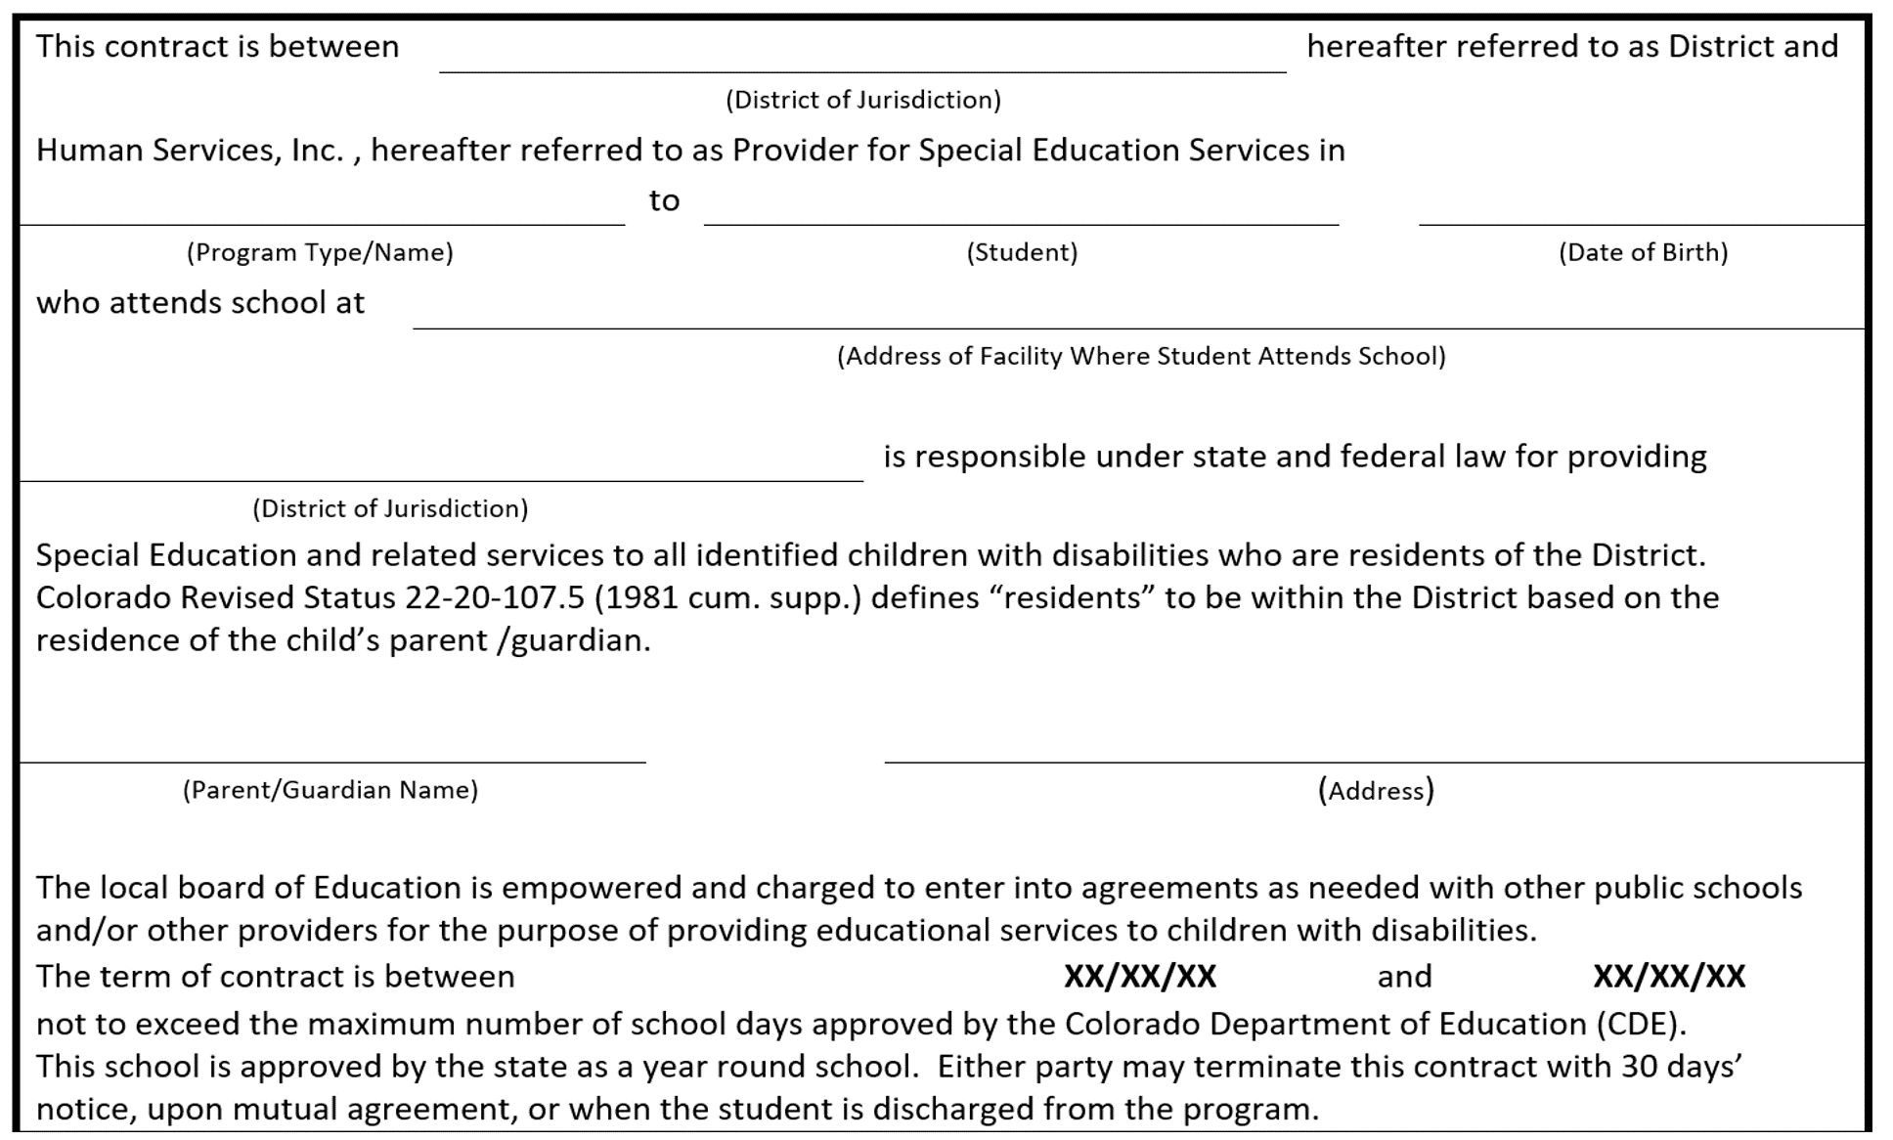

DRAFT

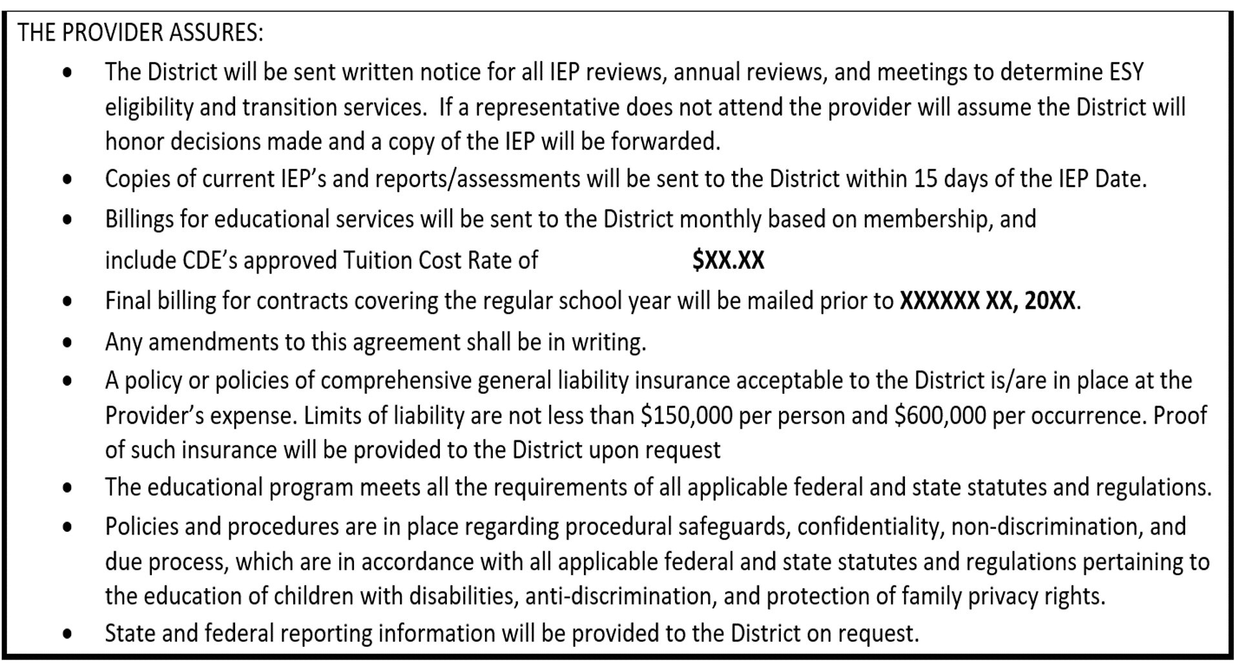

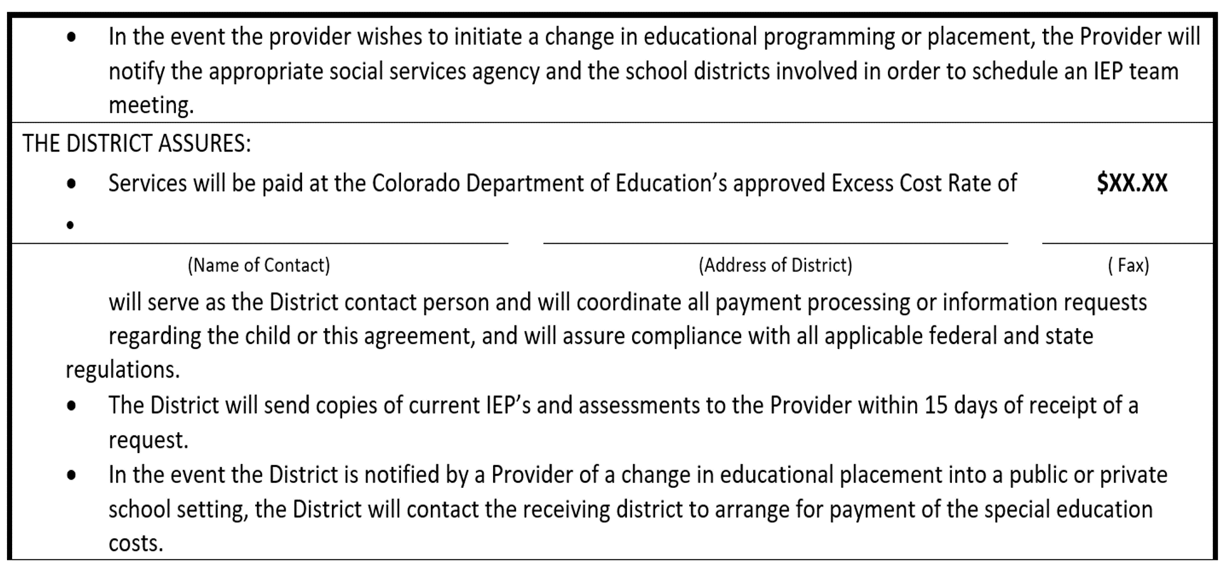

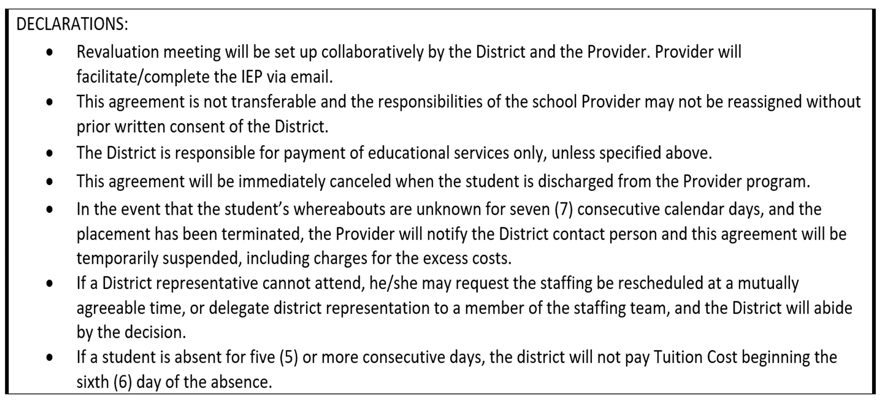

DRAFT

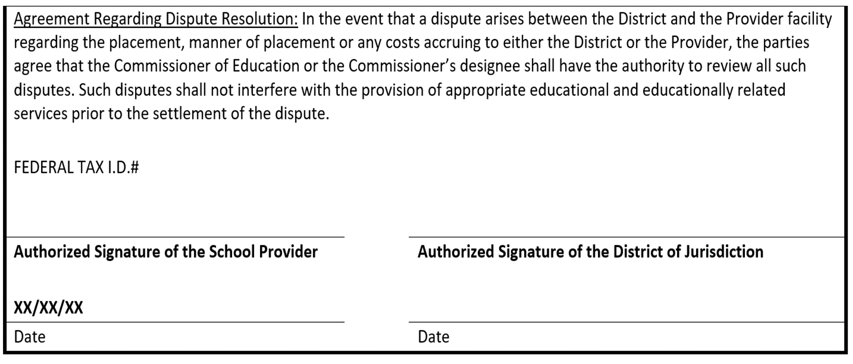

#### Notification of Placement

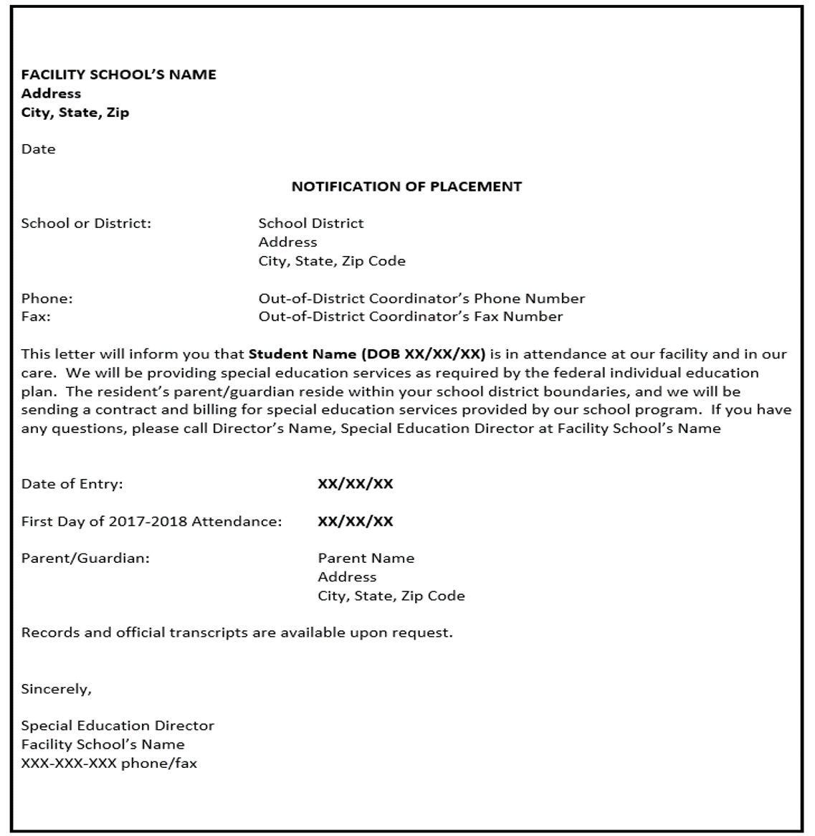

#### Notification of Release

