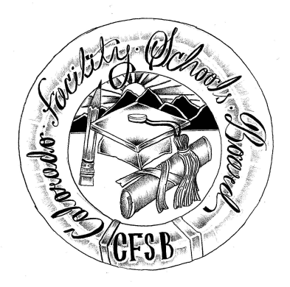
Colorado Facility Schools Board Agenda
August 10, 2023
9:30a.m. until the completion of the agenda

Shiloh Family Resource Pavilion In-Person & Zoom

9:30am  9:35am  9:40am  10:00am  10:15pm  10:30pm  11:00pm  11:30pm  12:15pm | Arrival  Board Meeting will start - Call to Order  Approval of Minutes  Approval of Agenda  Facility Schools Unit Update  - CDE/Facility Internal Updates  - Data Management and Systems Support  - iReady/Tuition Cost/December Staff  - Monitoring/Updates from the Field  - IEP System Updates/ State Assessments  - Curriculum/Induction/OOD Consortium/Workgroup  - Program Support  ROP Qualifying House  Break  End of year summary  Joshua Learning  Lunch  Election of Officers | Action Item  Action Item  Judy Stirman  Annie/Lori  Lori Kochevar  Robin /Ann  Annie Haskins  Wendy Dunaway  Darren Serrato  Kent Moe/Brittany Hoffman  Robin/Ann  Martha Muth  Board
1:00pm  2:00pm  2:15pm | Planning for ESSU Directors Meeting  Opportunity for the Public to Address the Board  Members of the public who wish to address the board must sign up prior to the meeting. Presentations are limited to 5 minutes.  Next Steps/Adjournment of Meeting | Members of the Public  Board

