Using Local Assessment Data: NWEA MAP
Improvement Planning & Supports Unit
Colorado Department of Education

Overview

The purpose of this document is to support local education agencies with use of local assessments for the improvement planning process. The shift in the UIP timeline, beginning in the 2021-22 school year, has made the use of local assessment data especially relevant for improvement planning, monitoring progress and determining student growth.

Additional Impact of COVID-related Disruptions in Data
COVID-19 has significantly disrupted state summative assessment testing and reporting in Colorado. During the Spring of 2021, this resulted in only a single CMAS test administration in each content area at the elementary, middle, and high school levels. Because multiple years of data are required for determining individual student growth, these disruptions have limited the availability of Colorado growth model data and reports.

State Summative Data in Improvement Planning
Beginning in 2021-22, all Unified Improvement Plans required for the year must be submitted for public posting by October 15th. This new timeline means that schools and districts have a fairly short window for reviewing and analyzing their state assessment data before the UIP public posting deadline.
Because schools have access to Local Assessment Data throughout the school year, on the other hand, they can use it to begin the planning process before state-level data is available. Once state-level data is released, it can be used to check and adjust the plans already in development.

Using Local Assessment Data for Improvement Planning
Because local assessments are under the control of the school and can be administered many times throughout the year, they play a crucial role in nimble and responsive school improvement efforts. They can be used to set and track progress towards meaningful interim student performance targets, which will in turn give schools an early indication of whether students are on track to meet the annual performance targets identified in the school’s improvement plan. Where these interim targets are met, this is a good indication that improvement strategies are positively affecting student outcomes. When targets are missed, schools have an opportunity to make mid-course adjustments to respond to student needs.
In order to better understand the scope of assessments being used by districts throughout the state of Colorado, the Colorado Department of Education conducted an analysis of Unified Improvement Plans to identify the key assessment systems utilized in recent academic years. The analysis indicated that NWEA MAP was one of the most frequently utilized local data assessments.
This resource provides guidance on how schools and districts can use MAP Growth native data reports to answer the following questions:
- Which students are on grade level? How far from grade level are others? (Student Proficiency)
- How much / how quickly are students growing? (Student growth)
- How can I view disaggregated data for these metrics? What levels of disaggregation are offered?
- How can I use MAP Growth reports to set meaningful targets for student performance annually (and/or interim targets throughout the year)?

MAP Growth (Reading & Math)

Accessing the Reports: How do I find the report I need?
All MAP Growth reports can be found by selecting “View Reports,” and then “MAP Growth.” The resulting screen will allow you to apply filters in order to determine the right report for your needs. If you know which report you are looking for, sort the list alphabetically to find it.
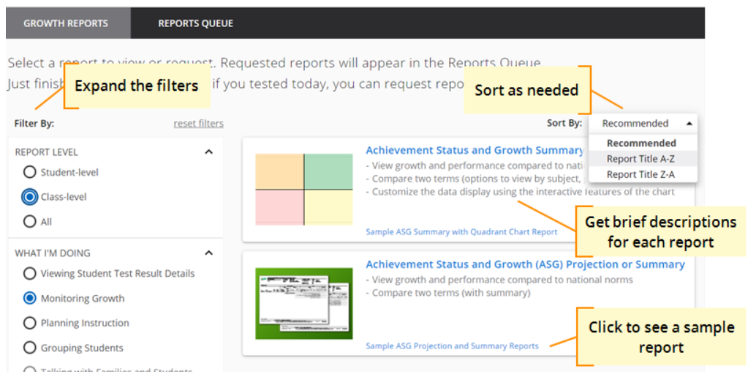

Understanding MAP Growth Reports: What is a RIT Score?
MAP Growth uses the RIT (Rasch Unit) scale to help you measure and compare academic growth. Specifically, the scale measures levels in academic difficulty. The RIT scale extends equally across all grades, making it possible to compare a student's score at various points throughout his or her education. Specific RIT scores correspond to what is commonly known as a student’s “zone of proximal development.”

The rest of this document provides guidance on how to use MAP Growth reports to find answers to specific questions about students’ performance and growth.

Student Proficiency: How can I see if students are on grade level?

Use this report: Projected Proficiency Summary Report [School/District level]
This report will show students’ projected proficiency on their state assessments. NWEA MAP assessments do not assess students in terms of “grade level,” but this report will indicate whether students are on track to reach proficiency as defined by the state assessments.
Note: There are no projections available for summer test results.
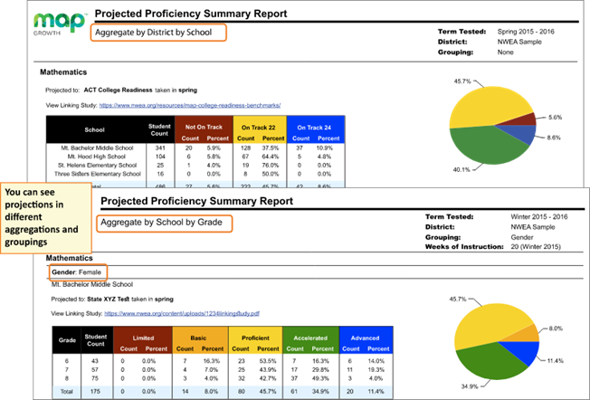

Student Growth: How much or how quickly are students growing?
There are two options for gauging student growth using MAP Growth reports: the Achievement Status and Growth Report and the Student Growth Summary Report.

Use this report: Achievement Status and Growth Report
This report shows three pictures of growth, all based on national norms: projections so you can set student growth goals, summary comparison of two terms so you can evaluate efforts, and an interactive quadrant chart so you can visualize growth comparisons.
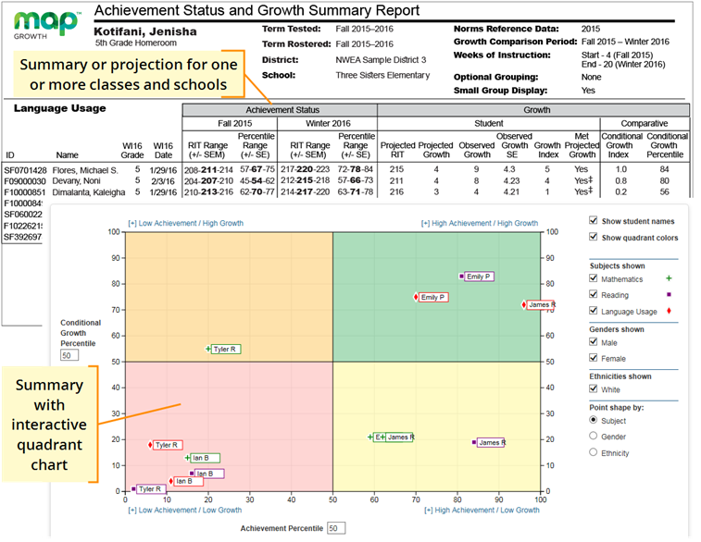

Note: In addition to PDF and online output, you can choose a spreadsheet output for the Achievement Status and Growth report. It provides all of the data in a single, comma-delimited file (CSV format).

Student Growth, continued

Use this report: Student Growth Summary Report
Note: This report can only be generated at the end of the term, once testing for the term has been completed. This report shows aggregate growth in a district or school compared to the norms for similar schools, so you can adjust instruction and use of materials.
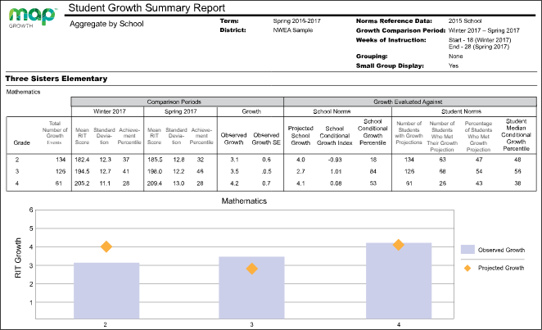

Disaggregation: How can I view disaggregated results from these assessments?
Depending on the report, you will see options for viewing results by School, Instructor, Class, and Subject. Under each option, the choices that appear depend on the MAP role assigned to you. For example, as a teacher (Instructor role), you can only view your class, but a school leader (Administrator role) can choose from multiple classes.

Many reports also enable you to group students by Gender, Ethnicity, or school Program (within district-level reports). If you choose a grouping, the report also shows totals for each group. The precision of the grouping information depends on how your leaders prepared the roster for the term.

The following categories of disaggregation are available (if this information has been shared with NWEA MAP):
- district (for Assessment Coordinators)
- school, class
- instructor
- subject
- gender
- FRL status
- IEP status
- Race/Ethnicity
Use the “optional grouping” field when generating your report to include data for particular student groups (e.g., gender or ethnicity), in reports where this is applicable (i.e., will not apply to Student Progress Report).
Note: Disaggregating data may result in n-counts below 16 or 20. Refer to CDE’s Data Analysis for Small Student Populations for guidance on protecting student information when reporting results in a public document (e.g., the UIP).

Target Setting: How can I use NWEA MAP results to set meaningful performance measures and targets?
Examples:
Sample measure type | Sample Interim Measure | Report used
Measure is set using student performance with respect to proficiency (RIT score). | By the end of the second quarter, 50% of students previously projected to not reach proficiency according to the BOY assessment will be on track to reach proficiency by the end of the year. | Achievement and Status Report  (Monitor progress using the Class Breakdown by Projected Proficiency Report)
Measure is set using student growth projections. | By the end of the first quarter, 90% of students are on track to meet or exceed their growth projections. | Achievement and Status Report
Sample target type | Sample Annual Target | Report used
Target is set using student performance with respect to proficiency (RIT score). | By the end of the year, 50% of students previously projected to not reach proficiency according to the BOY assessment will meet or exceed proficiency. | Achievement and Status Report (to determine BOY proficiency projections)
Target is set using student growth projections. | By the end of the year, 75% of students have exceeded their growth projections. | Student Growth Summary Report

Additional Resources from NWEA MAP:
- What does RIT Mean?
- MAP Growth Report Basics
- MAP Report Details
- Find Reports by Data
WHERE CAN I LEARN MORE OR GET ADDITIONAL SUPPORT?
The School Improvement & Planning team is available to provide professional development and technical assistance related to data use, state accountability, and improvement planning both remotely and in‐person. For more information, visit: http://www.cde.state.co.us/uip/uip_training or contact Erin Loften (loften_e@cde.state.co.us), Supervisor.
For questions about this resource, contact Dan Jorgensen, PhD (Jorgensen_d@cde.state.co.us) or Lauren Hesse (hesse_l@cde.state.co.us).

