Handbook for Resubmitting UIPs

-Spring-



Districts that must address ‘Required Changes’ by submitting a revised UIP for a CDE re-review (as noted in the CDE District-level UIP Feedback Form below) are required to resubmit the UIP with appropriate revisions by March 31.

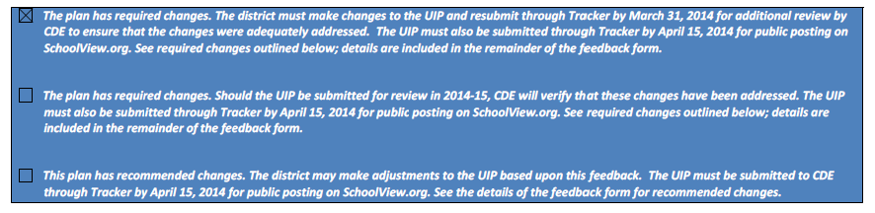

The following instructions will depict how to resubmit district plans with required changes for re-review and submit the LEA Assurance. The LEA Assurance states, “The LEA acknowledges the required changes specified in the comments from CDE. The LEA assures that necessary steps have been or will be implemented at all applicable sites within the LEA to meet the requirements specified.”

**Step-by-step Guide for Resubmitting Revised District UIPs to CDE**:

1. **Log on** to the Tracker system (<https://tracker.cde.state.co.us/Tracker/Security/Login.aspx>) using your e-mail address and password. Please remember that Tracker passwords are case sensitive.

*Note: CDE does not have a record of passwords. If you have forgotten your password, please click on the “Reset Password” link and follow the on-screen directions.*

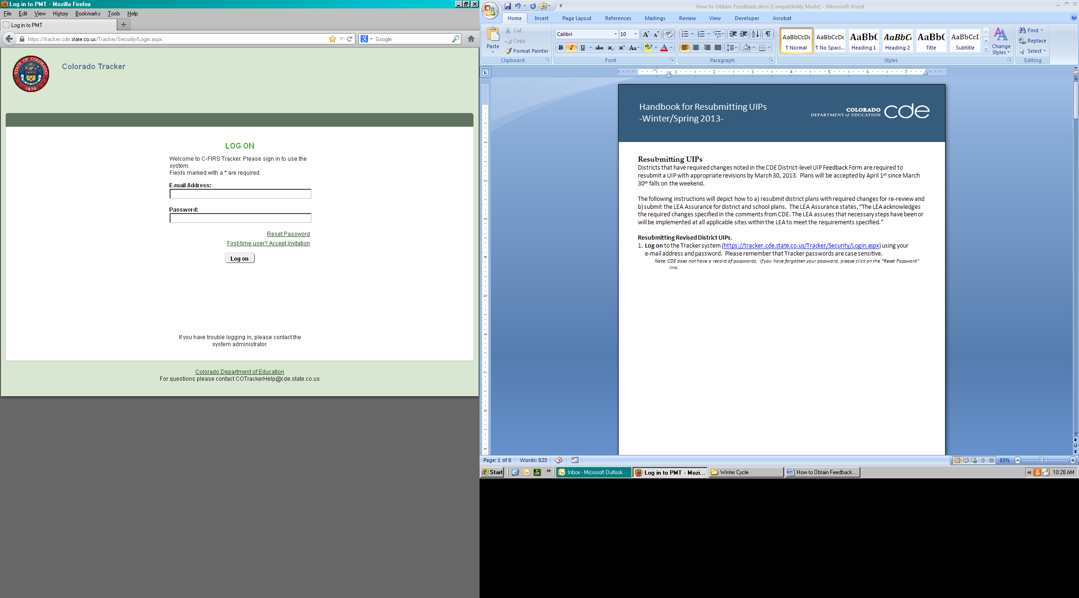

1. **Click** on the district name to resubmit the UIP for that district. If you have several districts on your account, you may search for the district you will be resubmitting for by typing the name of the district in the “LEA Name” search bar and **click** the “**Apply**” button.

* For this example, we are using “**Delta Training District - 7770.**”

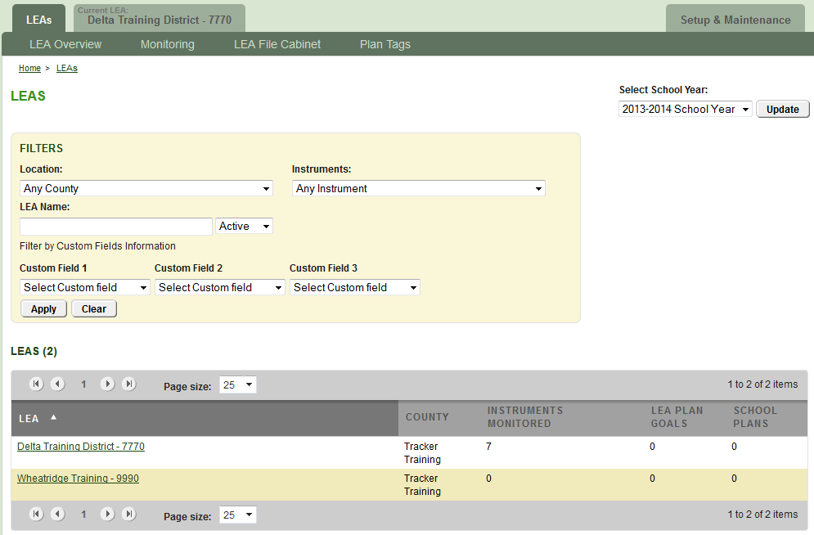

1. This is the **LEA Overview** page which shows the district’s different monitoring instruments. You will be using the “**UIP – Winter Cycle - Required Review**” instrument to submit the revised district UIP for re-review. **Click** on this instrument title to resubmit.

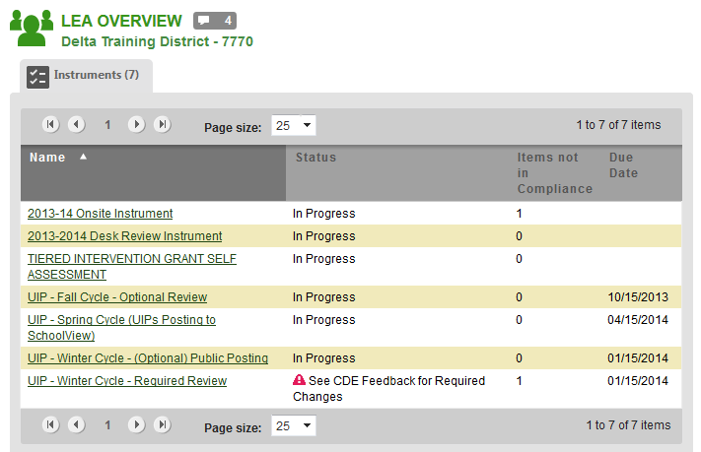

4. The **Instrument Overview** page is where you see the three different categories for the plans that were submitted in January. **Category A** contains items for the district-level plan and this is where you will resubmit the district plan. Click on the first item within Category A to resubmit the revised district UIP.

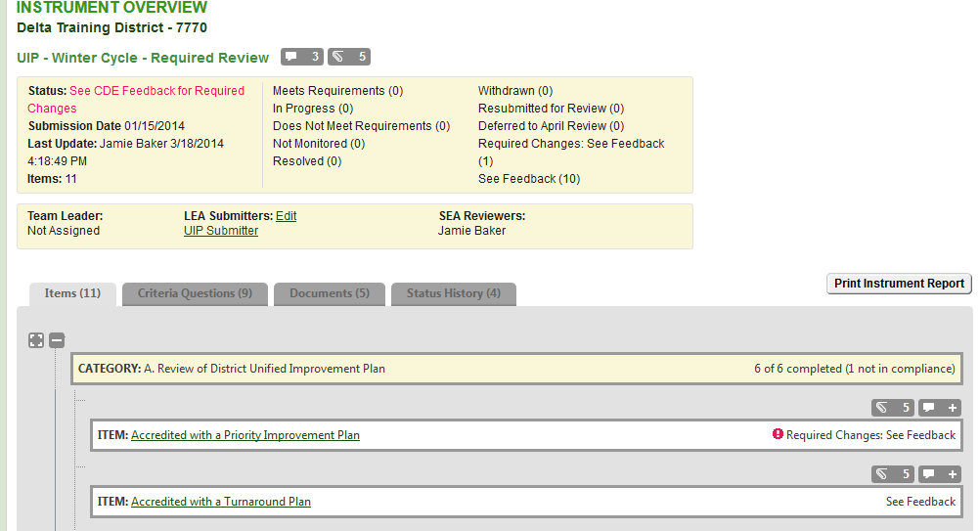

5. You will be taken to the **Item Overview** page which contains “Compliance Indicators” or a description of general requirements for every UIP. Below the Compliance Indicators, are the “State Findings” where comments from CDE as well as the status of the Item can be found. The bottom of the page is where you will click “Respond” to upload the revised district UIP for re-review. The steps for uploading a revised UIP are the same as the steps to upload the UIP for the first review. **Click** “Respond” next to “Current Unified Improvement Plan(s) for Review Winter 2014.”

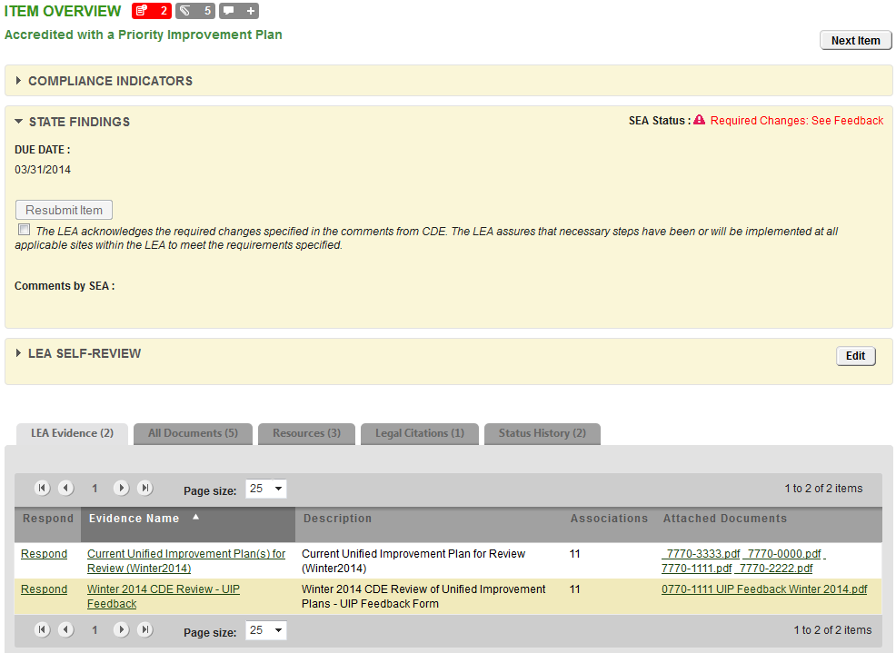

6. After clicking on the “Respond” link, you are taken to the “**Add New Document**” page. This page is where you will upload the revised district UIP for the required re-review. Be sure that the circle next to “New File” is filled in (default) and then **click** “Browse” to locate the document on your computer/network.

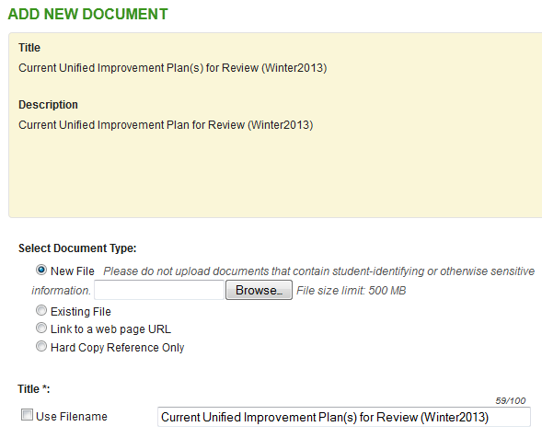

7. A dialogue box will open allowing you to search for the UIP file on your computer. When you have selected the appropriate UIP on your computer/network, **click** on “Open.”

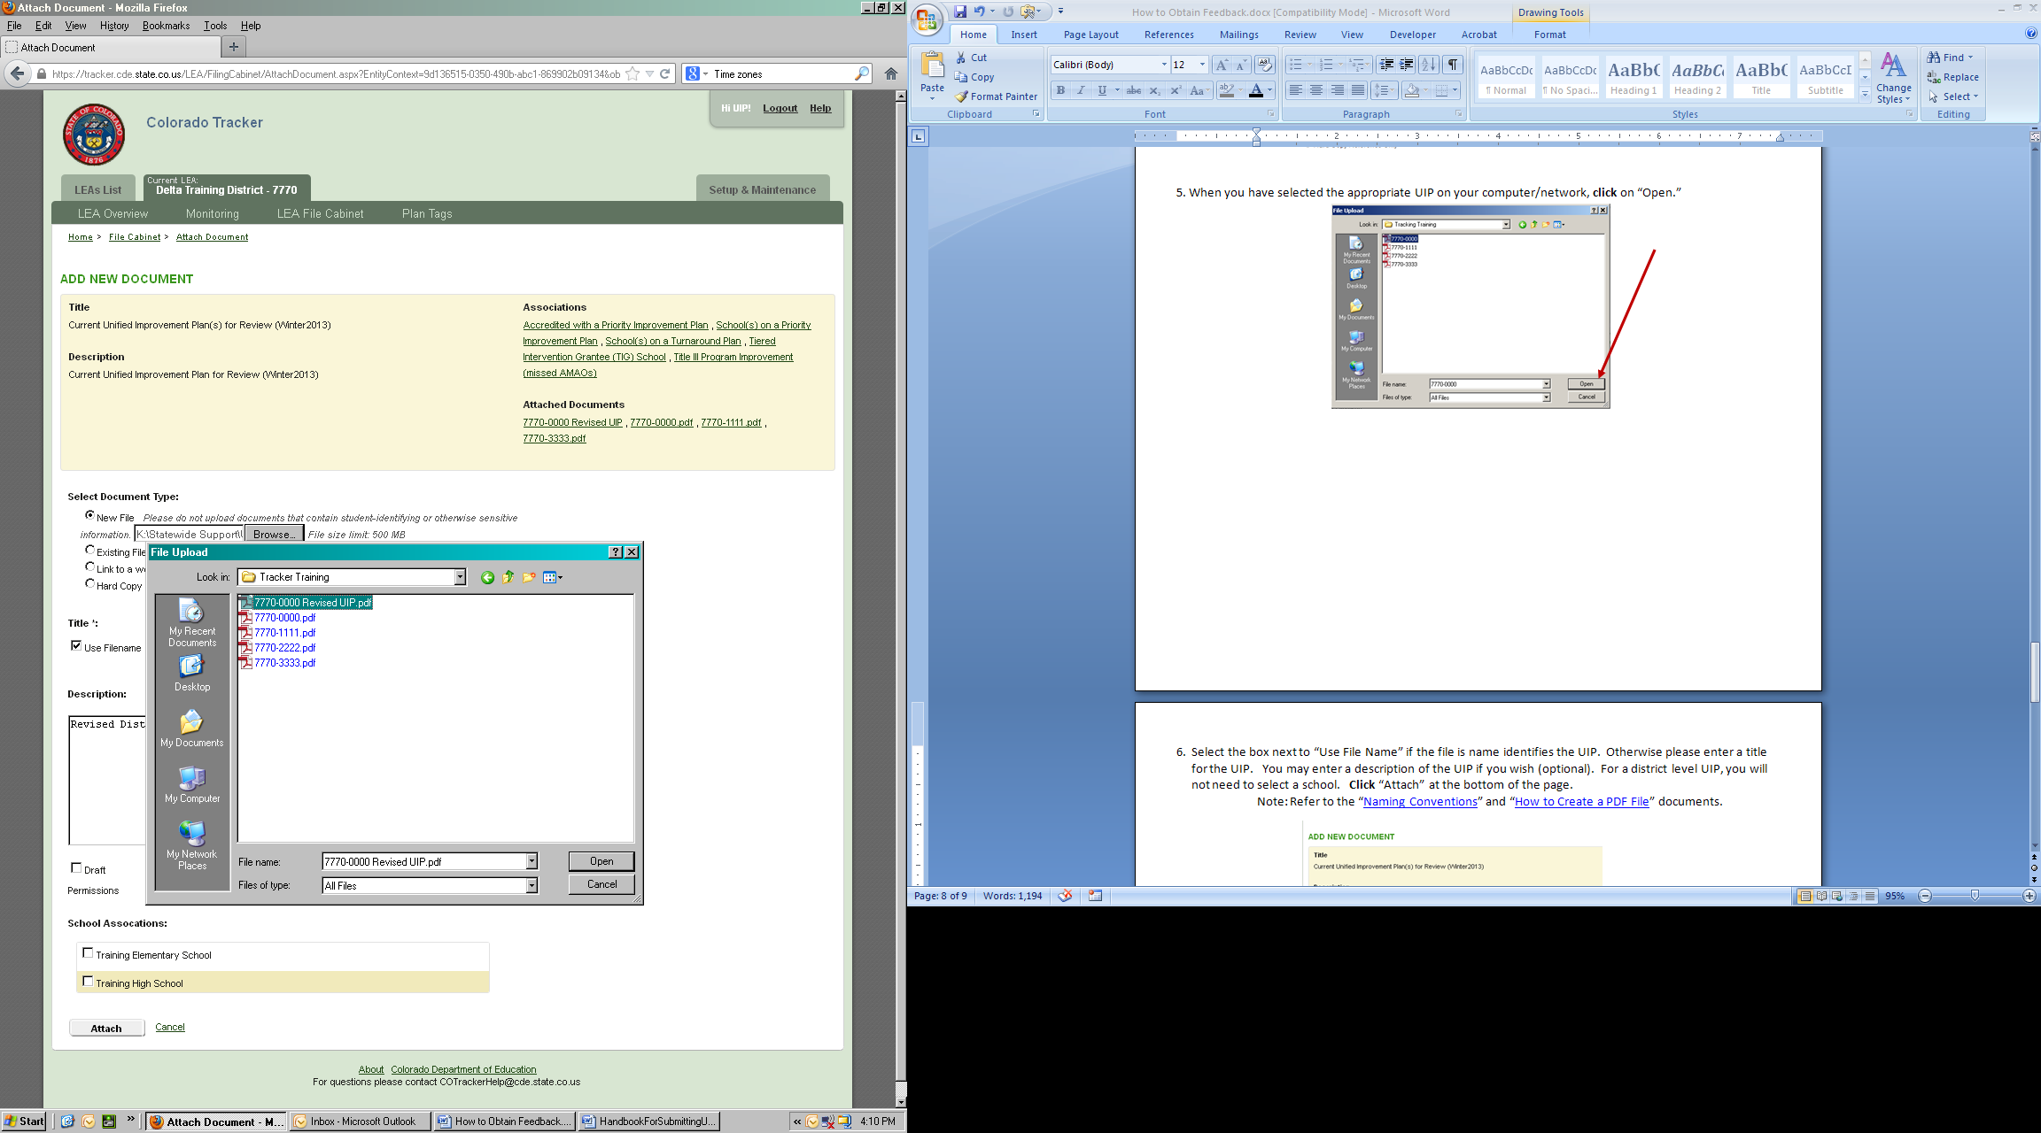

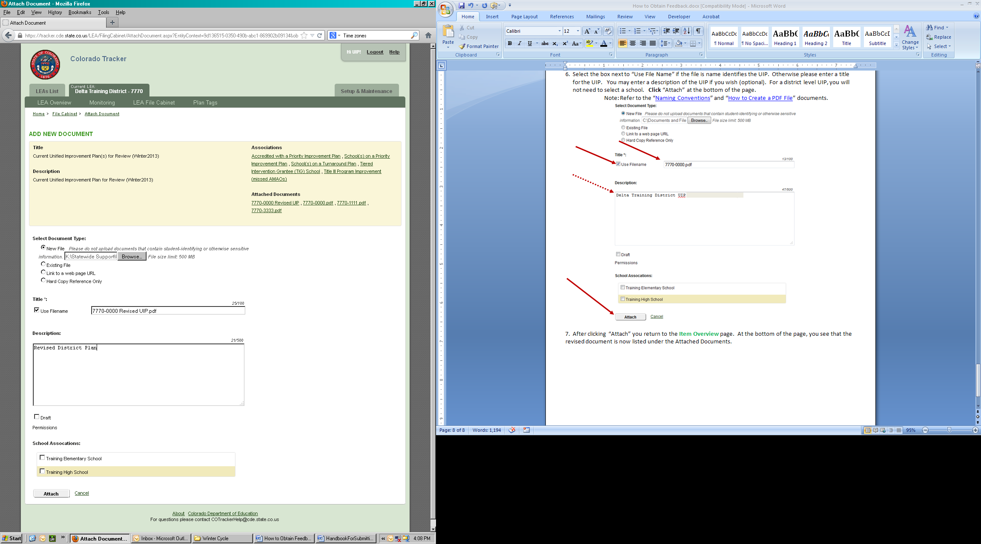8. Select the box next to “Use File Name” if the file name identifies the UIP. Otherwise please enter a title for the UIP. You may enter a description of the UIP if you wish (optional). For a district level UIP, you will not need to select a school. **Click** “Attach” at the bottom of the page.

9. After clicking “Attach” you return to the **Item Overview** page. At the bottom of the page, you see that the revised document is now listed under the Attached Documents.

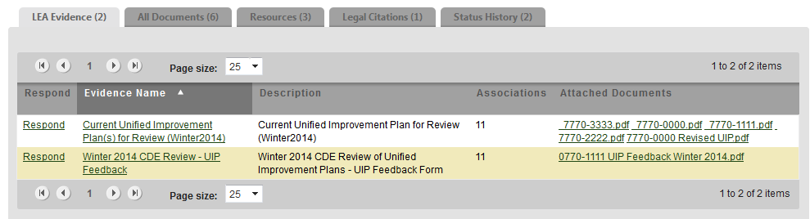

10. Within the “State Findings” section of the **Item Overview** page, you will see the LEA Assurance in italics. Districts must check the box next to the assurance to enable the “Resubmit Item” button. Once the box is checked, **click** on the “Resubmit Item” button.

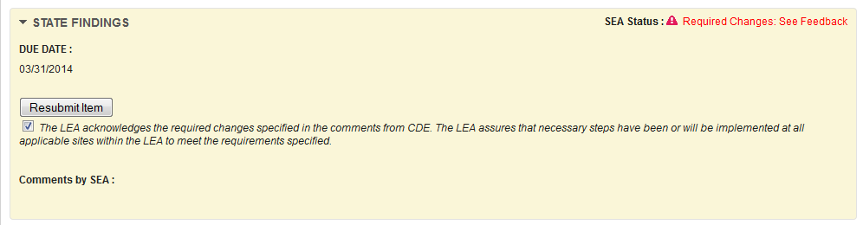

11. *Clicking on the “Resubmit Item” button changes the SEA status to “Resubmitted for Review” on the **Item Overview** page. Click on the “UIP – Winter Cycle – Required Review” ‘bread crumb’ at the top of the page to return to the Instrument Overview to ensure that the item indicates that the plan has been “Resubmitted for Review.” Log-out when finished resubmitting.

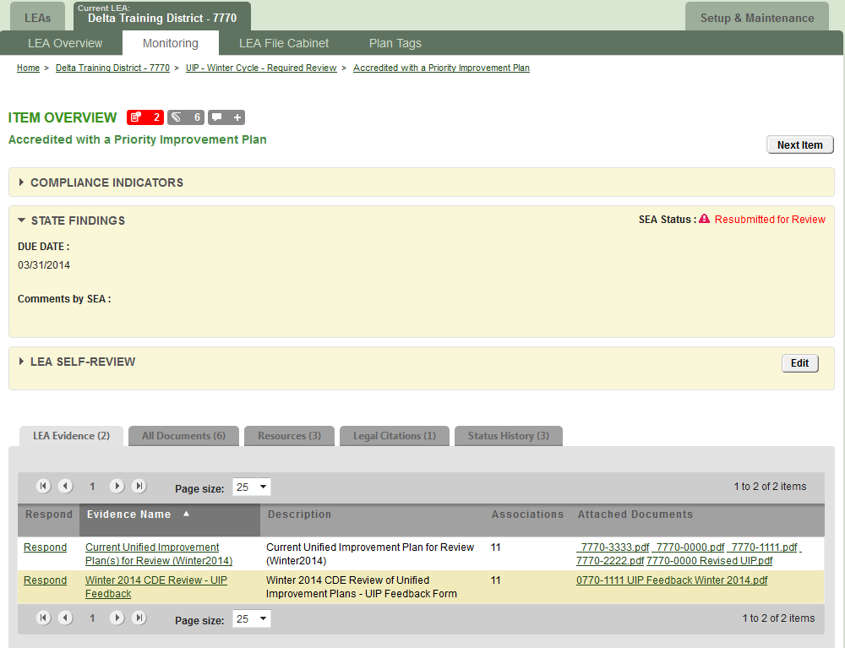



*Note that by clicking on the “Resubmit Item” button CDE is notified via email that an item has been resubmitted and is ready for re-review.

For help, contact Jamie Baker ([baker_j@cde.state.co.us](mailto:baker_j@cde.state.co.us); 303-866-6108)

*If you need assistance please contact Jamie Baker (*[*baker_j@cde.state.co.us*](mailto:baker_j@cde.state.co.us)*; 303-866-6108)*