Student Name _________________________________________ Date ____________________

The Mouse and the Clock
Dear Parent,
We are learning more about rhyming words that have the same ending sound. I hope you enjoy this activity with your child. This assignment is due _________________________. Thank you!

LET’S DO THIS

- With your child: Read Hickory Dickory Dock to your child pointing to each word. Ask your child to read the poem to you as you point to each word.

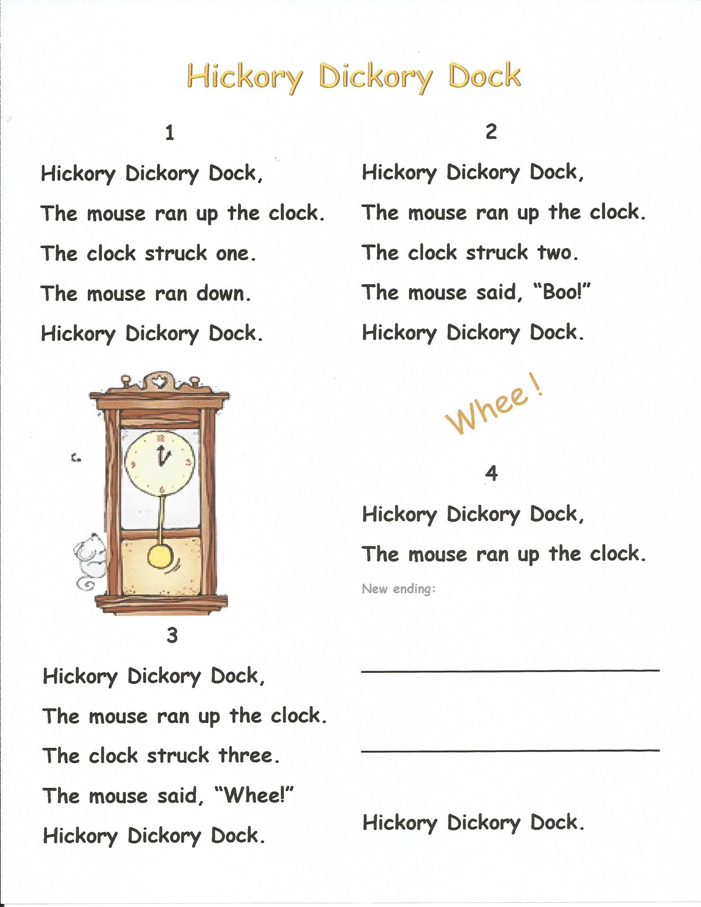

- Ask your child: Find and circle the rhyming words in the poem.

LET’S DO THIS

With your child: Read the poem again and ask your child to act out each verse.

With your child: Discuss an ending for a new verse.

Please write the new ending your child created
in the space on the front page.

Read it to your child, pointing to each word.

Ask your child to read the new ending to you.

EXTENSION

Try changing the words to Humpty Dumpty or Mary Had a Little Lamb.


For example: Humpty Dumpty sat on a ____

Finish the line and think of another line to rhyme, just for fun.

OR, start with: Mary had a little ____

Finish the line and think of another line to rhyme, just for fun.

HOME-TO-SCHOOL COMMUNICATION

Dear Parent,

Please give your reactions to your child’s work on this activity.
Write YES or NO for each statement.
______ 1. My child understood the homework and was able to complete it.
______ 2. My child and I enjoyed the activity.
______ 3. This assignment helped me know what my child is learning in class.

Comment ________________________________________________________________________

Parent Signature __________________________________________________________________

Sampish, A., Wallace, R., Epstein, J., & Greenfeld, M. (2016). Teachers Involve Parents in Schoolwork (TIPS) Interactive Homework-Literacy K-3. Colorado Series. Baltimore: Center on School, Family, and Community Partnerships, Johns Hopkins University.

