Student Name ______________________________________ Date ______________

The Prefix Builder
Dear Parent,
We are learning the meanings of common prefixes that are attached to the beginning of words.
I hope you enjoy this activity with me. This assignment is due ________________________.
Sincerely,
___________________________
Student Signature

THINGS TO REMEMBER

A prefix is placed at the beginning of a root word to change its meaning.
A prefix builds a new word.
Example: The prefix re means again. The word reprint means to print again.
The prefix un means not or opposite of. The word unopened means not opened or closed.

LET’S DO THIS

- Work with a family partner. Who is working with you? _____________________

The Prefix Builder has been working on root words to make new words.

Look at the root word in the first column.

Add the prefix in the second column.
Build a new word in the third column.
Write the meaning of the new word in the last column.
Two examples have been done for you.

Root Word | Add the Prefix | Build a new word | Meaning of new word
wind | re | rewind | wind again
play | re
do | re
lock | un | unlock | not locked
unsafe | un
unplug | un

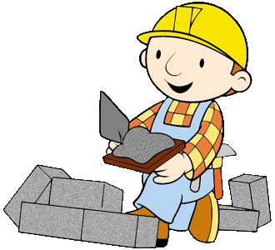

LET’S FIND OUT

- A Prefix Game: re or un or both?

With your family member take turns making new words by adding the
prefix re or un to some words you know.

Sometimes a root word can be changed to 2 new words using both re and un.

Example: reload means to load again and unload means to do the opposite.

YOU write the prefix in the blank before the word.
If both prefixes can be used, YOU write both new words on the page.

re- or un- or both?

_______make _______do

_______able _______cook

_______tie _______wrap

_______read _______cover
With your family partner:

- Take turns using the original root word in a sentence.

- Then, take turns using the new word with its prefix in a sentence.
HOME-TO-SCHOOL COMMUNICATION

Dear Parent,

Please give your reactions to your child’s work on this activity.
Write YES or NO for each statement.
______ 1. My child understood the homework and was able to complete it.
______ 2. My child and I enjoyed the activity.
______ 3. This assignment helped me know what my child is learning in class.

Comments _____________________________________________________________________

Parent Signature ________________________________________________________________

Parker, C. K., Castillo, M. D., Firme, K. K., Epstein, J. L., & Greenfeld, M. (2016). Teachers Involve Parents in Schoolwork (TIPS) Interactive Homework-Literacy K-3. Colorado Series. Baltimore: Center on School, Family, and Community Partnerships, Johns Hopkins University.

