Student Name ____________________________________ Date_______________

A Frog’s Life Cycle
Dear Parent,
We are learning about life cycles—such as the life cycle of a frog. We learn about the world around us by reading informational text (non-fiction). I hope you enjoy this activity with me. This assignment is due _________________________________.
Sincerely,
___________________________
Student Signature

LET’S DO THIS
1. Work with a family partner. Who is working with you? __________________

2. Ask your family partner: Would you like to hear about the life cycle of a frog?
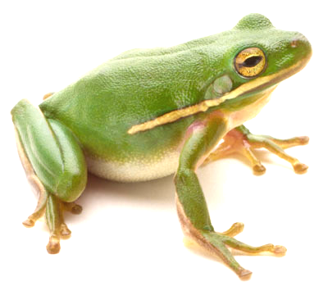
Read aloud to your family partner the passage
about the stages in the life of a frog.

Life of a Frog

A female adult frog lays eggs in water to keep the eggs moist. A frog will lay up to 4,000 eggs at one time! Tadpoles grow inside the egg and hatch when they can wiggle out and live in the pond.

The tadpole spends its time completely underwater and breathes through gills. In about 10 weeks, back legs begin to grow to prepare the frog to live on land.

Then, front legs develop and the tadpole begins to look more like a frog. At this stage, the tadpole still has a wiggly tail, along with its front and back legs. It can be called a “froglet.”

The froglet's tail shrinks. Its lungs develop and the back legs get stronger. Then, we have a frog.

LET’S FIND OUT

- Show your family partner. These pictures are mixed up. I will put them in order.

Draw a line from each picture to the correct place in the chart.

Write the correct word in the chart for each stage of the frog’s life cycle.

Froglet Egg Adult Frog Tadpole
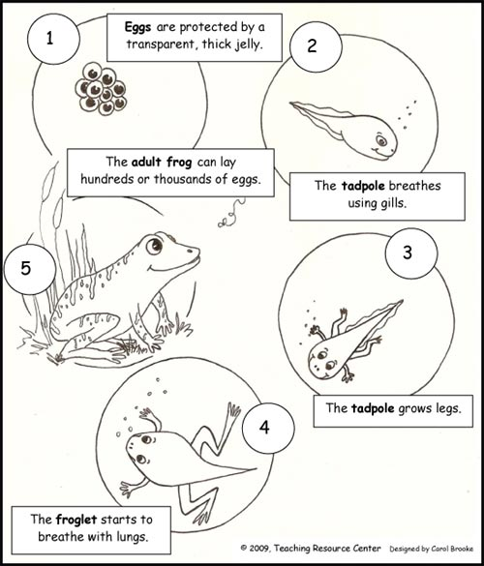

A frog starts as an  _______________.  Tell your family partner something about this stage of the life cycle. | Next, it becomes a  ________________.  Tell your family partner something about this stage of the life cycle. | After that it is a  _______________.  Tell your family partner something about this stage of the life cycle. | Finally, it is a  ________________.  Tell your family partner something about this stage of the life cycle.

- All creatures have a life cycle. Ask your family partner:

Tell me 2 ways that I have changed since I was born.

Which stage of your life cycle (so far) did you enjoy most?

HOME-TO-SCHOOL COMMUNICATION

Dear Parent,

Please give your reactions to your child’s work on this activity.
Write YES or NO for each statement.
______ 1. My child understood the homework and was able to complete it.
______ 2. My child and I enjoyed the activity.
______ 3. This assignment helped me know what my child is learning in class.

Comment _____________________________________________________________

Parent Signature ________________________________________________________________

Parker, C. K., Castillo, M. D., Firme, K. K., Epstein, J. L., & Greenfeld, M. (2016). Teachers Involve Parents in Schoolwork (TIPS) Interactive Homework-Literacy K-3. Colorado Series. Baltimore: Center on School, Family, and Community Partnerships, Johns Hopkins University.

