Student Name ____________________________________ Date _______________

Word Groups
Dear Parent,
Our class is practicing ways to increase vocabulary. I hope you enjoy this activity with your child. This assignment is due _________________________________. Thank you!

MATERIALS


A pencil and a small object to pass back and forth, such as a ball
or rolled-up socks.

LET’S DO THIS

Let’s play categories.

- Face your child with enough space to pass a ball or small object back and forth.

- Take turns naming objects in each category when you hold the ball or object.

For example, if you were naming Farm Animals, you might say “horse” when you hold the ball. Your child may say “cow” when he or she holds the ball.

- Go back and forth to name 5 items in each group of things.

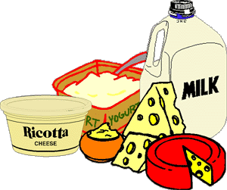


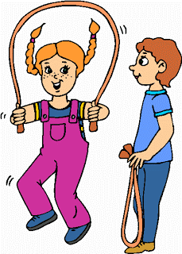

food wild animals games

- With your child: Write 2 of the words that you shared in each category.

Food: ______________________ ________________________

Wild Animals: ______________________ ________________________

Games: ______________________ ________________________

- Ask your child: Let’s read these words. Point to each word as your child reads it.

Use one word from each category in a sentence.

LET’S FIND OUT

1. Ask your child: Choose a new category of things you like
(e.g., cars, colors, or other things).

Pass the ball back and forth to name at least 5 items
in the new category.

Draw a picture of 1 item in this category.

2. Ask your child: Write one sentence about the item in your picture.

____________________________________________________________________.

____________________________________________________________________.

3. Ask your child: Read your sentence, pointing to each word.
HOME-TO-SCHOOL COMMUNICATION

Dear Parent,

Please give your reactions to your child’s work on this activity.
Write YES or NO for each statement.
______ 1. My child understood the homework and was able to complete it.
______ 2. My child and I enjoyed the activity.
______ 3. This assignment helped me know what my child is learning in class.

Comment _______________________________________________________________________

Parent Signature __________________________________________________________________

Wilshusen, M., Bognar, J., Handy, T., Epstein, J., & Greenfeld, M. (2016). Teachers Involve Parents in Schoolwork (TIPS) Interactive Homework-Literacy K-3. Colorado Series. Baltimore: Center on School, Family, and Community Partnerships, Johns Hopkins University.

