Student Name ______________________________________ Date ____________

Compound Words
Dear Parent,
We are learning about compound words—two short words put together to make a new word.
I hope you enjoy this activity with your child. This assignment is due ____________________. Thank you!

LET’S DO THIS
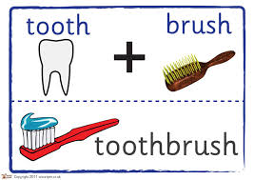

Here is an example of a compound word.

The words tooth and brush come together to form
one new word – toothbrush.

Ask your child: Read the two short words and then the compound word.

butter

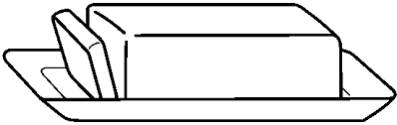
fly
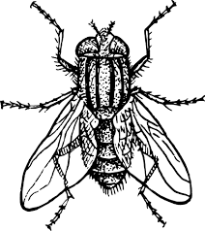
butterfly


+
=

cup

cake

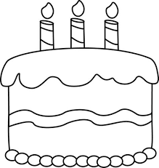
cupcake

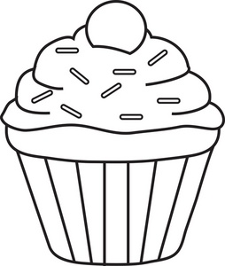
+
=

ball
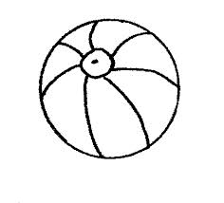
foot

football


+
=

+
=
rain bow rainbow
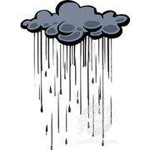



Share ideas: Tell each other: Which of these compound words do you think
makes good use of the two short words? Why?

LET’S FIND OUT

- Ask your child: Add a word from the box to the first word to make a
compound word that describes the picture.

paper cake plane berry

Write the short word and the compound word on the lines.
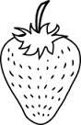

straw + _____________ = ______________________

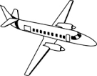
air + _____________ = ______________________


news + _____________ = ______________________

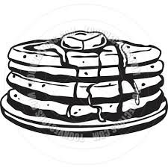
pan + _____________ = ______________________

- With your child: Read the two short words and the compound words, above.

HOME-TO-SCHOOL COMMUNICATION

Dear Parent,

Please give your reactions to your child’s work on this activity.
Write YES or NO for each statement.
______ 1. My child understood the homework and was able to complete it.
______ 2. My child and I enjoyed the activity.
______ 3. This assignment helped me know what my child is learning in class.

Comment ________________________________________________________________________

Parent Signature __________________________________________________________________

Wilshusen, M., Bognar, J., Handy, T., Epstein, J., & Greenfeld, M. (2016). Teachers Involve Parents in Schoolwork (TIPS) Interactive Homework-Literacy K-3. Colorado Series. Baltimore: Center on School, Family, and Community Partnerships, Johns Hopkins University.

