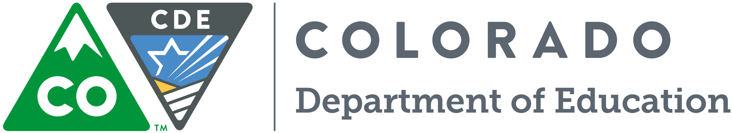
CDE School
Transportation Training 2018

Tuesday, July 24
Delta County District Office
145 West 4th Street
Delta, CO 81416

Wednesday, July 25
Eagle County Schools
Transportation Department (New location)
375 Lindbergh Drive
Gypsum, CO 81637

Thursday, July 26
Class Time:
9:00 a.m. to noon
Lunch break (on your own)
1:00 p.m. to 4:00 p.m.

Class fee:
No Charge

Provided by:
CDE School Transportation Unit
Susan M Miller

For more information
contact us at
Miller_s@cde.state.co.us

Register On-line at https://www.surveymonkey.com/r/MV2QY2V

Greeley-Evans Weld County School District 6
Transportation Department
155 East 27th Street
Greeley, CO 80631

Friday, July 27
Pueblo School District 70
Administration Office
301 28th Lane
Pueblo, CO 81001

Monday, July 30
Jeffco Public Schools Education Center
1829 Denver West Drive, #27
Golden, CO 80401

Thursday, August 2
Alamosa School District
Transportation Department
2050 Lava Lane
Alamosa, CO 81101

Friday, August 3
Lamar School District
Administration Office
210 West Pearl
Lamar, CO 81052

Tuesday, August 7
Holyoke School District
Transportation Department
125 North Sunflower Drive
Holyoke, CO 80734

