Colorado Media Literacy Advisory Committee
Meeting Agenda
September 4, 2019

Goal
Consider standards revision recommendations to implement media literacy into elementary and secondary education.

Agenda
- Welcome and introductions
- Review of the MLAC charge
- Accessing the work space in Google Drive
- Framing the work
- Defining the terms
- Working lunch
- Standards familiarization
- Standards recommendations: WestEd/CSAI
- Work Session 1
- Standards recommendations: Nancy White, MLAC Facilitator
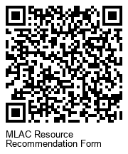
- Work Session II
- Homework
- Q/A and Plus/Delta
Next Meeting: Monday, September 30, 2:00 – 4:00 pm (online)

