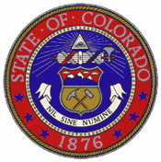
State Council for Educator Effectiveness
December 13th and 14th 2012

Developing a Name for “Other Licensed Personnel”

As requested by the State Council on Educator Effectiveness at the November 16 meeting, Colorado Department of Education (CDE) staff members led a process for engaging members of the Other Licensed Personnel in the development of their name. This process involved the following:
- CDE staff members identified a set of potential names for the collective groups and presented them to the practitioners involved in rubric development process.
- Practitioners voted on their choices for a new name from the CDE-generated list. They were also invited to suggest different names and offer them to the group for consideration and voting.
- Once votes were cast, those with the largest number of votes were discussed along with the practitioner-suggested names.
- CDE staff facilitated the development of a name based on the votes and subsequent discussion that was supported by everyone in attendance:

Licensed Support Services Professionals

