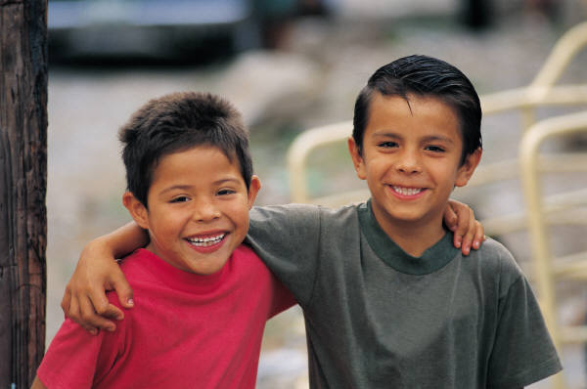

Place feedback, comments and suggestions in this column | Preschool Grade Level Expectations  What do students need to know and be able to do?  This column currently shows examples from Building Blocks. In the future, it will reflect benchmarks developed through standards revision process. | School Readiness Indicators  How do we know that a student can do it?
 | Demonstrates and expresses an awareness of self | - Identifies self according to gender, community membership, ethnicity, ability and family membership  - Separates from familiar people, places or things  - Demonstrates confidence in his/her range of abilities and expresses pride in accomplishments
 | Demonstrates capacity for self-control | - Demonstrates understanding and acceptance of rules and routines within the learning environment  - Accepts the consequences of his/her behavior  - Uses materials purposefully, respectfully and safely  - Effectively manages transitions between activities  - Expresses feelings, needs and opinions
Place feedback, comments and suggestions in this column | Preschool Grade Level Expectations  What do students need to know and be able to do?  This column currently shows examples from Building Blocks. In the future, it will reflect benchmarks developed through standards revision process. | School Readiness Indicators  How do we know that a student can do it?
 | Develops successful relationships with other members of his/her learning community | - Plays, works and interacts easily with one or more children and adults.  - Develops friendships with peers  - Demonstrates empathy and caring for others  - Takes turns in activities  - Participates in resolving conflicts and disagreements with others
 | Demonstrates a sense of belonging to the program, family and community | - Respects the rights of others  - Understands and appreciates the relationships, people and places that make up his/her community  - Participates in the care of the learning environment  - Understands and values similarities and differences among people  - Perceive the needs of others and demonstrates growing empathy

Place feedback, comments and suggestions in this column | Preschool Grade Level Expectations  What do students need to know and be able to do?  This column currently shows examples from Building Blocks. In the future, it will reflect benchmarks developed through standards revision process. | School Readiness Indicators  How do we know that a student can do it?
 | Listens to and understands language | - Listens to and understands stories, songs and poems  - Listens to and understands conversations and questions  - Follows directions that involve multiple steps  - Waits to take turns during conversations  - Listens to and understands English while maintaining home language
 | Uses verbal and non-verbal language to express and communicate information | - Communicates needs or thoughts through non-verbal gestures, actions, expressions and words  - Participates in communication around a topic  - Uses complex sentences  - Communicates clearly enough to be understood by unfamiliar listeners  - Begins a conversation with other children and adults  - Understands complex and varied vocabulary

Place feedback, comments and suggestions in this column | Preschool Grade Level Expectations  What do students need to know and be able to do?  This column currently shows examples from Building Blocks. In the future, it will reflect benchmarks developed through standards revision process. | School Readiness Indicators  How do we know that a student can do it?
 | Shows initiative, accepts help, takes risks and works towards completing tasks | - Invests time in a sustained activity despite distractions and interruptions  - Accepts help from another child or adult when encountering a problem  - Seeks help when appropriate from another child or adult
 | Demonstrates curiosity and participates in tasks and challenges | - Demonstrates an eagerness and interest in learning through questioning and adding ideas.  - Shows an interest in people, things and the world around him/her  - Chooses to participate in a variety of activities, tasks and play areas
 | Establishes goals, develops and follows through with plans | - Understands a task as a series of steps  - Organizes oneself and materials in the learning environment  - Follows through to complete tasks and activities
Place feedback, comments and suggestions in this column | Preschool Grade Level Expectations  What do students need to know and be able to do?  This column currently shows examples from Building Blocks. In the future, it will reflect benchmarks developed through standards revision process. | School Readiness Indicators  How do we know that a student can do it?
 | Identifies possible solutions to problems | - Generates different approaches to solving problems  - Seeks alternative approaches to problem solving
 | Uses prior experiences, sense and knowledge to learn in new ways | - Communicates about events and experiences  - Uses prior knowledge to understand new experiences

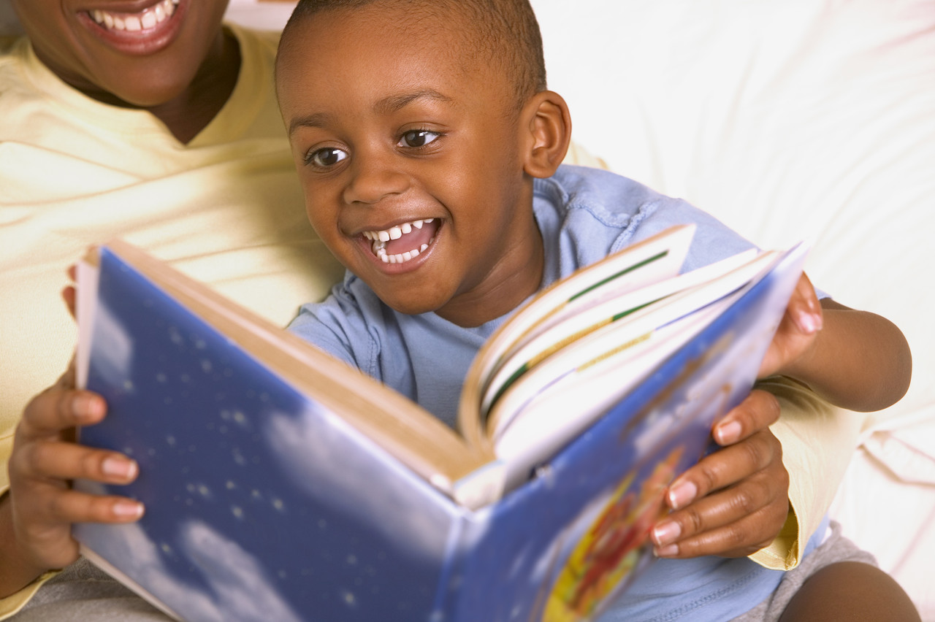

Place feedback, comments and suggestions in this column | Preschool Grade Level Expectations  What do students need to know and be able to do?  This column currently shows examples from Building Blocks. In the future, it will reflect benchmarks developed through standards revision process. | School Readiness Indicators  How do we know that a student can do it?
 | Uses symbols to represent words and ideas | - Prints letters in own name  - Understands that writing carries a message  - Experiments with a variety of writing tools and materials  - Uses scribbles, shapes, letter-like symbols and letters to write or represent words or ideas  - Dictates ideas, sentences or stories
 | Knows some letters and the combination of some letter sounds with letter symbols | - Discriminates and identifies the sounds of language  - Demonstrates growing awareness of the beginning sounds of words  - Hears and discriminates separate syllables in words  - Associates sounds with written words  - Recognizes and generates rhymes
 | Understands and appreciates that books and other forms of print have a purpose | - Attempts to read or tell a story and guesses what happens next  - Listens to and talks about a variety of types of literature  - Handles and cares for books in a respectful manner

Place feedback, comments and suggestions in this column | Preschool Grade Level Expectations  What do students need to know and be able to do?  This column currently shows examples from Building Blocks. In the future, it will reflect benchmarks developed through standards revision process. | School Readiness Indicators  How do we know that a student can do it?
 | Understands that spoken and written words have meaning | - Retells parts of a story with prompts  - Connects information to familiar experiences when being read a story  - Demonstrates understanding of the meaning of a story
 | Recognizes the association between spoken and written words by following print as it is read aloud | - Explores and investigates books and other forms of print  - Understands that print carries a message  - Understands how books are organized  - Recognizes some letters and words captured in books and in the environment  - Recognizes own name in print  - Recognizes individual words in sentences
 | Recognizes that symbols are associated with letters of the alphabet and that they form words | - Knows the names of some letters and words  - Identifies some letters in print  - Know sthe names of most letters in own name

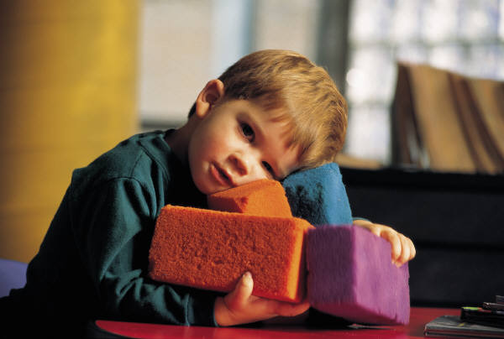
Place feedback, comments and suggestions in this column | Preschool Grade Level Expectations  What do students need to know and be able to do?  This column currently shows examples from Building Blocks. In the future, it will reflect benchmarks developed through standards revision process. | School Readiness Indicators  How do we know that a student can do it?
 | Counts and groups objects and numbers | - Matches, sorts, places in a series and regroups objects according to one characteristic  - Uses numbers and counting as a means for solving problems  - Predicts and measures quantity  - Uses one-to-one correspondence in counting objects and matching groups of objects  - Associates a number of objects with names and symbols for numbers  - Uses words such as more than, less than and add/subtract to express some number concepts
Place feedback, comments and suggestions in this column | Preschool Grade Level Expectations  What do students need to know and be able to do?  This column currently shows examples from Building Blocks. In the future, it will reflect benchmarks developed through standards revision process. | School Readiness Indicators  How do we know that a student can do it?
 | Recognizes and creates shapes and an awareness of position in space | - Describes and names common shapes found in the natural environment  - Understands the arrangement, order and position of objects that are on top of, next to, on the bottom, underneath, beside and in front of other objects  - Groups objects according to their shape and size
 | Recognizes and creates patterns, compares and measures time and quantity | - Groups a number of similar objects into simple categories  - Understands that events take place in the past, present or future  - Orders, compares or describes objects according to size, length, height and weight using standard or non-standard forms of measurement

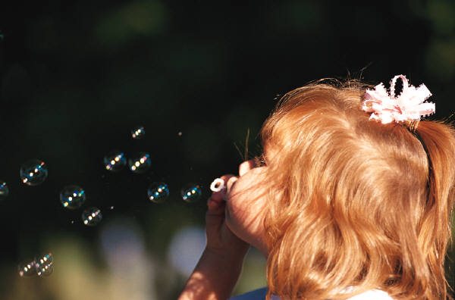
Place feedback, comments and suggestions in this column | Preschool Grade Level Expectations  What do students need to know and be able to do?  This column currently shows examples from Building Blocks. In the future, it will reflect benchmarks developed through standards revision process. | School Readiness Indicators  How do we know that a student can do it?
 | Demonstrates knowledge about the development of the natural and physical world | - Collects, describes and learns to record information through discussion, drawings and charts  - Uses tools and his/her senses to make observations, gather and record information and make predictions about what might happen  - Investigates changes in materials and cause-effect relationships  - Asks and pursues his/her questions through simple investigations
 | Uses scientific tools and methods to learn about the world | - Explores the natural processes of growing, changing and adapting to the environment  - Makes simple observations, predictions, explanations and generalizations based on real life experiences  - Explores time, temperature and cause-effect relationships based on everyday experiences
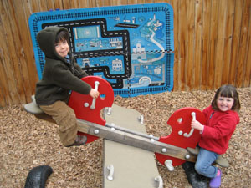

Place feedback, comments and suggestions in this column | Preschool Grade Level Expectations  What do students need to know and be able to do?  This column currently shows examples from Building Blocks. In the future, it will reflect benchmarks developed through standards revision process. | School Readiness Indicators  How do we know that a student can do it?
 | Demonstrates control, balance and coordination | - Demonstrates strength and stamina in movement activities  - Demonstrates body and space awareness to move and stop with control over speed and direction  - Demonstrates coordination and balance with a variety of playground equipment
 | Demonstrates hand-eye coordination, strength, control and ability to manipulate object | - Demonstrates strength to perform fine motor tasks  - Uses hand-eye coordination to perform fine motor tasks with a variety of manipulative materials  - Uses variety of tools for various learning activities
Place feedback, comments and suggestions in this column | Preschool Grade Level Expectations  What do students need to know and be able to do?  This column currently shows examples from Building Blocks. In the future, it will reflect benchmarks developed through standards revision process. | School Readiness Indicators  How do we know that a student can do it?
 | Understands how daily activity and healthy behavior promote overall personal health and safety | - Demonstrate safety awareness when purposefully using materials.  - Performs self-care skills independently when eating, dressing, toileting and washing hands  - Shows care for personal belongings  - Understands that some foods have nutritional value
 | Uses all their senses and understands how their senses work together | - Discriminates between a variety of sights, smells, sounds, textures and tastes  - Explores and learns to tolerate a wide variety of sensory input.  - Combines and uses different senses depending on the activity

Other comments:

