Education Data Advisory Committee Recommendation Form for the Repeal or Amendment of Statutory and Regulatory Data Reporting Requirements
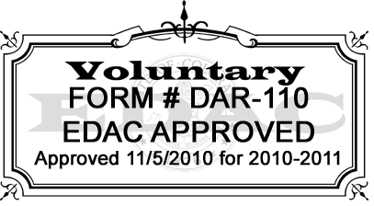
Justification: C.R.S. 22-2-304 (3) The EDAC shall annually, or more often if necessary make recommendations to the state board and the education committees of the senate and the house of representatives or any successor committees, for the repeal or amendment of statutory and regulatory data reporting requirements that the EDAC has identified as duplicative, obsolete or inefficient.

Date:
Name:
Title:
Unit:
Organization:
Address:
Phone:
Fax:
Specific Recommendations:

Recommendation: (Indicate One) |  | Delete  CRS Rule | Amend  CRS Rule | Other (Specify)
Reason: (Indicate One) |  | Duplicative | Obsolete | Inefficient
Data Collection(s) Impacted: (EDAC #)

Fields Affected:

Citation for statute or rule: (Provide language; Statute/Rule)

If an amendment, suggested language:

Explanation for recommended change:

Submit completed form to EDAC Secretary: Dennis St. Hilaire
201 East Colfax Avenue Suite 508
Denver, CO 80203
Phone: 303-866-6840
Fax: 303-866-6888
st.hilaire_d@cde.state.co.us

