
SCHOOL TRANSPORTATION VEHICLE ACCIDENT REPORT FORM
Colorado Department of Education – School Transportation Unit

The information provided on this School Transportation Vehicle Accident Report Form will be used to compile accurate, uniform, and reliable information about school vehicle (school bus, small vehicle, and multi-function bus) accidents so that problems and trends may be identified and needed safety programs can be developed.

Complete and mail this form within twenty (20) business days of the accident if it involved a school bus, small vehicle, or multi-function bus and:
- $2,500 or more of total property damage, or
- Personal injury (requiring treatment away from the scene), and/or fatality, to any involved vehicle occupant or pedestrian.

This form may be completed by a district designated person, the operator involved in the accident, or district supervisor. A district supervisor must review and sign the completed form. Enter only one response for each question.
* * * * * * * * * * * * * * * * * * * * * *
1. School District Name _________________________________________________________
2. Date of Accident 3. Day of week __ 4. Time __ ◻ AM ◻ PM
5. Vehicle Body Make ___ 6. School Bus Chassis Make ________________________
7. Vehicle Type: Small Vehicle ◻ School Bus - A ◻ B ◻ C ◻ D ◻ Multi-function Bus ◻
8. Model Year 9. Vehicle Capacity _____

10. Operator's Name ____________________

11. Was the Operator?
a. ◻ Route Operator
b. ◻ Activity Trip Operator

12. Operator’s Age:
a. ◻ 21-30 d. ◻ 51-60
b. ◻ 31-40 e. ◻ 61-70
c. ◻ 41-50 f. ◻ 71 +

13. Operator's Experience Driving School Vehicle:
a. ◻ Less than 1 year d. ◻ 10-14 Years
b. ◻ 1-4 Years e. ◻ 15-19 Years
c. ◻ 5-9 Years f. ◻ 20 + Years

14. In the last 3 years, how many school vehicle accidents has the operator had?
(do not include this accident) _________

15. School Vehicle Use at Time of Accident:
a. ◻ Route c. ◻ Field/Activity Trip
b. ◻ Other (Specify)

16. Total Number of Students:
a. In School Vehicle ____________
b. Waiting At Zone _____________

17. First Point of Impact (please circle appropriate letter)

A J H

B G

C D F
L - Underside
K - Roof

18. Type of Accident:
a. ◻ Between Vehicles e. ◻ Pedestrian
b. ◻ Fixed Object (complete #19) f. ◻ Animal
c. ◻ RR Crossing (with train) g. ◻ Other_______
d. ◻ Overturn (Specify)

19. Complete if Fixed Object Accident
(enter response which caused most damage):
a. ◻ Parked Vehicle g. ◻ Bridge Rail
b. ◻ Utility Pole h. ◻ Fence
c. ◻ Tree i. ◻ Curb or Wall
d. ◻ Culvert or Wall j. ◻ Median Barrier
e. ◻ Sign k. ◻ Embankment
f. ◻ Guardrail l. ◻ Other ______
(Specify)

20. Were Passengers Evacuated?
a. ◻ Yes b. ◻ No

21. Were Any Passengers Secured By?
a. ◻ Wheelchair e. ◻ Lapbelt
b. ◻ Safety Vest f. ◻ Car Seat
c. ◻ Other (Specify)
d. ◻ Not Secured

Loading/Unloading Zone Accident

22. Location of Accident:
a. ◻ On Route c. ◻ At School
b. ◻ Other (Specify)

23. Location Where Pupils Were Injured:
a. ◻ On Side of Road c. ◻ In Roadway
b. ◻ On Sidewalk d. ◻ Other _________
(Specify)

24. School Vehicle was:
a. ◻ Approaching Zone c. ◻ Stopped/Zone
b. ◻ Leaving Zone

25. Student(s) was:
a. ◻ Struck by School Vehicle
b. ◻ Struck by Other Vehicle

Did accident result in injuries (indicate number of):
 | In School Vehicle | While  Loading | While  Unloading | Other  Vehicle
Fatality | ^{26.} | ^{30.} | ^{34.} | ^{38.}
Serious Injury (Incapacitating) | ^{27.} | ^{31.} | ^{35.} | ^{39.}
Moderate (Non-incapacitating injury) | ^{28.} | ^{32.} | ^{36.} | ^{40.}
Minor Injury (Needing treatment away from scene) | ^{29.} | ^{33.} | ^{37.} | ^{41.}

School Vehicle Direction  Analysis: | Intersection | Non-intersection
a. Vehicle Going Straight | ^{42.} | ^{48.}
b. Vehicle Turning Right | ^{43.} | ^{49.}
c. Vehicle Turning Left | ^{44.} | ^{50.}
d. Vehicle Backing | ^{45.} | ^{51.}
e. Vehicle Stopped | ^{46.} | ^{52.}
f. Other Action ________  (Specify) | ^{47.} | ^{53.}

54. Lanes in Roadway:
a. ◻ 2 Lane
b. ◻ 4 Lane Divided
c. ◻ 4 Lane Undivided
d. ◻ Other (Specify)

55. Type of Road Surface:
a. ◻ Paved
b. ◻ Unpaved

56. Condition of Road:
a. ◻ Dry d. ◻ Icy
b. ◻ Wet e. ◻ Snow
c. ◻ Muddy f. ◻ Other _______ (Specify)

57. Road Surface Defect:
a. ◻ Holes or Ruts
b. ◻ Under Construction
c. ◻ Other (Specify)
d. ◻ No Defect

58. Light Condition:
a. ◻ Dawn c. ◻ Dark
b. ◻ Dusk d. ◻ Daylight

59. Weather Condition:
a. ◻ Clear e. ◻ Fog
b. ◻ Smog f. ◻ Sleet/Hail
c. ◻ Snow g. ◻ Rain
d. ◻ Dust h. ◻ Other ________
(Specify)

ACCIDENT DIAGRAM

Complete the following diagram showing direction and positions of vehicles involved. (If this diagram will not serve for the accident in question, attach separate sheet with illustration.)

Use solid line to show direction before accident and broken line after accident: →  ➔
Indicate school vehicle as number 1: → → → 1 and other vehicles as numbers 2, 3, etc.: → → → 2

INDICATE BY ARROW DIRECTION OF NORTH

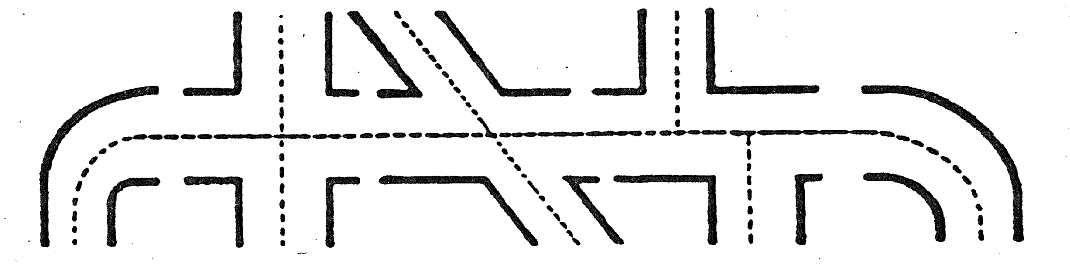

ACCIDENT DESCRIPTION (Required) (Attach separate sheet if necessary)(Please use complete sentences)

_________________________________________________________________________________

_________________________________________________________________________________

_________________________________________________________________________________

SIGNATURES

Person Completing Report ___________________

Reviewing District Supervisor ________________
SIGNATURE-Required
Date _________

MAIL COMPLETED FORM WITHIN 20 DAYS TO:

School Transportation Unit
Colorado Department of Education
201 East Colfax Avenue

Denver, CO 80203

STU-5 (9/09)

