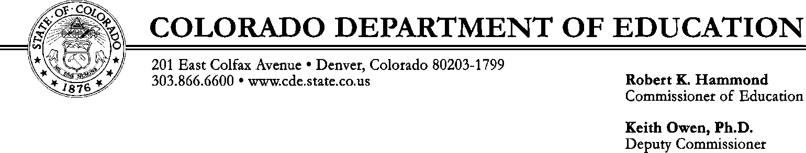
TO:
Food Service Director

FROM: Jennifer Otey, Office of School Nutrition

DATE: December 11, 2012

SUBJECT: 2013 Child Nutrition Programs State Matching Funds
_________________________________________________________________________________________

The Colorado General Assembly, in its 2001 regular session, passed legislation that affected Child Nutrition Programs. Section 35 of Senate Bill 01-129 amended the School Finance Act to include a new section, 22-54-123, National School Lunch Act, Appropriation of State Matching Funds. These matching funds respond to a federal statutory matching requirement. The amount of state funds authorized and appropriated for this purpose is statutorily set at $2,472,644. This represents the minimum level required to meet the federal matching requirement.

Payment in the amount of $ has been issued by CDE as your district’s share of the SY 2012-2013 Child Nutrition Programs State Matching Funds and is enclosed.

The distribution methodology and accounting requirements are as follows:

- Each participating district’s pro rata share of the state’s total number of reimbursable lunches served in the preceding school year is determined. This means that school year 2011-2012 meal totals are used to determine the distribution amount for 2012-2013.

- The pro rata share factor is applied to the total matching funds made available to determine each participating district’s share.

- Each participating district then receives a single lump sum payment each year.

- Although the payment is based upon a proration method using the prior year’s meal counts, the funds should be recognized as current school year (2012-2013) revenue.

- The payment will be identified as “SMCN – State Matching, Child Nutrition.” The funds must be deposited to the Food Service Fund (Fund 51), and the grant code must reflect grant code 3161, for proper tracking. It is not necessary to track expenditures with the grant code 3161 because these funds may be used for any allowable food service program costs. The statute is very specific in the requirement that these funds are to be used solely to benefit your Child Nutrition Program operations, and not for any other purposes.

- Furthermore, these funds are to be used to “supplement and not supplant” other funds.

If you have questions please contact me at 303.866.6450 or 888.245.6092 (outside the Denver metro area).

Enclosure

