Colorado Department of Education Office of School Nutrition
Online Claim System

SNP Site Claims

Point of Sale (POS) File Specifications

V1.0

September 12, 2012

State of Colorado  Department of Education  Child Nutrition Programs | 

Submitted by:


22420 N. 18th Drive
Phoenix, Arizona, 85027
623-209-1700

Table of Contents
1. Point of Sale (POS) Interface 3
1.1 Interface Characteristics 3
1.2 Constraints 4
1.3 Process Overview 4
1.4 File Layout 6
2. Accessing SNP Site Claim POS Option within SYSTEM 6

Point of Sale (POS) Interface
School Nutrition Program (SNP) site claim data may be either manually entered into THE ONLINE CLAIM SYSTEM via the SNP Claims module or imported via a file in a designated, pre-defined file format. Since some Sponsors maintain meal administrative systems that automatically capture point of sale (POS) data for meals served and generate reimbursement claims by site, THE ONLINE CLAIM SYSTEM provides the ability for authorized users to import a POS file in a defined file format. Once the file is imported into THE ONLINE CLAIM SYSTEM, claim validation and error checking will function in the same manner as if the site data was manually entered into THE ONLINE CLAIM SYSTEM and the user had selected the Save button.
This interface will accommodate non-Provision 2 and Provision 2 sites in a single data file.
This option is available only for the School Nutrition Program (SNP), which includes the following:
- National School Lunch Program (NSLP).
- School Breakfast Program (SBP).
- Afterschool Care Program (ASCP).
- Special Milk Program (SMP).

Interface Characteristics
The following table identifies the characteristics of this interface:
Table 1: POS Systems – Interface Characteristics
Category | Characteristic
Purpose of Interface(s) | To upload a Sponsor’s SNP site-level claim data
Type of Interface(s) | Batch
Initial Frequency Setting | On-demand initiated by Sponsor user
Interface Direction | Import into THE ONLINE CLAIM SYSTEM
Import Method | Via YYYY-YYYY SNP Claim Site List screen within the THE ONLINE CLAIM SYSTEM SNP Claims module (see Section 2)
Acceptable File Formats | ASCII Fixed Width per specification in this document
CO DOE Contact for Interface Development Questions | - Jennifer Otey  - Otey_J@cde.state.co.us
CO DOE Contact for Production Questions | - Jennifer Otey  - (303) 866-6450

Constraints
The import process relies on the creation of an interface file that is a fixed width ASCII text file and contains site-level claim reporting information from a Sponsor’s point of sale (POS) system. The file must be formatted according to the layout specified in the THE ONLINE CLAIM SYSTEM SNP POS File Layout specifications. Sponsors will need to develop a method of creating this file, which may require working with their POS vendor.

Process Overview
Creating the THE ONLINE CLAIM SYSTEM SNP Claims POS File
When a Sponsor is ready to import site claim data into THE ONLINE CLAIM SYSTEM for a specific month, they will initially execute an external process from their POS system to create the “import” file. This file can be saved on the Sponsor’s local computer hard drive, network directory, or in any location desired by the user. The name of the file is not relevant to THE ONLINE CLAIM SYSTEM; therefore, the Sponsor can choose their own naming standard for the file. It is recommended that the Sponsor includes the claim month (e.g., Sept2012) in the file name.
Importing the SNP Claims POS File into THE ONLINE CLAIM SYSTEM
Once the file is created, the user will log into THE ONLINE CLAIM SYSTEM to execute the import process. The interface process is initiated by a user with the appropriate ONLINE CLAIM SYSTEM security to load the file. The intent is for the Sponsor user to conduct the upload process using the SCN-granted ONLINE CLAIM SYSTEM security rights and access to the SNP Claims POS file.
To upload the file into THE ONLINE CLAIM SYSTEM, the Sponsor will click on a button on the ONLINE CLAIM SYSTEM SNP Claim Site List screen (see Section 2). THE ONLINE CLAIM SYSTEM will present the user with a “File Open” dialog box, and the user will navigate to and select the “import” file from the location where the user saved the file. After selecting the file, the user will click on an “import” link. THE ONLINE CLAIM SYSTEM will import the file and save the data. Uploaded files will be validated to ensure that Sponsors can only upload data for their sites.
Data Validation
After the file has been imported, THE ONLINE CLAIM SYSTEM will display a results screen so the user understands which, if any, records needs to be corrected. If there are errors in the data, the user can either correct them manually in THE ONLINE CLAIM SYSTEM or correct the errors in the POS system and re-upload the corrected file. The file can be uploaded as many times as the Sponsor would like; however, THE ONLINE CLAIM SYSTEM will overlay any existing data with new data. Repetitive uploads will always overlay existing data until the claim is paid. After the claim for the month being uploaded is paid, subsequent uploads for the same month will result in the creation of a revised claim.

File Layout
Appendix A defines the file format for the THE ONLINE CLAIM SYSTEM SNP Claims POS file. Please note the following:
- N = Numeric
Example: Numeric data that is represented with two digits and no decimal places will be shown in this document as N(2,0).
- C = Character
Example: Character data that fills a field that is 64 spaces wide will be shown in this document as C(64).
- Accessing SNP Site Claim POS Option within THE ONLINE CLAIM SYSTEM
The following screens identify the steps required to upload SNP site claims data.

Step 1: Access the SNP Claims Sub-module
Once an authorized user has logged into the SNP module, access to the claims component for SNP Claims is via “Claims” on the Menu Bar.

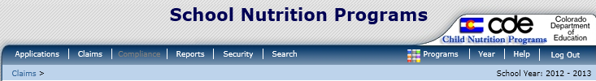

Step 2: Select “Claim – SNP”
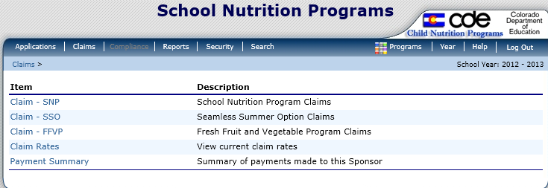

Step 3: On the SNP Claim Year Summary screen, select Claim Month for the file to be uploaded
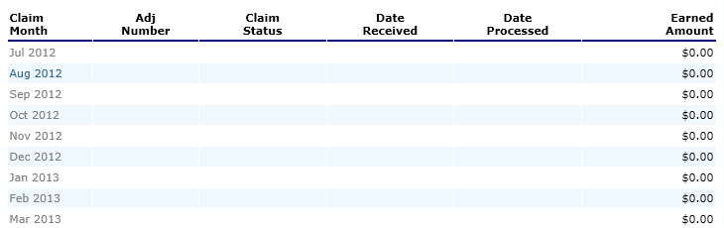

Step 4: On the SNP Claim Month Details screen, select the “Add Original Claim” button
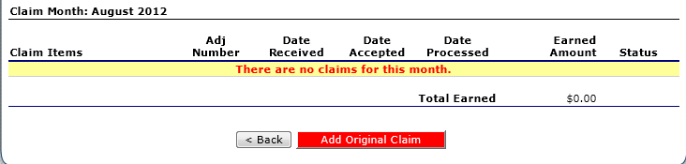
Step 5a: Select the “Upload Claim Data” button

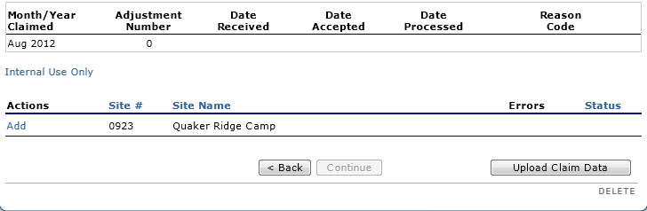

Step 5b: Select the POS claim file to be uploaded (use the Browse button to locate the file)
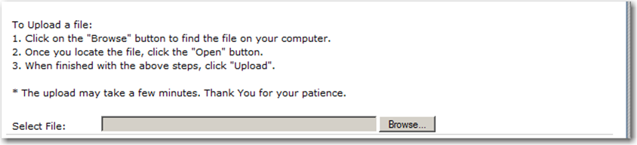

Step 5c: Select the “Upload” button
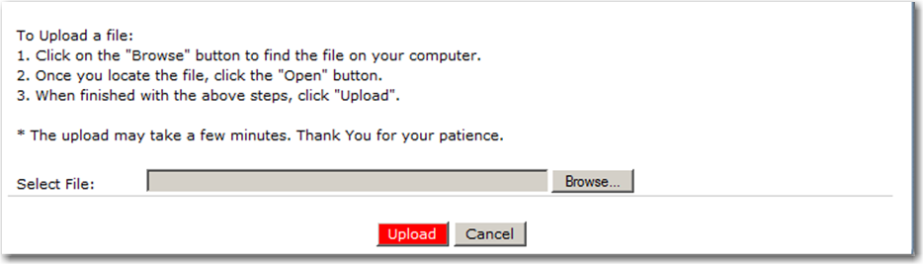

Appendix A

THE ONLINE CLAIM SYSTEM SNP Point of Sale (POS) File Format Specifications

Notes:
- Each row in the POS file is a site claim for a respective claim month; multiple sites (i.e., multiple records) are included in a single POS file.
- Fields related to each meal type are grouped and identified as follwos:
  - “L” fields = National School Lunch Program
  - “B” fields = School Breakfast Program (Regular)
  - “N” fields = School Breakfast Program (Severe Need)
  - “AN” fields = Afterschool Care Program (Non-Area Eligible)
  - “AE” fields = Afterschool Care Program (Area Eligible)
  - “M” fields = Special Milk
- If a site is claiming for a specific meal type (ex. Lunch), ensure that all related fields are completed correctly (e.g., “L” fields)
- A single POS file may contain regular sites as well as Provision 2 sites
- If you are entering data for a Provision 2 site, please read each field’s instructions carefully

Field Seq. | Position From | Position To | Description | Field Length | Field Type | Required Field? | Instructions
1 | 1 | 3 | Upload Form ID | 3 | N(3,0) | Y | Claim General Information  Insert value = “708” for every record
2 | 4 | 9 | Sequential Number | 6 | N(6,0) | Y | Claim General Information  Sequential Record Number (1, 2, 3, etc., so the sponsor can easily identify each site’s claim for this month…number may be determined by each sponsor)
3 | 10 | 17 | Process Date | 8 | N(8,0) | N | Claim General Information  Date the Sponsor exported the data from their system  Format: MMDDYYYY  NOTE: This data is not stored or used within THE ONLINE CLAIM SYSTEM; however, it may be useful to the Sponsor
4 | 18 | 81 | Sponsor Name | 64 | C(64) | Y | Claim General Information  Name of the Sponsor (as indicated within THE ONLINE CLAIM SYSTEM)
5 | 82 | 97 | Sponsor ID | 16 | C(16) | Y | Claim General Information  Unique five digit Sponsor ID that was system generated by THE ONLINE CLAIM SYSTEM—since all sponsors have a 4-digit code, use a leading 0; this MUST match the Sponsor ID defined within THE ONLINE CLAIM SYSTEM (e.g. 10281).
6 | 98 | 161 | Site Name | 64 | C(64) | Y | Claim General Information  Name of the Site (as indicated within THE ONLINE CLAIM SYSTEM).
7 | 162 | 177 | Site ID | 16 | C(16) | Y | Claim General Information  Unique four digit Site ID maintained within THE ONLINE CLAIM SYSTEM; this MUST match the Site ID defined within THE ONLINE CLAIM SYSTEM (e.g., 1005); if the ID is less than 4 digits, use leading 0s. Positions 174-177 should have digits filled in (0s if needed and the other numbers); positions 162-173 will need to be left blank.
8 | 178 | 179 | Claim Month | 2 | N(2,0) | Y | Claim General Information  The two-digit calendar month for which the claim is being submitted  Example: January = 01; February = 02, etc.
9 | 180 | 183 | Claim Year | 4 | N(4,0) | Y | Claim General Information  The four digit calendar year for which the claim is being submitted  Example: 2012
10 | 184 | 190 | G1 - Number of Children Approved for Free Meals | 7 | N(7,0) | N | SNP General Information  If site is not claiming Lunch or Breakfast for this claim month, leave blank  If site is participating in Lunch (L fields), Breakfast (B fields) or Severe Need Breakfast (N fields), enter number of children approved for free meals
11 | 191 | 197 | G2 - Number of Children Approved for Reduced Price Meals | 7 | N(7,0) | N | SNP General Information  If site is not claiming Lunch or Breakfast for this claim month, leave blank  If site is participating in Lunch (L fields), Breakfast (B fields) or Severe Need Breakfast (N fields), enter number of children approved for reduced price meals
12 | 198 | 204 | G3 - Number of Enrolled Children | 7 | N(7,0) | N | SNP General Information  If site is not claiming Lunch or Breakfast for this claim month, leave blank  If site is participating in Lunch (L fields), Breakfast (B fields) or Severe Need Breakfast (N fields), enter number of enrolled children
13 | 205 | 211 | L1 - Authorized Sites Participating | 7 | N(7,0) | N | Complete if participating in National School Lunch Program  If site is not claiming this program for this claim month, leave blank  If site is claiming Lunch for this claim month, enter “1”
14 | 212 | 218 | L2 - Total Monthly Attendance | 7 | N(7,0) | N | Complete if participating in National School Lunch Program  If site is not claiming this program for this claim month, leave blank  If site is claiming Lunch, enter total monthly attendance; it is recommended that this field be left blank
15 | 219 | 220 | L3 - Number Operating Days | 2 | N(2,0) | N | Complete if participating in National School Lunch Program  If site is not claiming this program for this claim month, leave blank  If site is claiming Lunch, enter number of operating days
16 | 221 | 227 | L4a - Free Reimbursable Lunches Served | 7 | N(7,0) | N | National School Lunch Program  If site is not claiming this program for this claim month, leave blank  If non-Provision 2 site, enter number of free reimbursable lunches served  If Provision 2 site, leave blank
17 | 228 | 234 | L4b - Reduced Price Reimbursable Lunches Served | 7 | N(7,0) | N | National School Lunch Program  If site is not claiming this program for this claim month, leave blank  If non-Provision 2 site, enter number of reduced price reimbursable lunches served  If Provision 2 site, leave blank
18 | 235 | 241 | L4c - Paid Reimbursable Lunches Served | 7 | N(7,0) | N | National School Lunch Program  If site is not claiming this program for this claim month, leave blank  If non-Provision 2 site, enter number of paid reimbursable lunches served  If Provision 2 site, leave blank
19 | 242 | 248 | L4d- Total Lunches Served (a + b + c) | 7 | N(7,0) | N | National School Lunch Program  If site is not claiming this program for this claim month, leave blank  Enter total lunches served
20 | 249 | 255 | B1 - Authorized Sites Participating | 7 | N(7,0) | N | Complete if participating in School Breakfast Program (Regular Reimbursement)  If site is not claiming this program for this claim month, leave blank  If site is claiming Regular Breakfast for this claim month, enter “1”
21 | 256 | 262 | B2 - Total Monthly Attendance | 7 | N(7,0) | N | Complete if participating in School Breakfast Program (Regular Reimbursement)  If site is not claiming this program for this claim month, leave blank  If site is claiming Regular Breakfast, enter total monthly attendance; it is recommended that this field be left blank
22 | 263 | 264 | B3 - Number Operating Days | 2 | N(2,0) | N | Complete if participating in School Breakfast Program (Regular Reimbursement)  If site is not claiming this program for this claim month, leave blank  If site is claiming Regular Breakfast, enter number of operating days
23 | 265 | 271 | B4a - Free Reimbursable Breakfasts Served | 7 | N(7,0) | N | School Breakfast Program (Regular Reimbursement)  If site is not claiming this program for this claim month, leave blank  If non-Provision 2 site, enter number of free reimbursable breakfasts served  If Provision 2 site, leave blank
24 | 272 | 278 | B4b - Reduced Price Reimbursable Breakfasts Served | 7 | N(7,0) | N | School Breakfast Program (Regular Reimbursement)  If site is not claiming this program for this claim month, leave blank  If non-Provision 2 site, enter number of reduced price reimbursable breakfasts served  If Provision 2 site, leave blank
25 | 279 | 285 | B4c - Paid Reimbursable Breakfasts Served | 7 | N(7,0) | N | School Breakfast Program (Regular Reimbursement)  If site is not claiming this program for this claim month, leave blank  If non-Provision 2 site, enter number of paid reimbursable breakfasts served  If Provision 2 site, leave blank
26 | 286 | 292 | B4d - Total Reimbursable Breakfasts Served | 7 | N(7,0) | N | School Breakfast Program (Regular Reimbursement)  If site is not claiming this program for this claim month, leave blank  Enter total regular breakfasts served
27 | 293 | 299 | N1 - Authorized Sites Participating | 7 | N(7,0) | N | Complete if participating in School Breakfast Program (Severe Need Reimbursement)  If site is not claiming this program for this claim month, leave blank  If site is claiming Severe Need Breakfast for this claim month, enter “1”
28 | 300 | 306 | N2 - Total Monthly Attendance | 7 | N(7,0) | N | Complete if participating in School Breakfast Program (Severe Need Reimbursement)  If site is not claiming this program for this claim month, leave blank  If site is claiming Severe Need Breakfast, enter total monthly attendance; it is recommended that this field be left blank
29 | 307 | 308 | N3 - Number Operating Days | 2 | N(2,0) | N | Complete if participating in School Breakfast Program (Severe Need Reimbursement)  If site is not claiming this program for this claim month, leave blank  If site is claiming Severe Need Breakfast, enter number of operating days
30 | 309 | 315 | N4a - Free Reimbursable Breakfasts Served | 7 | N(7,0) | N | School Breakfast Program (Severe Need Reimbursement)  If site is not claiming this program for this claim month, leave blank  If non-Provision 2 site, enter number of free reimbursable breakfasts served  If Provision 2 site, leave blank
31 | 316 | 322 | N4b - Reduced Price Reimbursable Breakfasts Served | 7 | N(7,0) | N | School Breakfast Program (Severe Need Reimbursement)  If site is not claiming this program for this claim month, leave blank  If non-Provision 2 site, enter number of reduced price reimbursable breakfasts served  If Provision 2 site, leave blank
32 | 323 | 329 | N4c - Paid Reimbursable Breakfasts Served | 7 | N(7,0) | N | School Breakfast Program (Severe Need Reimbursement)  If site is not claiming this program for this claim month, leave blank  If non-Provision 2 site, enter number of paid reimbursable breakfasts served  If Provision 2 site, leave blank
33 | 330 | 336 | N4d - Total Reimbursable Breakfasts Served | 7 | N(7,0) | N | School Breakfast Program (Severe Need Reimbursement)  If site is not claiming this program for this claim month, leave blank  Enter total severe need breakfasts served
34 | 337 | 343 | AN1 - Number of Children Approved for Free Snacks (Non-Area Eligible) | 7 | N(7,0) | N | Afterschool Care Program (Non Area Eligible)  If site is not claiming this program for this claim month, leave blank  Enter Number of Children Approved for Free Snacks (Non-Area Eligible)
35 | 344 | 350 | AN2 - Number of Children Approved for Reduced Snacks (Non-Area Eligible) | 7 | N(7,0) | N | Afterschool Care Program (Non Area Eligible)  If site is not claiming this program for this claim month, leave blank  Enter Number of Children Approved for Reduced Snacks (Non-Area Eligible)
36 | 351 | 357 | AN3 - Number of Enrolled Children (Non-Area Eligible) | 7 | N(7,0) | N | Afterschool Care Program (Non Area Eligible)  If site is not claiming this program for this claim month, leave blank  Enter Number of Enrolled Children (Non-Area Eligible)
37 | 358 | 364 | AN4 - Authorized Sites Participating (Non-Area Eligible) | 7 | N(7,0) | N | Afterschool Care Program (Non Area Eligible)  If site is not claiming this program for this claim month, leave blank  If site is claiming for this program for this claim month, enter “1”
38 | 365 | 371 | AN5 - Total Monthly Attendance (Non-Area Eligible) | 7 | N(7,0) | N | Afterschool Care Program (Non Area Eligible)  If site is not claiming this program for this claim month, leave blank  Enter Total Monthly Attendance (Non-Area Eligible) ; it is recommended that this field be left blank
39 | 372 | 373 | AN6 - Number Operating Days (Non-Area Eligible) | 2 | N(2,0) | N | Afterschool Care Program (Non Area Eligible)  If site is not claiming this program for this claim month, leave blank
40 | 374 | 380 | AN7a - Free Snacks Served (Non-Area Eligible) | 7 | N(7,0) | N | Afterschool Care Program (Non Area Eligible)  If site is not claiming this program for this claim month, leave blank  Enter number of Free Snacks Served (Non-Area Eligible)
41 | 381 | 387 | AN7b - Reduced Snacks Served (Non-Area Eligible) | 7 | N(7,0) | N | Afterschool Care Program (Non Area Eligible)  If site is not claiming this program for this claim month, leave blank  Enter number of Reduced Snacks Served (Non-Area Eligible)
42 | 388 | 394 | AN7c - Paid Snacks Served (Non-Area Eligible) | 7 | N(7,0) | N | Afterschool Care Program (Non Area Eligible)  If site is not claiming this program for this claim month, leave blank  Enter number of Paid Snacks Served (Non-Area Eligible)
43 | 395 | 401 | AN7d - Total Snacks Served (Non-Area Eligible) | 7 | N(7,0) | N | Afterschool Care Program (Non Area Eligible)  If site is not claiming this program for this claim month, leave blank  Enter number of Total Snacks Served (Non-Area Eligible)
44 | 402 | 408 | AE1 - Number of Children Approved for Free Snacks (Area Eligible) | 7 | N(7,0) | N | Afterschool Care Program (Area Eligible)  If site is not claiming this program for this claim month, leave blank  Enter number of Children Approved for Free Snacks (Area Eligible)
45 | 409 | 415 | AE3 - Number of Enrolled Children (Area Eligible) | 7 | N(7,0) | N | Afterschool Care Program (Area Eligible)  If site is not claiming this program for this claim month, leave blank.  Enter value in AE1
46 | 416 | 422 | AE4 - Authorized Sites Participating (Area Eligible) | 7 | N(7,0) | N | Afterschool Care Program (Area Eligible)  If site is not claiming this program for this claim month, leave blank  If site is claiming for this program for this claim month, enter “1”
47 | 423 | 429 | AE5 - Total Monthly Attendance (Area Eligible) | 7 | N(7,0) | N | Afterschool Care Program (Area Eligible)  If site is not claiming this program for this claim month, leave blank  Enter Total Monthly Attendance (Area Eligible); it is recommended that this field be left blank
48 | 430 | 431 | AE6 - Number Operating Days (Area Eligible) | 2 | N(2,0) | N | Afterschool Care Program (Area Eligible)  If site is not claiming this program for this claim month, leave blank  Enter Number Operating Days (Area Eligible)
49 | 432 | 438 | AE7a - Free Snacks Served (Area Eligible) | 7 | N(7,0) | N | Afterschool Care Program (Area Eligible)  If site is not claiming this program for this claim month, leave blank  Enter number of Free Snacks Served (Area Eligible)
50 | 439 | 445 | AE7d - Total Snacks Served (Area Eligible) | 7 | N(7,0) | N | Afterschool Care Program (Area Eligible)  If site is not claiming this program for this claim month, leave blank  Enter value in AE7a
51 | 446 | 452 | M1 - Number of Fluid Milk 1/2 Pints Purchased | 7 | N(7,0) | N | Special Milk Program  If site is not claiming this program for this claim month, leave blank
52 | 453 | 459 | M2 - Total Cost of Fluid Milk Purchased This Month | 7 | N(7,2) | N | Special Milk Program  If site is not claiming this program for this claim month, leave blank  If site is claiming for this month, the total cost must include a decimal point
53 | 460 | 466 | M3 - Authorized Sites Participating | 7 | N(7,0) | N | Special Milk Program  If site is not claiming this program for this claim month, leave blank  If site is claiming for this program for this claim month, enter “1”
54 | 467 | 473 | M4 - Total Monthly Attendance | 7 | N(7,0) | N | Special Milk Program  If site is not claiming this program for this claim month, leave blank  Enter Total Monthly Attendance; it is recommended that this field be left blank
55 | 474 | 475 | M5 - Number Operating Days | 2 | N(2,0) | N | Special Milk Program  If site is not claiming this program for this claim month, leave blank  Enter total Number Operating Days
56 | 476 | 482 | M6a - Free Milk Served | 7 | N(7,0) | N | Special Milk Program  If site is not claiming this program for this claim month, leave blank  Enter number of Free Milk Served
57 | 483 | 489 | M6b - Paid Milk Served | 7 | N(7,0) | N | Special Milk Program  If site is not claiming this program for this claim month, leave blank  Enter number of Paid Milk Served
58 | 490 | 496 | M6c - Total Milk Served | 7 | N(7,0) | N | Special Milk Program  If site is not claiming this program for this claim month, leave blank  Enter sum of M6a+M6b
59 | 497 | 504 | Provision Type - Lunch | 8 | C(8) | N | If the site does NOT participate in a provisional program for Lunch, leave blank  If the site participates in Provision 2 for Lunch, enter “PROV2”  If the site participates in CEO for Lunch, enter “CEO”
60 | 505 | 512 | Provision Type – Breakfast | 8 | C(8) | N | If the site does NOT participate in a provisional program for Breakfast, leave blank  If the site participates in Provision 2 for Breakfast, enter “PROV2”  If the site participates in CEO for Breakfast, enter “CEO”
61 | 513 | 519 | P1 - Number of participants Approved for Reduced-Price Meals | 7 | N(7,0) | N | PK-2 Reduced Lunch Information  If site is not claiming this program for this claim month, leave blank  If site participating in PK-2, enter number of children approved for reduced price PK-2 meals
62 | 520 | 526 | P2 – Number of PK-2 Reduced-Price Meals Served | 7 | N(7,0) | N | PK-2 Reduced Lunch Information  If site is not claiming this program for this claim month, leave blank  Enter number of Reduced Lunches Served (PK-2)

