CN13-G-005

TO: Child Nutrition Directors and Main Nutrition Contacts

FROM: Jane C. Brand, RD, SNS, Director, Office of School Nutrition

DATE: October 10, 2012

SUBJECT: Food Safety Inspection Reporting – SY 2011-2012
_________________________________________________________________________

Section 9(h) of the National School Lunch Act requires each State Agency (SA) to monitor and report to the Secretary of Agriculture the number of food safety inspections obtained by sponsors that participate in the National School Lunch Program (NSLP) and/or School Breakfast Program (SBP).

To fulfill this requirement, you must report information on the total number of food safety inspections conducted in food preparation and/or service areas in schools under your jurisdiction during 2011-2012. (Note that while this report is completed in 2012, it is based on data from the prior school year.) By November 1, 2012, you must then submit to the Office of School Nutrition a yearly compilation of information indicating the following:

• The number of schools that had zero health inspections during the school year covered by the report. Include a brief explanation for the reason for not meeting the inspections requirement of at least two inspections.

• The number of schools that had one health inspection during the school year covered by the report. Include a brief explanation for the reason for not meeting the inspections requirement of at least two inspections.

• The number of schools that had two health inspections during the school year covered by the report.

• The number of schools that had more than two health inspections during the school year covered by the report.

For accuracy, do not report the same schools under more than one category.

This year, the data collection will take place via the online claim system. Therefore, while any district employee may collect the information, it will need to be submitted by one of the staff within the district who has authorized access to the claim system (each district may have up to two users). To add a second user or to change a user, please email Jennifer Otey at otey_j@cde.state.co.us.

Please refer to the information on the following page for instructions on how to enter the data in the claim system.

Remember, this is a mandatory report, which must be completed by November 1, 2012.

If you have any questions, please contact Stacey Macklin at macklin_s@cde.state.co.us or 303-866-6661, as she will be overseeing most of this process.

cc: Claim system users

Attachment

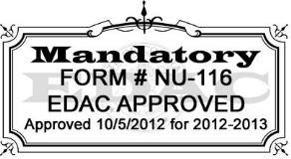
Food Safety Inspection Reporting Instructions

Authorized users will access the online claim system at http://www.cde.state.co.us/cdenutritran/nutriprogramrenewal.htm (the link is highlighted in yellow).

After logging in, the following screen will display. Click on Applications in the upper left hand corner:
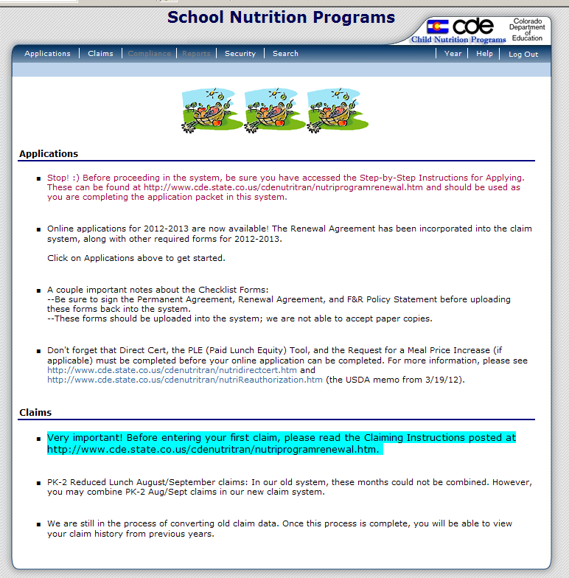

Next, click on Food Safety Inspections:

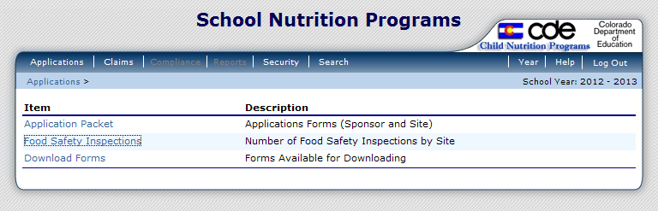
School Year 2011-2012 will display. Click on Modify:

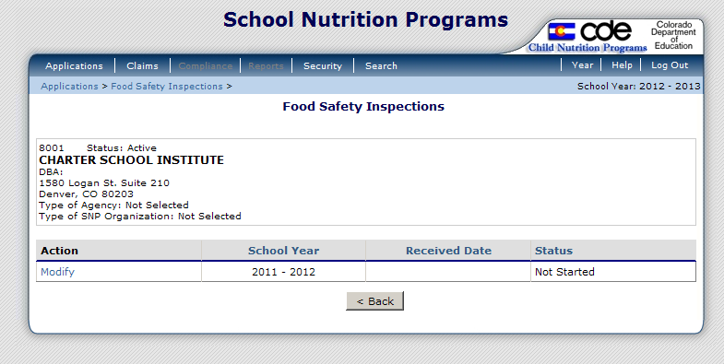

A list of the schools in the SFA will appear. Next to each school, click on the drop down to indicate the number of inspections obtained in 2011-2012. If reporting 0 or 1, click on the drop down in the next box to indicate the reason the federal requirement was not met. If needed, you may provide more information in the “Reason” box below.

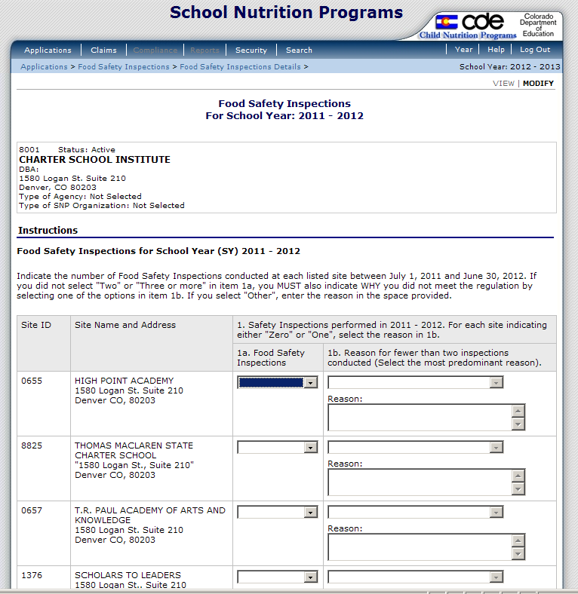

At the bottom of the screen, the Food Safety Inspection Summary will provide a total of how many schools obtained none, one, two, and three or more inspections. It will also provide a total of each reason that the number of inspections was not met.
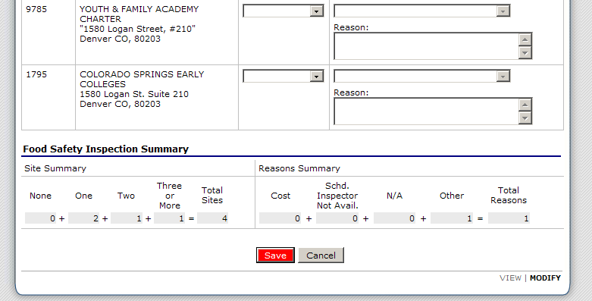
When you have filled in all of your information on the form, click on Save at the bottom of the screen.

This screen will then appear. Click on Finish.
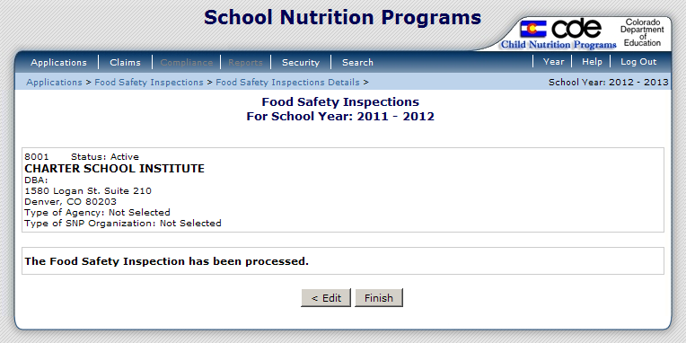

This is the final screen that will display:

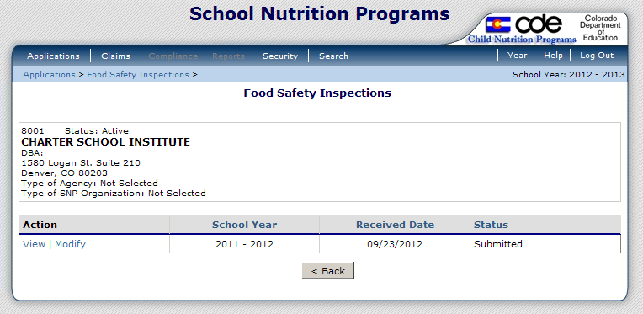

If you need to make any changes, you can go to Modify on this screen above, or if you have already logged out of the system and need to make changes, you can always return to the report by logging into the system, selecting Applications, and then selecting Food Safety Inspections again. This final screen will appear, again allowing you to make any needed modifications.

Once you have submitted your data, our office will contact you if we have any questions. As a reminder, this federal report is required, and it is due by Thursday November 1, 2012.

For questions, please contact Stacey Macklin at macklin_s@cde.state.co.us or 303-866-6661.

