12/20/12

Thursday Update

Dear Districts,

**Directors’ Conference**

Registration is now open for the annual Directors’ Conference at the Cheyenne Mountain Resort in Colorado Springs, February 20-22, 2013! District directors, menu planners, and small district cooks/managers are all encouraged to attend. A tentative agenda with meeting topics and registration details is on our website at:<http://www.cde.state.co.us/cdenutritran/nutridirectorsconference.htm>.

* **Registration Deadline: February 11**
* **Deadline for room reservations: January 30, 5:00 p.m.**

**Verification**

Thank you to everyone who completed the Verification Selection Worksheet. Just a heads up that the Verification Results Worksheet will be sent out to all Free & Reduced contacts in early January. It will be due 1 February.

**Claim System Reminder**

Thank you to everyone who has submitted the October claim. If you have not submitted this yet, don’t forget that the deadline is 30 December.

**Updated Food Buying Guide**

The Food Buying Guide was recently updated with revised Milk and Meat/Meat Alternate charts. This information can be obtained on our website at <http://www.cde.state.co.us/cdenutritran/nutritrainingsNewMealPatterns.htm> under Additional Resources.

**Certified!**

Congratulations to the following SFAs that were certified this week for the additional 6 cents: Alamosa, Durango, Woodland Park, Eaton, Cheyenne Mountain, Boulder Valley, and Weld County 5. Nice work!

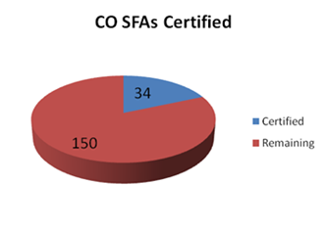

Thank you, and Happy Holidays!

**Jennifer**

**Jennifer Otey**, Senior Consultant | Office of School Nutrition | Colorado Department of Education | 1580 Logan St. #760, Denver, CO 80203 | 303-866-6450 | Fax-303-866-6133 | <http://www.cde.state.co.us/index_nutrition.htm>

~Thursday Updates (TU) are brought to you by the CDE Office of School Nutrition (OSN) & are provided to

Main Nutrition Contacts, F&R Contacts, Certification Contacts, Claim System Users, & our additional TU List.~

If today’s TU contains information pertinent to a different staff person in your district, please forward this information to that person. | To access the TU archives, click [here](http://www.cde.state.co.us/cdenutritran/nutriEmails.htm).