1/31/13

Thursday Update

Dear Districts,

**2013 Directors’ Conference**

Just a reminder that registration is open for the annual Directors’ Conference at the Cheyenne Mountain Resort in Colorado Springs, February 20-22, 2013! District directors, menu planners, and small district cooks/managers are all encouraged to attend. A tentative agenda with meeting topics and registration details is on our website at:<http://www.cde.state.co.us/cdenutritran/nutridirectorsconference.htm>.

* **Registration Deadline: February 11**
* **Deadline for room reservations: was January 30, 5:00 p.m.; you can always get another room nearby!**

**Direct Certification**

Attention all Direct Cert users! The third and final required upload timeframe for SY12-13 will begin on or after Tuesday 19 February. We will keep you updated when the new SNAP file is received and when the system is ready for the third upload period. SFAs will have one month from the time the system opens to complete the third upload.

**Norovirus**

The OSN recently received information from NFSMI (National Food Service Management Institute) regarding Norovirus and opportunities concerning related training. Please see the attached document, and contact Beverly Cross, [bcross@olemiss.edu](mailto:bcross@olemiss.edu), if you would like to request a training.

**Certified!**

Congratulations to the following SFAs that were certified for compliance with the new meal patterns this past week: Jefferson County, Pueblo City, Charter School Institute, Adams 12, Brighton 27J, Adams-Arapahoe, St. Vrain, Pueblo 70, Julesburg, Dolores RE 2J, Edison, East Grand, Stratton, RE-1 Valley (Sterling), Fort Morgan RE-3, and Weldon Valley! Way to go!

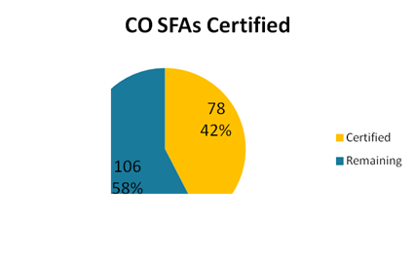

Thank you,

**Jennifer**

**Jennifer Otey**, Senior Consultant | Office of School Nutrition | Colorado Department of Education | 1580 Logan St. #760, Denver, CO 80203 | 303-866-6450 | Fax-303-866-6133 | <http://www.cde.state.co.us/index_nutrition.htm>

~Thursday Updates (TU) are brought to you by the CDE Office of School Nutrition (OSN) & are provided to

Main Nutrition Contacts, F&R Contacts, Certification Contacts, Claim System Users, & our additional TU List.~

If today’s TU contains information pertinent to a different staff person in your district, please forward this information to that person. | To access the TU archives, click [here](http://www.cde.state.co.us/cdenutritran/nutriEmails.htm).