1/16/13

Thursday Update (a few hours early)

Dear Districts,

**Verification Results Worksheet (VRW)**

Thank you to everyone who has submitted the VRW. If you have not yet completed it, this is just a reminder that the report is due by Friday 1 February. Please submit it early if possible, to allow time for any needed corrections to be made before the due date.

**ACSN**

Take action and be sure to visit our Advisory Council for School Nutrition (ACSN) website at <http://www.cde.state.co.us/cdenutritran/nutriSNAC.htm>. There have been several updates since this site launched last year, including the posting of best practices and meeting minutes. Also, the site provides a helpful list of your regional representatives. Hopefully you have been—and will be—in touch with your council representative as he/she seeks to advise the OSN and serves as a resource for the SFAs in his/her region. ACSN is incredibly important as the OSN and Colorado’s SFAs work together in implementing the Child Nutrition Programs.

**USDA Memo about Processed Product Documentation**

This week USDA reissued a memo (with updated references and web links) regarding issues related to processed product documentation, guidance on using product literature to make purchasing decisions, and guidance on reviewing product formulation statements. We have posted this memo at: <http://www.cde.state.co.us/cdenutritran/nutriUSDA-memos.htm>.

**Certified!**

Congratulations to the following SFAs that have been certified in the past couple of weeks for compliance with the new meal patterns: Colorado Springs D-11, Hi-Plains, Sheridan, Littleton, Douglas County, La Veta, East Otero, and Rocky Ford. Thank you for your hard work!

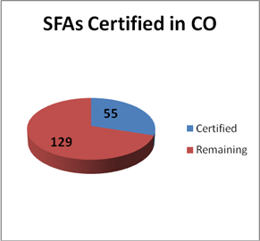

Thank you,

**Jennifer**

**Jennifer Otey**, Senior Consultant | Office of School Nutrition | Colorado Department of Education | 1580 Logan St. #760, Denver, CO 80203 | 303-866-6450 | Fax-303-866-6133 | <http://www.cde.state.co.us/index_nutrition.htm>

~Thursday Updates (TU) are brought to you by the CDE Office of School Nutrition (OSN) & are provided to

Main Nutrition Contacts, F&R Contacts, Certification Contacts, Claim System Users, & our additional TU List.~

If today’s TU contains information pertinent to a different staff person in your district, please forward this information to that person. | To access the TU archives, click [here](http://www.cde.state.co.us/cdenutritran/nutriEmails.htm).