1/3/13

Thursday Update

Dear Districts,

Happy New Year! We hope you have a fabulous 2013!

**OSN Staff Announcement from Jane Brand**

I am pleased to announce that the OSN has hired Lyza Brackett for the position of Review and Fiscal Manager! Lyza comes to us from Chartwells Food Service Management Company, where she has worked since 2004, first as food service director and then as district manager. Lyza has a Master of Science in Dietetics, and she will be starting with the OSN next Monday 7 January. Please join me in welcoming her to our team!

**Verification Results Worksheet**

The Verification Results Worksheet (VRW) is being emailed to all F&R Contacts today. This is the second and final reporting piece for the Verification process. The VRW is due by Friday 1 February.

**2013 Directors’ Conference**

Just a reminder that registration is open for the annual Directors’ Conference at the Cheyenne Mountain Resort in Colorado Springs, February 20-22, 2013! District directors, menu planners, and small district cooks/managers are all encouraged to attend. A tentative agenda with meeting topics and registration details is on our website at:<http://www.cde.state.co.us/cdenutritran/nutridirectorsconference.htm>.

* **Registration Deadline: February 11**
* **Deadline for room reservations: January 30, 5:00 p.m.**

**Certification Regional Trainings Reminder**

To assist districts in completing their Certification materials, don’t forget that the OSN has scheduled several regional trainings in January and February. Please see <http://www.cde.state.co.us/cdenutritran/nutriCertification.htm> for complete locations, dates, and details. To register, contact Stacey Macklin at [macklin_s@cde.state.co.us](mailto:macklin_s@cde.state.co.us) or 303-866-6661. Please note that the Lamar and Byers trainings are full (there is a waitlist option), and two spots have opened up in the previously full Grand Junction training, if anyone is interested.

**Posters for Identifying Reimbursable Meals**

The OSN still has some laminated dry erase posters on which SFAs can identify the daily reimbursable meal. Also, we now have these posters translated into Spanish. If you would like any (more) of these, please contact Stacey Macklin at [macklin_s@cde.state.co.us](mailto:macklin_s@cde.state.co.us) to let her know how many you will need.

**Certified!**

Congratulations to the following SFAs that were certified for the additional 6 cents over the past couple of weeks: North Park, Englewood, Academy, Holyoke, Haxtun, Lamar, Walsh, Burlington, Platte Canyon, Silverton (which just recently joined the NSLP!), Bromley East, Custer County, and DeBeque. Well done!

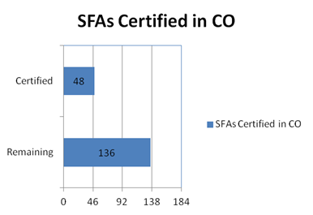

Thank you,

**Jennifer**

**Jennifer Otey**, Senior Consultant | Office of School Nutrition | Colorado Department of Education | 1580 Logan St. #760, Denver, CO 80203 | 303-866-6450 | Fax-303-866-6133 | <http://www.cde.state.co.us/index_nutrition.htm>

~Thursday Updates (TU) are brought to you by the CDE Office of School Nutrition (OSN) & are provided to

Main Nutrition Contacts, F&R Contacts, Certification Contacts, Claim System Users, & our additional TU List.~

If today’s TU contains information pertinent to a different staff person in your district, please forward this information to that person. | To access the TU archives, click [here](http://www.cde.state.co.us/cdenutritran/nutriEmails.htm).