Instructor: |  | Course:
Unit: Instructional Unit on Research Projects |  |  | Quarter:
Topic: Avoiding Plagiarism and Citing Sources |  |  | Time Range: 45 minutes
Standard(s):
# 2,3,4
- Reading for All Purposes
- Writing and Composition
- Research and Reasoning
21st Century skills:
Critical thinking and Problem Solving; Information Literacy; Collaboration; Self Direction; School Readiness and/or Post Secondary and Workforce Readiness; Relevance and Application; Communication
Objectives / Assessment Frameworks:
- Students must understand the importance of giving credit to authors/writers for their words and ideas.
- Plagiarism is stealing and it is unethical. Students need to know there are many forms of plagiarism.
- It is better to learn from the start how to avoid plagiarism. Before taking notes, a student must know the importance of citing every piece of information borrowed unless it is common knowledge.

Prerequisite Learning: in order to effectively master the objectives listed above, students must exhibit mastery in the following areas…
Students should be given examples of what might be considered “common knowledge” to avoid plagiarism. Examples are attached with this lesson.
Common Knowledge
(taken from: http://library.csusm.edu/plagiarism/howtoavoid/how_avoid_common.htm)
There is no clear boundary on what is considered common knowledge. Even experts on plagiarism disagree on what counts as common knowledge. For instance, many sources only consider facts — current and historical events, famous people, geographic areas, etc. — to be potentially common knowledge. Others also include nonfactual material such as folklore and common sayings. Some sources limit common knowledge to only information known by others in your class, other sources look at what is common knowledge for the broader subject area.
The two criteria that are most commonly used in deciding whether or not something is common knowledge relate to quantity: the fact can be found in numerous places and ubiquity: it is likely to be known by a lot of people. Ideally both conditions are true. A third criteria that is sometimes used is whether the information can be easily found in a general reference source.

Lesson Outline: (think about the following elements: instructional strategies, depth of knowledge, materials, resources, student engagement, mastery, closure)
Materials needed:
- Students need to bring in at least one print source to complete this lesson.
- A classroom set (one card per student) of cards with the word “odd” or “even” on them; or a deck of cards because both odd and even numbers are included.
- As students begin to read the sources they have gathered for their research paper or project, it is important they have an organized method for keeping track of the information and sources. This is extremely important because the reading and notes are what help the students write and create their papers or projects.
- Discuss the importance of giving credit to authors/writers’ words and ideas.
- According to Write Source, there are many ways to plagiarize:
- Using someone else’s paper -- this could be another student’s work or an essay bought from the internet. If you turn this in as your work, it is stealing and considered plagiarism.
- Using the copy and paste method – It is stealing to copy phrases, sentences, or entire sections from a source and paste it into your paper.
- Forgetting or “neglecting” to use quotation marks when you use the exact words from a source (419) – You must use quotation marks for exact words and identify which source was used in a citation.
- Use paraphrasing without citing the source -- Even when you restate ideas in your own words, you still need to give credit to the source it came from, so you must give credit.
- Confusing your ideas with the ideas you read or borrowed -- It is imperative when taking notes to always keep track of your information, knowing from what page and what source each piece of information came from.
- The Write Source also discusses other mistakes that a writer should be wary of making such as overusing or relying on one source instead of using several sources. A paper or project should be mainly your own words supported by outside sources (419). More about this will be shared in a later lesson.
- To avoid plagiarism, the student must cite in his/her paper or project every piece of information borrowed. Learning to use in-text citations, also called parenthetical references, and/or footnotes are helpful in showing proof of where words and ideas come from that are used in your research. Explain what a parenthetical reference is and a footnote.
- In-text citations (parenthetical references) refer to the entries on a “Works Cited” page at the end of an MLA paper or the “References” page at the end of the APA paper.
- After using words or ideas from a source, the student should create an in-text citation (parenthetical reference). When an in-text citation (parenthetical reference) is needed, use parentheses to insert the author’s last name and page number; if author’s name is not available, use the title and page number. This is one of the easiest ways to give credit for an idea or quote from a source.
- When no author is available and a title needs to be used, use only the first word or words by which the Works Cited entry is alphabetized.
- When a student paraphrases or uses direct quotes, one way a student can identify the source is to use phrases like: According to a biography of John Wayne written by Sean Smith, . . . (426).
In MLA, notice how the parenthetical citation is at the end of the sentence and before the end punctuation. However, in APA use (p. 426). or (pp. 423-26).
- Following, is an example of an in-text (parenthetical reference) taken from: http://www.mshill.net/graphics/longquote.gif
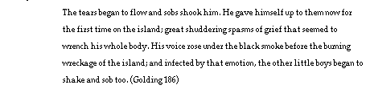

More guidance will be needed once the student starts to write.
- Footnotes may contain an explanation and source used. Maybe a paragraph was written about John Wayne.¹ In this case a small number is typed at the end of a sentence and the footnote will appear at the bottom of the page which will contain the source information and page number, if available. (e.g. ¹ My idea about John Wayne came when watching the movie True Grit.)

Another example of a footnote:
Taken from: http://turnitin.com/research_site/images/footnote_example.gif

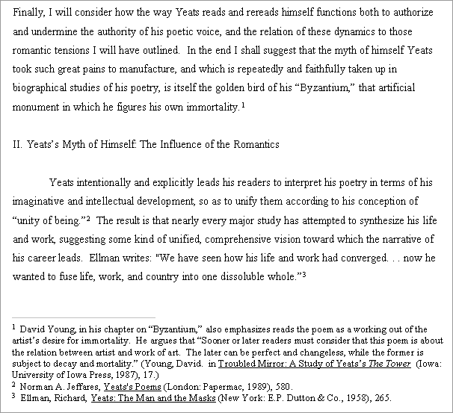

The student would use one or the other of these methods: in-text citations (parenthetical references) or footnotes. It depends on the purpose or guidelines required.
- Paraphrasing and using quotations for exact words are two ways to avoid plagiarism so long as credit is given. These will be examined again in the lesson on note taking.

- ASSIGNMENT: Students are to take any paragraph from their print source and either plagiarize part of it or paraphrase it in 15 minutes. While they are doing this, the teacher will go around and hand a secret number to each student. If the number is even, the student is to plagiarize his/her paragraph on paper; if the number is odd, the student needs to paraphrase the paragraph. In both cases, a parenthetical reference should be used at the end of the paragraph. As time allows, ask a few students to read their paragraphs and then ask the class if plagiarism took place. These will be labeled as plagiarized or paraphrased and turned in for credit.

notes:

Differentiation: use the data (CSAP, Acuity, TOSCRF, YPP…) collected to help identify how you will meet the needs of all students in your class.
- Requiring the students to take notes manually helps to avoid a copy/paste action used when writing a paper on the computer. Note taking is covered in the next lesson.
Re-Teach | Extensions |  |  | Accelerations
It is important to keep reminding students about no plagiarizing. | (Distributive Practice)  None of this lesson. |  |  | Find cases of plagiarism to read and report on it without using plagiarism.
Evaluation / Assessment: explain how you will determine mastery of this lesson to the objective/standard…
- The discussion was given, but the assignment was not given due to time constraints; however, the assignment is still to be considered.
- Mastery of this lesson can be noticed when students use parenthetical citations because the students are then citing where their sources are coming from and not claiming it as their own work.

Reflection:
Things that went well…
It was found that students would ask questions about “is this plagiarizing?” and some were surprised that parenthetical citations were needed to avoid plagiarizing.

Things that didn’t go well…
Lack of time to use the assignment.

Things to remember…
- Remember that direct quotes need to be cited, but in addition ideas taken from a source and paraphrased or summarized need to be cited, also.
- Remember to re-emphasize the importance of avoiding plagiarism throughout the project.

Things to change for next time…
Maybe allot more time for the assignment.

