Instructor: |  | Course:
Unit: Instructional Unit on Research Projects |  |  | Quarter:
Topic: Introducing the Research Project |  |  | Time Range: 45 min.
Standard(s):
#2, #4
2. Reading for All Purposes
4. Research and Reasoning
21st Century skills:
Critical thinking and Reasoning; Information Literacy; Collaboration; Self Direction; Inquiry Questions; Relevance and application
Objectives / Assessment Frameworks:
- Students will choose a topic for a research project.
- Students will learn and understand the purpose of the research project (to persuade, to inform, to create, etc.).
- Students will start to plan and coordinate a timeline from beginning to end for a research project.
- Students will be given a rubric for the final project.
Prerequisite Learning: in order to effectively master the objectives listed above, students must exhibit mastery in the following areas…
Students should have already mastered the art of writing in complete sentences with complete thoughts and with paragraphs.

Lesson Outline: (think about the following elements: instructional strategies, depth of knowledge, materials, resources, student engagement, mastery, closure)
NOTE: a PowerPoint 16-slide presentation is added to this lesson to help with the introduction of research projects. You may copy/paste the pics back into a PowerPoint or you may double click on the pic to make your own changes.

- Knowing what research is:
-- Research involves gathering information, and reading, interpreting, evaluating, and studying a topic.
-- After going through this process, we are able to share the information gathered to present it in an organized and effective manner.
- “A research paper presents and interprets information gathered through an extensive study of a subject
- An effective research paper has a clearly stated thesis,
- convincing factual support from a variety of outside sources, including direct quotations whose sources are credited,
- a clear organization that includes an introduction, body, and conclusion,
- a bibliography or works-cited list that provides a complete listing of research sources” (PHW&G 267). (Prentice Hall: Writing & Grammar)

- Choosing a topic -- sometimes a topic is already decided or given to a student, but often times a student has a choice.
- The topic should interest the student
- It should be researchable (sources should be available)
- Use strategies to help generate a topic (e.g. brainstorm ideas from major areas of study, review notebook, textbooks, newspapers, journals for ideas of interest)
- Once you know there is enough information available, narrow your topic to something more manageable.
- Be sure to consider your audience and purpose and make sure the topic fits the situation.
- Use STRAP (Write Source 194) Use strap questions to analyze your topic.
  - S – Subject – What subject should the student write about?
  - T – Type – What form of writing should the student create? (essay, letter, announcement, report, article)
  - R – Role – What position the student assume as the writer? (student, community member, son or daughter, friend)
  - A – Audience – Who is the intended reader? (classmates, teacher, principal, parents, city council)
  - P – Purpose – What is the goal of the student’s writing? (inform, explain, evaluate, persuade)
e.g. For multi-genre projects, students may choose an event or person for their topic. Giving students a list such as “100 famous people”, “ famous sports figures”, “famous women in history” can be helpful during the beginning of the brainstorming stage; these lists will sometimes help them recognize someone of interest, or it may help them think of another topic that they would love to learn more about.

- Understanding the purpose of the assignment (to persuade, to inform, to defend a position, to create, etc.)
- After briefly explaining the research process, explain the type of writing expected for the finished product. Students must understand the goal for their writing.
- Use examples to show students, so they have a clear idea of what is expected. (teacher may use student samples or examples from texts such as Write Source and Prentice Hall Writing and Grammar)
- Common research purposes could include persuading a reader to take your position (use facts and examples to influence the reader) or explaining a complex cause and effect relationship ( use facts and details to show connections).
e.g. The purpose of a multi-genre project may be to meld research plus creative writing by using a variety of real life genres ( poems, short stories, journal entries, obituaries, business letters or memos, etc.
e.g. The purpose of a science project may be to prove or disprove a theory.

- Timeline
- Give each student a calendar with general ideas of the time line. As the instructor, share your ideas of a workable schedule for the major events of the research and writing:
- gathering sources
- taking notes
- writing rough draft ( intro, body, conclusion)
- editing and proofreading
- rewriting and evaluating; adding additional information is needed
- final draft
- students and/or teacher can refine this calendar even further to organize themselves for the research process
- An example of a calendar month is attached to this lesson
- A Rubric should be discussed with the students so the students know what the expectations are for the final project. Teachers will use their own rubric for this project. Examples could be:
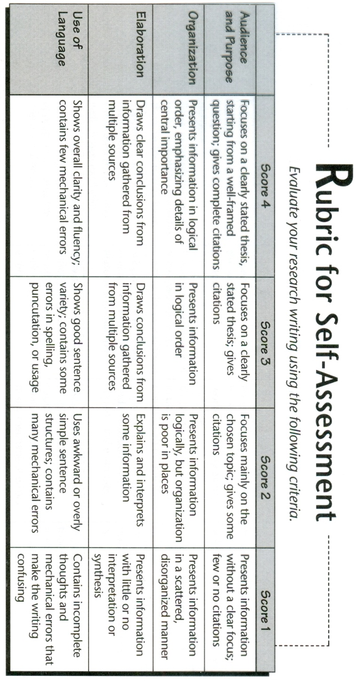
  - Six Trait rubric
  - Rubric for persuasive writing
  - Rubric for problem solution essays
  - Rubric for compare / contrast writing
  - Rubric for research writing
  - Rubric for a multi-genre project
The example below is for research writing, which came from the Prentice Hall, Writing and Grammar, 2001.

notes:

Differentiation: use the data (CSAP, Acuity, TOSCRF, YPP…) collected to help identify how you will meet the needs of all students in your class.
Some students may need help in choosing a topic. Examples may help students decide on a topic.

Re-Teach | Extensions |  |  | Accelerations
None for this lesson. | (Distributive Practice)  None for this lesson. |  |  | None for this lesson. This is just the start of the project.
Evaluation / Assessment: explain how you will determine mastery of this lesson to the objective/standard…
None at this time; this is just the start of the project.
Reflection:
Things that went well…
This lesson helped students begin to think about possible topics.

Things that didn’t go well…
For the most part students were excited, but there were a few that were skeptical.

Things to remember…
- Give the students another day or two to choose a topic.
- Use of the 16-slide PowerPoint presentation should help with the discussion of the process.

Things to change for next time…
- It was decided to start the “engagement” survey after this first lesson. This way a comparison can be more easily compared with a first feeling of the students.
- One objective stated that the students will choose a topic. However, instead of choosing a topic, students should think about and/or list 5 events or people they would like to do research. This should help the process of choosing a topic.
- Students felt a little intimidated seeing a “whole” process when they have not even started. The teacher needs to show interest and enthusiasm when introducing this process. Remind the students this is a process that will be completed in steps.
This is just an example of how a calendar might be helpful in organizing a time line.
Read and take notes all week
Use citation machine for citing a source
Find online article in EBSCO
Library: find 2 print sources

STUDENT NAME ________________________ PERIOD _________
For this survey, the teacher is to tell the students:
“This is not graded. This is to help the teacher measure your engagement throughout this project. You will be evaluating your own confidence and interest level several times. It takes only five minutes. A “1” is very low; and a “10” is extremely high. No two students should have the same answers because they are based on “your” perceptions, not somebody else’s. Your feelings can change each time and your numbers can go up or down as you progress. Try to be as truthful as possible. Thank you.”

SURVEY 1: DATE: _______________
A “1” is very low; “10” is extremely high.
How you feel today about each of the following: | 1 | 2 | 3 | 4 | 5 | 6 | 7 | 8 | 9 | 10
How excited are you about completing this project?
How much do you know about adding a works cited page properly?
Are you learning anything new about the topic or the research process?
How confident are you in using parenthetical citations?

Comment so far about this assignment _________________________________________________
_______________________________________________________________________________

SURVEY 2: DATE: _______________
A “1” is very low; “10” is extremely high.
How you feel today about each of the following: | 1 | 2 | 3 | 4 | 5 | 6 | 7 | 8 | 9 | 10
How excited are you about completing this project?
How much do you know about adding a works cited page properly?
Are you learning anything new about the topic or the research process?
How confident are you in using parenthetical citations?

Comment so far about this assignment _________________________________________________
_______________________________________________________________________________

SURVEY 3: DATE: _______________
A “1” is very low; “10” is extremely high.
How you feel today about each of the following: | 1 | 2 | 3 | 4 | 5 | 6 | 7 | 8 | 9 | 10
How excited are you about completing this project?
How much do you know about adding a works cited page properly?
Are you learning anything new about the topic or the research process?
How confident are you in using parenthetical citations?

Comment so far about this assignment _________________________________________________
_______________________________________________________________________________

SURVEY 4: DATE: _______________
A “1” is very low; “10” is extremely high.
How you feel today about each of the following: | 1 | 2 | 3 | 4 | 5 | 6 | 7 | 8 | 9 | 10
How excited are you about completing this project?
How much do you know about adding a works cited page properly?
Are you learning anything new about the topic or the research process?
How confident are you in using parenthetical citations?

