Year End Closing/Federal Reporting Instructions for EZReports-Phase 1

21st Century Community Learning Centers
TO BE COMPLETED BY MAY 15

Office of Community Partnerships
April, 2013

Overview

Each year the EZReports database changes over into a new database.
The 2012-2013 EZReports database will close on June 28^{th.}
The new EZReports 2013-2014 database will open up on June 3rd.

The Federal Reporting process is complicated. These instructions will guide you thru entering the final data required in the 2012-2013 EZReports database. Some of this information may already be in your database. If so, please check the database for accuracy.
The information that you are putting into EZReports will serve as your Federal Reporting requirement. This means that after this information has been entered into EZReports, the Colorado Department of Education, Office of Community Partnerships, as your state evaluator, will submit this data to the Federal Reporting system, PPICS, for your grant.

There are two phases to Federal Reporting. Each phase has time constraints.

PHASE 1 - Information for 2012–2013 EZReports database: This information must be completed by May 15.

PHASE 2 - Information for 2012-2013 EZreports database. This information must be completed by June 28.

PHASE 1 – Items to be completed:

- Grant Objectives (PD-You must have Program Director access to enter this information):

You entered your grant objectives when you set up your program in EZReports last spring. Now you need to evaluate the progress you have made toward meeting your objectives (SMART Goals) and enter the status for each objective.

Go to Program, down to Grant and click on Grant. On the left you will see a list of your 21st CCLC grants. Click on a grant name to highlight it, then move to the right and click on Edit Grant. A new screen will open. Select the second tab labeled Grant Objectives.

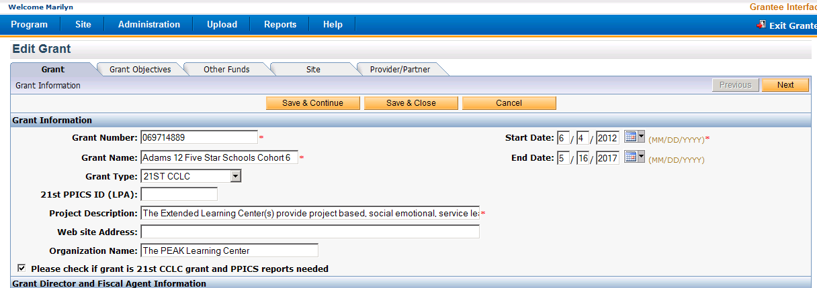
Be sure that this box is checked so that your data is reported to PPICS.

Move to the far right and click on the Edit icon for the first objective.

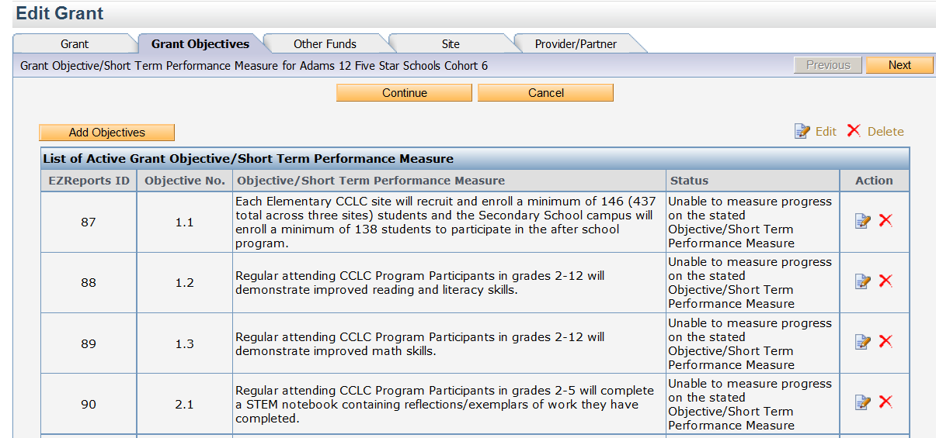

You will see this pop up screen:

This view is the top portion of the Objective Status screen. Verify that the objective your are reviewing is classified correctly, and then scroll down to the second section of the pop up screen.

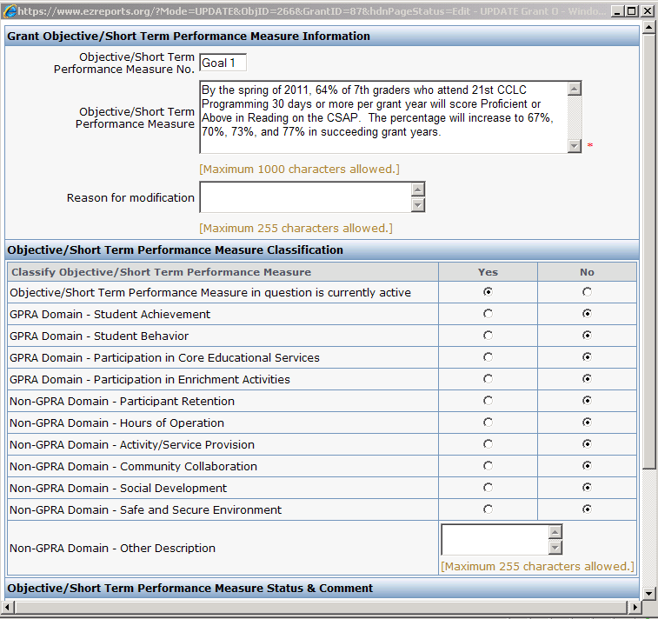

The lower portion of the Objective Status screen is where you will enter the status for the objective (SMART Goal) for this year of your grant.

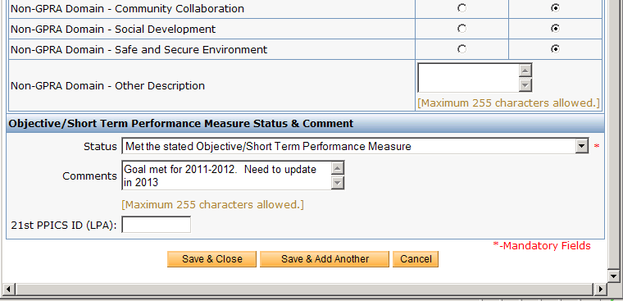

You will need to enter the status for this reporting period for each objective (SMART Goal) in your grant. After you have entered the status of the objective, press Save and Close.

If you have more than one 21st CCLC grant, you will need to do this for each objective in each grant.

- Activity Descriptions (PD-You must have Program Director access to enter this information):

What is this? This is where you specify which activities are offered to your sites, and more information about what is offered, a description of the activity, the populations you want to serve with this activity, and the subjects covered by this activity.

Go to Program, down to Activity and click on Activity. On the left you will see a list of activities that are available to all your sites. Click on an activity on the left, then click Edit.

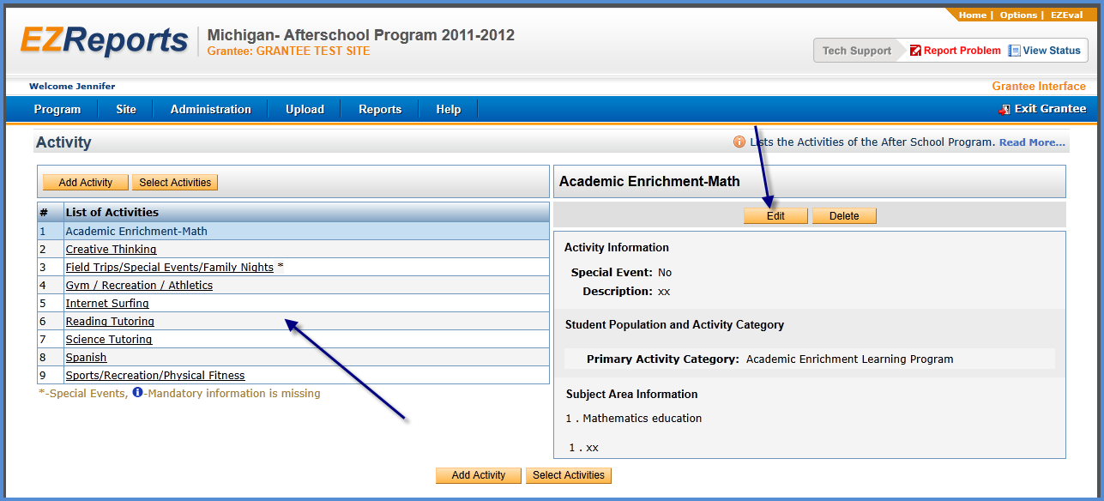

Go thru the following steps for each Activity. Review and/or complete the information for each section in the screen shown below:
- Activity Information: make sure you have filled out the activity description. Note: Once you have associated students with this activity, you cannot change the Activity Information.
- Activity Categories: choose a primary category for this activity. You may (not required) also want to use a second category to classify this activity.
- Specific Student Populations Targeted: click the box next to one or more of the student populations you serve with this activity. If none of the listed populations are targeted choose none of the above.
- Activity Subject Area(s): click the box next to one or more of the subject areas for this activity
- Save & Close: click on this to save your information
- You will need to do this for EACH Activity listed
- ANY ACTIVITIES NOT IN USE SHOULD BE DELETED FROM THIS PAGE. If you try to delete an activity and receive an error – then that activity is being used by one of your sites.

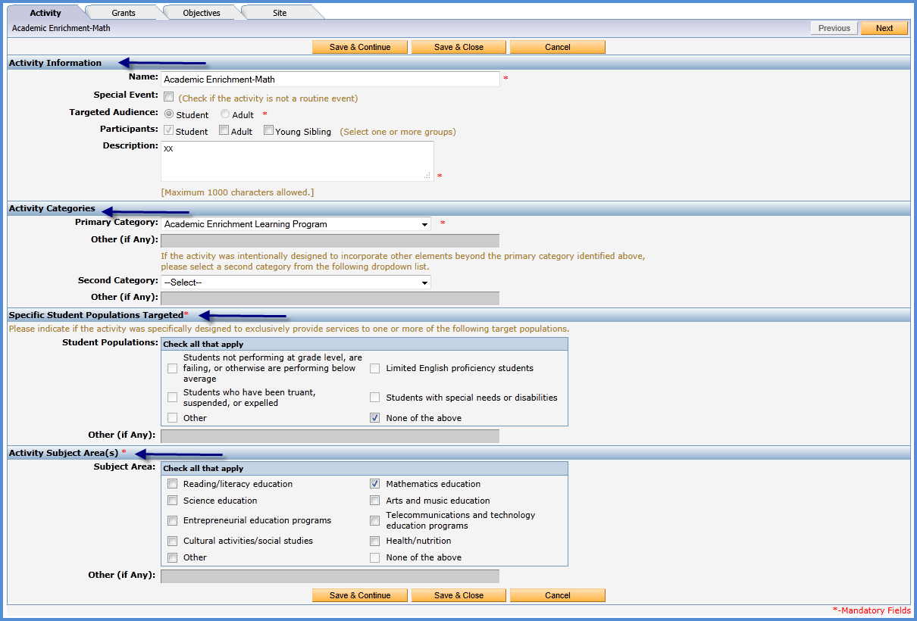

- Activity Objectives (PD-You must have Program Director access to enter this information.):

What is this? This is where you connect the objectives are you trying to meet with an activity. These objectives are pulled from your original grant proposals. Here you identify which objectives are targeted by each particular activity. Remember you need to do this with each activity that is listed. For example, if you offer Youth Development as an activity- you may be focusing on trying to “provide drug and violence prevention and abstinence education”

Go to Program, down to Activity and click on Activity. On the left you will see a list of activities that are available. Click on an activity on the left, then click Edit. Click on the Objectives tab at the top.

You will see ALL your grants listed on this page. You will also see objectives listed on the right. Check the objective you are working on associated with this particular activity.

Click save and close when you are finished to save your work.

You will need to check objectives for EACH grant you have associated with this particular activity.
(See diagram below. IF you have multiple grants they will all be listed here.)

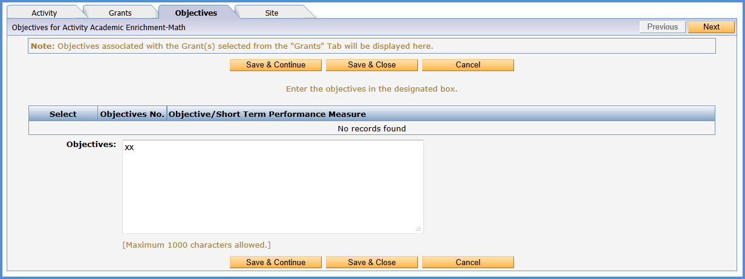

- Grant Director Information (PD-You must have Program Director access to enter this information):

What is this? This is where you specify who the program director or person responsible for the grant(s). If you have multiple grants then you need to do this for each grant. You will also need to fill in the award amount per year of the grant.

Go to Program, down to Grant, click on the grant you are working with (you will need to do this with each grant listed that is currently active), click Edit Grant. Look over this page to be sure the information is correct for the Grant Director Information, and the Funding Information. Be sure to save & close to save your work. Below is the location in EZReports where you will be working.
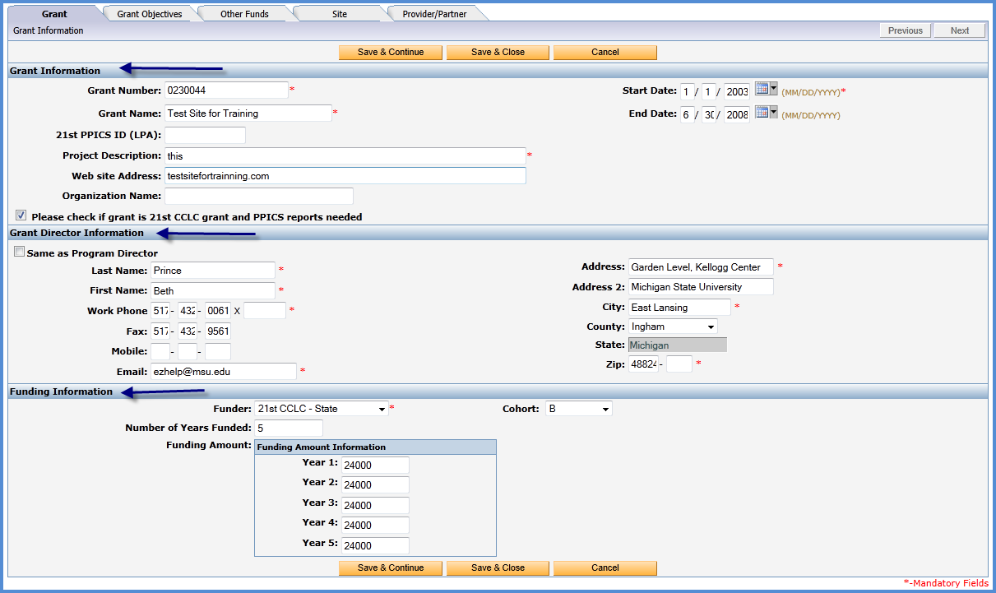

- Other Funding (PD-You must have Program Director access to enter this information):

What is this? This is to document if your grant received addition funding from any sources other than 21st CCCLC. If you received funding from a source not listed, you may click Other and then fill in where that funding came from in the box below. This will need to be done for each grant award that is active.

To see this information go to the menu bar at the top of your screen to Program, then down to Grant. Click on Edit Grant. There will be 5 tabs at the top of the page. Click on the Other Funds Tab. You will see this screen.

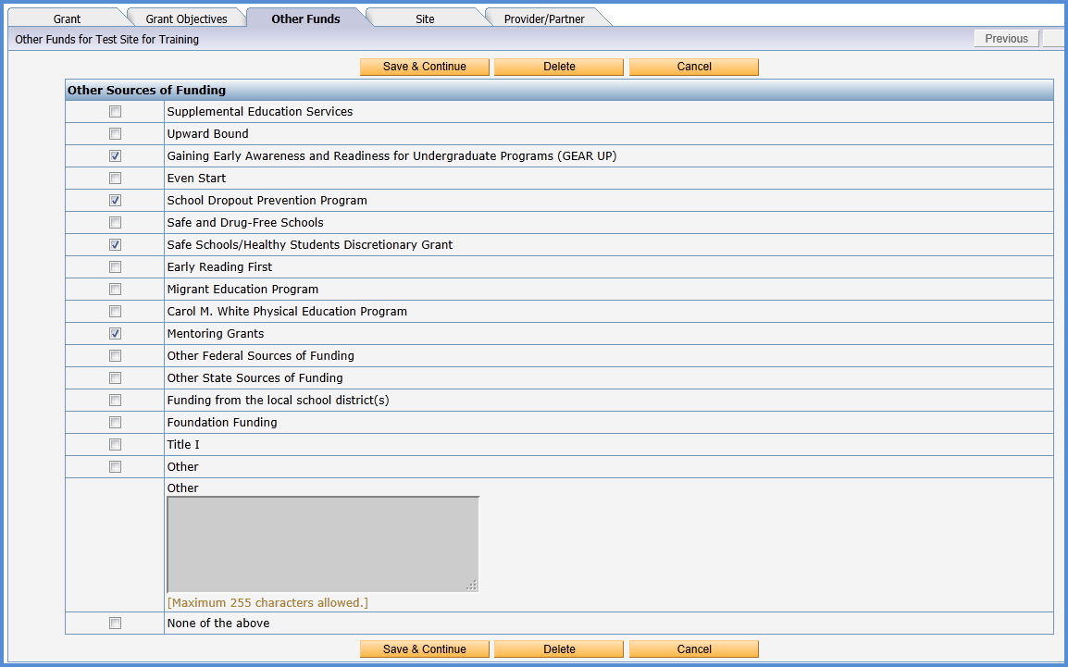

Check the additional funding you may have and then SAVE & CONTINUE. (This will save your information but take you to the next tab. You don’t need to continue after that page but want to save what you have entered.) You will need to enter this information for each grant you have.

- Partners/ Providers (PD-You must have Program Director access to enter this information):

What is this? You enter the community support for your program here. This can be in the form of partners, providers, or vendors. This could be the local library, sheriff’s department, the YMCA, or a local dance studio. These organizations all show how your program uses community support to offer programs to your students. In addition, this can be local organizations that do not offer direct programming to students, but provide supplies or the use of a facility or even consultation services. This is an area you will come back to in Phase 2. Later, in Phase 2, you will be asked to input how much you paid to this provider (per grant award). Start collecting this information.

To see this information go to the menu bar at the top of your screen to Program, then down to Grant.

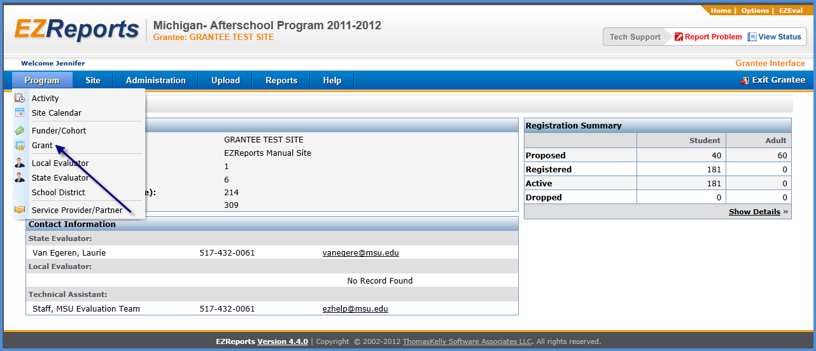

Click on Edit Grant. There will be 5 tabs at the top of the page. Click on the last tab Partner / Provider. All you are doing is verifying that all providers that are used for this grant are listed correctly. It is important that you see all your Partners / Providers / Vendors listed so you can show your community collaboration. You will see this screen.

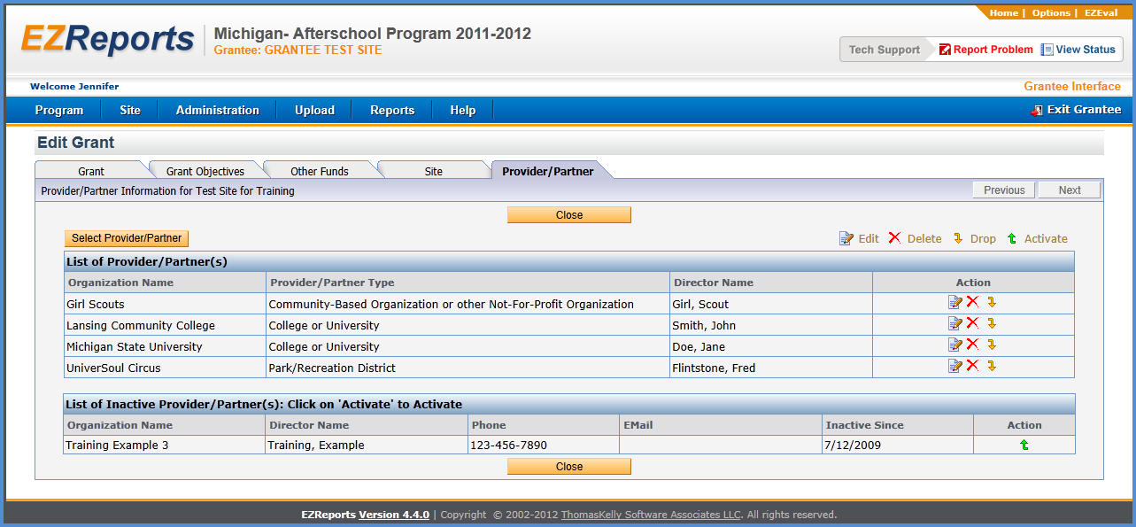

You may see some providers listed as active or inactive. You can activate any inactive providers by clicking on “Activate” under the Action column. A box will pop up and will ask if you are sure you want to activate this provider. Click yes. You will be asked to put in an activation date - be sure to choose the start date of your program. Save and close when you are finished.

You may also see no providers listed or not see a provider that should be on your list. Click on Select Provider /Partner button on the left side of the screen. You will have a box pop up and you have an option to select your provider from a dropdown list. Select a provider from the drop down and then also put the start date in. Save and close when done.

If you do not see a partner or provider from the drop down list that should be in the list, go to the Program tab, select Service Provider/Partner from the drop down menu. Click the Add button and enter information for the partner or provider. Click Save & Close when finished.

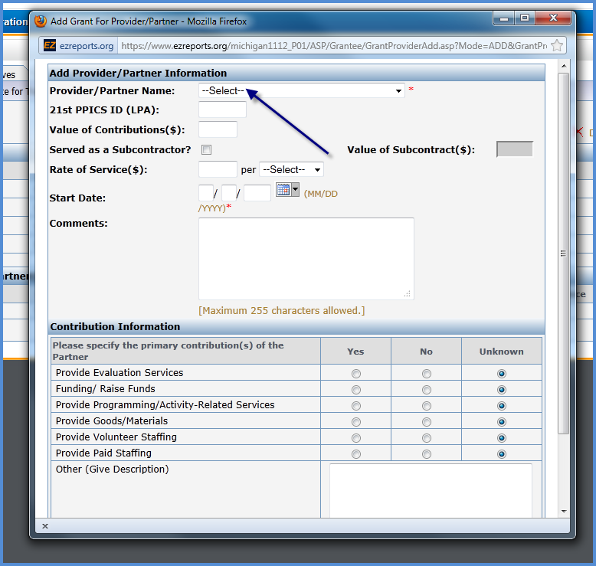

Add provider/partner details:

Go to the Program tab, select Grant from the drop down menu. Highlight your grant on the left, and then select Edit Grant. A new page will open. Click on the Provider/Partner tab.
You will come back to this section in Phase 2. In Phase 2 you will fill out the rest of the Add Provider/Partner Information box. THIS CAN BE A TIME CONSUMING PART OF FEDERAL REPORTING. PLAN AHEAD NOW. YOU WILL NEED TO GET THE AMOUNTS THAT YOU PAID THESE PARTNERS/ VENDORS FROM YOUR BILLING OFFICE. IF YOU HAVE VOLUNTEER STAFF, GO TO THIS LINK TO CALCULATE THE VALUE OF THEIR TIME http://independentsector.org/volunteer_time

- Proposed Number of Participants (PD-You must have Program Director access to enter this information.):

What is this? In your original grant you proposed to serve a certain number of students and a certain number of adults).

Go to Site, then down to Manage site. You will see a list of sites in your program. You will need to click on each site, and select Edit Site, to enter the proposed number of participants.

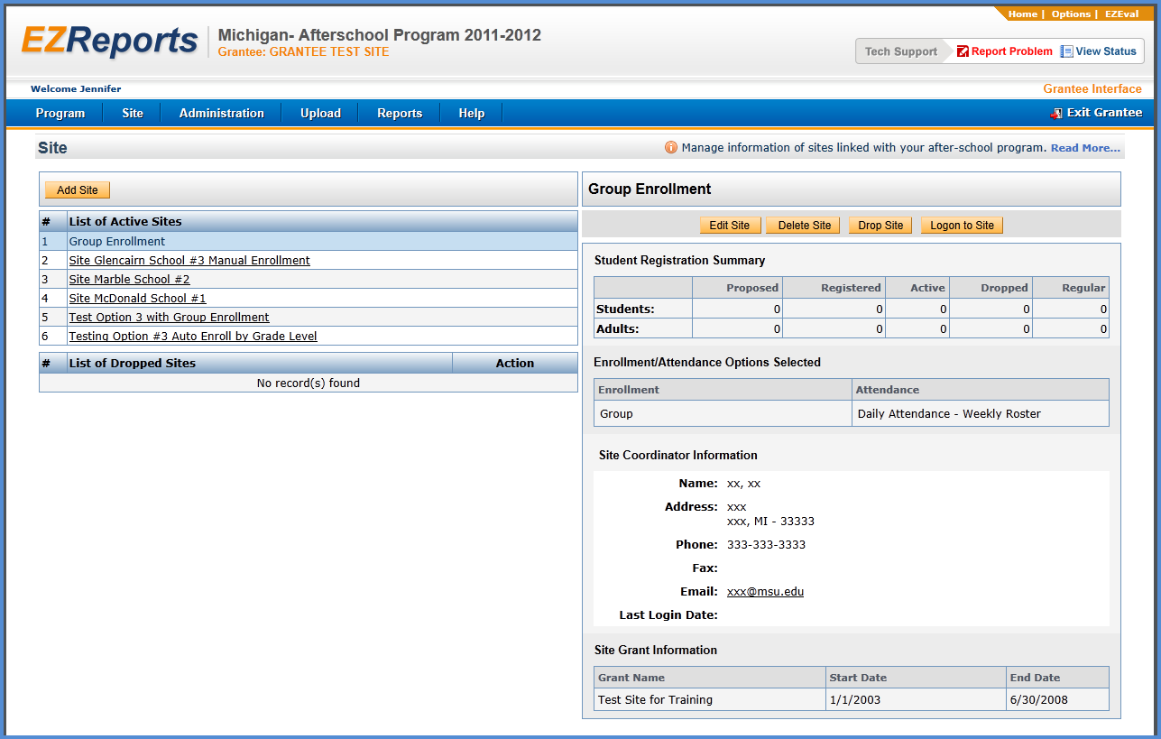

Click on the site on the left, and then click Edit Site. You will see a page that contains site information. On the right side you will see a box for proposed number of students and another box for proposed number of adults, enter the appropriate numbers in the boxes or verify that the numbers entered are correct. Be sure to save & continue to save your work. Below is the location in EZReports where you will be working.

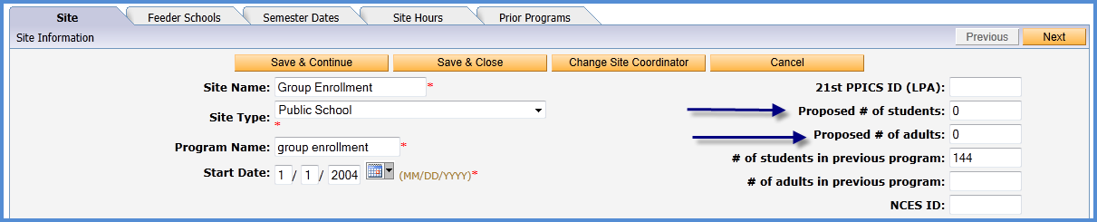

- Site Hours (PD-You must have Program Director access to enter this information.):

What is this? This is where you enter the number of hours your site was in operation. However, if in January you changed your hours and they were longer than previously, use the longer amount of time. For example, from September to December you were 4 days a week 3 hours per day. In January you started offering 5 days a week 4 hours a day. Input the longer duration of hours.

To see this information go to the menu bar at the top of your screen to Site, then down to Manage site. You will see a list of your sites. Click on Edit site and you will see 5 tabs. Click on the Site Hours tab and you will see this screen.

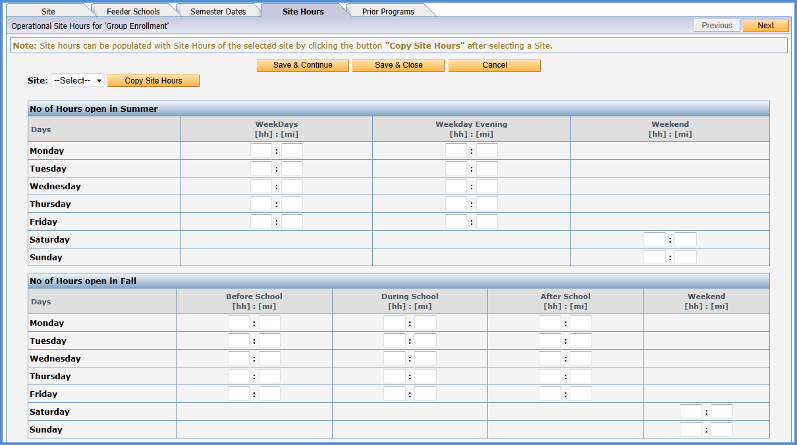

You will need to fill out the hours that your site was in operation. For example, if your site was open on Monday from 3pm to 6:30pm, then you would put 3 in the (hh) box and 30 in the (mi) box. Be sure to Save & Close when done.

You will need to complete this process for each of your sites.

- Attendance Records Completed (SC- this data is entered at site level and can be done by site coordinator or program director.):

Your attendance entries need to be completed in order for EZReports to calculate your regular attendees. Your regular attendees need to be identified for you to send out the correct number of teacher surveys. If you have been completing and submitting your attendance monthly, your attendance records should be complete. If you still have a month of programming to go, you may need to estimate the students that you expect to reach the 30 day attendance level to become a regular attendee, and add them manually to the teacher survey template. If they reach the regular attendee level by the end of your Spring semester, you will have teacher survey responses. If they do not reach regular attendee status, EZReports will not include them in the surveys report to PPICS.

- Activity Priority (SC- this data is entered at site level and can be done by site coordinator or program director.):

What is this? This specifies the priority of each activity you offered at your site. Of the activity categories provided, if your site focused on several of these, then you click “high”. If you did not offer career/job training for adults, then you click “N/A”. This is done for each site.

Click on Activity and down to Activity Priority. Remember you are working within a particular site.

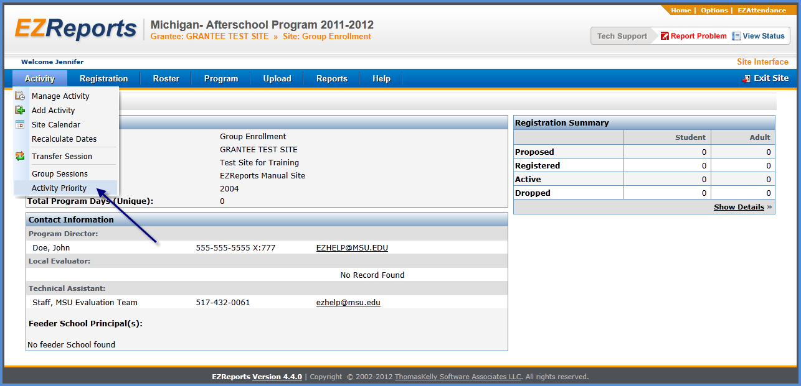

When you select Activity Priority from the drop down menu, you will see the screen below. Priorities are set for the Activity Categories and the Subject Areas at your site. In the top portion you will designate the Activity Priorities, and in the bottom portion, the Subject Area priorities. This is the priority for each site. This process will need to be repeated for each of your sites.

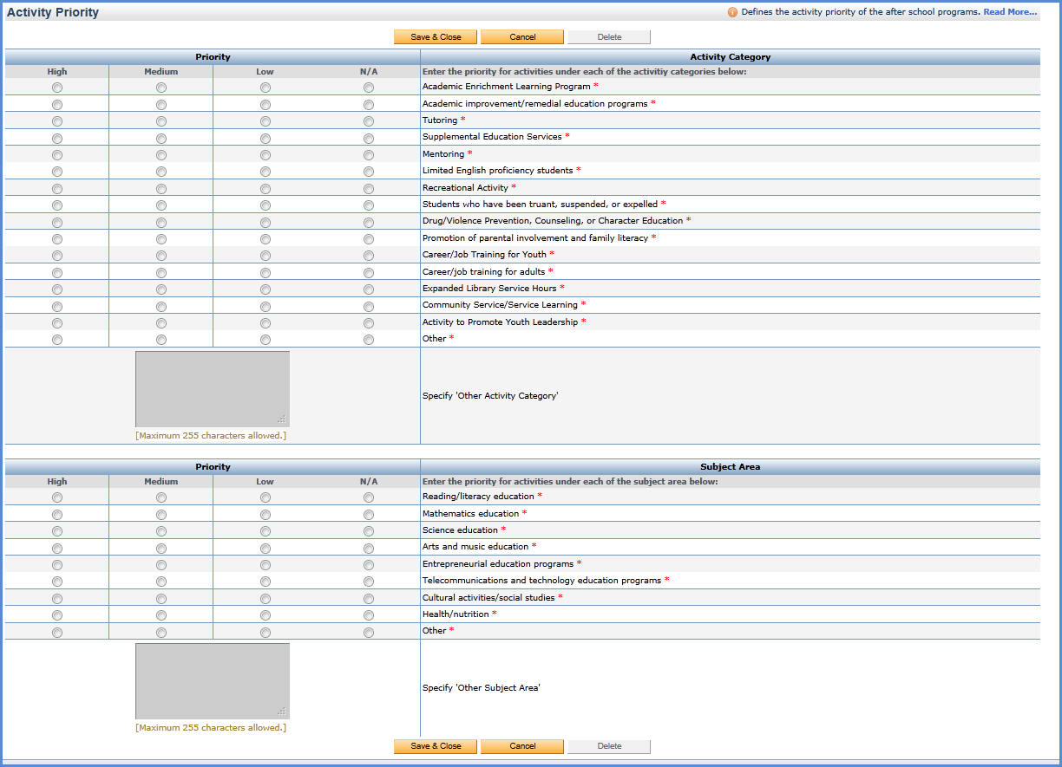

- Prior Programs (SC- this data is entered at site level and can be done by site coordinator or program director.):

What is this? This is where you identify if the current program started at a location where there was no other program in place. If there was a program offered, it identifies the types of activities that the previous program offered. This identifies any infrastructures present at the location prior to the 21st Century programs as well as the types of programs that have been previously offered.

Go to Program and down to Prior Program. You will see this screen.

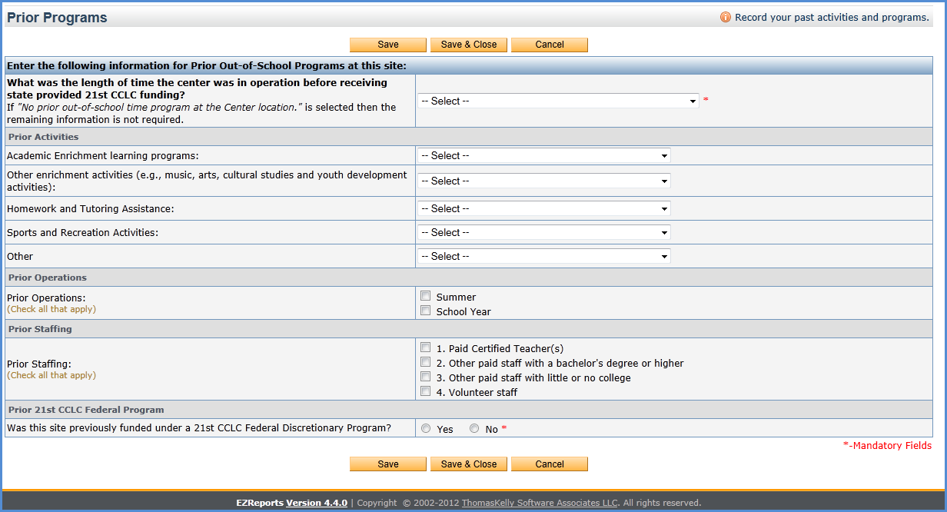

Remember to click Save and Close after you have answered all the questions for Prior Programming.

- Supplemental APR Data (Staff Turnover) (SC- this data is entered at site level and can be done by site coordinator or program director.):

What is this? This identifies information about the site regarding staff replacement. Replacing staff is difficult and can hinder the smooth operation of the program. These are obstacles that need to be identified.

Go to Program and down to Supplemental APR Data. You will see the screen shown below.

On this page only the top two blanks need to be filled out. If you did not have any staff turnover, enter a zero.

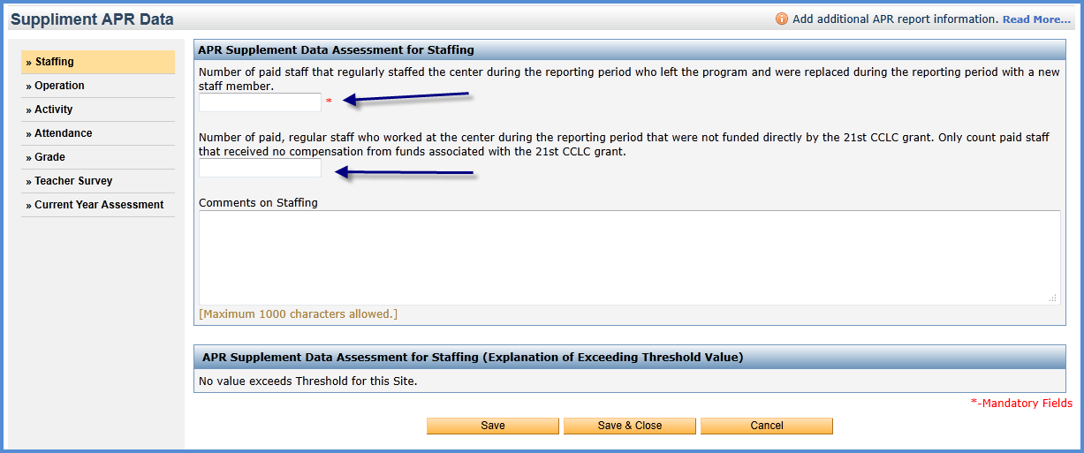

You will need to do this for every site. Save & Close when you are finished.

- Missing Staff or Provider for sessions/classes (SC- this data is entered at site level and can be done by site coordinator or program director.):

What is this? This is missing information that did not get entered when the session was entered. This could be because the staff was not entered into EZReports and therefore could not be selected to teach the session, or this could be an error in the data entry.

Many sites are missing staff or provider information in their sessions. These must all be filled in. Check to see if you are missing any staff or providers in your sessions, go to Activity and Manage Activity. You will see a list of your sessions. If you see red “???” under the column staff / provider then you are missing this information and it should be filled in. The missing staff or provider will look like the screen shown below.

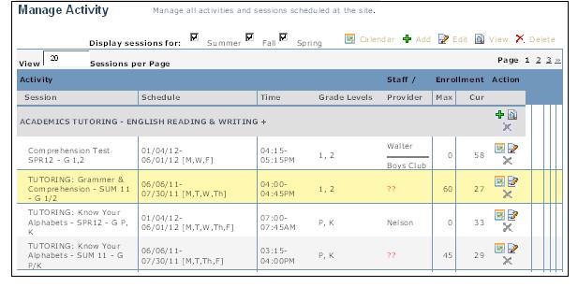

To fix this, go to the far right of the session and click on the edit (pencil and paper) icon, you will be taken to the screen shown below.

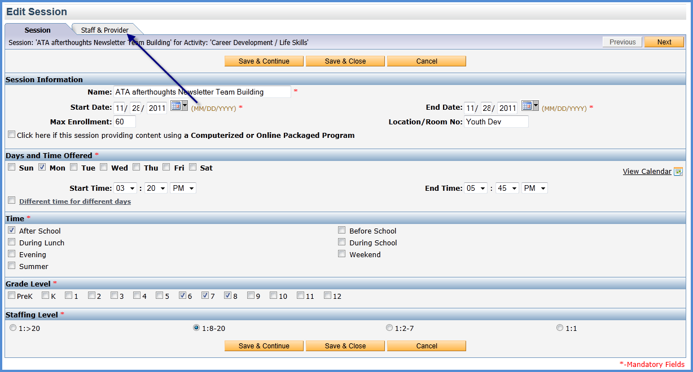

There are two tabs at the top of the screen. Click on the Staff & Provider tab. On this screen you will need to affiliate either a staff and/or provider with this session. Click Add Staff or Add Provider and you will see a small box. This will give you the option to select from a list. Select the staff and/or provider and save and close. Do this for every session where you see the red “???” to fill in the missing information.

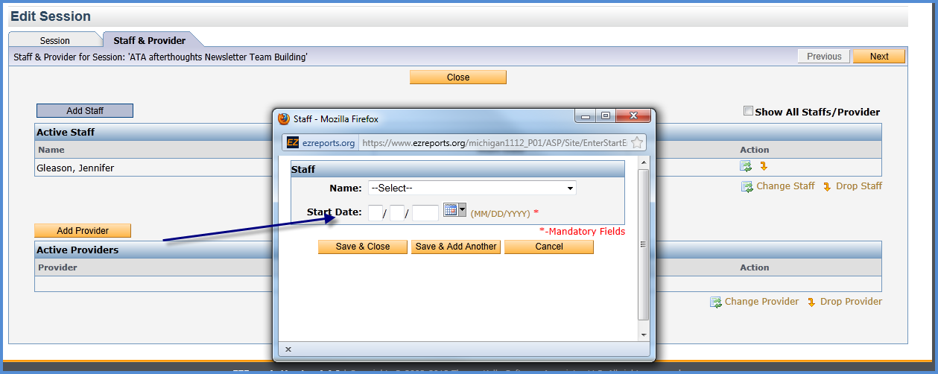

YOU ARE FINISHED WITH PHASE 1
PLEASE CONTACT Marilyn McGrath WHEN YOU ARE FINISHED at mcgrath_m@cde.state.so.us

