Data Reporting for Program Directors
Some of the duties of grant directors using EZReports are:
- Ensuring monthly attendance entries are complete
- Ensuring that your grant and all sites have complete profile data ready for upload to PPICS
- Reviewing the data to assess compliance with grant requirements
- Ensuring that your program is high quality and is improving outcome for participants
- Reviewing and analyzing the data to assess appropriate allocation of staff, funds, resources and space
EZReports provides grant directors with a wealth of information that can be a great help in managing your program.
When you first log onto EZReports and select site → manage site, then highlight a site name, you are given a current status of that site.
(In this example we’ve highlighted “Town Elementary School”)
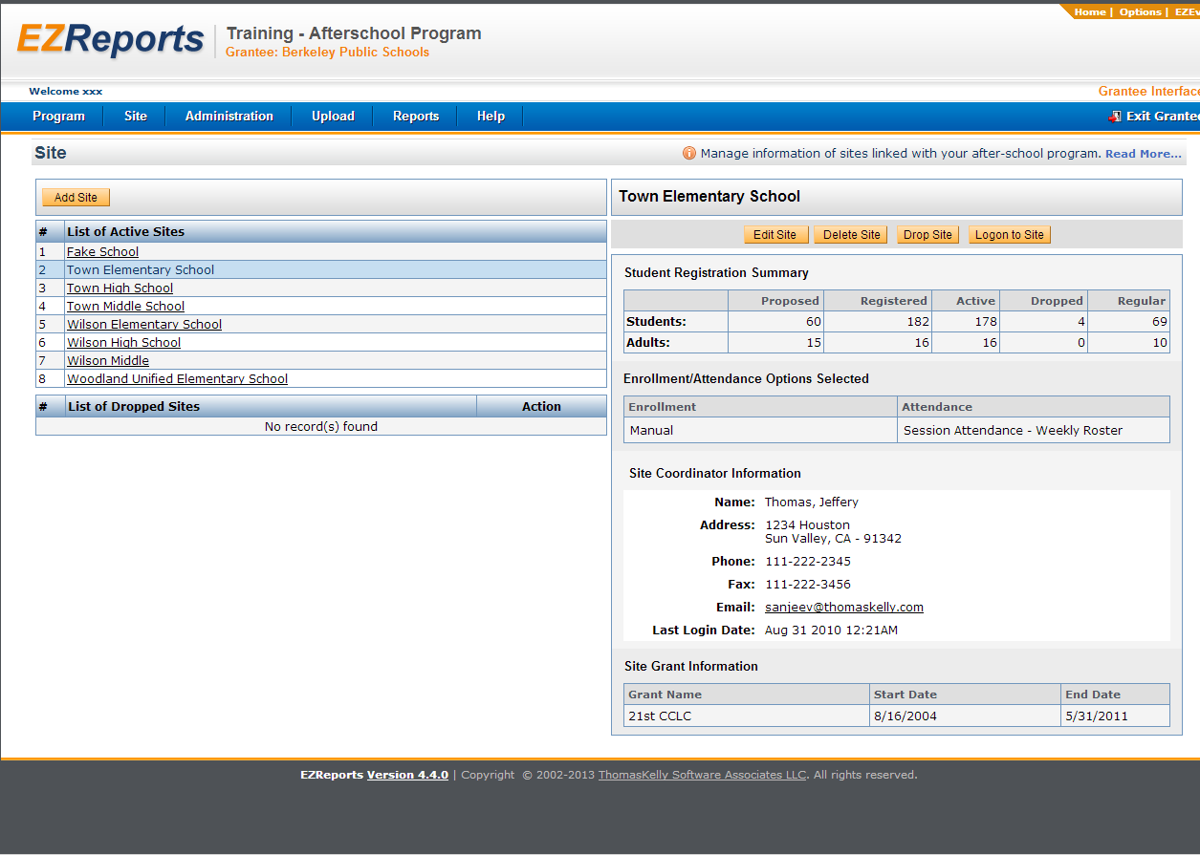
Student Registered summary: shows Proposed, Registered, Active, Dropped and Regular attendees for both students and adults.
Site Grant Information: shows Grant Name, Start and End Dates as entered into the grant profile page.
If you have instructed your site coordinators to enter attendance weekly, and the last log on date was two weeks ago, you can send the coordinator a quick email by clicking on their email address on this page.
One of your functions is to complete your programs attendance monthly. Attendance is due by the 10th of the following month. You may want to set up a system of checks with your program for a week earlier.
To check attendance completion:
- Log onto a site, by clicking on “Logon to Site” (for this example we are using “Town Elementary School”)

- Click on “Roster”, and then select “Submit Attendance”.
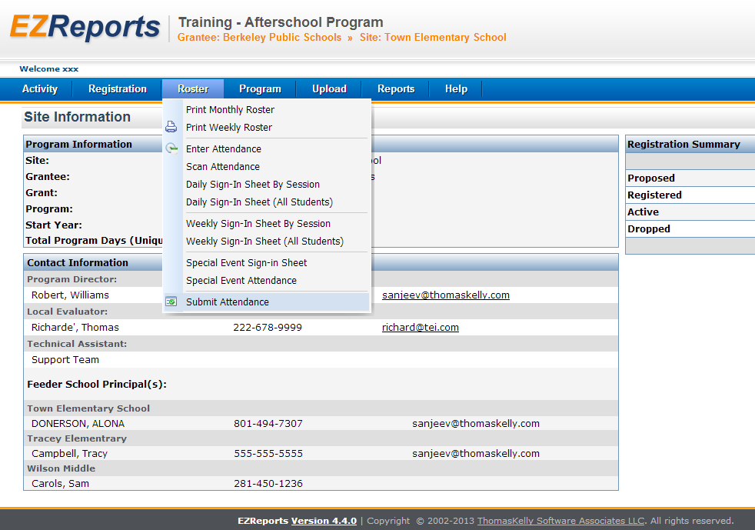
- Click on months with a red “X”. This will take you to the missing attendance (In our example we have quite a few incomplete months, but we’ll select “November 2011”)
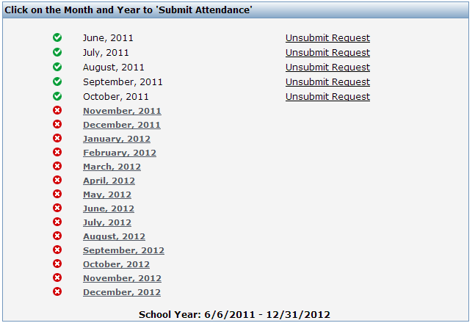
- This screen will show missing regular attendance and special even attendance. Click the green plus button to enter attendance (for this example, we chose the first one).
* Special event attendance is handled differently from regular attendance, so it is taken in a different screen. However, it does count toward regular attendee days and your attendance will not show complete if you have not entered attendance for your special events.
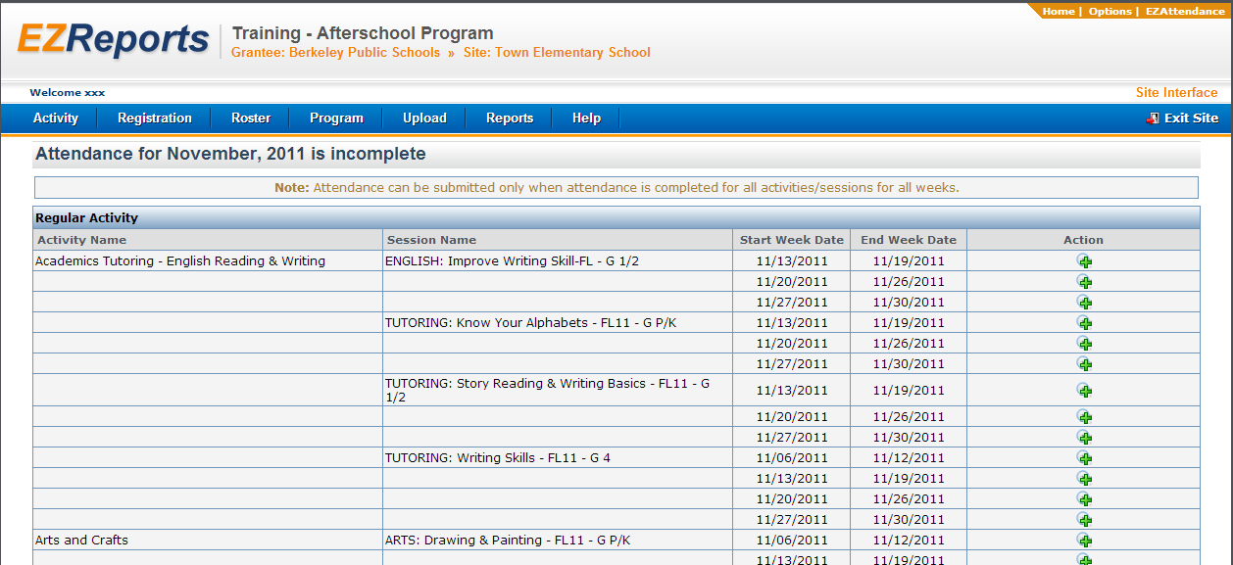
- Enter attendance on this screen and remember to check the “Attendance for…is complete” box at the bottom of each attendance entry page. Some sites may have very long lists (especially if you are using Drop In attendance), so you may need to scroll down to see this box. Repeat as needed until attendance is complete.
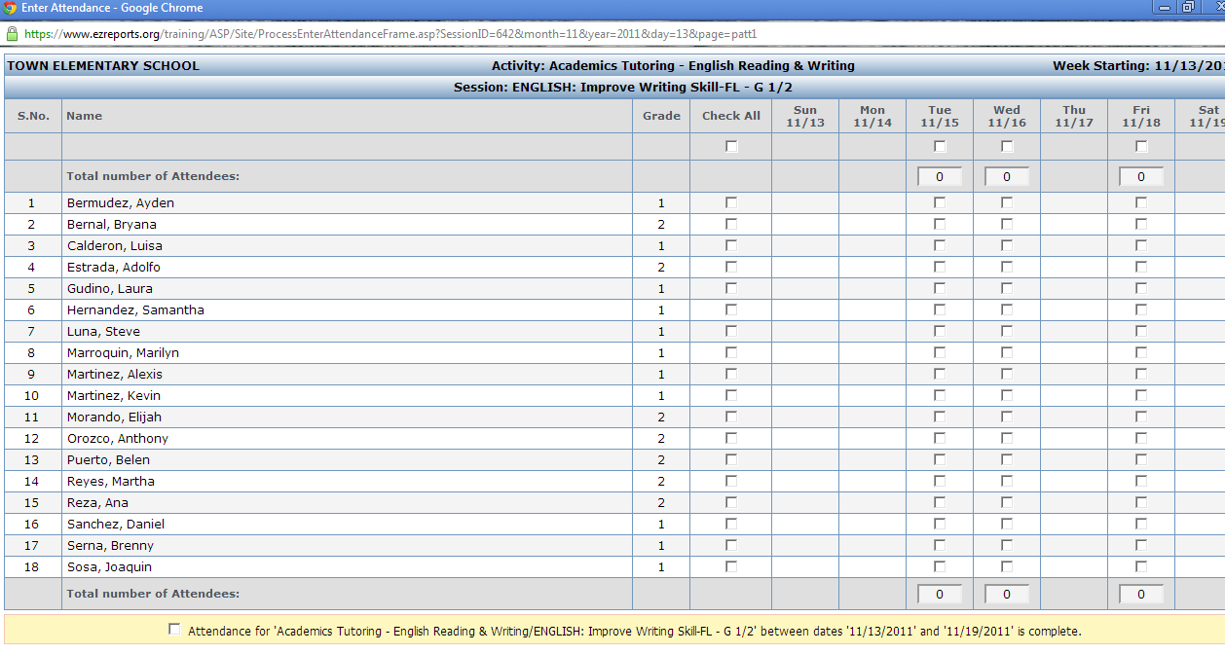
- When you are finished entering attendance you may proceed to the “Next Session” by clicking that button, “Previous Session” button (in this example, we chose the first option, so there is no Previous Session). You may also save the work you are doing and close the window by clicking “Save & Close”.
You may use the site calendar to get a quick look at expected attendance and pick up on any program holidays that are not identified. Click on “Activity” and choose “Site Calendar” from the drop down menu.
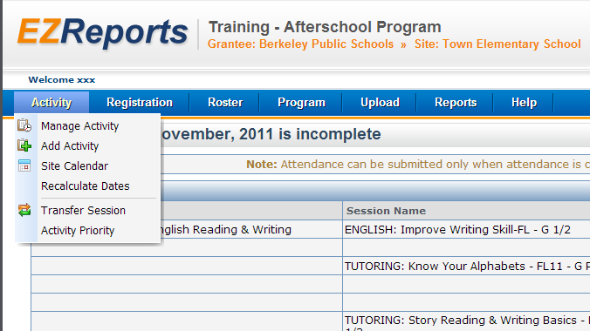

Dates marked in red indicate a program holiday. Dates with a tan background indicates days that EZReports is expecting attendance to be taken, but has not been entered. Click on an underlined date to see the attendance information for that day, as well as session attendance details.
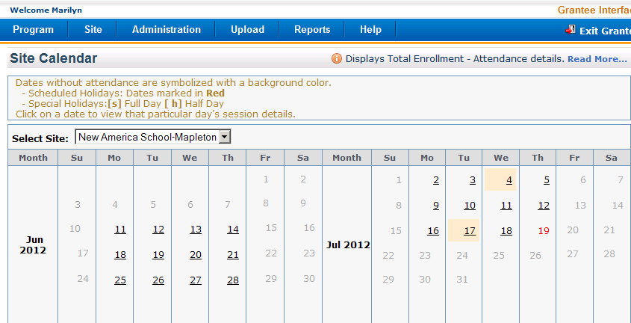
For our example, we selected July 16, 2012
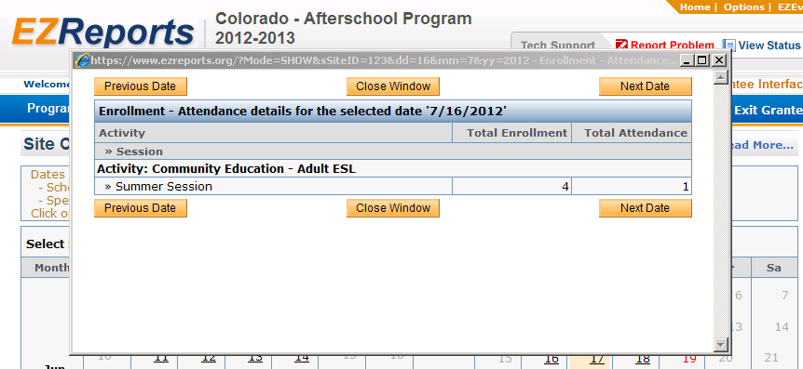

At grantee level, you can use the Attendance Status by month for a quick check on multiple sites at one time.
Click on “Reports”, select “Attendance” from the drop down, then “Status by Month” from the “Attendance” dropdown menu.
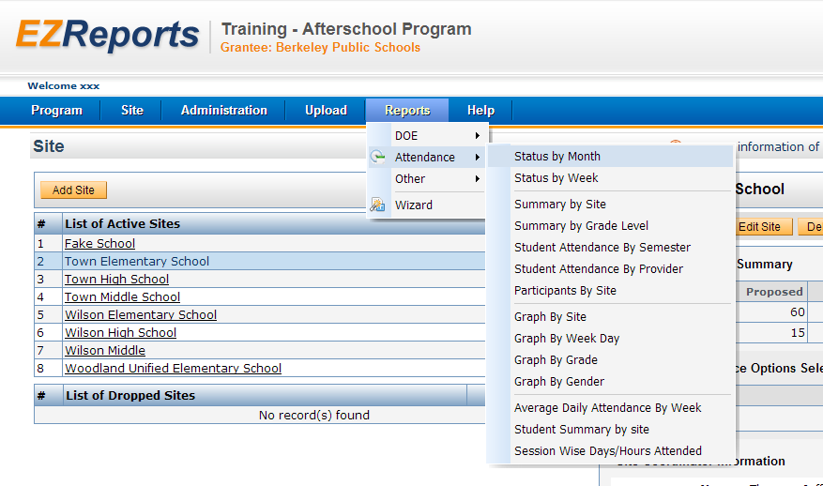
Select the month/year you want to see, and click “Show Attendance Submission”
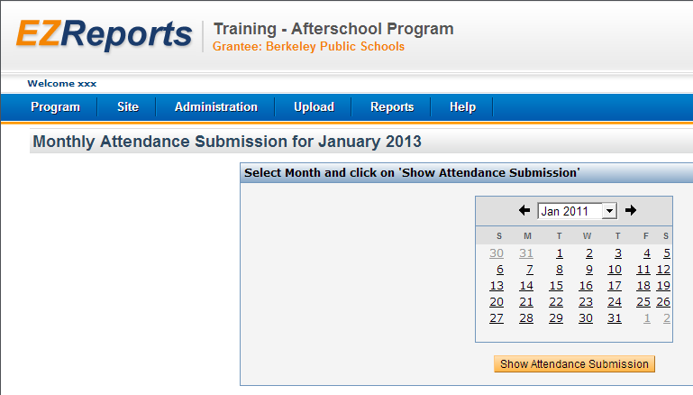
For our example we chose September of 2011.
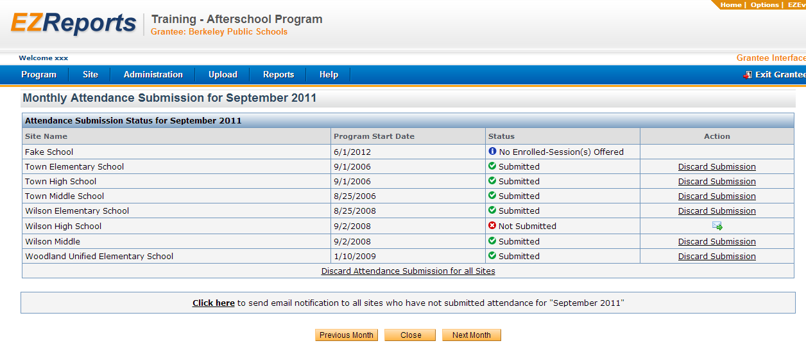
*If a site does not have sessions scheduled within your semester dates, EZReports will show that month or week as incomplete with no sessions scheduled. You may need to adjust your semester dates to the true dates your program ran, and/or adjust the calendar for that session and remove dates when no sessions were held.
In addition to checking attendance, we are also reviewing grant and site data in preparation for the upload into PPICS that will occur after the current reporting period has closed.
The educational programs that we report on to the US Department of Education are: Bilingual, English Language Learners/Limited English Proficiency, Gifted and Talented, and Special Education.
These are already entered into EZReports and are included in the feeder school demographics that you complete for each of your feeder schools.
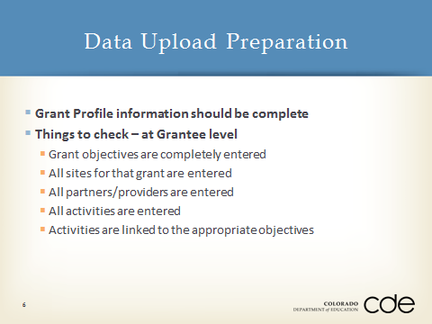
These are the things we will be looking for from the Grant Directors. Activities, service providers and partners should be entered into the Grantee level by the program director. If the same partner, for example, is entered by each site, it will report multiple times to PPICS.
In May, you will want to request the value of provider contributions from your fiscal agent. We will address this in more detail later.

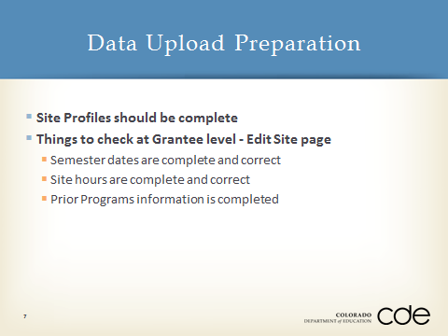
At this time, site profiles should be complete for your programs. To check this, go to “Manage Site”
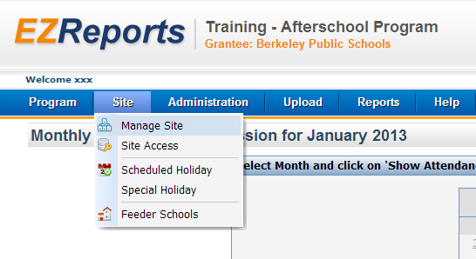

Highlight the site name on the left (for this example, we used Town Elementary School), then click “Edit Site” on the right.
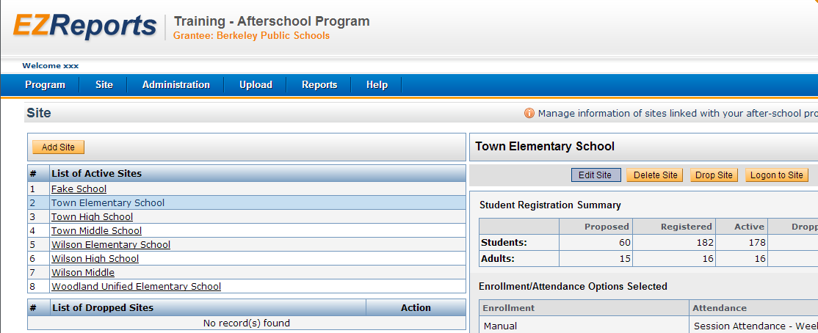

Click the “Semester Dates” tab
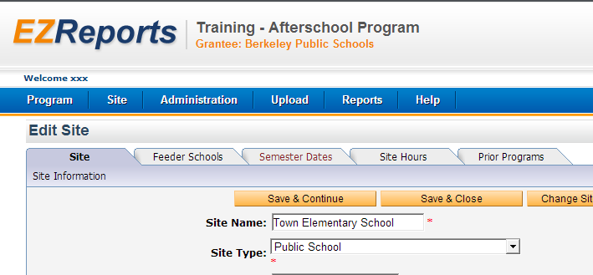

Edit these dates as necessary. Semester dates should be the dates you actually provide programming. EZReports will look for attendance within those dates and will not allow you to schedule sessions outside of those dates.
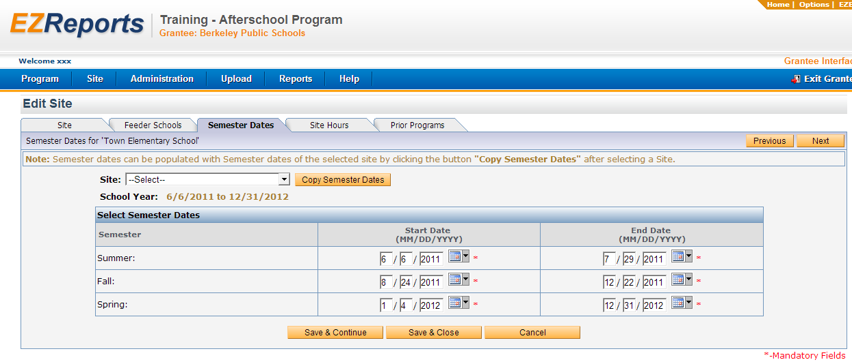

For Site Hours, click the “Site Hours” tab, and edit as necessary. There are 3 segments to this page; one for each semester in the reporting period. Remember that only adult sessions can occur during regular school hours.

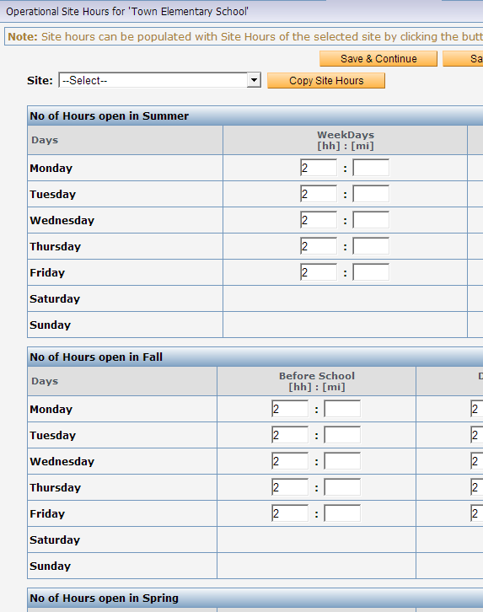

For Prior programs, select the “Prior Programs” tab.
Edit as necessary. Enter any prior out-of-school time programs at your site. If you have the same prior program at several sites, you can select another site and click on “Copy Prior Program”.
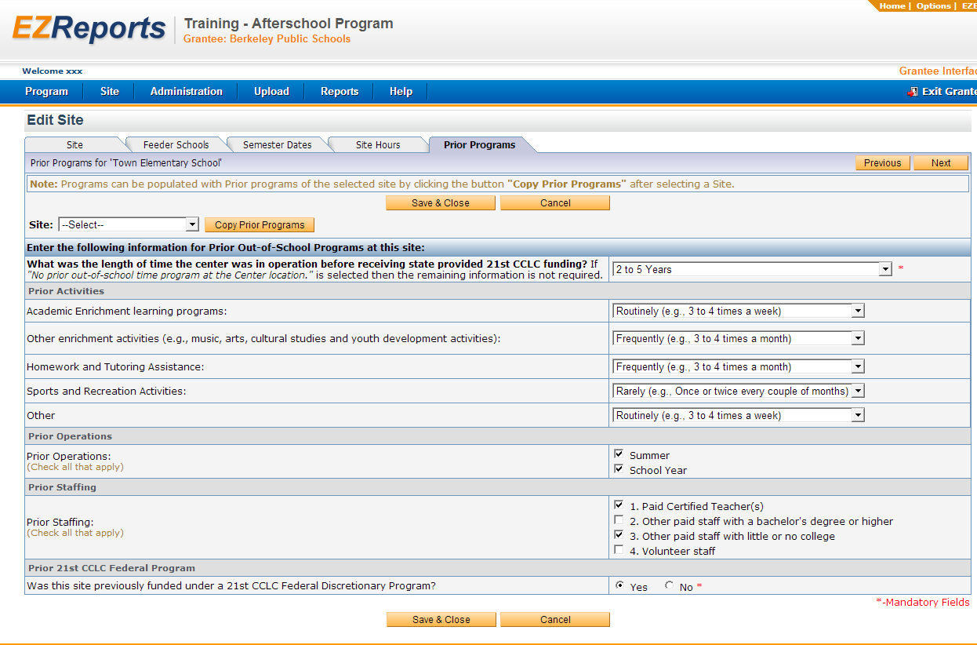

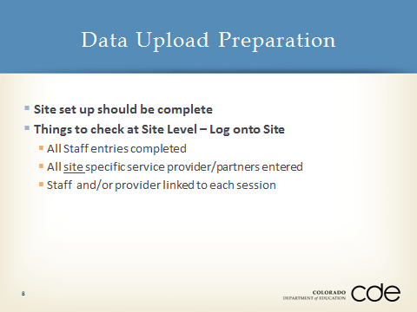
You can check this by logging into the site, click on “Program”, then “Staff”, to see, edit or add staff.
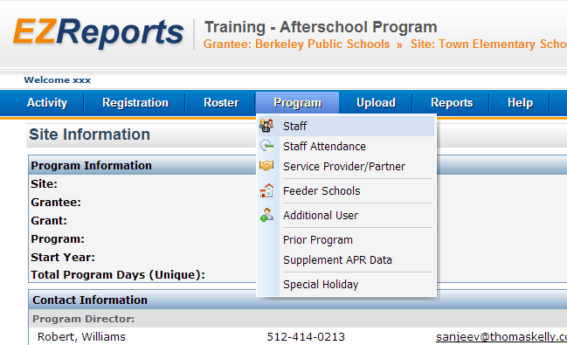

Edit as necessary
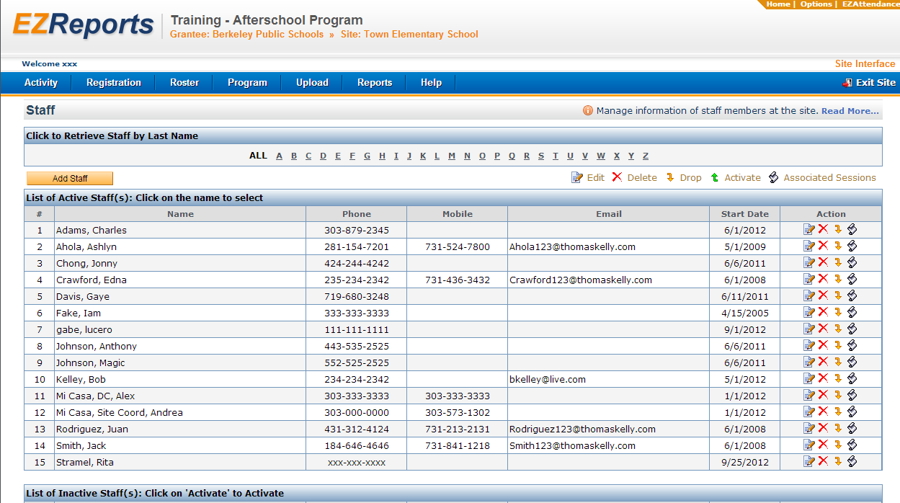
To add the primary contributions types for a service provider or partner, click on “Program”, then Service Provider/Partner.

You can also add service providers or partners here that are working exclusively with this one site.
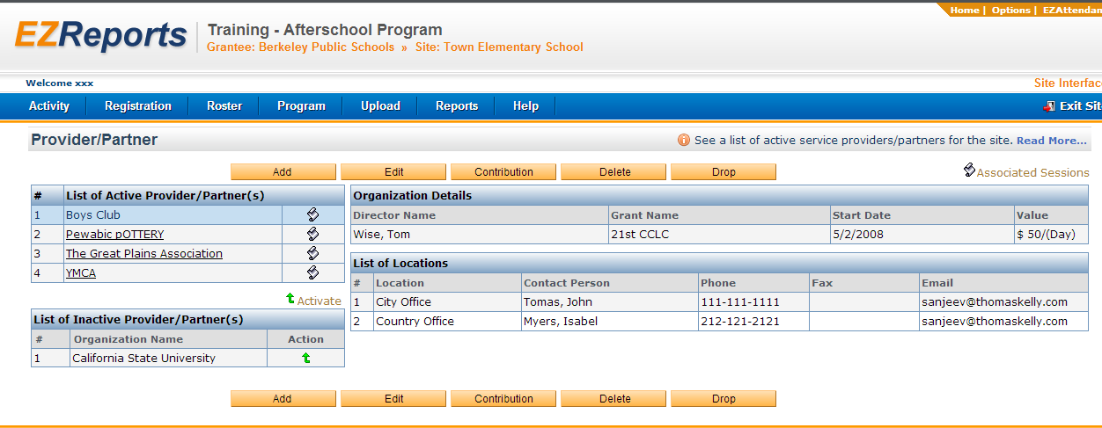
To link staff and/or provider/partners with each session select “Activity”, then “Manage Activity”.
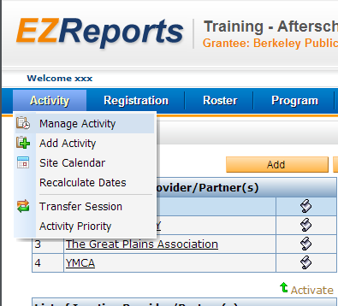

Select “Edit Session”, it looks like a pencil with a piece of paper (for our example we picked “Creative Books”).
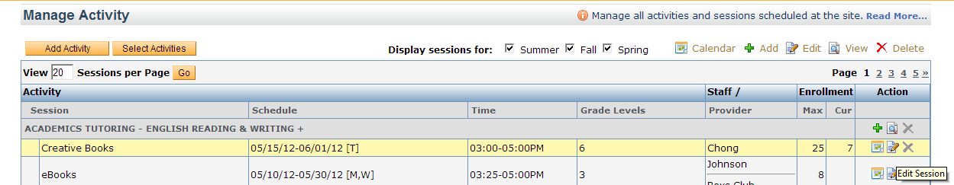
Select the “Staff & Provider” tab.
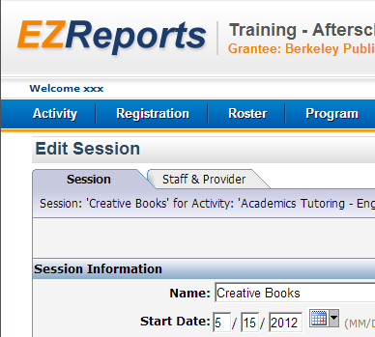

Select “Add Staff”
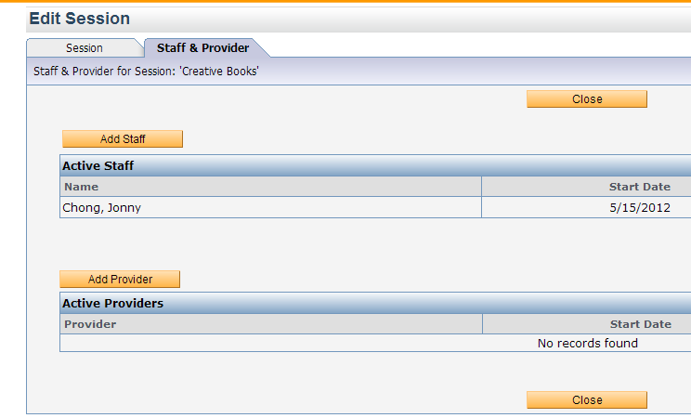
Select from the drop down menu, and remember to save and close when you are done.
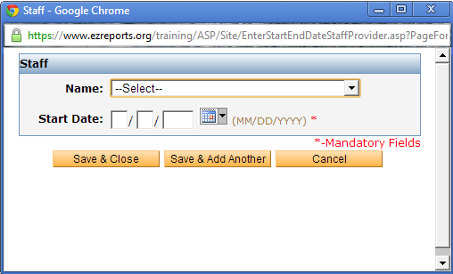.
You can link multiple staff and providers to the same reason.
If you need to link providers or staff to more than one session that occur at the same time, go to “Options” at the top right.
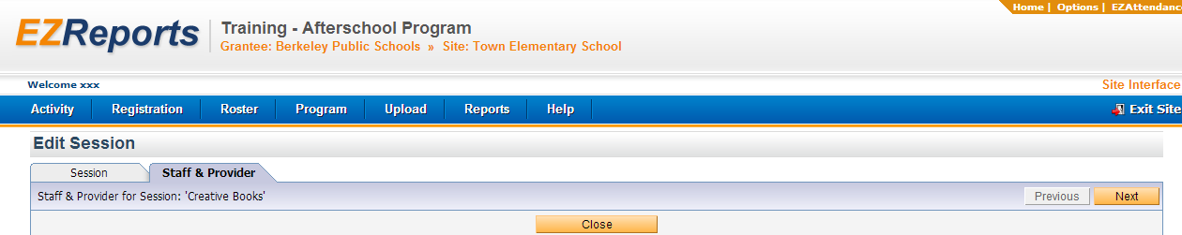

Click the appropriate box, then “Save and Close”.
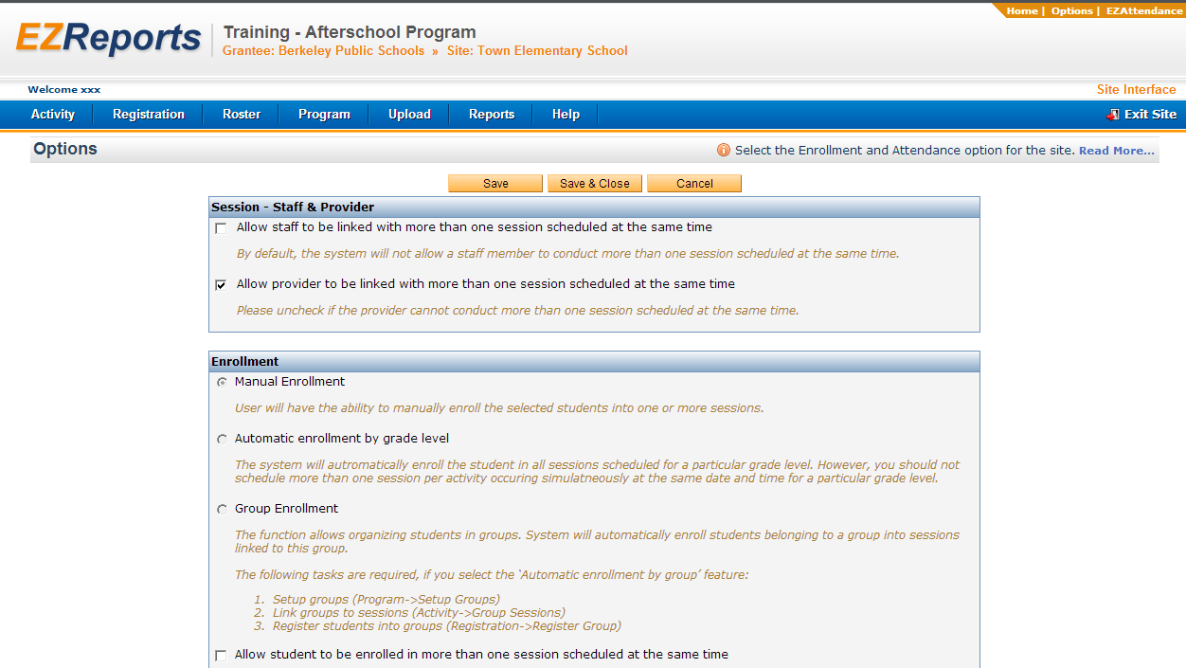

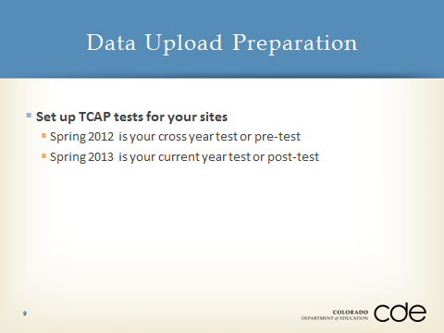
TCAP tests are already set up at the state level. You will set up the TCAP at the grantee level for your program.
Select “Administration”, then “Manage Tests”.
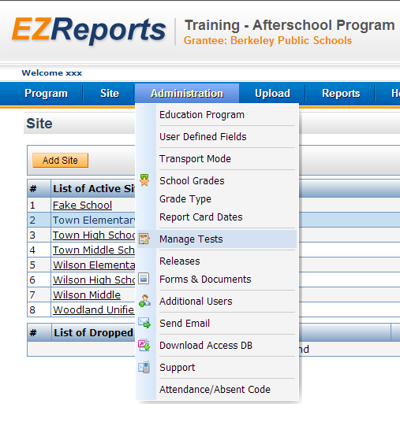
Click “Add”.
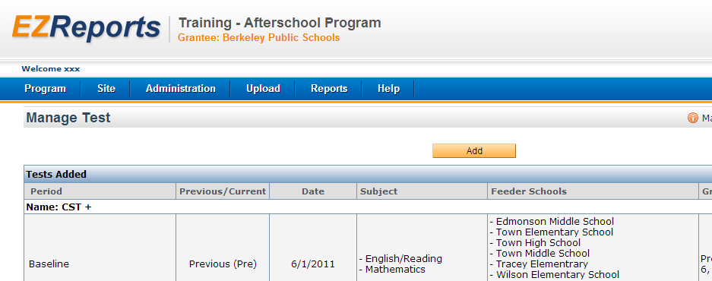
Once you have selected the parameters for your grant, remember to click “Save and Close”. This sets up the test for later upload, which will be done after TCAP scores are available next August or September.
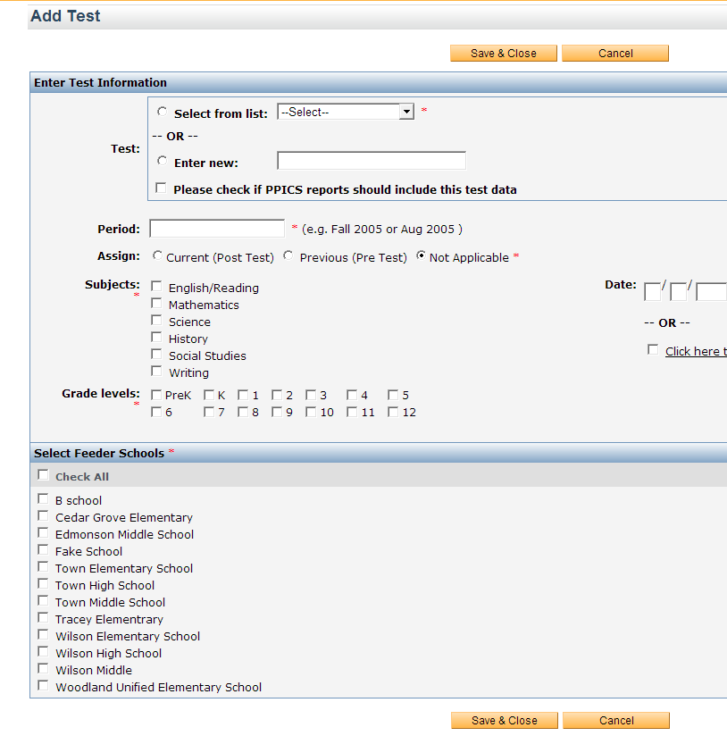
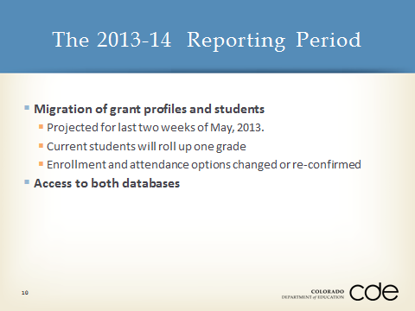

Migration: May 16 – May 31.
Access: You will have access to both databases for a short period of time. During this period, when you log in, you will be asked to select a database, either 2012-12 or 2013-14.
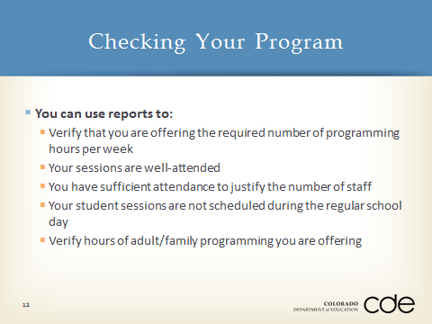
These reports offer you tools for analyzing your data to manage and assess your program’s effectiveness.
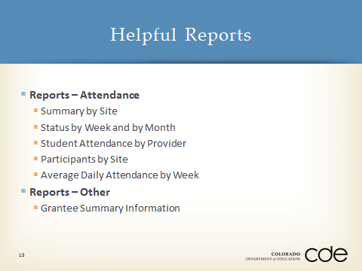
All of the reports you see listed here are Grantee level reports. The Site Summary report can also be run at the Site level.

Click “Reports”, then “Attendance”, then “Summary by Site”.
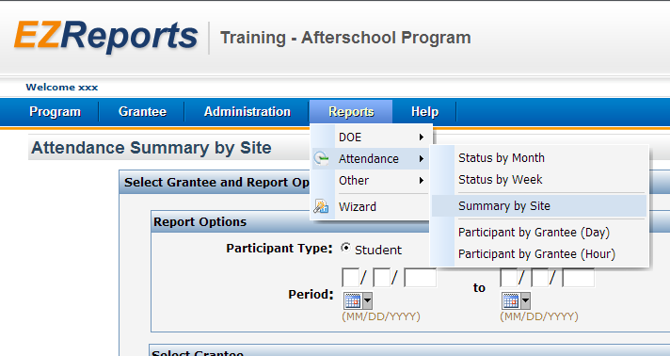
For this example we used the month of September 2011 at Town Elementary School. Click “Generate Report”.
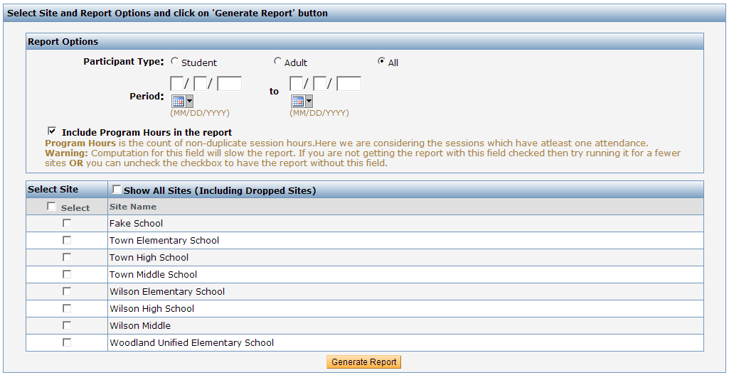

The summary by site report will tell you the number of students attending by site; the average number of days attended by site; the average numbers of hours attended by site; and for multiple site grants, the total number of unduplicated students attended during the selected time period.
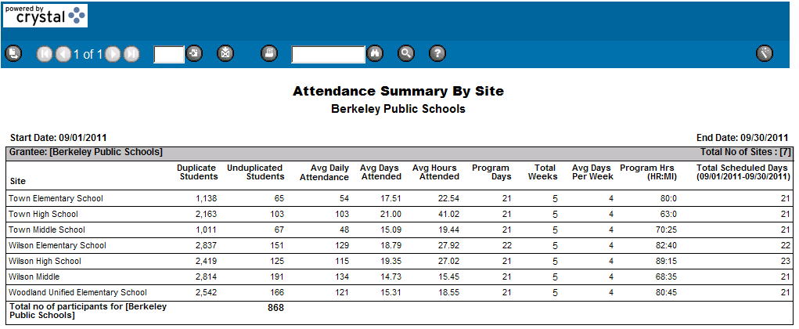
This report is useful for checking your program hours by week. Divide the number of program hours by the number of program days. This will give you the program hours per day. Multiply that by the days per week that that programming is offered to get the number of programming hours per week.
Example: Town Elementary has 80 Program hours in 21 days or 3.8 hours per day. Multiply by the days of the program ran per week (4) and you see that they offered 15.2 hours of programming per week that month.
Status by week gives you more detailed information. Both monthly and weekly reports show attendance completed, entered but not completed, not entered and is not applicable (no sessions scheduled).
We encourage you to explore other the other reports listed, as well as the reports that some of you had said you are using that we have not talked about.
If you have questions about using EZReports, please use the “Report Problem” button in the upper right section of your EZReports screen.

