You are an advisor to the President of the United States. It is your responsibility to advise the president on important matters of state. The president has come to you requesting information and guidance on a delicate situation in Country M.
The leader of Country M is a dictator that is severely limiting the civil rights of its citizens. In response, the citizens have been engaged in various acts of civil disobedience. The President of the United States must decide whether the civil disobedience has been effective in upholding the citizens’ rights or if the United States needs to intervene.
Write a memo that advises the President on whether you believe Country M’s civil disobedience activities will be successful. Think about the factors that are leading to the civil disobedience. Then think about the activities of the Civil Rights Movement in the United States (referencing the documents provided) and the current issues in Country M. Think about whether or not the civil disobedience in Country M will be successful based on the precedents set in the American Civil Rights Movement. Finally, make a recommendation to the president based on your investigation and argument.

Document A
Civil Disobedience in the 60s Civil Rights Movement | Civil Disobedience in  Country M
Background/Need for Civil Disobedience  - Until the 1960s, racial and ethnic minorities were sometimes refused service in restaurants and motels, denied access to city swimming pools and parks, and excluded from public schools and universities. In some states, it was even a crime to marry someone of a different race.  - This racism was socially acceptable, and justified under the law. Violators were subject to arrest and imprisonment.  Non-Violent Resistance Strategies  - Sit-ins at segregated businesses (esp. restaurants)  - Boycotts of segregated buses and businesses  - Marches  - Lawsuits  - Voter registration drives  - Newspaper ads and articles  Reactions to Resistance  - Activists were fired from jobs and expelled from schools.  - Law enforcement used dogs, fire hoses, tear gas .  - Hate groups employed beatings, bombs, house & church fires, and even murder.  Successes of the Civil Rights Movement  - Legislation: Civil Rights Act of 1964, Voting Rights Act of 1965, Open Housing Act of 1968.  - Ignited other civil rights movements in the U.S.: for Latinos, women, Native Americans, people with disabilities, immigrants, prisoners, gays & lesbians, etc.  - Developed political strategies used by other groups as well.  Leadership  - Martin Luther King, Jr. (MLK) helped organize the bus boycott of 1955-56, which sparked the modern civil rights movement.  - MLK and others led numerous civil rights marches and activities involving nonviolent direct action.  - MLK was assassinated in 1968, as he was beginning to build an anti-war and economic justice coalition.  - MLK had traveled to Birmingham to lead a demonstration against segregation of lunch counters and job discrimination.  - Civil Rights activists sought and been denied a parade permit, but decided to march anyway.  - MLK was arrested. In jail, he wrote a letter responding to criticism of his non-violent action. His actions were called “untimely and unwise.” | Background/Need for Civil Disobedience:  - Country M was created in 2015. The country was a colony of a European power and was carved out of diverse, religious and ethnic regions of the country.  - Ethnic minorities live in separate areas of cities or in the countryside.  - Many of the ethnic minorities have also experienced religious discrimination. They want equal representation in the government.  - They also want leadership opportunities in corporations and high level positions in the government.  - The approach so far has been non-violent, but the citizens are frustrated with the lack of change.  - If Country M can’t resolve the conflict, other countries may be asked to intervene.  Non-Violent Resistance Strategies  - Social media requests for action  - Computer hacking  - Spontaneous assemblies  - Picketing  - Clandestine planning  - Secret stockpiles of resources  - Strikes  Reactions to Resistance  - Activists were barred from influential government jobs and fired from universities.  - Protestors thrown in jail without cause and killed in sniper attacks.  - Drone strikes  Successes of the Civil Rights Movement  - Few successes to this point – UN has proposed a discussion  - Sympathy of the foreign press – made the international stage  - Proposing: Legislation for equal rights for all citizens and limiting the actions of those in power.  Leadership  - The Civil Disobedience Movement of Country M is a social media movement with no central leader.  - The power of the people is in their ability to apply selective and progressive strikes, coupled with massive assemblies, on a national basis.  - Citizens communicate through Twitter accounts.  - Citizens are willing to leave their homes and jobs to quickly assemble and remain in large squares in the center of the city.

Document B
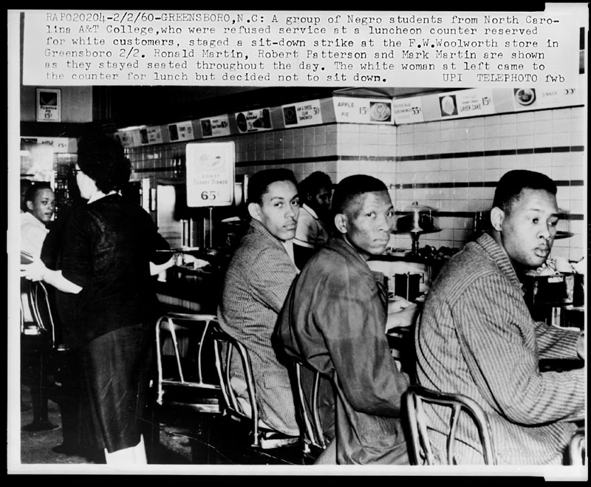

Source: Library of Congress. NYWTS - SUBJ/GEOG--Racism [item] [P&P]

Document C
“An individual who breaks a law that conscience tells him is unjust, and who willingly accepts the penalty of imprisonment in order to arouse the conscience of the community over its injustice, is in reality expressing the highest respect for the law”

– Martin Luther King Jr.

Document D

The Occupy movement is dead . . . But why?
One reason, it seems to me, is that the Occupy protesters were purposely — even proudly — rudderless, eschewing leadership in favor of broad, and thus vague, consensus. It’s hard to get anything done without leaders. A second is that while they had plenty of grievances, aimed mainly at the “oppressive” power of corporations, the Occupy protesters never got beyond their own slogans.
But the main reason is that, ultimately, Occupy Wall Street simply would not engage with the larger world. Believing that both politicians and corporations were corrupt, it declined to dirty its hands by talking to anyone in power. The takeover of the park — especially as the police threatened to force the protesters out — became an end in itself rather than the means to something larger. Occupy was an insular movement, whose members spoke mainly to each other.
From: “Two Days in September”, By JOE NOCERA Published: September 14, 2012

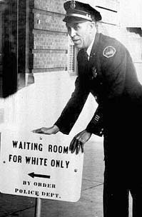
Document E
[AP photo (Jan. 9, 1956)]

Documents F, G, and H are created for the fictitious country of Country M for the purpose of this assignment. They are not representative of documents of an actual country.

Document F

Document G

Document H

“All we are asking is for is that all men and women to have the same rights as those who are now in power. We will shut down this economy in order to get these rights.

Not only will we stop working, we will stop paying taxes, stop riding the trains, stop riding the buses, and stop doing anything that supports the Country M economy. When this economy fails then the rich will be poor and be forced to provide equal rights to all.”

Social media posting from a member of the movement for equality in Country M

Sign posted by the Country M Government

Civil Disobedience

Is Still

Disobedience

Keep Country M Safe - Obey the law.

“. . . the lawlessness of the few troublemakers will not be tolerated by the law abiding citizens of Country M. We will act as necessary to keep them from tearing apart our country.”

Statement from the Citizens Against Country M Lawlessness

