Sequencing of Services Flow of Services: Individual Student Level
Student Name: ______________________________________________________
Date: ____________________________ Age: ______________________________
Post-secondary Vision: ________________________________________________
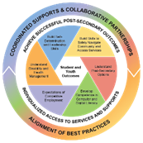

Build Self-Determination and Leadership Skills
Build Skills to Safely Navigate the Community and Access Services
Understand Post-Secondary Education and Training Options
Develop Competence in Computer and Digital Literacy
Expectation of Competitive Employment
Understand Disability and Health Management

Roles & Responsibilities of:
Education
Vocational Rehabilitation

Family

Interagency Transition Team Members:

Name: ___________________ Date: _________________
Contact: ________________________________________
Role: _______________________

Name: ___________________ Date: _________________
Contact: ________________________________________
Role: _______________________

Name: ___________________ Date: _________________
Contact: ________________________________________
Role: _______________________

