Student Profile

To what do you attribute your student’s reading difficulties?
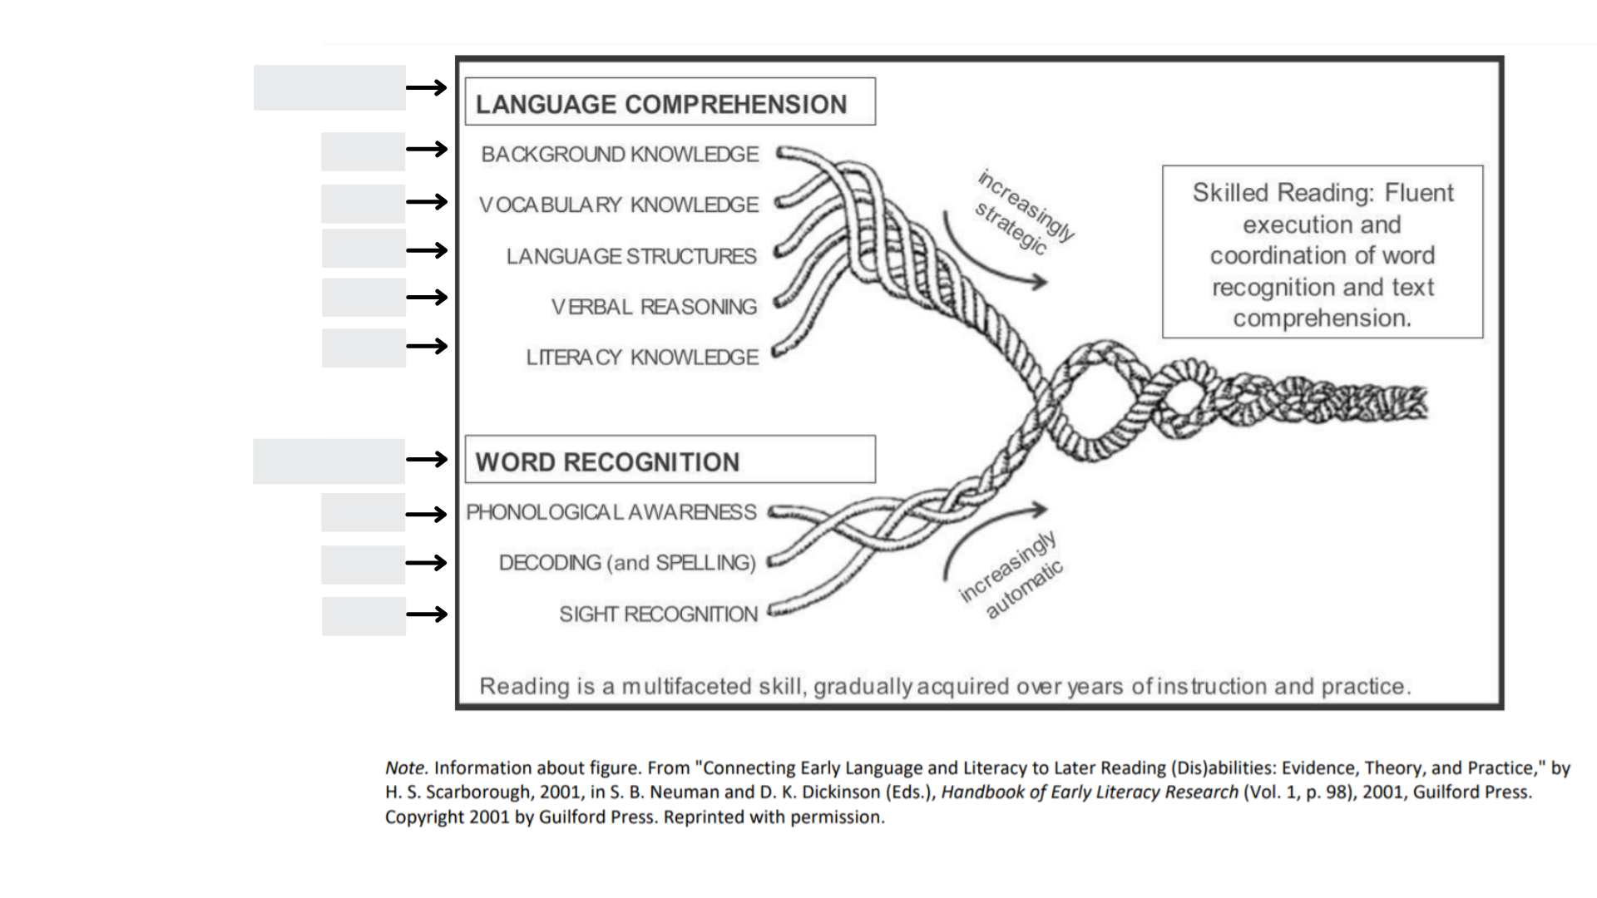
Comments:
Student:
Oral Language |  | Phonological and Phonemic Awareness
Questions to consider:  What do you notice about the students’ oral language? How might oral language strengths or needs be related to the child’s reading performance?  What oral language structures could be beneficial to support the student’s language development? | Observations: | Questions to consider:  What data do you have about the student’s phonemic awareness skills? What more might you need to know?  How might skill deficiencies in phonemic awareness be affecting the students’ reading performance, and how are these needs being addressed?  What plan of action is needed to address skill deficits in phonemic awareness? | Observations:
Assessment data: |  | Assessment data:
Current supports: |  | Current Supports:
Questions/Next Steps: |  | Questions/Next Steps:

Student:
Phonics |  | Advanced Phonics/Word Study
Questions to consider:  What data do you have about the child’s decoding skills? What more might you need to know?  Does the student have underlying phonemic awareness concerns that may be contributing to a problem with word level decoding?  How might skill deficiencies in phonics be affecting the students’ reading performance, and how are these needs being addressed?  What plan of action is needed to address skill deficits in phonics? | Observations: | Questions to consider:  What information do you have about the student’s knowledge about syllable types?  How does the student attack multisyllabic words?  Does the student have knowledge of prefixes and suffixes?  What additional information do you need, and how does what you know about this student’s skills connect back to your notes from previous learning? | Observations:
Assessment data: |  | Assessment data:
Current supports: |  | Current Supports:
Questions/Next Steps: |  | Questions/Next Steps:
Student:
Fluency |  | Vocabulary
Questions to consider:  What do you notice about your students’ fluency with grade appropriate material?  (think about all levels of fluency - grapheme, word, phrase, sentence/connected text levels)  How does the child’s fluency connect back to prior skill deficiencies or strengths?  What supports for fluency might benefit the student? | Observations: | Questions to consider:  What data do you have about the child’s vocabulary knowledge? What more might you need to know?  Does the student have underlying vocabulary concerns that may be contributing to a problem with language comprehension?  How might deficiencies in vocabulary knowledge be affecting the students’ reading performance, and how are these needs being addressed?  What plan of action is needed to address skill deficits in vocabulary? | Observations:
Assessment data: |  | Assessment data:
Current supports: |  | Current Supports:
Questions/Next Steps: |  | Questions/Next Steps:

Student:
Sentence and Text Structure |  | Text Structure
Questions to consider:  What information do you have about your student’s comprehension at the sentence level?  Does the student’s writing provide insight into any concerns at the sentence level?  Do complex or complicated sentences seem especially difficult for the student to navigate? | Observations: | Does the student struggle making sense of cohesive devices (pronoun referents, word substitutions, ellipses)?  Does the student understand the difference between narrative and informational text structures?  Does the student know and use various text features appropriate to his/her grade?  Does the student understand patterns of organization change among texts, or do these changes create confusion for the student? | Observations:
Assessment data: |  | Assessment data:
Current supports: |  | Current Supports:
Questions/Next Steps: |  | Questions/Next Steps:

Student:
Comprehension Strategies
Questions to consider:  Is the student able to recall basic information accurately from the text?  Is the student able to make inferences from text?  Can the student accurately categorize information from text?  Can the student retell a story in the appropriate sequence?  Can the student accurately identify the main idea and supporting details in informational text?  Does the student summarize information from text effectively?  Is the student able to answer questions about text effectively?  Does the student generate appropriate questions about text?  For both text read aloud and text read independently:  - In general, does the student seem to have sufficient background knowledge to effectively access grade level content and topics?  - When reading aloud, does the student make unresolved decoding errors that indicate he/she is not monitoring for understanding?  - Does the student appear to use metacognitive strategies to “fix up” understanding when engaging with text? | Text Read Aloud Text Read independently | Observations:
Assessment data: |  | Questions/Next Steps:
Current supports:

Summary
Review your student notes for all areas of the Reading Rope:
Where is the student's earliest area of concern?
What goals and objectives for support will best address the student’s needs?
What targeted intervention or additional supports will the student need to make progress towards targeted goals?
How will you know if the student is making progress adequate for closing the gap?

Student profile summary:

