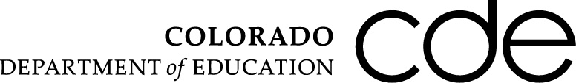
Memo
To: Colorado School Districts and Charter Schools
From: Rebecca Holmes, Associate Commissioner of Innovation, Choice and Engagement
Date: August 28, 2013
Re: Charter schools seeking waivers to 22-32-109(1)(kk), the state board adopted graduation guidelines.

A charter school may operate free from specified state rules and statutes as provided in section 22-30.5-104(6)(b), C.R.S. The graduation guidelines, specified in section 22-32-109(1)(kk), C.R.S., do not fall in an area of statute identified by the State Board of Education as an automatic waiver. The graduation guidelines also do not fall in any of the areas of statute for which charters may not seek waivers. This means that any request for a waiver from this area of statute would need to be presented to the State Board of Education for review and approval or denial.

In reviewing all waiver requests, the State Board of Education must consider whether the waiver would, “enhance educational opportunity and quality within the school district…” section 22-2-117(1)(a), C.R.S. In doing so, the staff at the Colorado Department of Education recommends that the State Board of Education consider waiver requests in which a charter school seeks to set out different graduation requirements than its district, but the school’s graduation requirements still meet or exceed rules adopted by the State Board of Education related to state-wide graduation guidelines.

This same flexibility could be accomplished by any charter school by seeking a waiver from its district graduation policies in its negotiated charter contract. Many charter schools already had waivers from district graduation policies prior to the adoption of the graduation guidelines by the State Board of Education. Charter schools and their authorizers may therefore determine that waiving the state statute and creating a replacement plan is unnecessary.

For schools that wish to seek the waiver from the state, there is a complicating timeline issue. Districts do not need to identify their plans for meeting or exceeding those criteria until 2014-15. Therefore, it is unlikely that the State Board of Education would be able to identify what a school would be waiving with this request until the fall of 2015. The staff of the Colorado Department of Education therefore recommends that the State Board of Education not consider applications for waivers to this area of statute until the content of the state and district adopted requirements have been completed.

For further questions on this matter, please contact Kelly Rosensweet at Rosensweet_k@cde.state.co.us.

Thank you,
Rebecca Holmes

