Concurrent Enrollment Advisory Board
Meeting Minutes

Date: October 24, 2019
Time: 1:00-4:00pm

Location:
Community College of Aurora
Centretech Campus, Fine Arts Bldg, Room F100
16000 Centretech Parkway
Aurora, CO 80011

Present Absent |  | Present Absent
P | Brandon Protas | P | Mark Thompson
 | Dan Hoff | P | Rebecca Fernandez Martinez
 | Danny Martinez | P | Renise Walker
 | Diana Zakhem | P | Sarah Heath
P | Georgia Reagan |  | Sheri Bryant
 | Heather Exby |  | Susan Clough
P | Kimberly Caplan | P | Tammy Ward
P | Bobby Pace | P | Dahl Gehle

Andy Tucker, Carl Einhaus, Michelle Romero, Mary Anne Hunter

Welcome & Minutes Approval

-Meeting called to order at ____.
-Dahl moved to pass minutes. Bobby second.

CDE Updates – Andy Tucker

Introduction – Michelle Romero, Concurrent Enrollment Coordinator
Concurrent Enrollment statewide, comprehensive website for students and parents.
Michelle has met with CDHE (Carl) and CCCS (Tammy) reps to evaluate the easy and heavy lifts, based on the minimum requirements in statute. Also met with CDE web developers to receive training and access to content management system to upload content. She will attend several conferences and meetings to gather secondary and post-secondary feedback, including possibly creating a CE Website workgroup from members of the CCCS CE Workgroup. Michelle is also asking HS counselors for student and parent focus groups to receive their input as they test the website before it goes live. The following minimum requirements were shown (below):
Concurrent Enrollment Website Requirements
SB 19-176

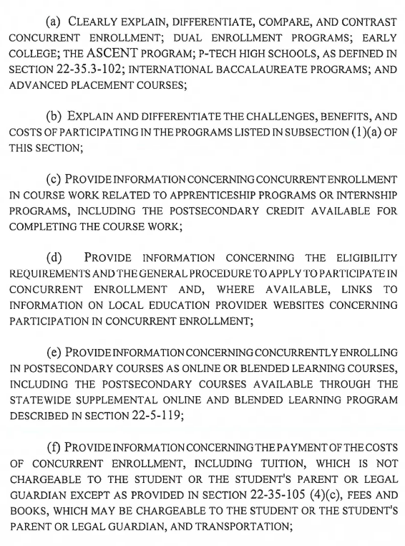

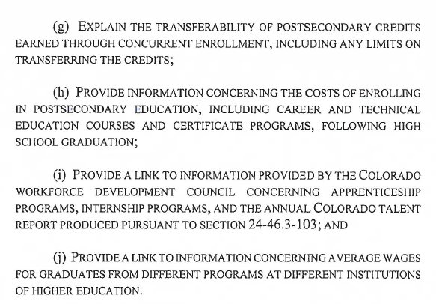

Michelle would like the CEAB to review the website pieces as they are built.
- SB 19-176 – CE Expansion & Innovation Grant Program
-Successful application webinar for potential applicants on Oct. 2, 50-60 participants. Recording of webinar online at CDE CE website.
-Letter of Intent (LOI) deadline on Oct 11, 60+ LOIs. Pleased with interest.
-Grant application is Nov. 4.
-Review of applications on Nov. 20, looking for reviewers. Link to apply to review on CDE CE website. Flyer with information handed out. Information to apply will also be posted on CDE CE/ASCENT Google group.
- SB 19-176 – Q&A Document Review
Andy shared the collaborative work being done to complete the SB19-176 FAQs. Current draft is in the AG’s office. Once it is returned, the FAQs document will be shared with the CEAB to provide their input. Anticipating release of FAQs by Thanksgiving.

CDHE Updates – Carl Einhaus

- Free College Application Day
-2nd annual Free Application Day. Last year, the day was on Oct. 30. Received just under 23,000 applications. It was a new initiative.
-This year had promotional materials ready. Held on Oct. 15. Received over 44,000 applications (preliminary #). Will most likely double last year’s #. Carl wants to thank the admissions offices for processing applications and HS counselors for their help with students applying.
-Due to its success, will likely continue and become part of the college-going culture. This is part of Colorado Applies Month, prepares students to apply for college and the FAFSA. Stay tuned for improvements.
-How do we know it’s successful? CDHE is working with colleges to determine enrollment from Free Application Day, retention, and graduation. Will take years to determine full impact on success, however, it has been successful in Colorado students finding higher education more accessible. They are applying to institutions they normally may not have.
-Some private institutions participated this year as well.
-CCCS colleges always have free applications. But last year, ACC started offering free transcripts on Free Application Day. Others are joining in for a 2-week period. Hoping others join in.
Question from Mark Thompson: do students only have that one day to start and finish their application? Per Carl, students have to submit by that date. They are welcome to begin whenever. Will review future promotional materials to make sure that is clear.
- Test Optional
-Commission on Higher Education meeting held today. Building up to legislative session. One item being considered is going test-optional as a state for admissions. 4-year institutions would have the option, if they wanted to, to not require a test score as part of the admissions process. Students would not have to submit an ACT/SAT as part of admissions.
-National research has shown this change increases student populations on college campuses such as minority and low-income. Also, these students persist and graduate at the same rate or higher than students who do submit test scores. Increasing in prevalence across the nation.

Sarah mentioned SAT is a required assessment in Colorado for state accountability. Carl followed up with the SAT is still important for course placement and pre-requisites, and benchmarking for student progress.

Discussion on potential consequences of change including using HS GPA as a measure for placement.

CE Credit for Work Based Learning (WBL) – Marty Goldberg, Dir. of Concurrent Enrollment, Front Range Community College
- Presentation
Marty presented how FRCC awards college credit for WBL. First, they attach the WBL experience to a for-credit Internship course. For example, many of their CTE programs offer a 280 Internship. Although other courses do not, they could.
-Requirements – the internship must:
1. Align with the course of study the student is pursuing
2. Be in a course of student that allows internship credit
3. Be specific learning outcomes defined for the experience
4. Include sufficient hours working in the subject area to earn college credit
Students must be enrolled for the Internship course in the semester when the work experience takes place and tuition must be paid for the credits earned.
Process Outline
1. Identify the WBL opportunity (initiated by student, department, industry)
-identify learning opportunities (IHE staff works with WBL partner)
-check alignment with student’s course of study
-partnership with hiring manager and faculty member to develop the job description and performance rubric
2. Complete and sign off on the internship application (contract)
-45 work hours per credit hour earned
-Most allow up to 6 credits for internship credit but can be 1-12 credits
-Question: do students have credits in course of study before? Yes, FRCC typically requires some progress toward a degree, the fundamental skills before Internship. Outside of P-TECH, these WBL are in a student’s last semester.
3. Faculty and hiring manager touch base at regular intervals
4. Hiring manager submits final performance review to faculty
5. Faculty meets with student, measures performance vs rubric, and assigns student a grade.

Another way may include Prior Learning Assessment (PLA) credit as well.

Question: Since this is CE, do LEPs pay for this credit? FRCC: Yes, students register for these 280 courses of x # of credits and the district covers the tuition.
Question: Will the faculty or secondary staff do observations? FRCC: Neither. The hiring manager supervises the student at the worksite and has conversations with the faculty member to determine the performance and grade.

Question: What about liability issues at the work-site from the secondary-side? FRCC: Needs to be negotiated in advance. Being that it is a college class, that may be mitigated. Will vary with individual districts.

Discussion on what FRCC is doing being innovative and wanting to encourage others to implement.

Previous discussions follow up

- CEAB summer workgroup draft recommendations for future CE and ASCENT legislation
CEAB members met as a workgroup in September to discuss items brought up in August 2019 meeting, including potential legislation suggestions. Result: CEAB recommendations drafted for full board review and vote.

Recommendations do not meet lobbying but if anyone were to ask what the desire of the CEAB when it comes to a particular bucket.
1. ASCENT Recommendations
The Concurrent Enrollment Advisory Board recommends to the JBC to create a new process for ASCENT allocations and fund a “pay it forward” year, in essence to fund an one time two year allocation so that the timeline is more user friendly to identify students and encourage their participation before other postsecondary deadlines including financial aid occur.
Move to approve recommendation: Mark. Second: Rebecca. Approved unanimously.

The Concurrent Enrollment Advisory Board recommends to the JBC to expand the funding for ASCENT to fully fund for all qualified students that apply.

Move to table recommendation: Sarah. Second: Dahl. Approved unanimously.

2. Matriculation Recommendations
The Concurrent Enrollment Advisory Board recommends to CDHE and CDE to include in the Concurrent Enrollment Annual Report the completion rate, time to completion, matriculation to additional postsecondary of ASCENT students.
Move to approve recommendation: Mark. Second: Tammy. Approved unanimously.
The Concurrent Enrollment Advisory Board recommends to CDHE to include a specific report about ASCENT students in the ROI Report.
Move to approve recommendation: Mark. Second: Tammy. Approved unanimously.

3. Teacher Qualifications Recommendations
The Concurrent Enrollment Advisory Board recommends to CDHE and CCCS the creation of a multi-institution work group to identify or create accessible statewide programs for educators to achieve HLC faculty qualification requirements for instructing Concurrent Enrollment.
Move to approve recommendation: Tammy. Second: Rebecca. Approved unanimously.
The Concurrent Enrollment Advisory Board recommends the creation of policy to have the courses identified in the previous recommendation offered at the Community College Tuition Rate with the goal of creating a statewide reimbursement process for years of service in the future.
Move to approve recommendation: Tammy. Second: Mark. Approved unanimously.

The Concurrent Enrollment Advisory Board recommends communication to (overall CASE) CASBO and other Human Resources Officers to review the HLC faculty qualification requirements for instructing Concurrent Enrollment to advise prospective masters participants.
Move to approve recommendation: Mark. Second: Dahl. Approved unanimously.

4. Telepresence and Other Online Programs PD and Promising Practices
The Concurrent Enrollment Advisory Board recommends to CCCS staff to gather qualitative data on current practice in offering “telepresence” and online programs and once programs are reviewed, offer professional development and showcase promising practices at various conferences and events.
Move to approve recommendation: Tammy. Second: Sarah. Approved unanimously.

5. CEAB Policies & Procedures (internal recommendations)
The members present recommend that a work group meet annually during the end of summer - early fall to create recommendations to the full board for consideration. A meeting date and location will be established at the April meeting annually.
The members present recommend that the Concurrent Enrollment Advisory Board Handbook be updated and orientation materials be created for new board members.
- Improving CE Next Steps prioritization from DHE Annual Report
One of the main responsibilities of the CEAB is to provide recommendations to the legislative body on improvements to CE and ASCENT. The method in the past was to include these recommendations in the CDHE/CDE Annual CE Report, Next Steps section. Carl suggested the previous recommendations may be included in the next annual report.

- New Members
Michelle shared details on two applicants for the newly expanded governor’s appointed CEAB members (# went from 3 to 5 in SB19-176). Applicants include a parent of a student in a public school and a high school student.
Sarah mentioned possibly changing the time of meetings to accommodate the student’s school schedule. Decision tabled.

Public Input
-Mimi Leonard thanks the board for the CE/ASCENT recommendations.
-Guest in the audience suggested moving Free Application Day to later October rather than mid-October, due to some schools having fall breaks. Carl mentioned the date moved up based on early scholarship deadlines. A survey was sent out to counselors asking for their choice of dates.

-Sarah noted appreciation for Renise Walker and Kim Caplan who have stepped down from the CEAB.

Action Plan and Next Steps
Ideas for next meeting(s): OER practices from colleges, SAI legislation and best practices from colleges

-Michelle suggested CEAB members attend OER workshops by CDHE to become OER Ambassadors and possibly CEAB members attend NACEP as a group. Funding unknown.

- Schedule 2020 meetings
Reviewed prior year meetings schedule to plan for 2020 meetings. Settled on holding January 23, 2020 for next meeting. Metro’s south campus offered as a tentative, future meeting location.
- Officer Elections
By-laws on officer elections reviewed. Nominations were held for Chair and Vice Chair. Tammy Ward nominated for Chair by Sarah Heath, Mark Thompson second. No other nominations. Mark Thompson nominated for Vice Chair by himself. No other nominations. Vote will be held at January 2020 meeting.

- Next meeting:
  - Date: January 23, 2020
  - Location TBD

Meeting Adjourned: ___

