Colorado’s School Counselor Corps Grant Program (SCCGP) funding is awarded to eligible school districts, BOCES, charter schools or Institute charter schools. The purpose of this program is to increase the availability of effective school-based counseling within secondary schools. Grant funds are also used to increase the level of school counseling services provided to improve the graduation rate and increase the percentage of students who appropriately prepare for apply to, and continue into postsecondary education.
Supporting Colorado’s Counselor Corps Grant
Facts and milestones

Fact Sheet
www.cde.state.co.us/postsecondary
Office of Postsecondary Readiness

Districts and Schools
- Over the six-year history of the Counselor Corps Grant Program, 153 secondary schools, representing 64 districts have participated, representing all regions throughout Colorado.
- More than 200 licensed school counselors have served Colorado schools, districts, BOCES, and students through the grant.
- Eligible grantees have a higher than average dropout rate and/or free and reduced lunch rate as compared to all other Colorado secondary schools.

Goals
- Decrease student/counselor ratios
- Increase graduation rate
- Decrease dropout rate
- Decrease remediation rate
- Increase college matriculation rate

Outcomes
Highlights from Cohorts One, Two, and Three (2008 – 2014)
- Comparable non-SCCGP schools showed increasing dropout rates and decreasing graduation rates, while SCCGP schools showed decreasing dropout rates and maintaining graduation rates over the same period of time.
  - Graduation rates increased by 5 percentage points
  - Dropout rates at School Counselor Corps secondary schools decreased by 3.7 percentage points from the baseline rate of 7.7 percent.
- Student enrolling in postsecondary within one year following high school graduation increased by 13 percent.
- Enrollment and completion of academic, postsecondary, and career and technical courses increased by 284 percent or 83,396 students.

About Students
- More than 128,000 students have been served through the schools and districts represented in the SCCGP cohorts.

- Approximately, 60 percent of these students participate in the free and reduced lunch program.

School Counselor Research and Promising Practices
- As found through the Colorado School Counselor Corps efforts, national research reinforces that the presence of effective school counseling has a dramatic impact on the academic success of students.
- Research shows (Belasco, 2013):
  - Low-income students are more likely to attend college if they met frequently with a school counselor who supported their college goals.
  - Students attending high schools with fully implemented school counseling programs earned higher grades and received more college-related information, which improves enrolling and persisting in postsecondary education.
  - School-based college counseling is shown to narrow the college participation gap.

District Map of Counselor Corps Participants 2008-2014

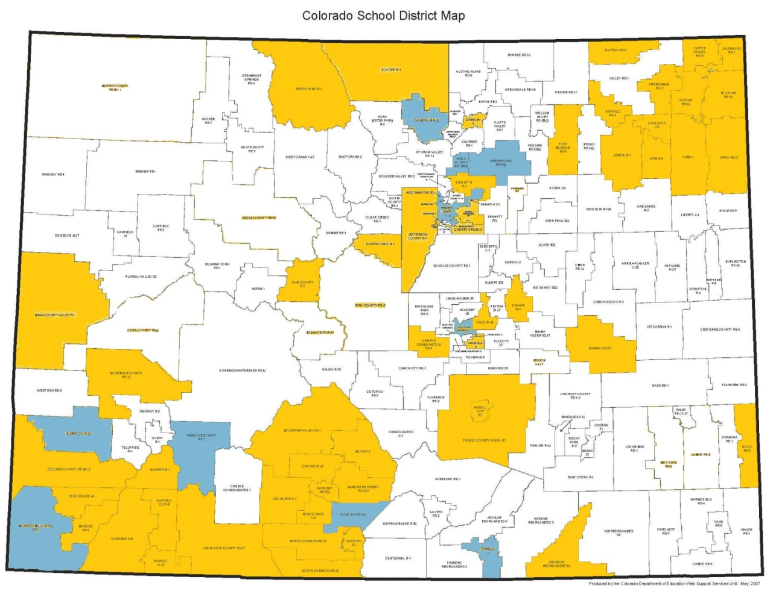

The Colorado Department of Education
201 E. Colfax Ave., Denver, CO 80203 • 303-866-6206 • ruthven_m@cde.state.co.us

