Self-Assessment Survey (SAS) Instructions for taking the survey and Retrieving Reports

SAS survey is intended to be taken by the entire staff (If you are not a pbisapps coordinator, survey window needs to already be opened for you from CDE)

Taking the Survey/Sending out the link

Step 1: go to pbisapps.org

Step 2: in the upper right hand corner click login

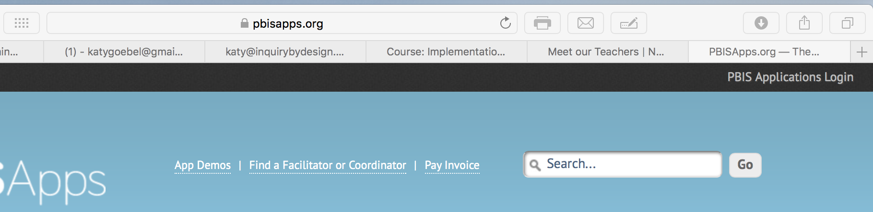

Step 3: After you login select the PBIS Assessment tab
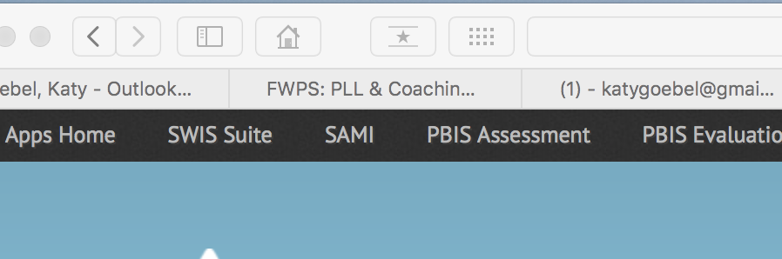

You should now see this window,

Step 3: Select “dashboard” from the top tabs
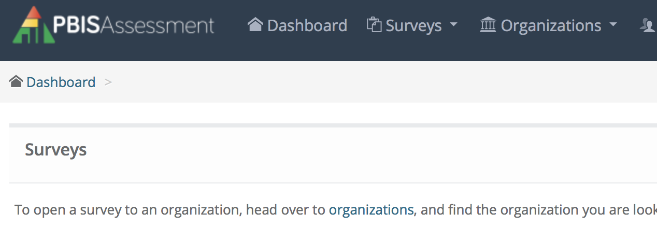
Step 4: Under Open Surveys Window select “Self-Assessment Survey 3.0”

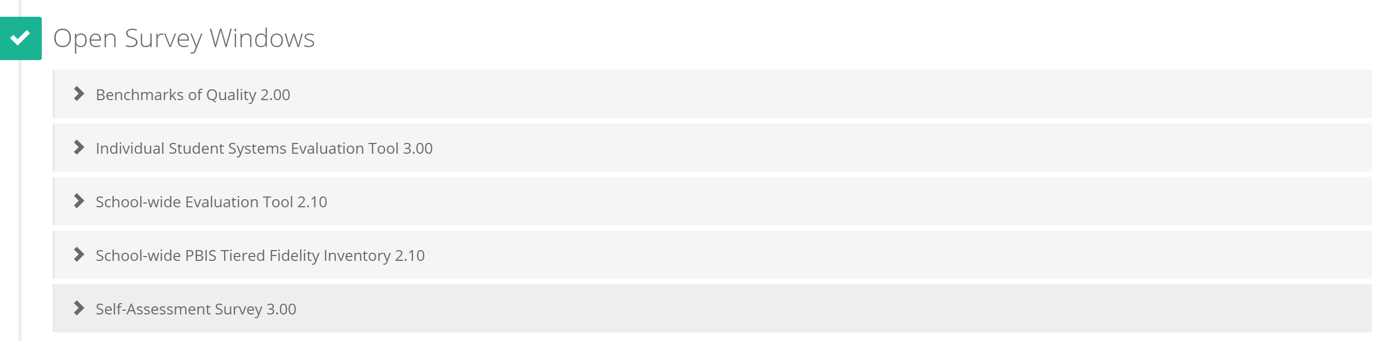

Step 5: Locate the school you want to take the survey and click “Link”

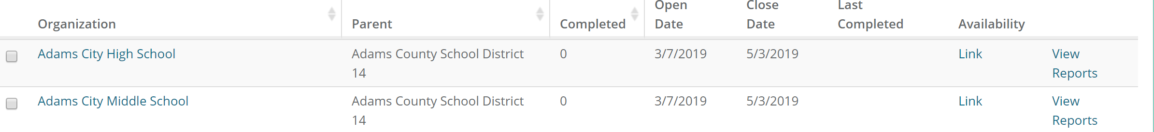

Step 6: You will have a choice, you can take the survey yourself or get the link using the “Copy URL” option to send to others. If you are a staff member in the school, it is always advised to take the survey first before sending out the link to familiarize yourself with the survey. Staff members will be able to take the survey by clicking the link once you send it to them.
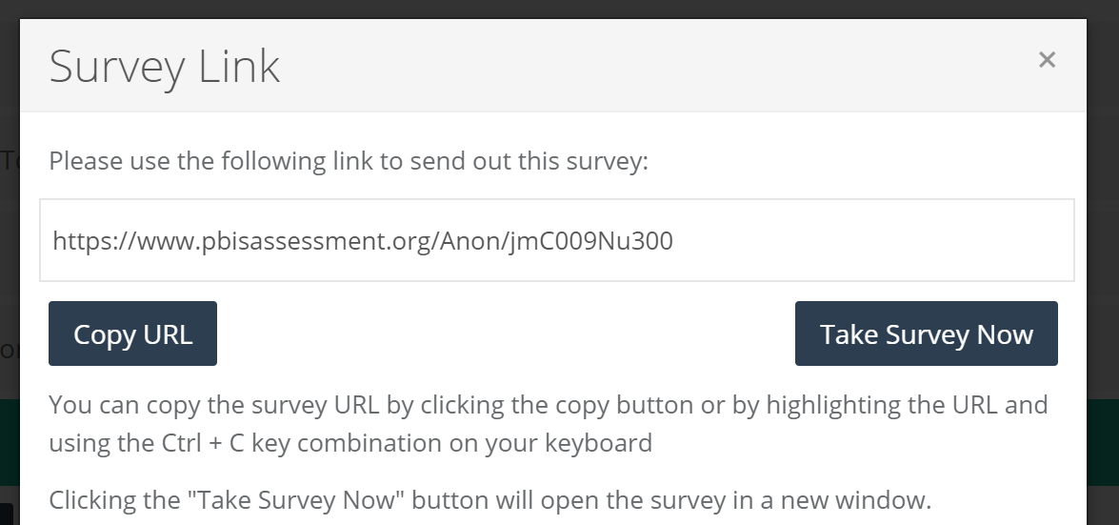

Step 7: follow the instructions on the survey and click submit when finished,

ONE final Note: You can keep your school apprised of how many staff members have taken the survey by looking here. Based upon this number, you may choose to extend the close date to allow for more respondents. You want at least 60% to take the survey so that results can be valid:

Retrieving Survey Reports
Follow Steps 1-2 above

Step 3: Click on the “Reports” tab
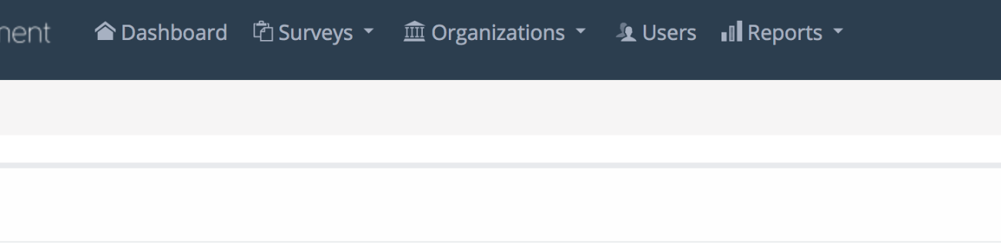
Step 3: Select “Survey Reports” from the drop-down menu

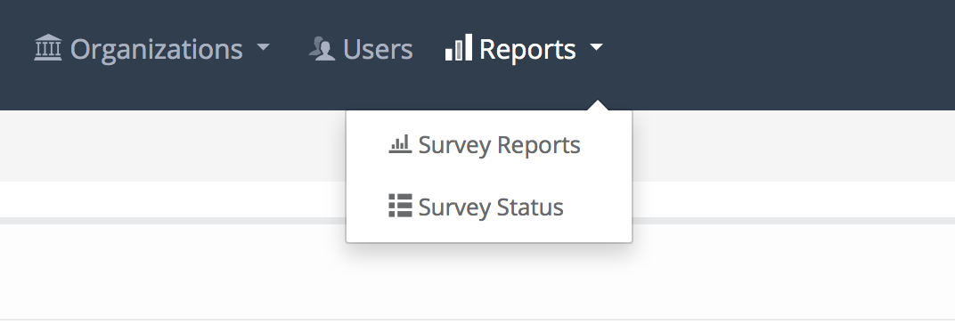
Step 4: Click select survey and find SAS. Next, select which report you want to view (total, subscale, and item). Decide the range you would like to view. You can view up to 5 years on a single report.
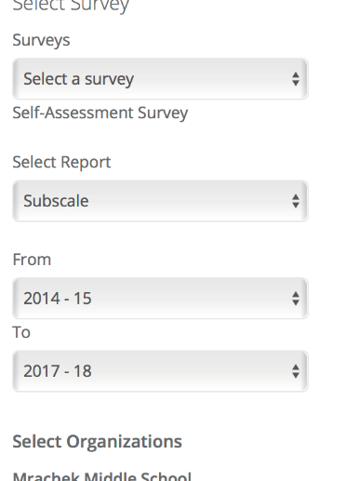

Step 5: Select organization, school district name, and school name
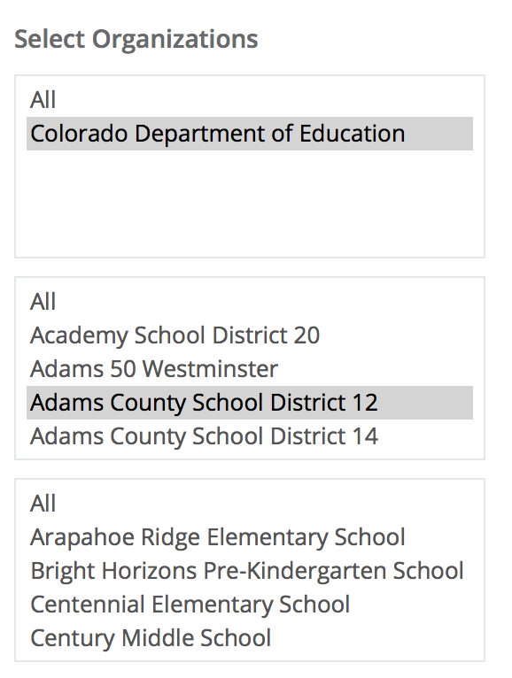

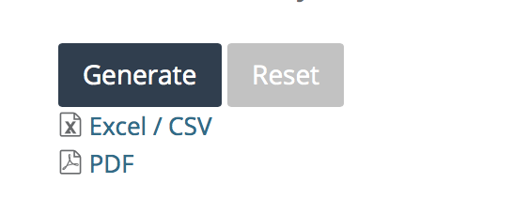
Step 6: Click generate report (to save and / or send reports select PDF and it will download to your computer)

