Positive Behavioral Interventions and Supports (PBIS)
within an
Multi-Tiered System of Supports (MTSS) Framework:
Check-In/Check-Out Training

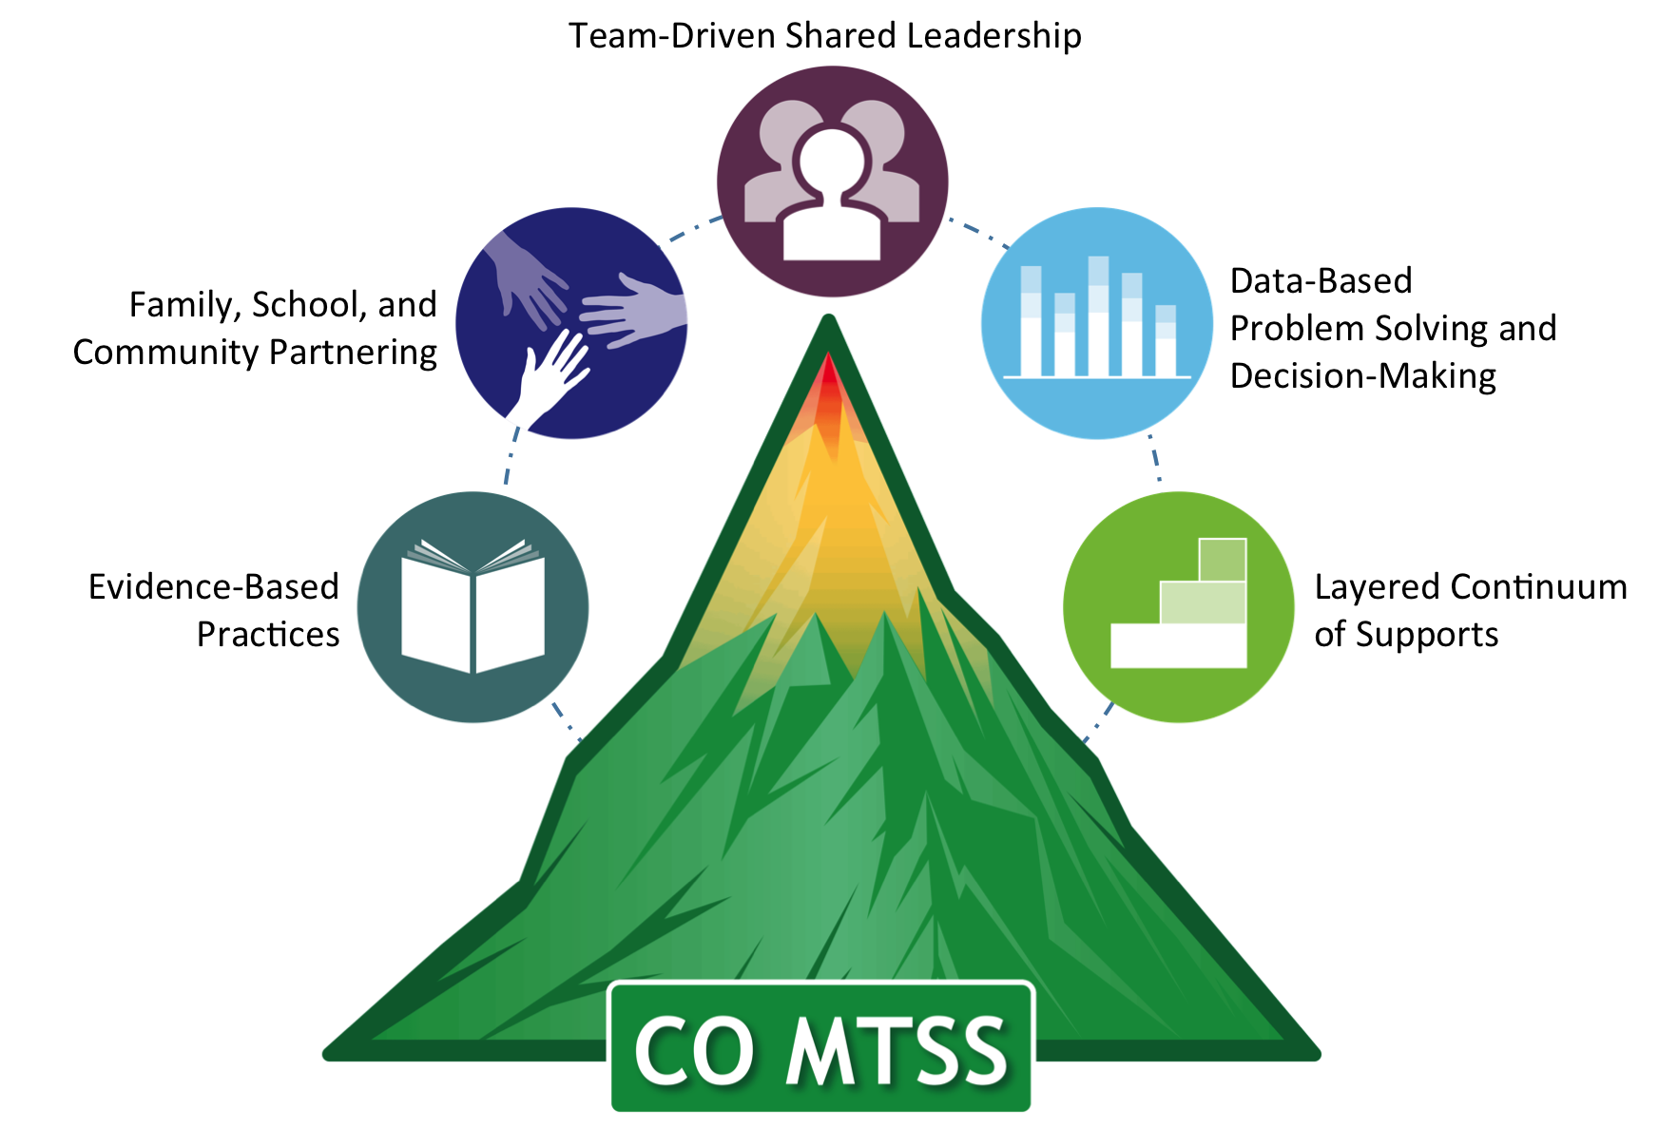

Supplemental Packet

Table of Contents

Activity 1. Goal for Today 3
Features of Tier 2 Interventions 4
Partner Work 5
Activity 4: Systems Thinking 5
Example Data Matrix for Pre-Existing Data 5
Example Teacher Nomination Form 6
Brief Functional Behavior Assessment Interview 7
Activity 5: Data Matrix 9
Questions that Tier 2 Teams Ask 10
Activity 6: Table Brainstorm 10
Activity 7: Resources and Logistics 10
Check-In / Check-Out Self-Assessment 11
CROSS-WALK DOCUMENT FOR TIER II INTERVENTION TOOLS: TFI TIER II, CICO SELF-ASSESSMENT, AND CICO FIDELITY TOOL 16
Check-In/Check-Out Fidelity Of Implementation Measure (CICO-FIM) 21

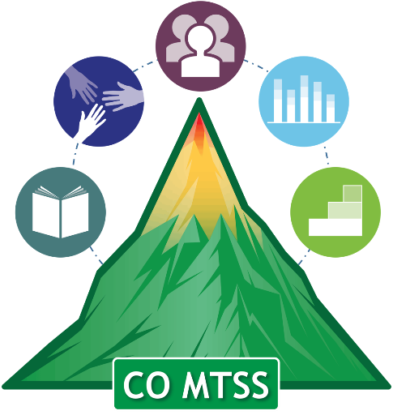
Positive Behavioral Interventions and Supports (PBIS) within an Multi-Tiered System of Supports (MTSS) Framework:
Check-In/Check-Out Intervention

Agenda
8:00 to 8:30 am | Registration
8:30 to 9:00 | Welcome and Introductions (Lynne DeSousa, Jason Harlacher)
9:00 to 10:00 | Overview of Tier 2 and Tiered Fidelity Inventory  (Jason Harlacher)
10:00-10:15 | Break
10:15-11:15 | Data and Selection for Tier 2/CICO and the Problem Solving Process  (Jason Harlacher)
11:15-12:00 | Systems, Practices, and Products for CICO (Lynne DeSousa)
12:00-1:00 | Lunch
1:00-2:15 | Systems, Practices, and Products for CICO (Lynne DeSousa)
2:15-2:30 | Break
2:30-3:10 | Outcomes: Monitoring and Measuring Implementation and Impact of CICO (Lynne DeSousa)
3:10-3:30 | Wrap-up, Kahoot (Lynne DeSousa; Jason Harlacher)

Activity 1. Goal for Today
What is a goal you have for today? What do you want to get out of this training today?

Features of Tier 2 Interventions

Feature | Description
Explicit instruction of expectations/skills | Teach the student exactly what is expected using examples and non-examples to illustrate appropriate from inappropriate behaviors. This often involves defining behaviors, role plays, and feedback during initial intervention implementation as well as regularly throughout.
Structured prompts for appropriate behavior | This might include reminders of expected behaviors, visuals or cues on a point card.
Opportunities to practice the skills | Skill practice should be embedded throughout the school day and across relevant environments (and not just in an isolated instructional/skills group setting).
Frequent feedback to the student | Students should receive positive and corrective feedback at regular intervals throughout the school day on the expectations or skills being targeted (usually at least once per period or subject area). Feedback should be contingent and specific and focus on positive interactions.
Mechanism to fade support | This often involves reducing the number of times the student is prompted or receives feedback about a skill. It can also involve increasing the interval between delivery of acknowledgements or rewards associated with success.
Communication with students’ parents | Efforts to include or communicate with parents might include brief notes home on a daily or weekly basis, phone calls, emails, student success post card mailers or other quick, culturally relevant communication forms.
Source: Harlacher & Rodriguez, in press; Adapted from Anderson & Borgmeier, 2010.

Activity 2: TFI
- As a team, complete the Tiered Fidelity Inventory (TFI) for Tier 2
  - Talk as a team about each item
  - Rate each item 0, 1, 2
- Once completed, prioritize items that your team wants to focus on

Activity 3: Problem Solving Culture
- Our goal is to create a problem solving culture within your site
- What does “problem solving culture” means to you? Include a list of 3 words and write them down

Partner Work
- First person: Answer in 45 seconds
- Second person: Use active listening.
- When partner is done, summarize what you heard in 30 seconds.
- Then change roles

Activity 4: Systems Thinking
- Why is it important to also consider systems-level problem solving?

Example Data Matrix for Pre-Existing Data

Measure | Low Risk | Some Risk | At Risk
Major ODRs | 0-1 | 2-5 | 6 or more
Minor ODRs | 2-4 | 5-12 | 13 or more
Absences | 5/semester | 6-9/semester | 10+/semester
Tardies | 3/semester | 4-9/semester | 10+/semester
Suspension | 0 | 1 | 2
Course Grades | 2.5 or higher | D or F in one course | 2 or more Ds or Fs in courses
Adapted from MO SWPBIS

Example Teacher Nomination Form

Student’s Name: __________________________________________ | Date: __________
Teacher: ________________________________________________ | Grade: _________
Please describe the students’ strengths:

Please fully describe the behavior(s) of concern:
a.) What does the problem behavior(s) look like? Please describe.
b.) How often does the problem behavior(s) occur?
c.) How long does the problem behavior(s) last when it does occur?
d.) What is the intensity/level of danger of the problem behavior(s)?
e.) What do you think reinforces the behavior?
f.) What settings or situations is the behavior most likely to occur?
g.) What settings or situations is the behavior least likely to occur?

Please describe any previous strategies or interventions used to address the behavior(s).

How successful were they?

How do you want the team to support you?

Brief Functional Behavior Assessment Interview

1. What is the behavior of concern? Please describe the behavior in concrete, observable, and measurable terms.
2. How often does the behavior occur daily? Circle one.
A. <1
B. 1–3
C. 4–6
D. 7–9
E. 10–12
F. >13

Antecedents
Think of the things that occur before the behavior and respond to the following questions. If the answer to a question is yes, further describe the behavior or situation.
1. Does the behavior occur during a certain type of task?
2. Does the behavior occur more often during easy tasks?
3. Does the behavior occur more often during difficult tasks?
4. Does the behavior occur more often during certain subjects?
5. Does the behavior occur more often during new subject material?
6. Does the behavior occur more often when a request is made to stop an activity?
7. Does the behavior occur more often when a request is made to start an activity?
8. Does the behavior occur more often during transition times?
9. Does the behavior occur more often when a request has been denied?
10. Does the behavior occur more often when a specific person is in the room?
11. Does the behavior occur more often when a specific person is absent from the room?
12. Are there other behaviors that precede the behavior?
13. Are there events at home that seem to precede the behavior?
14. Does the behavior occur more in certain settings? Circle all that apply.
a. Large group
b. Small group
c. Independent work
d. One-on-on interaction
e. Common areas
f. Lunch/cafeteria
g. Other:

Consequences
Think of the things that occur after the behavior and respond to the following questions. If the answer to a question is yes, further describe the behavior or situation.
[AQ: These aren’t questions below; please reword for clarity. see changes]
1. Does the student receive access to a preferred activity?
2. Does the student receive access to a preferred object?
3. Does the task the student was given stop?
4. Is the student’s behavior ignored?
5. Is the student removed from the setting (that is, given time alone)?
6. Does the student receive attention from classmates or peers?
7. Does the student receive teacher attention in the form of
A. praise?
B. redirection?
C. interrupting the teacher?
D. a reprimand?

Is there any task that you stopped presenting to the student as a result of the behavior?
Does the student receive any sort of positive benefits or attention from the behavior?

Strategies Attempted:

Environmental Arrangements
__ Teach desired behavior  __ 5 to 1 positives  __ Preferential Seating  __ Pre-correction  __ Proximity praise  __ Prompts/signals  __ Class discussion | __ Provide extra support: What  support? ________________  __ Modified Assignment: How?  ________________________  __ Clarify rules  __ Practice Expected Behaviors  __ Breaks | __ Self-management program  __ Behavior Contract  __ Other: ________________  _______________________

Positive Rewards Other Consequences
__ Increase tangible rewards and tokens  __ Used group contingencies  __ All stars  __ Hoorays!!! How many? _______  __ Systematic feedback about behavior  __ Other: _________________________ | __ Reprimands  __ Removal of privileges  __ Time outs  __ Owed time  __ Apology/Self-reflection  __ Individual meeting with student  __ Contact parent—How many calls? ____  __ Meeting with parents—How many? _____  __ Office referrals—How many? ____  __ Other: ______________________________
Source: Adapted from Steege & Watson, 2009.
See also https://sites.google.com/a/pdx.edu/basicfba/

Activity 5: Data Matrix
Discuss as a team:
- What are pre-existing data and criterions?
- What are indicators that CICO would be appropriate for a given student?
  - What are indicators that CICO may not be appropriate for a given student?

You may also work as a table to complete this activity for your respective site.
- List out all of the data that you gather on students, such as grades, office referrals, attendance, etc.
- Then identify appropriate thresholds for each level of risk. This should be based on research and criterion-based evidence, but your team can draft logical criterion as a start.
- Finally, decide which data is most relevant for identifying which students may need additional support.

Measure | Low Risk | Some Risk | At Risk

Questions that Tier 2 Teams Ask

 | Systems | Student
Implementation | Systems-Implementation:  - Who is on the team?  - When/where does the team meet?  - What interventions are available at Tier 2?  - What training and support is provided to staff?  - Fidelity of interventions overall is at least 90%? | Student-Implementation:  - How does a student receive Tier 2 services?  - What is the process?  - What paperwork is needed? Who completes it?
Impact | Systems-Impact:  - 10-15% of student population need Tier 2?  - At least 80% of students in Tier 2 are successful? | Student-Impact:  - Which students needs interventions?  - What intervention does a given student need?  - What is the progress of a given student?  - Is a given group of students successful with Tier 2?
*Note: Not an exhaustive list of questions

Activity 6: Table Brainstorm
- A teacher made a request/nomination for a student to be in the CICO intervention within 5 days.
- What systems or processes are ideally needed to go from point of identification to the intervention?
  - Take 10 minutes and sketch out the steps as a table, placing one step on a post-it
  - Have one person from your table place the post-its across the board in a horizontal fashion

Activity 7: Resources and Logistics
- Coordinator
- Facilitator
- System Protocols
- Name of CICO

Check-In / Check-Out Self-Assessment

School: ___________________________ Date: ___________________

Instructions: As a team, review and record each of the CICO elements. For all elements that are rated as “in progress” or “not in place” build action planning steps.

CICO Element | In  Place | In Progress | Not In Place
- Faculty and Staff Commitment for CICO

- Team Defined and Coordinator Available

- School-wide PBIS in place

- Student Identification Process for CICO

- Daily CICO progress report card developed

- Home report process defined

- Point Trading System established

- Process for collecting, summarizing and using data

- Morning check-in routine established

- Teacher check-in/ check-out routine established

- Afternoon check-out routine established

- Home review routine established

- Team meeting schedule, routine, process

- Planning for Success (fading support; establishing self-management elements)

- Planning for Individualized Support Enhancement

- Substitute Teacher routine

- Playground, cafeteria, bus routine (Other areas)

Action Plan for Completion of Start-Up Activities

Activity | Activity Task Analysis | Who | When
- Faculty and Staff Commitment | a.
 | b.
 | c.
 | d.
 | e.
Establish Team | a.
 | b.
 | c.
 | d.
 | e.
- School-wide PBS in place | a.
 | b.
 | c.
 | d.
 | e.
- Student Identification Process in Place | a.
 | b.
 | c.
 | d.
 | e.
- Daily Progress report defined  - Home Report Defined | a.
 | b.
 | c.
 | d.
 | e.
- Point Trading Systems Defined | a.
 | b.
 | c.
 | d.
 | e.

- Data Collection, Summarization and Use for Decision-making Defined | a.
 | b.
 | c.
 | d.
 | e.
Morning Check-in Routine  Teacher Check-in Check-out Routine  Afternoon Check-out Routine  Home Review Routine | a.
 | b.
 | c.
 | d.
 | e.
- Team Meeting Schedule | a.
 | b.
 | c.
 | d.
 | e.

- Process defined for moving off CICO  - Process defined for use of self-management strategies within CICO | a.
 | b.
 | c.
 | d.
 | e.
- Process defined for moving student into Individualized Support Systems | a.
 | b.
 | c.
 | d.
 | e.
- Process defined for informing substitute teachers  - Process defined playground, cafeteria, bus areas  - Other areas? | a.
 | b.
 | c.
 | d.
 | e.

CROSS-WALK DOCUMENT FOR TIER II INTERVENTION TOOLS: TFI TIER II, CICO SELF-ASSESSMENT, AND CICO FIDELITY TOOL

Overarching  Feature | TFI Tier II | CICO Self-Assessment | CICO Fidelity of Implementation
TEAMING | 2.1 Team Composition:  Tier II (or combined Tier II/III) team includes a Tier II systems coordinator and individuals able to provide (a) applied behavioral expertise, (b) administrative authority, (c) knowledge of students, and (d) knowledge about operation of school across grade levels and programs. | Faculty & Staff Commitment for CICO  Team Defined and Coordinator Available | Does the school employ a CICO coordinator whose job is to manage the CICO (10-15 hours per week allocated)?  Does the administrator serve on the CICO team or review CICO data on a regular basis?
 | 2.2 Team Operating Procedures:  Tier II team meets at least monthly and has (a) regular meeting format/agenda,  (b) minutes, (c) defined meeting roles, and (d) a current action plan. | Team meeting, schedule, routine, process | Does the school budget contain an allocated amount of money to maintain the CICO (e.g. money for reinforcers, DPR forms, etc.)?
DECISION RULES / SCREENING | 2.3 Screening:  Tier II team uses decision rules and multiple sources of data (e.g., ODRs, academic progress, screening tools, attendance, teacher/ family/student nominations) to identify students who require Tier II supports. | School-wide PBIS in place  Student Identification Process for CICO | Do students who are referred to the CICO receive support within a week?
 | 2.4 Request for Assistance:  Tier II planning team uses written request for assistance form and process that are timely and available to all staff, families, and students. | Student Identification Process for CICO | Do students who are referred to the CICO receive support within a week?
BEHAVIOR INTERVENTIONS | 2.5 Options for Tier II Interventions:  Tier II team has multiple ongoing behavior support interventions with documented evidence  of effectiveness matched  to student need.
 | 2.6 Tier II Critical Features:  Tier II behavior support interventions provide (a) additional instruction/time for student skill development, (b) additional structure/predictability, and/  or (c) increased opportunity for feedback (e.g., daily progress report). | Daily CICO progress report card developed  Morning check-in routine established  Teacher CICO routine established  Afternoon check-out routine established  Home report process defined  Home review routine established  Point trading system established | Do 90% of the students on the CICO check-in daily? (Randomly sample 3 days for recording)  Do 90% of students on the CICO check-out daily? (Randomly sample 3 days for recording)  Do 90% of students on the CICO receive regular feedback from teachers? (randomly sample 50% of student DPR’s across 3 days)  Do 90% of students on the CICO receive feedback from their parents?  Do 90% of students on the CICO report that they receive reinforcement (e.g. verbal, tangible) for meeting daily goals?
 | 2.7 Practices Matched to Student Need:  A formal process is in place to select Tier II interventions that are (a) matched to student need (e.g., behavioral function), and (b) adapted to improve contextual fit (e.g., culture, developmental level). | Student Identification Process for CICO
CONNECTION TO TIER 1 | 2.8 Access to Tier I Supports:  Tier II supports are explicitly linked to Tier I supports, and students receiving Tier II supports have access to, and are included in, Tier I supports. | School-wide PBIS in place
PROFESSIONAL DEVELOPMENT | 2.9 Professional Development:  A written process is followed for teaching all relevant  staff how to refer students and implement each Tier II intervention that is in place. | Student Identification Process for CICO  Morning check-in routine established  Teacher CICO routine established  Afternoon check-out routine established  Substitute Teacher routine  Playground, cafeteria, bus routine (Other areas)  Home review routine established | Do 90% of CICO team members state that the CICO system has been taught/ reviewed on an annual basis?  Do 90% of students on the CICO receive regular feedback from teachers? (randomly sample 50% of student DPR’s across 3 days)
DATA | 2.10 Level of Use:  Team follows written process to track proportion of students participating in Tier II supports, and access is proportionate. | Process for collecting, summarizing, and using data | Do 90% of students on the CICO receive feedback from their parents?
 | 2.11 Student Performance Data:  Tier II team tracks proportion of students experiencing success (% of participating students being successful) and uses Tier II intervention outcomes data and decision rules for progress monitoring and modification. | Planning for Success (fading support; establishing self-management elements)  Planning for Individualized Support Enhancement | Does the CICO coordinator enter DPR data at least once a week?  Does the administrator serve on the CICO team or review CICO data on a regular basis?
 | 2.12 Fidelity Data:  Tier II team has a protocol for ongoing review of fidelity for each Tier II practice. | Process for collecting, summarizing, and using data | Do 90% of CICO team members indicate that the daily CICO data is used for decision-making?  Do 90% of students on the CICO report that they receive reinforcement (e.g. verbal, tangible) for meeting daily goals?  Do 90% of students on the CICO receive regular feedback from teachers? (randomly sample 50% of student DPR’s across 3 days)
EVALUATION | 2.13 Annual Evaluation:  At least annually, Tier II team assesses overall effectiveness and efficiency of strategies, including data-decision rules to identify students, range of interventions available, fidelity of implementation, and on- going support to implementers; and evaluations are shared with staff and district leadership. | Process for collecting, summarizing, and using data | Do 90% of CICO team members indicate that the daily CICO data is used for decision-making?

Check-In/Check-Out Fidelity Of Implementation Measure (CICO-FIM)

Directions: The purpose of this tool is to measure the fidelity of implementation of Check-In, Check-Out (CICO) in a school or facility. The items in this measure will also help teams’ action plan to increase the efficacy of their CICO implementation.

Please complete the CICO-FIM one to three months after initial CICO training (Baseline) and then annually each year after training. The evaluation questions should be completed by the CICO coordinator or by the CICO school-based team. If a team completes the CICO-FIM, the team must come to consensus and provide one answer per question. It is also important to note that each question provides a prompt for a data source to be utilized to score each item. The collection of this data is not required but suggested.

Thank you for taking the time to complete this tool.

Colorado Department of Education
Positive Behavioral Interventions and Supports (PBIS)
Check-In, Check-Out Fidelity Of Implementation Measure (CICO-FIM)

Name: ____________________________________ Contact Email: _________________________________________
School: _________ _________ District: ___________________ Date: ____________
Evaluation Question | Data Source  P = Permanent product;  I = Interview; O= Observation |  | Score  0-2
1. Does the school employ a CICO coordinator whose job is to manage the CICO (10-15 hours per week allocated)? | Interviews with I  Administrator &  CICO Coordinator | 0 = No CICO Coordinator  1 = CICO coordinator but less than 10 hours per week allocated,  2= CICO Coordinator, 10-15 hours per week allocated
2. Does the school budget contain an allocated amount of money to maintain the CICO ? (e.g. money for reinforcers, DPR forms, etc.)? | CICO Budget P / I  Interviews | 0 = No  2 = Yes
3. Do students who are referred to the CICO receive support within a week? | Interview P / I  CICO Referrals &  CICO Start dates | 0 = more than 2 weeks between referral and CICO support  1 = within 2 weeks  2 = within a week
4. Does the administrator serve on the CICO team or review CICO data on a regular basis? | Interview I | 0 = no  1 = yes, but not consistently  2 = yes
5. Do 90% of CICO team members state that the CICO system has been taught/ reviewed on an annual basis? | Interview I | 0 = 0-50%  1 = 51-89%  2 = 90–100%
6. Do 90% of the students on the CICO check-in daily? (Randomly sample 3 days for recording) | CICO recording form P | 0 = 0-50%  1 = 51-89%  2 = 90–100%
7. Do 90% of students on the CICO check-out daily? (Randomly sample 3 days for recording) | CICO recording form P | 0 = 0-50%  1 = 51-89%  2 = 90–100%
8. Do 90% of students on the CICO report that they receive reinforcement (e.g. verbal, tangible) for meeting daily goals? | Interview students on CICO I | 0 = 0-50%  1 = 51-89%  2 = 90–100%
9. Do 90% of students on the CICO receive regular feedback from teachers? (randomly sample 50% of student DPR’s across 3 days) | CICO Daily Progress Reports P | 0 = 0-50%  1 = 51-89%  2 = 90–100%
10. Do 90% of students on the CICO receive feedback from their parents? | CICO Daily Progress Reports P | 0 = 0-50%  1 = 51-89%  2 = 90–100%
11. Does the CICO coordinator enter DPR data at least once a week? | Interview I | 0 = no  1 = once every other week  2 =once a week
12. Do 90% of CICO team members indicate that the daily CICO data is used for decision-making? | Interview I | 0 = 0-50%  1 = 51-89%  2 = 90–100%
Adapted from Crone, Hawken, &, Horner, 2010

