Free Meals
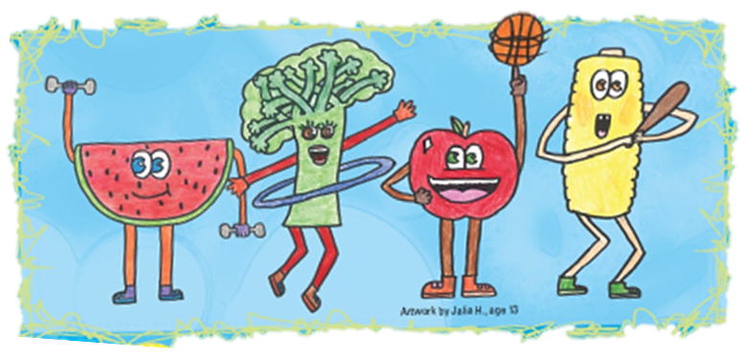
For Kids and Teens 18 and Under

Dates of operation
Breakfast: Breakfast serving time
Lunch: Lunch serving time
Snack: Snack serving time
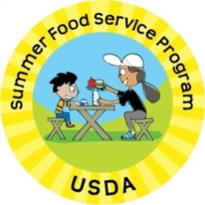
Supper: Supper serving time
Site contact information

This institution is an equal opportunity provider.

