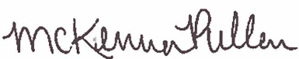
^{State of Colorado}
^{Be it known that}
Completed 1.5 hours of training in
Name
CDE and Nourish Meal Quality Training #4
April 21, 2021
Learning Codes: Menu Planning (1100), Food Production (2100), Serving Food (2200)
McKenna Pullen
Nutrition Programs Senior Consultant
Colorado Department of Education

