Solicite en línea en [Insert Webpage]
[Insert District Name] 2018-2019 Solicitud del hogar para comida escolar gratuita y de precio reducido
Llene una solicitud por hogar. Por favor usa una pluma negra o azul (no lápiz).
Mencione a todos los estudiantes que asisten [Insert District Name] (si necesita más espacios para nombres adicionales, adjunte otra hoja)

PASO 1
Niño de Head Bajo Custodia
Acogida Start Temporal Sin Hogar Migrante
Inicial
Nombre del estudiante
Apellido del estudiante
Fecha de nacimiento
M M D D A A
Grado
Marque todas las que apliquen. Lea Cómo solicitar comida escolar gratuita y de precio reducido para más información.

PASO 2
Si algún miembro del hogar (incluido usted) actualmente recibe asistencia de cualquiera de los siguientes programas: SNAP, TANF o FDPIR enumeran el número de caso a continuación.

Programa de Asistencia Nutricional Suplementaria (SNAP), Asistencia Temporal para Familias Necesitadas (TANF/Colorado Works – Asistencia Básica en Efectivo o Asistencia Alternativa Estatal), o Programa de Distribución de Alimentos en Reservas Indígenas (FDPIR). Provea el número de caso y vaya al Paso 4.

Número de caso FDPIR
Número de caso TANF
Número de caso SNAP
Informe el ingreso de TODOS los miembros del hogar (omita este paso si proporcionó un número de caso en el PASO 2)

PASO 3
¿Con qué frecuencia?
Ingreso del estudiante
$
Semanal | Cada 2 Semanas | 2x Mes | Mensual | Anual

Fecha de hoy
FIRMA del miembro adulto del hogar
Código postal
CO
Ciudad
“Certifico (doy mi palabra) que toda la información en esta solicitud es verdadera y que todos los ingresos fueron informados. Entiendo que esta información es proporcionada en relación con la recepción de fondos federales, y que los oficiales de la escuela pueden verificar (comprobar) la información. Soy consciente de que, si doy falsa información a propósito, mis hijos pueden perder los beneficios de comida, y yo podría ser procesado criminalmente conforme a las leyes estatales y federales”.
PASO 4 Información de contacto y firma del adulto. Envíe la solicitud firmada y completa a: [Insert School/District Mailing Address]
Semanal | Cada 2 Semanas | 2x Mes | Mensual | Anual

$
$
$
$
Semanal | Cada 2 semanas | 2x Mes | Mensual | Anual

$
$
$
$
Semanal | Cada 2 Semanas | 2x Mes | Mensual | Anual

$
$
$
$
Ingresos del trabajo
Asistencia pública/ Manutención de hijos/Manutención de cónyuge
- Ingresos del estudiante
Por favor incluya el ingreso TOTAL, si alguno, recibido por los estudiantes mencionados antes.

- Todos los demás miembros del hogar (inclúyase a sí mismo)
Escriba los nombres de todos los miembros del hogar que no mencionó en el Paso 1 (inclúyase a sí mismo) aun si no reciben ingresos. Por cada miembro del hogar mencionado, solo si reciben ingresos, informe el TOTAL BRUTO (ANTES DE IMPUESTOS Y DEDUCCIONES) por cada fuente redondeando los dólares (no centavos). Si no reciben ingresos de ninguna fuente, escriba ‘0’. Si escribe ‘0’ o deja cualquier espacio en blanco, usted certifica que no tiene que informar ingresos.

¿Con qué frecuencia?

¿Con qué frecuencia?

¿Con qué frecuencia?
Nombres de todos los otros miembros del hogar
(Nombre y apellido)
Pensiones/Jubilación/
cualquier otro ingreso

XXX-XX-
Marque si no tiene SSN
Últimos números del Seguro Social (SSN) del adulto que firma o marque ‘NO SSN’ SOLO si completó el Paso 3B.
Total de miembros del hogar
(Estudiantes y adultos de los pasos 1 y 3)

# Apt o # Lote
Dirección de correo electrónico
Dirección postal o PO Box

Nombre y apellido de la persona que firma en letra de imprenta
Teléfono
PASO 5 Divulgación de información
La información proporcionada en esta solicitud será usada en conjunto con los programas educativos del estado y podría ser compartida con las oficinas de Medicaid o el Programa Estatal de Seguro Médico para Niños (SCHIP) para inscribir a los niños en los programas mencionados. Además, si sus estudiantes califican para recibir comidas gratuitas o a precio reducido, está información puede ser compartida con la escuela/distrito con el propósito de eximir del pago de ciertos costos del programa de la escuela/distrito que su hijo(a) podría estar obligado a pagar. No se le permite a la escuela/distrito compartir su información con nadie más. Usted no está obligado a consentir a la divulgación de su información; esto no afectará el cumplimiento de su estudiante con los requisitos para recibir comidas escolares. Su información SERÁ compartida a menos que usted marque una de las casillas a continuación

Ver atrás de la aplicación

NO compartan mi información con Medicaid/SCHIP programas
OPCIONAL Identidad racial y étnica de los niños
Raza (marque una o más):
Indio americano o nativo de Alaska
Negro o afroamericano
Nativo de Hawái u otra isla del Pacífico
Hispano o latino
Ni hispano ni latino
Tenemos que pedir información sobre la raza y etnia de sus hijos. Esta información es importante y nos ayuda a asegurarnos de que estamos sirviendo plenamente a nuestra comunidad. Responder a esta sección es opcional y no afecta el cumplimiento de su hijo con los requisitos para comida gratuita o de precio reducido.

Etnica (marque una):
Asiático
Blanco
Podría también calificar para el Programa de Asistencia Nutricional Suplementaria. Vea más información a continuación.

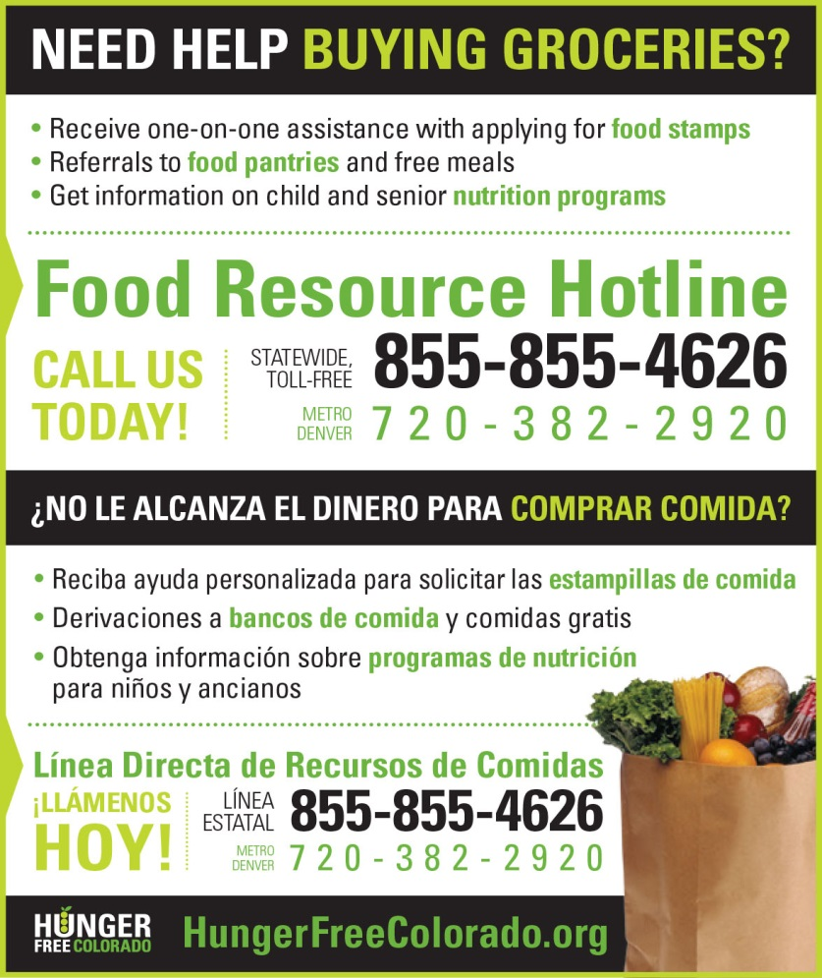
Colorado PEAK es un servicio en línea para los residentes de Colorado para evaluar y solicitar programas de asistencia médica, de alimentos y dinero en efectivo.

Para conocer más, visite coloradopeak.force.com

NO ESCRIBA DEBAJO DE ESTA LÍNEA. SOLO PARA USO DEL DISTRITO
Annual Income Conversion: Weekly x 52; Bi-Weekly x 26; 2 Times per Month x 24; Monthly x 12
Application Type:   Total Household Income: $ Household Size:_  Household Income Frequency -  Weekly  Bi-Weekly  2x/Month Monthly Annually  Categorical Eligibility - SNAP FDPIR TANF Foster  Homeless/Migrant/Runaway/Head Start | Application Status:  Approved - Free Reduced  Denied - Over Income Guidelines Incomplete/Missing: Notes:
Determining Official Signature: Approval/Denial Date: Notification Sent:
La Ley Nacional de Comedores Escolares Richard B. Russell pide la información arriba en esta solicitud. No tiene que dar la información, pero si usted no la provee, no podemos aprobar comida gratuita o de precio reducido para sus niños. Usted debe incluir los últimos cuatro números del Seguro Social (SSN) del miembro adulto que firma la solicitud. Los últimos cuatro números del SSN no se requieren cuando usted solicita de parte de un niño adoptivo temporal o usted incluye un número de caso del Programa de Asistencia Nutricional Suplementaria (SNAP, por sus siglas en inglés), el Programa de Asistencia Temporal Para Familias Necesitadas (TANF, por sus siglas en inglés) o el Programa de Distribución de Comida en Reservaciones Indígenas (FDPIR, por sus siglas en inglés) u otra identificación FDPIR de su niño. Tampoco necesita indicar el número del SSN si el miembro adulto del hogar que firma la solicitud no lo tiene. Utilizamos su información para determinar si su niño es elegible para la comida gratuita o de precio reducido, y para administrar y hacer respetar los programas de almuerzo y desayuno. Podemos compartir la información sobre su elegibilidad con los programas de educación, salud, y nutrición para ayudarles a evaluar, financiar, o determinar los beneficios de sus programas, así como con los auditores de revisión de programas, y los oficiales encargados de investigar violaciones del reglamento programático.

