Equity Focused Enrollment
Policy and Procedures Audit

Part I: Enrollment Policy Review

First, consider the discussion prompts in the Equitable Policy Review Protocol (Part I) . Then answer the following additional questions specific to your enrollment policy:

Question | Notes
- Is the policy legally compliant?
- Does the policy include a nondiscrimination statement, clearly welcoming all prospective students?
- Does the policy clearly articulate the application and enrollment process including: 1) enrollment eligibility, 2) process and timeline, and 3) selection process?
- Does the policy establish any undue barriers such as mandatory information meetings, mandated volunteer service, or parent contracts?
- Does the policy address enrollment after October Pupil Count Day?
- Does the policy prioritize students from subgroups who are currently underrepresented in the School?

Then, refer back to Parts II-IV of the Equitable Policy Review Protocol to revise your policy language and create a theory of action.

Part II: Admissions and Enrollment Procedures Review

Use the following questions to collaboratively reflect on your admissions and enrollment practices:

Question | Notes
- When, where, and how is enrollment advertised? Is information accessible to all current and prospective families?
- Is there anything on your enrollment overview page that might have a “chilling effect” on prospective families?
- When and where are the applications available? Are families required to visit the school in order to apply?
- How does a family’s access to technology influence the application process?
- What supports are there for families who do not speak English?
- How much time and what resources are required to complete the application process?
- What information are families required to supply for the application? Does the application request more information than needed during this stage in the process?
- Are there any questions on the application that could deter particular categories of families, such as undocumented or homeless?
- Are there any admission requirements such as academic assessments, auditions, or essays that could limit access based on students’ prior experiences or achievements?
- Is the enrollment process well-articulated and supervised?
- Have staff (e.g. front office, receptionist, registrar) been appropriately trained regarding the application process and interactions with families?
- Are students admitted at all grade levels? That is, does the school “backfill” vacated seats in higher grades?
- Are there parent and/or family participation requirements, uniform costs, or other schools fees required for enrollment that could pose barriers for low-income families?
- Does the school participate in the federal free and reduced-price lunch program or provide a comparable program?
- Does the school provide transportation for enrolled students?
- How can the school be proactive about enrolling a more diverse student body?
- How can the school be proactive about retaining a diverse student body?

Part III: Action Planning

Step 1: Set a goal
Resource: Setting a Diversity Goal

Our goal is to increase our ________ student population by ________ for the __________school year.

Step 2: Use Enrollment Policy Audit to Identify Action Areas
Reflect on the answers to the questions in parts I and II of this document. Circle or highlight answers that are potential areas for action. Once you have completed this step, organize each action area using the four quadrants below.

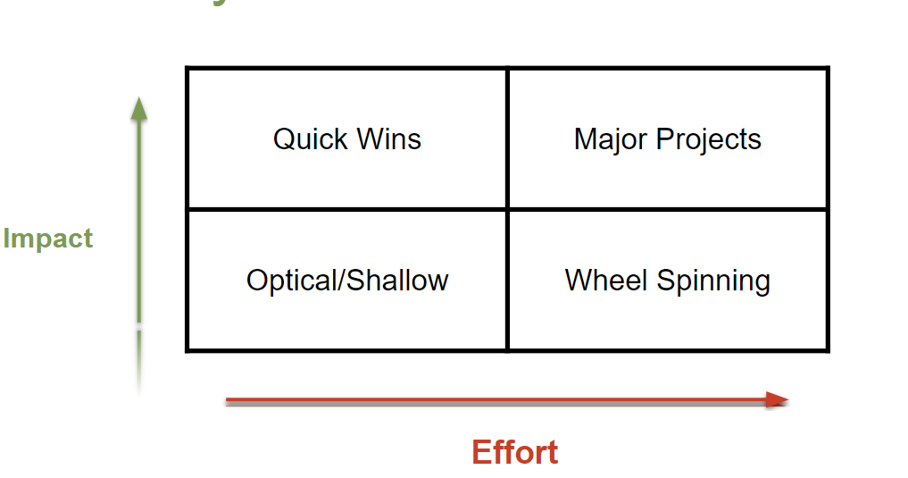

Step 3: Create Action Plan
Focus on the Action Areas listed in the Quick Wins and Major Projects quadrants to create an Action Plan.

Resource: Generic Action Planning Template

Please note- the resource above mimics the Action Planning section of the UIP- if you’ve identified Enrollment as an area of focus, you may consider including your planning in your school’s UIP.

Step 4: Monitor Progress
Create a detailed plan to monitor whether the Action Areas and Action Plan you’ve identified above are having the intended impact, and whether they are the correct areas to focus on to reach your goal.

This typically includes monitoring adult behavior change. Remember- policies exist to inform practice. Be sure to create a monitoring plan that looks at behavior change, rather than outcomes.

Step 5: Start again!

