“We cannot seek achievement for ourselves and forget about progress and prosperity for our community. Our ambitions must be broad enough to include the aspirations and needs of others, for their sakes and for our own.”
—César Chávez

Agenda item | Links
Welcome | bit.ly/MLLenrollment
Grounding in Equity | 2/10 webinar recording: School Policy Review through a Multicultural Lens  https://www.nationalequityproject.org/resources
Multilingual Families in Colorado | 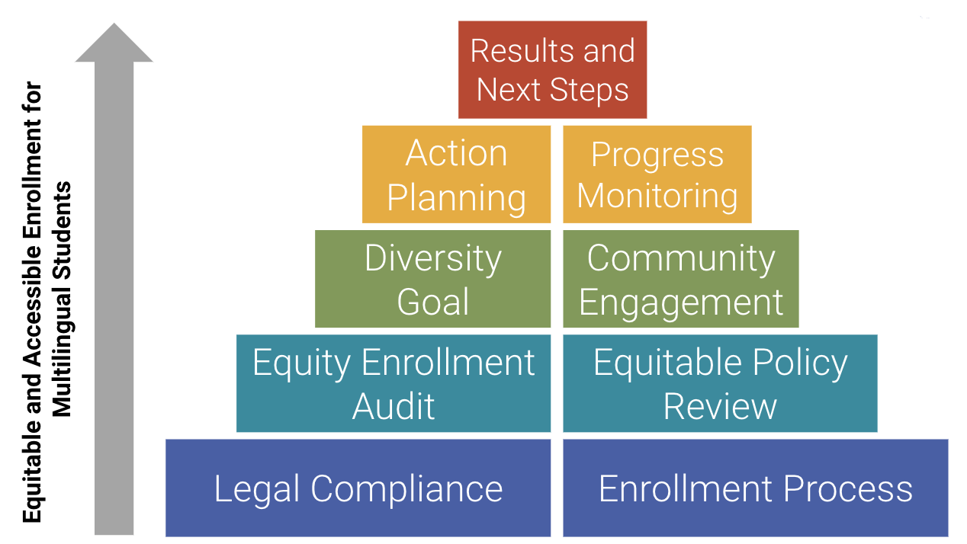
Legal Compliance & Enrollment Process | CSI Enrollment Resources (Legal and Policy)  https://www.cde.state.co.us/choice/equitablepolicyreviewprotocol
Equity Focused Enrollment Audit | Equity Focused Enrollment Policy and Procedures Audit
Community Engagement | https://www.coloradononprofits.org/  https://www.coloradogives.org/communityresourcecenter/overview  https://coloradoimmigrant.org  Local chambers of commerce
Action Planning and Progress Monitoring | Creating a Diversity Goal  Generic Action Plan Template
Results and Next Steps | 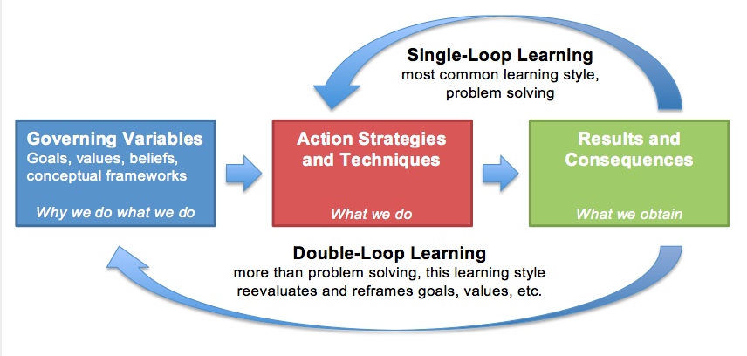

Additional Resources | Links
English Learners and School Choice: Helping Charter Schools Serve Multilingual Families | https://tcf.org/content/report/english-learners-school-choice-policies-delivering-charter-schools-equity-potential/?agreed=1
Making Students and Families Feel Welcome | https://www.colorincolorado.org/immigration/guide/welcome
Racial Equity Tool:  Policy Review Worksheet | https://resources.finalsite.net/images/v1533747604/psesdorg/iitlnnnhmnv3txzin6zs/PSESD_RET_PolicyReviewWorksheet.pdf
A Comprehensive Marketing Guide for Charter Schools | https://www.brightmindsmarketing.com/blog/a-comprehensive-marketing-guide-for-charter-schools/
Equity Pause Guide | https://www.publicdesignforequity.org/blog/2020/5/25/equity-pause-questions
Inclusive Language Guide | https://nasaa-arts.org/nasaa_research/inclusive-language-guide/
Weighted Lottery Slide Deck from National Charter School Resource Center | https://charterschoolcenter.ed.gov/sites/default/files/files/field_webinar_attachments/NCSRC%20SEA%20Webinar%20-%20Weighted%20Lotteries.pdf
Intentionally Diverse Charter Schools:  A Toolkit for Charter School Leaders | https://charterschoolcenter.ed.gov/sites/default/files/files/field_publication_attachment/NCSRC%20Intentionally%20Diverse%20Charter%20School%20Toolkit.pdf
Minnesota’s Chartered Public Schools | https://www.mncharterschools.org/_uls/resources/WELCOMING_ALL_statement_on_recruitment_booklet_v_2_-_2017.pdf
NYC Charter School Center Enrollment & Recruitment: Student Recruitment and Lottery | https://nyccharterschools.org/resources/student-recruitment-and-lottery/
SMARTe Goal Framework and Exemplar | https://www.ousd.org/cms/lib/CA01001176/Centricity/Domain/3667/SMARTe%20Goal%20Guidance.doc  *Automatically downloads graphic organizer
Leading an Equity-Focused Response Through and Beyond COVID-19 | https://www.leadershipacademy.org/resources/leading-an-equity-focused-response-through-and-beyond-covid-19/
A Survival Guide for Leaders | https://hbr.org/2002/06/a-survival-guide-for-leaders
COVID-19 and student learning in the United States: The hurt could last a lifetime | https://www.mckinsey.com/industries/public-and-social-sector/our-insights/covid-19-and-student-learning-in-the-united-states-the-hurt-could-last-a-lifetime#

