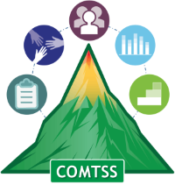
Colorado Multi-Tiered System of Supports
OFFICE OF LEARNING SUPPORTS

Colorado Multi-Tiered System of Supports Communication Planning Tool V1.1

March 2022 Version 1.0

Purpose: The Colorado Multi-Tiered System of Supports (COMTSS) Communication Planning tool provides a structured process to guide teams to effectively communicate with internal and external stakeholders. Ongoing communication ensures effective coordination, collaboration, and implementation of the COMTSS systems change framework. This tool was adapted from the Dissemination Plan Template – AI Hub (unc.edu) created by State Implementation and Scaling-up of Evidence-based Practices Center and the National Implementation Research Network.

Procedure: Creation of the Communication Plan should be a collaborative effort and reviewed by the Implementation Team.

Implement and Evaluate: As you implement and evaluate your communication plan, consider the following:
- What is the delivery timeline? Is communication being provided by the intended delivery date and frequency?
- Are the communication methods and channels of delivery aligned with the intended audience?
- How are you ensuring that the plan is implemented as written (ensuring accountability from creators and reviewers throughout)?
- How will you ensure all Implementation Team members have access to the plan?
- Is the communication plan being reviewed at regular intervals with the Implementation Team? Does the plan need to be updated/modified?

Explanation of table

Topic and Purpose:
Identify what you want to develop communication around in this column. If you would like to add more detail about the reasoning or purpose behind the communication, add that to this column as well.

Audience/Stakeholders (recipients):
In this column you will add who you want to receive your communication. This is the target audience. There may be several target audiences for each topic.

Message (content):
This column is used to capture the key points of your message. There is no need to craft a finished message in this document. This document is only for planning communication. Customize your message to your target audience.

Method(s) or Channel(s):
Communication can happen in many forms. Use this column to note what type of communication will be used to get your message across. Some examples of methods or channels could be email, staff meetings, webpage, social media, radio, QR codes, newsletter, television, presentation to the board, and/or professional learning community.

Accountability:
- Responsible for creating: This is where to name the person(s) that will create and/or deliver the message.
- Responsible for review: This is where to name the person(s) responsible for reviewing the created message for content, grammar, and clarity. It is important that messages are reviewed before they are delivered to the audience.
Initial Delivery Date(s):
This column acts as a timeline for delivering the message for the first time. It is a place to set a target date to get your message out initially.

Frequency:
Use this column to note how often the message will need to be delivered to ensure that it is internalized by the audience. It could be a one-time message or something the needs to be delivered several times for it to be fully understood.

Feedback:
It is best if this feedback is a two-way communication. Use this column to capture the method by which to gather the audience's understanding of the content and/or audience input on a topic. The way you collect feedback can depend on the delivery method. For example, if delivered in a staff meeting you could use an exit ticket to gather input or clarification about the topic. If you were to deliver it on a webpage, include a feedback option on the page. Note the type of feedback in this column.

Communication Planning Form

Topic and Purpose | Audience / Stakeholders (recipients) | Message (content) | Method(s) or Channel(s) | Accountability  - Responsible for creating  - Responsible for review | Initial Delivery Date(s) | Frequency (e.g., weekly, monthly) | Feedback  (Ensure two-way communication)

Editing a Table in Word

Written Instructions | Visual Aids
To add a row in a table in a Word document, follow the steps below:  - Right click in the table.  - Select “Insert”.  - Select “Above” or “Below” to insert a row where needed. | 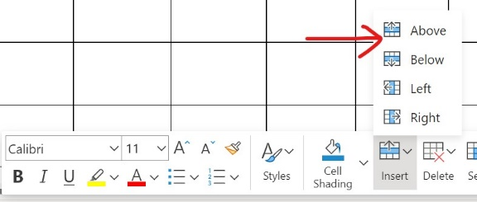
To split a cell in a table in a Word document, follow the steps below:  - Right click the target cell.  - Select “Split Cell.”  - In the window that appears, insert the intended new number of rows or columns.  For example, if one cell should become two rows, “Number of columns” should be “1” and “Number of rows” should be “2”.  - Click “OK.” | 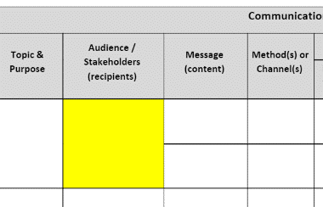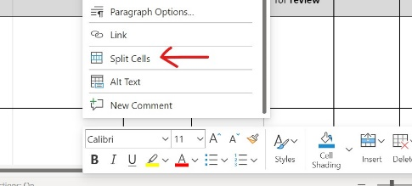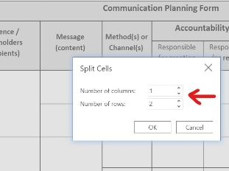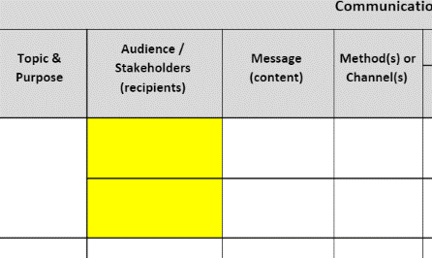
To merge two or more cells in a table in a Word document, follow the steps below:  - Highlight the cells to be merged.  - Right click.  - Select “Merge Cells.” | 