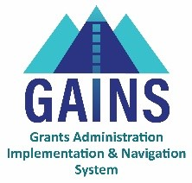

**GAINS Training and System Navigation**

# **Supplemental Funding**

## This training is for when supplemental funding is awarded after the initial award funds have been distributed.

1. Start within the application in which you will be receiving supplemental funding
   1. The allocation will be updated within the application and the application status will be “Revision Started”
2. Navigate to the budget – Add a budget line item or revise an existing budget line item to account for the added supplemental funding
3. Once the additional funding has been budgeted, change the application status to Revision Completed > LEA Fiscal Representative Edits Approved > LEA Authorized Representative Edits Approved

The next steps do not require any action on the part of the LEA

1. After the edits have been approved by the program teams, CDE will generate a fund request on behalf of the LEA to enable fund distribution.

# **Related GAINS Training and Navigation Topics**

* Completing a Budget in GAINS