Detail – CDE - LEA

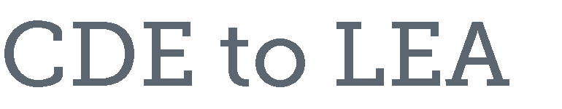
- CDE receives allocation figures by individual LEA from USDE
- CDE adjusts allocation figures for the following:
  - State Administration
    - 1% of USDE established base amount for State Title I-A Allocation
      - This amount is sent to CDE by USDE in a spreadsheet that shows the amount of admin for all Title I Programs (Title I-A, Title I-C, Title I-D)
  - Special LEAs
    - A special LEA is one that is not listed by the Census Bureau
    - The state has two special LEAs, the Charter School Institute (CSI) and the Colorado School of the Deaf and the Blind (CSDB)
    - The USDE provides guidance that states must adhere to in order to allocate funds to special LEAs
    - Manual adjustments are made to determine this funding
    - District of residence, at-risk count, formula children
  - Multi District Online Pilot Program
  - Set Asides
    - Title I-D Delinquent
      - Delinquent State allocation is sent to USDE and allocated to delinquent facilities based on prior year student counts.
    - School Improvement
      - Set-Aside for School Improvement is 4% of the State Allocation
      - LEAs with increases over last year provide the funding for the required set-aside amount
    - School Achievement Award Program
      - Up to 5% of the amount of the State allocation that is greater than the previous year adjusted allocation amount is available for this program.
      - If there is no increase in State funding, there is no funding available.
  - Hold-Harmless provision is applied
    - Statute guarantees that the LEA receive at least 85, 90, or 95 percent of the amount it was allocated in the preceding year.
    - Basic, Targeted, and Education Finance Incentive Grant
      - If the LEA is no longer eligible for funding under these Title I, Part A components, hold- harmless provisions do not apply.
      - The percentage guarantee varies according to the percentage of formula children in each LEA.
    - Concentration Grant
      - Guaranteed four consecutive year hold-harmless provision.
      - No annual eligibility requirements during the hold-harmless period.
- CDE sends updated allocation figures to individual LEAs

Office of Grants Fiscal Management September 2016

